Pulmonary cellular toxicity in alpha-1 antitrypsin deficiency: Detailed Methods

Figure 1

scRNAseq
Peripheral human lung samples from 11 donors (4 wild type “MM” COPD, 2 ZZ-AATD, 5 controls without chronic lung disease) were dissociated and CD45-reduced by magnetic-activated cell sorting. An average of 12,000 cells per donor and a total of 134,000 cells were profiled by single cell RNA sequencing (scRNAseq, 10X Chromium and Illumina). Integration was performed using Harmony. Processing and Louvain clustering were performed using Seurat.

Cell identity assignment
Cell identities were assigned to clusters using previously published single cell atlas expression signatures.
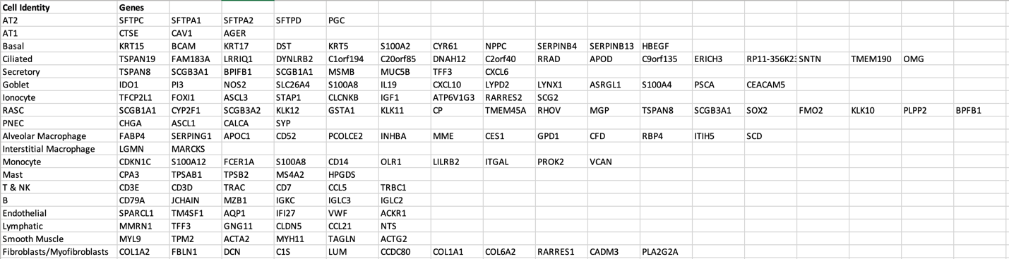
AAT and pro-SFTPC IF & imaging
FFPE peripheral human lung samples from 15 donors (4 wild type “MM” COPD, 8 ZZ-AATD, 3 controls without chronic lung disease) underwent deparaffinization and rehydration followed by antigen retrieval with pH9 EDTA-Tween vector retrieval solution (microwave 20 minutes 30% power, let stand for 10 minutes). Slides were permeabilized with 5% normal goat serum + .25% Triton for 30 minutes, followed by blocking with 5% normal goat serum for 30 minutes. Primary antibodies were diluted in 5% normal goat serum at the following concentrations: AAT (Santa Cruz Biotechnology sc-59438) - 1:100, pro-SFTPC (Seven Hills WRAB-9337) - 1:500. Mouse monoclonal IgG (Santa Cruz Biotechnology sc-3877) and normal rabbit serum, respectively, were used as isotype controls. Primary antibodies incubated overnight at 4 C. Following primary antibody staining, slides were washed 5 times in .1% Triton diluted in PBS. Secondary antibodies - goat anti-mouse IgG Fcγ subclass 1 specific AlexaFluor 647 (Jackson Immunoresearch 115-605-205) and goat anti-rabbit IgG AlexaFluor 488 (Invitrogen A11034) - were diluted in 1.25% normal goat serum at 1:1000 and incubated at room temperature protected from light for 1 hour. Following secondary antibody staining, slides were washed 5 times in .1% Triton diluted in PBS. Nuclei were stained with Hoechst (Invitrogen 33342) at 1:200 for 5 minutes, rinsed, and mounted using vibrance antifade mounting media (Vector Labs). Images were taken at 20x magnification on the Nikon Eclipse Ni-E microscope (quantification) or at 60x magnification on the Leica SP5 confocal microscope (representative).

AAT and pro-SFTPC quantification
For each sample, 3 sections were analyzed. For each section, 3 5x5 mm images were quantified. Fields of view that met the criteria of >100 AT2s present were randomly chosen. Co-localization, as determined by the presence of AAT within a pro-SFTPC positive AT2, was counted manually using FIJI. Results are expressed as the percentage of positive AT2s relative to the total number of AT2s examined. Percentages from each field of view were averaged to determine percent positive for each sample.

AAT and CD68 IF & imaging
FFPE peripheral human lung samples from 15 donors (4 wild type “MM” COPD, 8 ZZ-AATD, 3 controls without chronic lung disease) underwent deparaffinization and rehydration followed by antigen retrieval with pH9 EDTA-Tween vector retrieval solution (microwave 20 minutes 30% power, let stand for 10 minutes). Slides were washed with D-PBS twice for two minutes. Slides were then permeabilized for 30 minutes with 5% normal goat serum + 0.25% Triton, followed by blocking with 5% normal goat serum for an additional 30 minutes at around 500 uL per slide. Primary antibodies AAT (Santa Cruz Biotechnology sc-59438) and CD68 (Abcam Ab213363) were diluted in 5% normal goat serum at a 1:100 concentration. Mouse monoclonal IgG (Santa Cruz Biotechnology sc-3877) and Rabbit monoclonal IgG (Abcam Ab172730), respectively, were used as isotype controls at 1:100 and 1:500 concentrations. Slides were incubated overnight at 4 C. The following day, slides were washed 4 times for 5 minutes in 0.1% Triton diluted in DPBS. Secondary antibodies, Goat anti-mouse IgG, subclass 1 specific AlexaFluor647 (Jackson Immunoresearch 115-605-205) and Goat anti-rabbit IgG, AlexaFluor488 (Invitrogen A11034) were diluted in 1.25% normal goat serum a 1:1000 concentration. Slides were incubated for 1 hour at room temperature and protected from light prior to a second round of washing with 0.1% Triton, 4 times for 5 minutes. Nuclei were stained with Hoechst (Invitrogen 33342) at 1:200 for 5 minutes, rinsed twice with ddH2O, mounted using vibrance antifade mounting media (Vector Labs), and stored at 4 C. Images were taken at 60x magnification on the Leica SP5 confocal microscope.

Figure 2

Cleaved caspase 3 (+/- caspase 4) IF
FFPE peripheral human lung samples from 9 donors (3 wild type “MM” COPD, 3 ZZ-AATD, 3 controls without chronic lung disease) underwent deparaffinization and rehydration followed by antigen retrieval with pH9 EDTA-Tween vector retrieval solution (microwave 20 minutes 30% power, let stand for 10 minutes). Slides were washed with D-PBS twice for two minutes. Slides were then permeabilized for 30 minutes with 5% normal donkey serum + 0.25% Triton, followed by blocking with 5% normal donkey serum for an additional 30 minutes at around 500 uL per slide. Primary antibodies anti-caspase 3 active (Sigma C8487) and pro-SFTPC (Santa Cruz sc-518029) were diluted in 5% normal donkey serum at a 1:100 and 1:500 concentration, respectively Secondary only sections were used as controls. Slides were incubated overnight at 4 C. The following day, slides were washed 4 times for 5 minutes in 0.1% Triton diluted in DPBS. Secondary antibodies, donkey anti-mouse IgG AlexaFluor488 (Invitrogen A21202) and donkey anti-rabbit IgG, AlexaFluor647 (Invitrogen A32795) were diluted in 1.25% normal donkey serum a 1:1000 concentration. Slides were incubated for 1 hour at room temperature and protected from light prior to a second round of washing with 0.1% Triton, 4 times for 5 minutes. Nuclei were stained with Hoechst (Invitrogen 33342) at 1:200 for 5 minutes, rinsed twice with ddH2O, mounted using vibrance antifade mounting media (Vector Labs), and stored at 4 C. Images were taken at 20x magnification on the Nikon Eclipse Ni-E microscope.

Cleaved caspase 3 (+/- caspase 4) quantification
For each sample,1 section was analyzed. For each section, 10 single field-of-view images were quantified. Fields of view that met the criteria of >25 AT2s present were randomly chosen. Co-localization, as determined by the presence of CASP3 within a pro-SFTPC positive AT2, was counted manually using FIJI. Results are expressed as the percentage of positive AT2s relative to the total number of AT2s examined.
Tissue Samples
