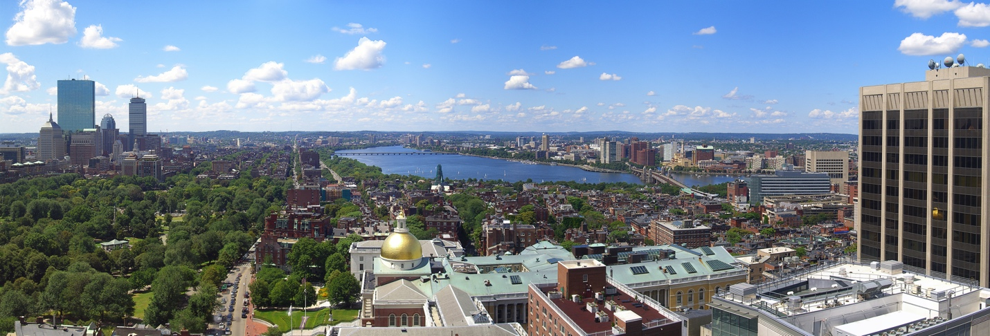

BU URBAN Graduate Program in Urban Biogeoscience and Environmental Health

Trainee Handbook

2023/2024 Academic Year

Table of Contents
About the Program 3
Mission, Vision, and Values 3
Program Leadership, Faculty, and Staff 3
Policies and Procedures 4
Participation in the Program 4
Advising and Mentorship 4
Commuting between Campuses 4
Class Registration and Course Petitions 4
NSF Acknowledgement 5
Funding 5
External and Internal Advisory Boards 5
Evaluation 5
Program Requirements 6
Coursework 6
Seminars 6
Workshops 6
Internship 7
Ph.D. Dissertation Research 7
Example Timelines 7
Other Resources for BU URBAN Trainees 8

Trainee Handbook Acknowledgement Form……………………………………………………………………………………..9

About the Program

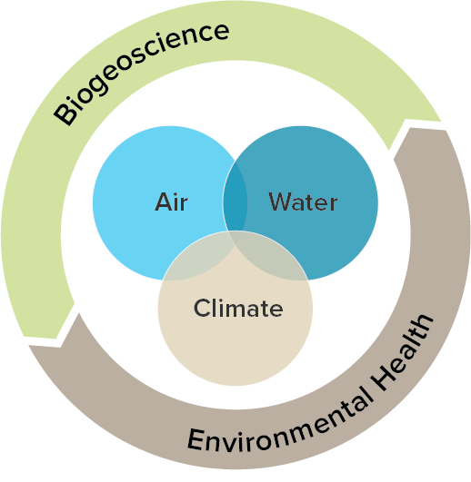
More than half of the world’s population lives in cities and this proportion will grow in the next few decades. People living in cities can face elevated levels of air and water pollution and extreme weather events such as heat waves and storm surges.

The Boston University Graduate Program in Urban Biogeoscience and Environmental Health (“BU URBAN”) was founded as a National Science Foundation (NSF) Research Traineeship (NRT) Program to prepare Ph.D. students to tackle the major environmental problems confronting cities using an interdisciplinary approach that fuses Biogeoscience and Environmental Health. Trainees design research projects whose results are scientifically transformative and useful for decision-makers, with a common focus on urban air and water quality, climate impacts, and urban greenspace.

Mission, Vision, and Values
The mission of BU URBAN is to prepare Ph.D. students to tackle urban environmental challenges using interdisciplinary methods and a co-production approach centered on partnerships with governments, non-governmental organizations, and the private sector.

Our vision is to create a diverse workforce of scientists and practitioners equipped with the technical knowledge and communication skills necessary for building a sustainable, healthy, and equitable future.
We strive to be an inclusive and welcoming community where all members develop a sense of belonging and truly thrive. We value:
- Training of students for a variety of career paths
- Diversity in all its intersectional forms, embracing the full range of contexts, experiences, and futures that our community members hold
- Communication and operations that are open, accessible, inclusive, respectful, and consider all voices
- Equitable relationships within the Boston University community and beyond
- Solutions to environmental challenges faced by cities and their residents, especially the most exposed and vulnerable

For our statement on diversity, equity, and inclusion, visit our program website.

Program Leadership, Faculty, and Staff
The BU URBAN Leadership Team consists of Pamela Templer (Director; Department of Biology), Lucy Hutyra (Associate Director; Department of Earth & Environment), Jon Levy (Associate Director; Department of Environmental Health), and Heather Ho (Program Manager).

Participating faculty from the Departments of Biology and Earth & Environment have expertise in biogeochemistry in terrestrial and aquatic systems, microbial and plant ecology, hydrology, geomorphology, biogeophysics, and remote sensing. Participating faculty from the Department of Environmental Health have expertise in epidemiology, exposure science, risk assessment, and toxicology, with applications that span air pollution and climate change, chemicals in soil, water and food, as well as non-chemical hazards such as noise, heat, and social stressors. Participating faculty from the Department of Mathematics & Statistics have expertise in hierarchical modeling, spatial and temporal modeling of data, multivariate analysis, network analysis, Bayesian statistics, and computational biology. Participating faculty from the Faculty of Computing & Data Sciences have expertise in agent-based modeling, algorithmic mechanism design and techniques for working with big data, ecosystem value mapping, systematic conservation planning, policy instrument design, impact evaluation, decision theory, and data visualization. Affiliated Staff bring expertise in communications, urban governance, sustainability, energy, diversity, equity, inclusion, and accessibility. See our program website for the current list of Faculty and Staff.

Policies and Procedures

Participation in the Program
Upon notification that you have been selected to participate in BU URBAN, you will be asked to sign an agreement to complete all required program elements. Your enrollment in the program starts in the semester that you are accepted and lasts until the completion of your Ph.D. at Boston University.

Advising and Mentorship
The BU URBAN Program provides interdisciplinary training for graduate students interested in a variety of career options. To ensure proper balance of coursework, research interests, professional development, and other activities,
we provide trainees and their advisors with an Annual Activities Report Form, which explains program requirements and tracks trainee progress. The Annual Activities Report Form is populated from the Self Report Survey that trainees complete at the end of the Fall and Spring semesters. The Program Manager also provides mentorship through 1) Semesterly Group Check-in’s, 2) Weekly Office Hours, and 3) easy-to-schedule individual meetings.

Commuting between Campuses
Due to the interdisciplinary nature of this program and the layout of Boston University, trainees often commute between the Charles Rover Campus (CRC), where the Biology, Earth & Environment, and Mathematics & Statistics Departments are housed, and the Boston University Medical Campus (BUMC), where the Department of Environmental Health is housed. To help you plan your travel between campuses we created this list of options:
- Take the BU Shuttle (BUS). The BUS runs approximately every 10-20 minutes and stops at several locations on the Charles River and the BU Medical Campuses to provide transportation between the two. The trip takes approximately 30 minutes, but varies with traffic. Keep in mind that during the summer months the BU Shuttle does not operate as frequently as during the academic year.
- There is a bike lane that connects the two campuses. The trip takes between 15 and 20 minutes.
- Take a nice 45-minute walk between the two campuses.
- Uber/Lyft. Install the App and hail a ride. The App will tell you how long your trip will take, but count on approximately 20-30 minutes.
- Drive and park.

Class Registration and Course Petitions
Due to the interdisciplinary nature of the program, trainees enroll in classes outside of their discipline and may encounter conflicts due to specific course prerequisites. If this is the case, email the course instructor and copy your advisor, Program Director (ptempler@bu.edu) and Program Manager (URBAN@bu.edu) and explain your concerns and/or questions.
We carefully created a suite of required courses that provide a broad background in Urban Biogeoscience and Environmental Health. If you think that a non-BU URBAN listed course you have taken should count towards your requirements, please complete a course petition form. Please be aware that filling out this petition does not guarantee approval.

NSF Acknowledgement
All presentations and publications generated during your enrollment in this program must acknowledge funding support from NSF with the following statement: “This work was supported by a National Science Foundation Research Traineeship (NRT) grant to Boston University (DGE 1735087).”

Funding
Scholarships and Stipends: As a Ph.D. student at Boston University you are guaranteed five (5) years of funding through various sources, including teaching fellowship, research grants, and training grants. There are also external financial sources you can apply for to support your work (e.g. NSF GRFP, Switzer Fellowship).

Research and Travel Awards: There are competitive funds set aside for BU URBAN Trainees to carry out individual interdisciplinary research projects and/or for conference participation. Calls for application to these competitive funds are only open to BU URBAN Trainees and have deadlines in October and February, annually.

Broadening Participation Awards: These competitive funds seek to advance diversity and inclusion in STEM by supporting BU URBAN trainees to participate in 1) public engagement activities that specifically reach under-represented groups and/or 2) participation in educational activities (e.g., conferences, trainings, reading groups) that build capacity for scientific research and/or communication centered on inclusion, equity, and intersectionality. Broadening Participation Awards are capped at $500 and proposals can be submitted at any time.

Program Fundraising
Each year, BU URBAN participates in Boston University’s Giving Tuesday Campaign in November and Giving Day Campaign in April to supplement existing program funding. 100% of all monies raised go directly towards stipends, awards, internship funding, and materials for trainees. Trainees are welcome to support the Giving Days by helping to create content about the positive impacts the program has had, designing marketing materials, and spreading the word about the campaigns within their circles of influence, including social media networks. Any and all participation is completely voluntary!

Internal Advisory Board and Social Committee
The BU URBAN internal advisory board (IAB) consists of faculty, affiliated staff, and trainees. The IAB guides the leadership team on decisions pertaining to program policies and operations. IAB members are selected through nomination (including self-nomination) and will serve for year-long terms. The BU URBAN Social Committee organizes events for trainees that are fun (e.g., URBAN outings) and productive (e.g., pitch nights). If you are interested, please contact the Program Manager at URBAN@bu.edu.

Evaluation
The BU URBAN Program internally evaluates our events and operations through both post-event surveys and end-of-semester feedback sessions with trainees and with faculty. We take feedback seriously and make program adjustments frequently. BU URBAN has an open-door policy and our leadership team welcomes your questions, suggestions, and concerns so we can improve the program. We encourage proactive, open communication, feedback, and discussion about any concerns you may have. Please visit https://sites.bu.edu/urban/program-feedback/ to leave feedback anonymously at any time.

Program Requirements

Coursework
- Colloquium in Urban Biogeoscience and Environmental Health (Fall, 2 credits)
- Applied Research Methods in Urban Biogeoscience and Environmental Health (Spring, 2 credits, for students who entered the URBAN Program fall 2022 and before)
- One course in Biogeoscience (4 credits)
- One course in Environmental Health (4 credits)
- One course in Statistics or Data Analysis (4 credits)
- Urban Biogeoscience and Environmental Health: From Research to Policy (variable credits, see internship below)
The courses are designed to provide trainees with a foundation in Biogeoscience and Environmental Health, with skills and techniques in Statistics, applied to topics that span air, water, and climate in urban environments. In general, courses that meet URBAN requirements also fulfill elective requirements in each department. For a complete listing of courses, check the program website.

Seminars
Both the Biogeoscience and Environmental Health programs have seminar series that you are encouraged to attend. You can find relevant seminar listings in our weekly e-newsletters. You can attend many of the seminars remotely via Zoom.

Workshops
Participation in five workshops and URBAN’s Annual Symposium is required for trainees in their first year of the program. Following the first year, trainees are required to participate in at least one of the following each year: Science Communication, Urban Governance Series, Professional Development, or the Annual Symposium.
- Introduction to the BU URBAN Program – half day workshop, Fall semester
- Workshop introduces trainees to each other, the leadership team, and the program.
- Science Communication – half day workshop, Fall semester
- This short workshop has a rotating theme each year, covering anything from communicating with a journalist, to writing a blog post or news story, or making short videos.
- Urban Governance Series – 3-4 lectures, events, and/or workshops, Spring semester
- A multi-part lecture and discussion series held by BU’s Initiative on Cities
- Professional Development – 1-2 hour workshop, Fall or Spring semester
- This workshop has a different focus each year, ranging from career panels to networking or making a personal website. Trainees are also encouraged to participate in Professional Development opportunities provided by BU Professional Development & Postdoctoral Affairs and BU’s BEST.
- Annual Symposium—2-2.5 hour event, Fall or Spring semester
  - This event focuses on exploration of URBAN program-related themes and features lightning talks, panels, roundtables, and/or networking opportunities with trainees, program alumni, affiliated faculty and staff, stakeholders, and partners.
- Responsible Conduct of Research (held by the BU Provost’s office)
- All trainees are required by the National Science Foundation to complete a multi-part training focused on responsible conduct of research. The BU Office of Research offers the introductory and intermediate workshops online, whereas the final, advanced workshop consists of a 4-part live series offered on both campuses and remotely. More information is available on the BU Research Office website.

Internship
Each trainee is required to carry out an internship with a city government office, NGO, and/or the private sector. The internship is required to be a minimum of 80 hours and are flexible in terms of number of days per week and timing. Please note that trainees are required to simultaneously enroll in the companion internship course (GRS BI/EE 795 or SPH EH 795). The course covers professional development associated with the internship experience, lessons about science policy integration, and science communication skills.

Ph.D. Dissertation Research
Trainees fulfill dissertation research requirements of their home department and are required to form an interdisciplinary dissertation committee. Trainees in the Departments of Biology, Earth & Environment, and Environmental Health must form a dissertation committee with at least A) one faculty member from Environmental Health; and B) one faculty member from either BU URBAN with a Biology or Earth & Environment affiliation or the Biogeoscience Program. Trainees in the Department of Mathematics & Statistics and the Faculty of Computing & Data Sciences must form a dissertation committee with at least one faculty member from either Environmental Health, BU URBAN with a Biology or Earth & Environment affiliation, or the Biogeoscience Program.

Example Timelines
All trainees in BU URBAN must complete the required program elements described above. Beyond that, trainees “make their own adventure” by participating in program opportunities that advance their academic and professional goals. The table below demonstrates two example timelines for a trainee participating in BU URBAN.

 | Example A (meet minimum requirements) |  | Example B (get the most out of URBAN)
 | Courses, Internship, Research | Workshops and Events | Courses, Internship, Research | Workshops and Events
Year 1 | - URBAN Colloquium Course  - Statistics Course  - Biogeoscience Course | - Intro Workshop  - Professional Development  - Science Communication  - Urban Governance  - Responsible Conduct of Research training  - Annual Symposium | - Same as A  - Apply for URBAN Research Award to pilot interdisciplinary project | - Same as A  - Participate in URBAN-sponsored events (social gatherings, networking, seminars, etc.)  - Join URBAN Social Committee
Year 2 | - Environmental Health Course  - Interdisciplinary committee formation  - URBAN Internship & Internship Course | - Pick one:  - Professional Development  - Science Communication  - Urban Governance  - Annual Symposium | - Same as A  - Apply for URBAN Travel Award to present research at conference | - Participate in multiple workshops  - Join Internal Advisory Board
Year 3 onward |  | - Pick one:  - Professional Development  - Science Communication  - Urban Governance  - Annual Symposium | - Continue partnering with internship host; write dissertation chapter based on internship  - Apply for URBAN funding to publish manuscript | - Same as A but participate in multiple workshops  - Apply for Broadening Participation Award to attend workshop on Inclusive Science Communication

Other Resources for BU URBAN Trainees
The BU URBAN Program is committed to help trainees complete their graduate work and forge their career. Below are programs and resources that Boston University offers its students to succeed in graduate school and beyond.

Stay current. Each week we alternate between emailing a TRAINEE TRIBUNE (for trainees and faculty advisors only) and URBAN UPDATE (for the broader URBAN community) newsletter that includes information on upcoming program events, relevant webinars, interesting events on campus, and other useful information.

Follow us on Social Media. Follow BU URBAN on Twitter @BU_URBAN and on Instagram @BU_URBAN. Feel free to tag our handle and #NSFNRT in your own posts so we can amplify your posts or send us information about something you are working on so we can tweet it for you. We also suggest adding @BU_URBAN to your bios.

Stay in Touch! If you know of relevant upcoming events on campus or elsewhere, we want to know so we can share then with the community. If you have any newsworthy items (e.g. you won an award, published a paper, presented at a conference), please tell us so we can amplify your work! Please send all news to URBAN@bu.edu. BU URBAN Trainees also stay connected with our BU URBANites slack channel. New students will be invited to join by the Program Manager.

Other BU Resources
In addition to the professional development opportunities that the BU URBAN program offers, there are many other resources on campus:
- ARROWS – Advance, Recruit, Retain, and Organize Women in STEM (https://www.bu.edu/arrows/) keeps a current list of funding sources and career resources for graduate students.
- Broadening Experience in Scientific Training (http://www.bu.edu/best/) is a network of 17 academic organizations in the country selected by the National Institutes of Health that enhance career development for biomedical trainees. Boston University belongs to this network and offers several resources for Ph.D. students to explore careers both inside and outside standard academic research.
- BU Career Center (http://www.bu.edu/careers/) offers many career resources and professional development opportunities for STEM graduate students.
- BU Professional Development and Postdoctoral Affairs (https://www.bu.edu/postdocs/professional-development/) A community for socializing, networking, and advocacy at Boston University. PhD Progression (https://www.bu.edu/pdpa/for-doctoral-students/phd-progression/) is an online training program that provides you with modules, or badges, to support your career & professional development during your PhD, and help you prepare for your post-PhD career.
- Office of the Associate Provost for Graduate Affairs and Professional Development & Postdoctoral Affairs
(https://www.bu.edu/grad/) A central place to connect with information and resources for graduate students at Boston University. Find information here to tap into available resources and to connect with the graduate community at BU.

Boston University is home to numerous resources and organizations that can support you in other ways:
- BU Sexual Assault Response & Prevention Center (www.bu.edu/cgsa/resources/sexual-assault-resources/)
- Center for Gender, Sexuality, and Activism (CGSA - http://www.bu.edu/cgsa/)
- Graduate Women In Science and Engineering (GWISE - https://www.bu.edu/gwise/)
- Howard Thurman Center for Common Ground (HTC - https://www.bu.edu/thurman/)
- Out in STEM (oSTEM - https://sites.bu.edu/ostem/)
- Underrepresented Graduate Students Organization (UGSO - https://sites.google.com/view/buugso/)
And many more: https://www.bu.edu/grad/community/

Trainee Handbook Acknowledgement Form
Thank you for reviewing the URBAN Trainee Handbook for Academic Year 2023-2024. You’re almost done! Please visit http://sites.bu.edu/urban/urban-trainee-handbook-acknowledgement-form-ay-2023-24/ to complete the Trainee Handbook Acknowledgement Form.

