Internship Write-up Assignment
Developed by Erin Xu, BU URBAN Impact Intern, Spring 2022

As part of the BU URBAN internship course, each trainee writes a summary of their internship experience and the impact of the partnership. The summary can be viewed as an elevator pitch, with the target audience being interested members of the public. As such, it should be short, punchy, and inspiring rather than long, technical, and bland.

The summary should be 100-150 words and include the following: the urban environmental challenge your internship addressed, your actions/tasks, and the impact your work brought to the organization and/or world. You are welcome to cover the social, organizational, or environmental impacts of your internship and/or how the experience helped you in your professional development. We also encourage you to mention any future plans with your partner organization.

If you have not completed your internship by the time of this assignment, please write about the likely impact and the Program Manager will follow up with you to update your summary once the internship is complete.

Template:
Problem, Action, Impact (and Future, if relevant)

Pitch Writing Step-by-step:
Step 1: Draft a short description of your internship project using the format below. We recommend using text from your internship proposal and/or agreement letter as a starting point!
- Problem: What is the problem? Why is it important/significant?
- Action: What were your tasks/goals/actions to address the issue?
- Impact: What impact did your actions have? OR What are some likely impacts? (Social, organizational, and/or environmental, etc.)
- (Optional) Future: Was this internship experience helpful in your career development? If you are continuing another exciting project with the organization, we’d love to hear about it!
- Project deliverables: include and link any products/policy brief/reports/programs you have created for this internship.
Step 2: Bold the most important words or concepts
Step 3: Experiment with rearrange words and flow for a more concise and compelling narrative
Step 4: Proofread and edit! Try reading it out loud as if it were an elevator pitch. Make adjustments so that it feels exciting and punch to deliver.
Step 5: Include a relevant picture (especially of you doing the work, if possible) and hyperlink your final product in the write-up.
Example: Raquel Jimenez - Improving Tree Equity in the City of Boston: Finding Space for New Trees

Project Summary: Urban trees make for healthy communities. In Boston, as in many cities, tree canopy is unequally distributed, such that some residents receive many health and environmental benefits, and others receive very few. [Problem]

Raquel partnered with Speak for the Trees to identify areas in Boston where new trees could be planted in order to improve tree equity. She integrated remote sensing, land cover, and administrative data and accounted for available planting space, existing tree canopy, and neighbourhood-level environmental and sociodemographic characteristics. [Action]

Raquel created an interactive and publicly available online map that supports Speak for the Trees’ outreach and education efforts as well as targeted tree-planting initiatives aimed at both increasing tree canopy and reducing racial, ethnic, and socioeconomic disparities in access to benefits from urban trees. [Impact]

PICTURE!
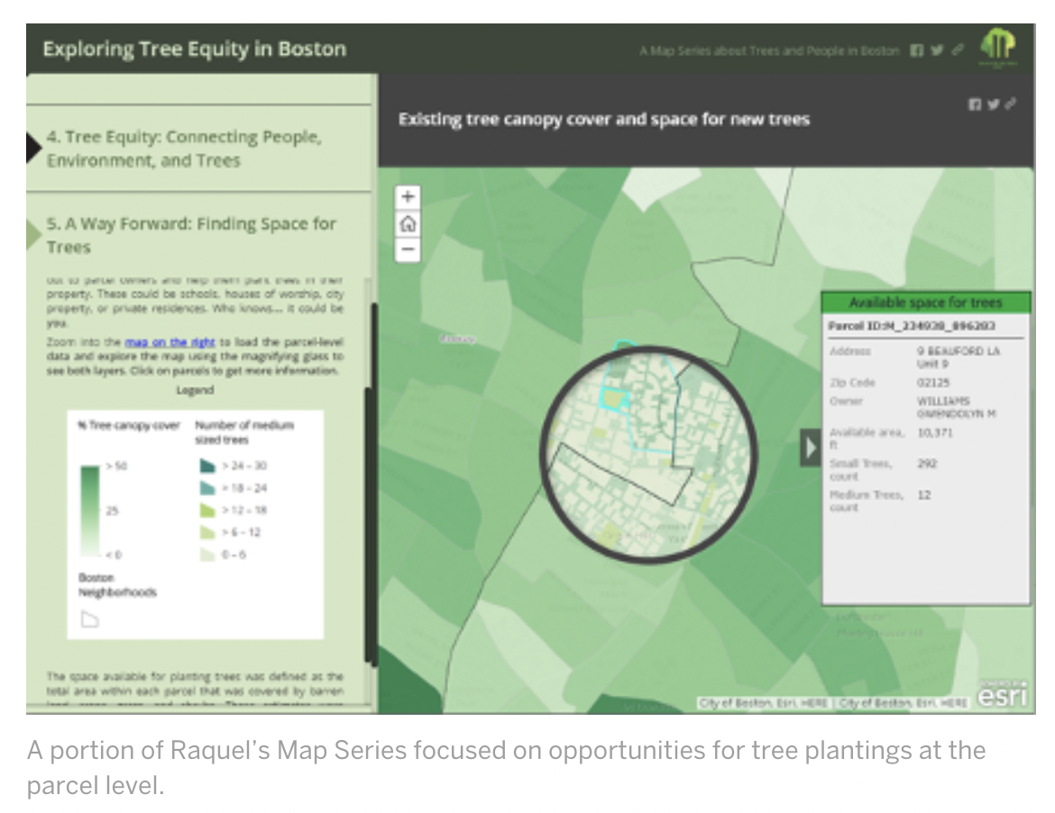

Project Deliverables: Exploring tree equity in Boston: A Map Series about trees and people. Also, see the Twitter campaign celebrating Raquel’s work by searching #TreeEquityBoston.

If you need more guidance on writing the elevator pitch, also see an MIT policy pitch example for reference.

Notes:
- Use simple language. Cut back on unnecessary details, be concise with the language and stick to shorter sentences. Less is more!
- Please use active tone and action verbs such as “design,” “examine,” “contribute,” “support,” etc.
- Please try to avoid any jargon terms, and limit the use of acronyms and buzzwords. If they are necessary, keep it to no more than 3 jargon terms and define them for lay audiences
- Feel free to run your summary through a readability tool to check.

