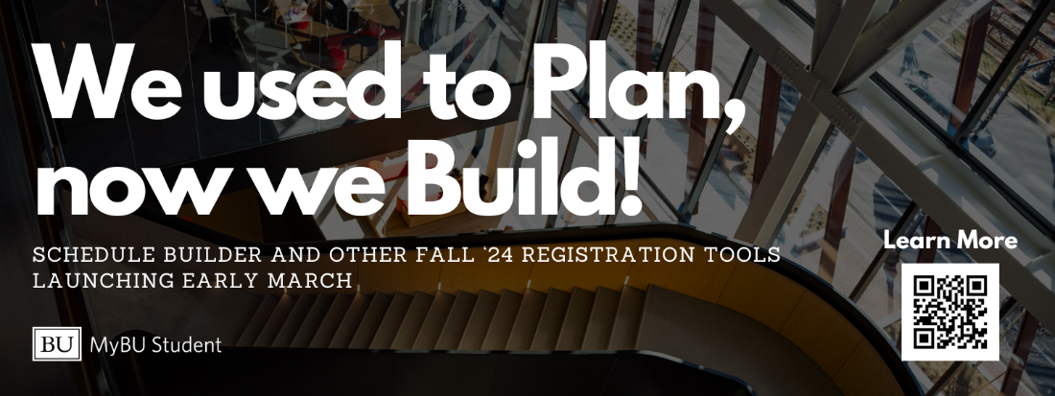

On March 6th, MyBU Student will launch new class registration planning tools, including Class Search, Schedule Builder, and Shopping Cart. Schedule Builder replaces the Registration Planner in the Student Link.
Search for classes using Class Search, place them in the Schedule Builder to compare potential options, and validate that you can register for your preferred classes in the Shopping Cart. Using these planning tools and putting classes in your Shopping Cart will make your registration appointment faster and easier.
The MyBU Student Portal has training videos and knowledge articles to support you through these changes. On March 6th, the Student Portal will point you to the new planning tools. You will also access class registration through the Student Portal at your registration appointment in April.

