An Analysis of a Color Trend in Hollywood and its Effects

Ata Leblebici
QM222 D1
Prof. Shulamit Kahn
December 15, 2016

EXECUTIVE SUMMARY

To directors and colorists making movies worldwide,
It is a common belief that colors have influence over human behavior and emotion. Such as the color red making you hungrier or the color blue calming you down, it is theorized that certain colors have certain associations. This idea extrapolates in to the seventh art form, movies.
Cinema has long been a fresh an accessible art form and one of the most directly affective. It has been theorized by different people in Hollywood that color schemes for movies matter so much as to influence likeability and success of the movie. The most eye pleasing scheme being a blue and orange one.
Basic color theory tells us that colors that are opposite of each other, also called complimentary colors, look better to the eye when paired together; these are red-green, yellow-purple, and blue-orange.
The specific reasoning why blue and orange, of all these pairs, is the optimal is because the theory then states that human skin tones are closest to hues and shades of orange. By juxtaposing actors and actresses with blue backgrounds, this composition would make the actors pop-up in the scenes more, direct more attention to them.
This study aims to test three different questions: if there is a trend in Hollywood towards movies that have blue-orange color schemes, if these blue and orange movies more successful in the box office or have better reviews meaning they are more well liked.
Data was gathered through ‘Movie Barcodes’, a webpage that takes movies and squeezes each frame in a movie into a pixel wide line. When all frames in a movie combined into lines, a representation of color scheme throughout the movie is shown. This image is then run through an image processor that feeds out what the eight most dominant colors are and the values for their colors. The values are then compared to a color wheel to determine which color they represent. The formula used to determine id the movie is blue-orange looks at whether at least two of the eight colors are orange and two of the eight are blue, as to also test for prevalence of such colors rather than just presence. Data includes about three hundred movies that came out starting from 1953 to 2016.
One regression was chosen for each question in this paper. The first regression looks at the trend of blue and orange movies in relation to time, keeping budget constant. The second regression looks at box office success of the movie, the amount US dollars it made while it was out in theatres, in relation to whether it was blue and orange, keeping values like budget, genre and viewer score constant. The third regression looks at the viewer scores for the movie on IMDb.com, perhaps the most reliable measure of likeability for a movie, not just because amount of reviews for an average score is high but also exceptional wide coverage of nearly all movies. IMDb score is tested for its relation to the color scheme, keeping budget and year constant.
The first regression yields the result that for movies which came out in the same year, the more with the higher budget will have a higher probability of having a blue-orange color scheme but more importantly, for the movies that have the same budget, the one that came out later will have a higher probability of being blue and orange as well.
The second regression portrays rather uninteresting results. According to the regression, budget seems to be the dominant affecter of a movie’s box office success with a little help from how good the movie actually is. Both budget and IMDb score yielded positive correlations with box office success, whereas genre and being blue and orange cannot be said are determinants of how much money the movie makes.
The third regression paints a similar scene as well. Budget also came out as the dominant correlation with IMDb score, perhaps intuitively where movies that have higher budgets have more money to spend to make sure everything looks as good as it does. On the other hand, color scheme, namely blue and orange, also did not prove itself to be correlated with IMDb score at all.
Based on this analysis, it can be seen that there in fact is a trend in Hollywood where more movies have adopted a blue and orange color scheme as time went on. However, strangely enough the reason as to why still eludes the eye, as it cannot be positively concluded whether or not movies with blue and orange color schemes either make more money or are well liked.

INTRODUCTION
Rumor has it that a trend has been sweeping Hollywood for the past few years. That is the trend that every movie has becoming more blue and orange. There is two layers of this phenomenon; directors and set assistants have been superimposing actors with blue backgrounds, and that colorists, during the post production process, have been using filtering, which we know from our own picture editing software in these contemporary times, to make scenes look blue and orange. Perhaps not sticking out the average viewer’s eye at first, once you see the trend you can never un-see it.

Picture taken from: http://tvtropes.org/pmwiki/pmwiki.php/Main/OrangeBlueContrast
But why blue and orange? According to color theory, opposite colors such as blue and orange in the color wheel, create a more harmonious color composition that is pleasant for the viewers’ eyes. Even though other opposite color pairings exist – such as green and red, and yellow and purple – blue and orange is the most preferred because as theorized, the human skin is closest to orange between these primary and secondary colors, therefore a blue and orange color scheme is the most attractive color composition without altering the characters’ and the actors’ natural skin tone too much and risk making them look alien.
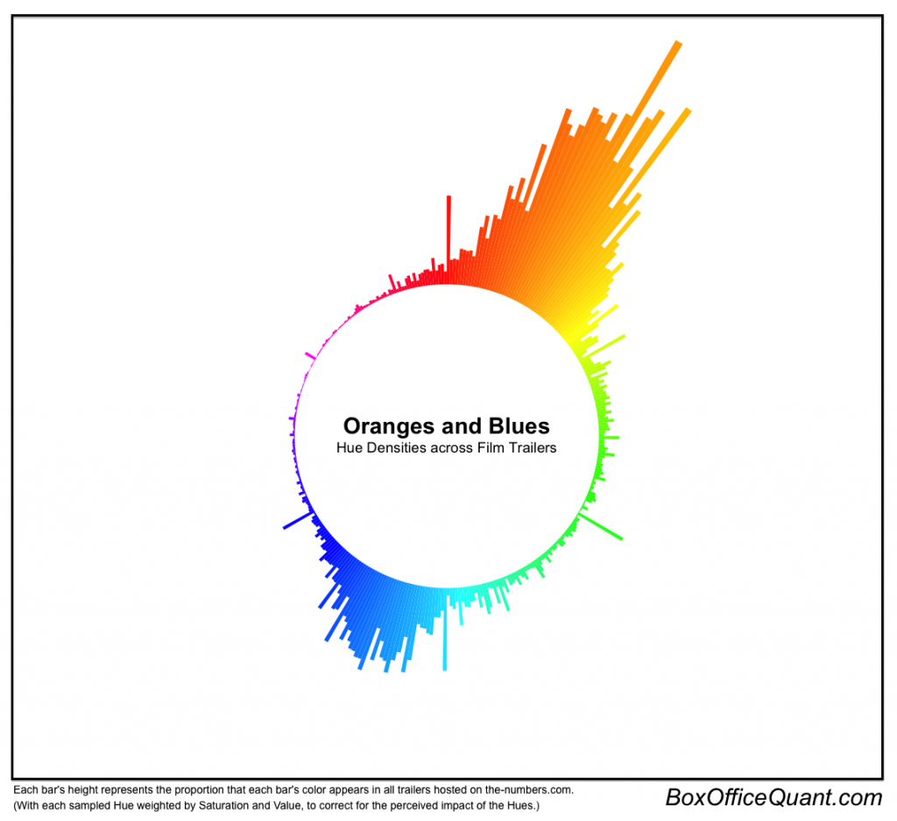
Just how prevalent is this phenomenon? According to a study of about 300 movie trailers, the answer is quite prevalent. As you can see from the illustration below, there is a huge discrepancy between the use of blue and orange vs other color schema:

Picture taken from: http://boxofficequant.com/oranges-and-blues/
Could the same thing be said about the movies themselves and not just their trailers? This project studies how the color schemes of movies have changed over time and how this correlates with success to find answers to questions like; have movies become more blue and orange recently? Is there a relationship between whether or not a movie is blue and orange and how well the movie does in the box office?

DATA SETS
Gathering color data for a movie without having to download and analyze every single scene is difficult for a whole movie. That’s where something called a “Movie Barcode” is deferred to. Moviebarcode.tumblr.com takes movies and produces a ‘barcode’ by taking every single frame in a movie (usually 1/24th or 1/30th of a second in the film industry) and pressing the frames into single pixel, horizontal lines. Taking the compressing frames into dominant colors, this method allows to illustrate a mode distribution of color throughout a movie. Individual movie barcodes of movies are then taken and run through an image color analyzer, which breaks down images to at most 8 dominant colors and gives RGB and HSV values. Then by comparing the ‘hue’ value under HSV to a sample color wheel, it can be shown which color these 8 dominant colors correspond to. This analysis has taken the hue range from 0-360 and divided as such: Red = 331-20, Orange = 21-50, Yellow = 51-80, Green = 81-169, Blue 170-240 and Purple = 241-330. As it can be seen, color ranges for blue and orange are relatively low, with orange tied for lowest by covering 30 hue values, and blue fourth lowest by covering 71 hue values. This analysis was done for a total of 294 color movies that came out between 1953 and 2016. The variables used for the analyses are as follows:
Question 1: Is there a trend of more movies adopting a blue and orange color scheme over the years?
- Dependent Variable
  - BlueandOrange: Indicator variable that tests if at least 2 of the most dominant 8 colors in a movie are classified as orange and if at least 2 of the most dominant 8 colors in a movie are classified as blue
- Explanatory Variables
  - MovieYear: Year in which the movie came out
  - BudgetMil: Budget of the movie, taken from the Internet Movie Database (IMDb), in millions of US dollars
- Additional Variables
  - Color1Hue-Color8Hue: HSV values of most 8 dominant colors of a movie
  - Color1Color-Color8Color: The color previous HSV values correspond to in the color wheel

Question 2: Do blue and orange movies make more money at the box office?
- Dependent Variable
  - BoxOfficeMil: The amount of millions of US dollars the movie has made in the box office
- Explanatory Variables
  - MovieYear: Year in which the movie came out
  - BudgetMil: Budget of the movie, taken from IMDb, in millions of US dollars
  - BlueandOrange: Dummy variable that tests if at least 2 of the most dominant 8 colors in a movie are classified as orange and if at least 2 of the most dominant 8 colors in a movie are classified as blue
  - IMDbScore: A score between 1-10 assigned by the average of all user reviews and scores for the movie in IMDb
  - GenreVal: The genre of the movie
      - GenreVal = 0 – Drama
      - GenreVal = 1 – Action
      - GenreVal = 2 – Sci-FI
      - GenreVal = 3 – Animation
      - GenreVal = 4 – Comedy
      - GenreVal = 5 – Horror
      - GenreVal = 6 - Biography
- Additional Variables
  - Color1Hue-Color8Hue: HSV values of most 8 dominant colors of a movie
  - Color1Color-Color8Color: The color previous HSV values correspond to in the color wheel
Question 3: Do blue and orange movies get higher average user scores?
- Dependent Variable
  - IMDbScore: A score between 1-10 assigned by the average of all user reviews and scores for the movie in IMDb
- Explanatory Variables
  - BoxOfficeMil: The amount of millions of US dollars the movie has made in the box office
  - BlueandOrange: Dummy variable that tests if at least 2 of the most dominant 8 colors in a movie are classified as orange and if at least 2 of the most dominant 8 colors in a movie are classified as blue
- Additional Variables
  - Color1Hue-Color8Hue: HSV values of most 8 dominant colors of a movie
  - Color1Color-Color8Color: The color previous HSV values correspond to in the color wheel
Many confounding variables were taken into account for these analyses such as box office-budget relationships, genre-box office relationships and score-box office relationships. Regression tables for these questions are given under Appendix C, D & E, as well under regression analyses themselves.

ANALYSIS
QUESTION 1
While the primary relationship for this question is the one between the variables BlueandOrange and MovieYear, variable BudgetMil was also added, with the assumption that movies that have a higher budget would
more likely to be able to afford colorists for filtering in the post production process as well as afford staff for lighting like grips and electric, but also lighting equipment like color bulbs and light filters. This puts the variable BudgetMil in the position for a confounding factor and its inclusion helps the variable MovieYear be a more accurate predictor of the dependent variable, given that we can expect more recent movies to able to have a higher budget and access all the benefits.
REGRESSION
Table 1. Dependent Variable: Indicator variable if the movie has a blue and orange color scheme. (BlueandOrange)
Variable | Coefficient
Movie Year | 0.0036297**  (2.01)
Budget Mil | 0.0010356**  (2.03)
Constant | -7.092448**  (-1.97)
AdjRsquared = 0.00451 | Root MSE = .3983
Number of Observations = 239
Regression table in Table 1 shows us that both movie year and the budget of a movie have a significant impact on the probability of whether or not a movie has an overall blue and orange color scheme.
Values in parentheses are t-statistics.
**Indicates significance at the 95% confidence interval (5% significance level)

The coefficient while on the edge of significance, is at the 95% confidence interval and the relatively high negative value for the indicator variable BlueandOrange is corrected through high values that would be entered for BudgetMil and especially MovieYear.

Since the range for the movie year variable is from 1953-2016, minimum probabilities can be inferred. This means that a movie that came out in 1953 with no budget would have a -0.0036% probability of being blue and orange while a movie that came out in 2016 would with no budget would have a 0.225% probability of being blue and orange, every individual year adds a 0.36% probability of the movie being blue and orange, holding the budget constant.
However, since BudgetMil is a significant confounding factor, it has to be accounted for. This means that for movies that come out in the same year, an additional $1 million US adds a 0.10% probability of blue and orange. Taking median values for budget and year from the data set, the median movie came out in 1998 with a budget of $22M; which means that it has a 0.182% probability of being blue and orange. The maximum values for the variables point out to a movie that came out in 2016 with a budget of $300M which has a 0.536% probability of being blue and orange.

QUESTION 2
A lot of possible confounding factors were weighed into this question. The primary relationship being tested is the one between BlueandOrange and BoxOfficeMil, if a movie being blue and orange contributes to a movie’s financial success. It is empirically sensible that a movie with a higher budget is likely to have a higher box office number, generally because the ability to market more, get more exposure through advertisements, trailers and posters better. The variable MovieYear was excluded due to the fact that its major affect would be through increased budget capacity. Variable IMDbScore reflects a movie’s success in terms of audiences’ appreciation towards it. Higher rated movies are expected to gross more intuitively. Also the categorical variable Genre was included through i.Genre outlying a theory how different genres could achieve different box office successes. Other confounding factors could be though about for this question but they were excluded due to immeasurability, such as number of the theatres the movie has opened in; which is largely also reflected through a movie’s available budget

REGRESSION
Table 2. Dependent Variable: Amount of money the movie made while it was playing in theatres, in millions of US dollars (BoxOfficeMil)
Variable | Test 1 | Test 2 | Test 3 | Test 4
Blue and Orange | 44.969**  (2.50) | 3.656  (0.25) | 6.224  (0.43) | 3.010  (0.21)
Budget Mil |  | 1.380**  (12.06) | 1.367**  (13.06) | 1.245**  (10.43)
IMDb Score |  |  | 22.304**  (3.57) | 22.906**  (3.70)
Movie Year |  |  |  | -0.235  (-0.58)
Action |  |  |  | 10.170  (0.54)
Sci-FI |  |  |  | 18.883  (1.28)
Animation |  |  |  | -11.524  (-0.61)
Comedy |  |  |  | 27.914  (1.61)
Constant | 65.423**  (8.23) | 17.022**  (2.19) | -137.784**  (-3.13) | 321.053  (0.40)
Adjusted R Squared | 0.021 | 0.4351 | 0.4635 | 0.4387
Root MSE | 111.83 | 87.39 | 85.16 | 78.02
Number of Obs | 246 | 225 | 225 | 207
Values in parentheses are t-statistics.
**Indicates significance at the 95% confidence interval (5% significance level)

Table 2 proves a common sense interpretation. Budget and score are most dominantly the two important factors determining box office success. It makes sense that the higher the budget is for a movie, the more successful it is at the box office because factors like more marketing, better editing staff, more or better computer generated imagery, or even higher salaries to pay for better actors. Every million dollars increase in the budget seems to impact the box office numbers, increasing about 1.3 million dollars.
Overall it is also pretty intuitive that the better the movie is, the more money it makes. On a scale of 1 through 10, an increase of 1 point seems to indicate the movie makes around 22 million dollars more in theatres. It should be noted that in the absence of both budget and IMDb score variables, the movies’ blue and orange color scheme did seem to have a significant effect. However, the line at the table that denotes Adjusted R-squared shows that this first regression is not at all a good predictor of the actual trend in the data. As this value gets larger in later regressions, it is apparent that the most accurate portrayal of the data is the third regression from the left, if anything the inclusion of genre variables seems to make the regression less accurate.
Not only the genre of the movie independently cannot be said to influence the box office more than drama movies, which are the omitted category; but also turns out whether a movie is blue and orange does not significantly affect the box office success (only about 1 million if it is) but also it cannot be confidently said this coefficient is different from 0 after all. Compared to other regressions, there is a sizeable gap that tells us that this model isn’t as prone to change with larger observation pools.

QUESTION 3
This questions aims to resolve whether or not audiences psychologically tend to like or dislike movies more depending on their color scheme. The primary relationship is again between the variable BlueandOrange and IMDbScore, however the variable measuring box office success was added in generally because a movie that is liked more will get viewed more through a Y causes X scenario and a movie’s blue and orange color scheme had any effect on box office success, then that relationship would also be omitted in the absence of BoxOfficeMil variable.

REGRESSION
Table 3 shows the relationship between these three variables through 246 unique observations, which are different individual movies.
Table 3. Dependent Variable: Average viewer score on IMDb.com, on a scale between 1 and 10 (IMDbScore)
Variable | Coefficient
Blue and Orange | -0.16794  (-1.18)
Box Office Mil | 0.0015852**  (3.16)
Constant | 6.85336**  (97.45)
AdjRsquared = 0.0334 | Root MSE = .8754
Number of Observations = 246
Values in parentheses are t-statistics.
**Indicates significance at the 95% confidence interval (5% significance level)

The distribution of audience behavior for these observations is too disperse to precisely model, with a predicted IMDb Score having a chance to shift almost a whole point higher or lower proven through the Root MSE value. However, all of these considered, we can infer that box office success has a positive and significant correlation with IMDb Score while being blue and orange does not. Firstly, looking at the constant coefficient. in the absence of at least a million-dollar budget when the movie is not blue and orange, we can expect that movie to have a score of 6.8 quite precisely. Given that is true, it can be reasoned by looking at the coefficient for BoxOfficeMil, that every additional million dollars of box office revenue is the result of a 0.00159 increase in the IMDb score, holding everything else constant. Ultimately an effect of the movie’s color scheme is not significant enough to draw out a conclusion.
CONCLUSION AND LIMITATION
There are some limitations to the study above. The ‘movie barcode’ as a portrayal of the color scheme of a movie can be slightly misleading. Since every frame gets diluted into one pixel wide lines, scenes with blue and orange elements, perhaps as the direct focus of the scene, will tend to get watered down if the surrounding colors are different.
Obviously this method only takes the most dominant colors of every scene into account and when the image analyzer software also takes the most dominant colors of the entire image, this results in an ‘average of the average’ scenario where there is little chance for false positives but may not be an accurate representation of what the average viewer sees.
The average viewer also has a fundamentally different understanding of what colors are necessarily blue and necessarily orange. Too high or too low values and luminosities for a certain hue might not seem orange and blue to the human eye but would be considered as such for a computer. These value limits aren’t taken into account because they bear too much of an arbitrary line, and considering that all color decision in movies are intentional, there must be a particular reason for using a very dark orange vs a very dark red.
Adversely, a barcode might entirely be dominated by close but distinct shades of orange that the software would count as different colors and yield the most dominant 8 colors as being just orange, even though blue shades are also represented just not as dominant to be in the first 8. Such movies might seem blue and orange to human eye but be excluded in this experiment. Mad Max: Fury Road seems to an example of such a movie.
The key takeaway from this experiment is that movies over time have significantly become more adoptive of the blue and orange color scheme. However, when looking at specific implications of the trend, it cannot be positively stated a correlation between a movie being blue and orange and its box office success, nor how much the movie is liked through user reviews.

APPENDIXES

Appendix A
Example of a ‘movie barcode’, the barcode for Mad Max: Fury Road (2015). Every pixel wide line corresponds to one frame in the movie (a frame is 1/24th of a second).

Appendix B
Reference color wheel. For the purposes of this analysis color ranges classification is as follows: ranges denoting Red-Orange, Orange-Brown and Orange- Yellow are lumped under the category “Orange”; ranges denoting Yellow and Yellow-Green being “Yellow”; Green and Green-Cyan being “Green”; Cyan, Cyan-Blue and Blue under “Blue”, Blue-Magenta, Magenta and Magenta-Pink being “Purple”; Pink, Pink-Red and Red being “Red”.

Appendix C
Table 1. Dependent Variable: Indicator variable if the movie has a blue and orange color scheme. (BlueandOrange)
Variable | Coefficient
Movie Year | 0.0036297**  (2.01)
Budget Mil | 0.0010356**  (2.03)
Constant | -7.092448**  (-1.97)
AdjRsquared = 0.00451 | Root MSE = .3983
Number of Observations = 239

Appendix D
Table 2. Dependent Variable: Amount of money the movie made while it was playing in theatres, in millions of US dollars (BoxOfficeMil)
Variable | Test 1 | Test 2 | Test 3 | Test 4
Blue and Orange | 44.969**  (2.50) | 3.656  (0.25) | 6.224  (0.43) | 3.010  (0.21)
Budget Mil |  | 1.380**  (12.06) | 1.367**  (13.06) | 1.245**  (10.43)
IMDb Score |  |  | 22.304**  (3.57) | 22.906**  (3.70)
Movie Year |  |  |  | -0.235  (-0.58)
Action |  |  |  | 10.170  (0.54)
Sci-FI |  |  |  | 18.883  (1.28)
Animation |  |  |  | -11.524  (-0.61)
Comedy |  |  |  | 27.914  (1.61)
Constant | 65.423**  (8.23) | 17.022**  (2.19) | -137.784**  (-3.13) | 321.053  (0.40)
Adjusted R Squared | 0.021 | 0.4351 | 0.4635 | 0.4387
Root MSE | 111.83 | 87.39 | 85.16 | 78.02
Number of Obs | 246 | 225 | 225 | 207

Appendix E
Table 3. Dependent Variable: Average viewer score on IMDb.com, on a scale between 1 and 10 (IMDbScore)
Variable | Coefficient
Blue and Orange | -0.16794  (-1.18)
Box Office Mil | 0.0015852**  (3.16)
Constant | 6.85336**  (97.45)
AdjRsquared = 0.0334 | Root MSE = .8754
Number of Observations = 246

WORKS CITED
- https://en.wikipedia.org/wiki/Complementary_colors#In_color_theory
- http://boxofficequant.com/oranges-and-blues/
- http://moviebarcode.tumblr.com/
- http://mkweb.bcgsc.ca/color-summarizer/?home
- https://en.wikipedia.org/wiki/RGB_color_model
- https://en.wikipedia.org/wiki/HSL_and_HSV
- http://www.workwithcolor.com/red-color-hue-range-01.htm
- http://www.imdb.com/

https://en.wikipedia.org/wiki/Complementary_colors#In_color_theory
http://boxofficequant.com/oranges-and-blues/
http://moviebarcode.tumblr.com/
See Appendix A
http://mkweb.bcgsc.ca/color-summarizer/?home
https://en.wikipedia.org/wiki/RGB_color_model
https://en.wikipedia.org/wiki/HSL_and_HSV
http://www.workwithcolor.com/red-color-hue-range-01.htm
see Appendix B for the color wheel
http://www.imdb.com/
http://www.imdb.com/
Note: MetacriticScore and AvgScore variables were not used for the analysis because these variables only applied to a limited number of observations in an already limited sample size

