QUESTROM SCHOOL OF BUSINESS
QM222: Modeling Business Decisions
Fall 2017 – Section A1 (Project Section)

Professor Shulamit Kahn
Email: skahn@bu.edu Phone: (617) 353-4299
Office 518C

Schedule:
Class: MWF 10:10-11 MW: KCB 104 F: HAR 314 or HAR 315
Prof. Kahn’s Office Hours: M 2:15-3:15, Th 12:00-1:30, or by appointment (just email me with your availability!)
Teaching Assistants:
James Stuart jdstuart@bu.edu Ata Leblebici leblat@bu.edu

- Course Description, Learning Objectives & Materials

A. Course Description

Data is everywhere. This course is about making sense of data and extracting value from it, using statistical tools. Data can improve the decisions you make in business (and in your personal life!), but only if you know how to accurately translate data into facts that can be used to make decisions. The tools you will learn are being used every day in major companies to predict what customers and employees will do and to explain why customers and employees behave the way they do.

B. Broad Learning Objectives

1. Improve ability to analyze data and correctly interpret statistical information about the relationships between variables;
2. Translate statistical results into better business decisions;
3. Hone analytical skills so that you use models to identify the true story told by data;
4. Acquire hands-on, practical experience with common business applications of statistical modeling, including correlation, regression and forecasting;
5. Become proficient in using statistical software (Stata) and Excel for quantitative and statistical analysis.
6. Learn how to make a useable data set and clean/prepare it to be used for statistical analysis.
7. Interpret what can be learned from statistical analyses for non-statistician business executives.

This course is different from QM221: we are not focused on learning about statistical formulas, but on working with data and using it to inform decisions. The skills acquired in QM222 will prove essential in the QM323 project and in your summer internships and future jobs.
In the Project Section A1, your learning will revolve around analysis of a specific question that you’d are interested in. The TAs and I will help you find data to answer this question. If you have no ideas, we have several data-set suggestions that you can look at. You are sure to find something of interest to research in one of them. We will mostly use a statistical program (Stata) that makes running regression and other statistics convenient, although we will also illustrate some analysis with Excel and will get you familiar enough with Excel to prepare you for QM323.

C. Course Materials:

- The main text we will use is: QM222: Making Decisions with Data – Project Section A1 ONLY
This can be purchased at FedEx at 115 Cummington St. DO NOT PURCHASE THE NOTES FOR OTHER SECTIONS. Our notes have a RED cover. Note that this semester’s version is new, so please do not use an old copy.
- The Manager’s Guide to Statistics text used in QM221 will also be a useful additional resource this semester but is not an assigned text.
- You are asked to buy the student version of the statistical package Stata/IC.
You can buy Stata/IC for $45 for one semester, or for $89 for a year (or for $198 for a permanent license). DO NOT BUY SMALL STATA – IT WILL NOT FIT MOST DATA SETS. The website to purchase Stata is:
http://www.stata.com/order/new/edu/gradplans/student-pricing/
Sign-up using your BU email address.
- Because we will be using Excel somewhat, in order to learn it, install the Excel add-in “Analysis ToolPak”. Once you have added it in, “Data Analysis” should show up somewhere under your Excel menu’s Data tab.

For Mac Users, you must make sure that you have the most updated version of Microsoft Excel for this course. Older versions of Excel for Mac (e.g. Office 2011) will not have all the tools you need for class. You may download Excel for free from this website:
http://www.bu.edu/tech/services/support/desktop/distribution/microsoft/studentoffice/

D. Course Websites
- There will be two websites for this course. The main website will be on http://sites.bu.edu/qm222projectcourse Here you will find the syllabus and schedule, class powerpoints, assignments, practice tests, in-class exercises information on datasets, Stata and the project.
- The QM222 Questrom Tools A1 website is for handing in online assignments is our section’s QuestromTools website only. Grades will also be posted on this website. Ignore the Questrom Tools QM222 All Sections site (which is for other sections).
- Course Policies

A. Attendance Policy

Satisfactory class contributions require attendance at every class session including student presentations, and active, quality participation in class discussions. Recognizing that you are facing complex demands on your time, we excuse two absences during the term (for any reason). We advise that you not use these absences early in the semester, since emergencies happen. Students who miss 3 or more class sessions will lose points on their final course grade for each additional missed class.

B. Accommodations for Students with Special Needs

In keeping with University policy, any student with a disability who needs or thinks they need academic accommodations must call the Office of Disability Services at 617-353-3658 or stop by 19 Deerfield Street to arrange a confidential appointment with a Disability Services staff member. Accommodation letters must be delivered to your instructor in a timely fashion (within two weeks of the date on the letter and not later than four weeks before any major examination).

C. Academic Integrity Policy

We have the following expectations regarding academic integrity:

Test: Cheating on a test includes any copying or sharing of answers or, in the words of the Universal Academic Conduct Code “any attempt by a student to alter his or her (or any other student’s) performance on an examination in violation of that examination’s stated or commonly understood ground rules.” Any use of your phone during a test or use of any supplemental information except for what fits on a single piece of paper is also considered a violation of the Academic Conduct Code.

Projects: It is very difficult to plagiarize your project, since you have to develop it in steps and discuss each step with the professor/TA and/or in class. However, in case you are thinking of some way to use work that others have done or that has been published, you must hand in your final project using the turn-it-in option . Also, if I feel that any sentences in your project do not seem to be written by you, I will separately search for it at Google. Any indication of any copying in your projects will be considered a major violation of the Academic Conduct Code similar to cheating on a test.

D. Professional Conduct Policy

Class discussions will be conducted by the norms of a professional business meeting. Arriving for class after the session has begun, causing disruptions (including via ringing cell phones), and unnecessarily leaving class will count against your class contributions. It is particularly unprofessional for you to sign up for an appointment with me or with a TA and then not show up or call/email beforehand.

Also, you must keep your laptops closed during class except during in-class exercises or at other times when I request you open them. During in-class exercises, you should not have your computer open to any other website unless you have already completed the exercise.

- Course Evaluation and Expectations

The final grade will be a weighted average of the numerical scores on the following components. I do not assign letter grades to individual components of the course.

To allay any anxiety you may have about your project, I will calculate your grade two ways and give you the highest of the two weighted averages. It is my intent that you will end up with higher grades using V2 (heavily weighting your project) as long as you have put in a good amount of effort into your project.
Course Component | Weight in Final Grade V1 | Weight in Final Grade V2
Project | 44% | 68%
Test | 43% | 20%
(Timely) Assignment completion | 6% | 6%
Attendance, Apptmts, Participation, Presentation | 5% | 4%
Ungraded Research Obligation (URO) | 2% | 2%
Details and policies related to each of these requirements are given below. Grades on each component will be posted on our QuestromTools website.
A. Project
The only way people learn to model with statistics is by doing it. Just hearing people explain things does not make you able to start with a blank Word document or piece of paper and a downloaded data set and figure out how to proceed on your own. Moreover, the best way to learn to model with statistics is to research something you really care about and understand. That is why we have created this opportunity to do so.
Each person will do their own project, addressing a research question substantially different from other students. You may however share the data collecting and data cleaning process with one or two other students who plan to use the same data set.
Near the end of this syllabus, I have included the Final Project Assignment. It is also posted on http://sites.bu.edu/qm222projectcourse

B. Assignments
The project-related Assignment due dates and a brief summary of what each entails are below. The Assignments themselves are at http://sites.bu.edu/qm222projectcourse
There are 7 Assignments, designed to keep you on track with your project. The assignments cannot be left until the last minute – They are steps along the way to completing your project and each step takes a considerable amount of time and thought. Each is worth between ½ to 1½ points towards your final grade (depending on the amount of work required). To receive these points, you must complete all of the parts adequately and hand them in on time. If an Assignment is not completed and handed in by the due date/time, you can still hand it in for the next 20 days but will lose 5% of the points each day.
There are also two mandatory meetings with me (Prof. Kahn) – the first to discuss your topic ideas and the second to discuss your results (as reported in Assignment 6). If course, I hope you each meet with me many other times during office hours.
C. Schedule of Assignments and Appointments
Sept.18: Assignment 1 due. Submit 2 choices of topic and the data set you will use for each topic. ( ½ point)
Sept. 11 – 20 First required appointment with Professor Kahn to discuss project topic. ( ¼ point)
Sept. 27 Assignment 2: After meeting with Professor Kahn, make your final decision on topic, find the data set, and identify the variables you will use. ( ½ point)
Oct. 10 Assignment 3: Clean your data set and create and describe the variables that you will use. (1½ pts)
Oct. 16 Assignment 4: Describe your dependent variable and explanatory variables, and the relationships between them (including histograms, correlations, regression). (1½ pts)
Oct. 23 Assignment 5: Run a multiple regression and interpret it. ( ½ point) This regression will be used in the midterm.
Oct. 30,31 or Nov. 1 MIDTERM
Nov. 6 Assignment 6: Run various multiple regressions, including ones with special terms, and interpret results. Try answering the main question you posed. (1 point)
Nov. 6 - 13 Second required appointment with Professor Kahn to discuss your project to date and
the multiple regressions you plan to use from Assignment 6. (¼ point)
Nov. 20 Assignment 7: First draft. (½ point)
Nov. 15 – Dec. 11 Presentations.
Dec. 15 Final project due.

D. Test
There will be only one exam for this section, to be held either on Monday, Tuesday or Wednesday evening, October 30th, 31st or November 1. We will schedule the test date that most students can attend.
If you have accommodation for additional test time etc., please bring me your accommodation notice and we will make individual test arrangements.
Unexcused test absences will result in substantial penalties and may result in an exam grade of 0.

The exam is closed book. You will be required to bring your regression from Assignment 5 to class. You can add any additional notes that you can fit on both sides of that sheet.
You should bring a calculator to the test. If you don’t have a calculator you might consider the financial calculator HP10BII (or HP10BII+) which is the “recommended” calculator for FE323. Alternatively, you can usually buy an adequate simple calculator on Amazon for less than $10. You are not allowed to have any other electronic devices in sight during the test, including cell-phones.

If you do poorly on the test, you may take a second test (during finals week at the same time as the other QM222 sections during finals week.) More details will be shared later in the semester.

Attendance, Appointments, Participation, Presentation
The 5 points for this (if you end up getting the “V1” grade) will be allocated as follows:
- 2 points attendance;
- 1½ point class participation
- ¼ point each of the two required appointments
- 1 point for your presentation.
(For V2 grades, the total for this item gets multiplied by .8 so the maximum is 4).
For attendance, you will not be penalized if you miss up to two classes. Classes with presentations require attendance.
There are 2 required appointments with me (Professor Kahn), to discuss your project: once sometime between September 12 – September 21 and a second time sometime between the test and November 13. If you do not have a scheduled appointment, you will lose the points but still need to meet with me before you can get credit for alter assignments. However, if you miss your appointment without giving me advance notice, you will lose participation points as well.
Starting with the second lecture, you are asked to choose a seat and use that seat throughout the semester, to ensure you get all of your participation points.
We will take off participation points for unprofessional conduct as described earlier, including arriving late, using your laptops except when we are doing computer exercises, etc.

Ungraded Research Obligation (URO)
This class is about analysis of data. Students are also required to participate in the subject pool for two hour-long sessions during the term, where you will be an “observation” in a faculty member’s research data. This requirement is similar to what you have done in QM221.

To make sure that you do not do the same study twice, you must complete one Friday session between Sept. 8th through October 13th and one Oct. 20th through Dec. 1st. The sign-up website is http://bu-smg.sona-systems.com and the contact person for this is Sarah Whitley at questromblab@@bu.edu. Complete details are at the end of this syllabus.

If you prefer not to participate in the subject pool, please let me know before Oct. 1. You will then be given alternative written assignments to complete.

F. When and Where to Hand in Written Assignments:

It is much more efficient for me and useful for you if I read your assignments and final projects in hard copy and give written comments on them. This is why I ask you to hand them in a paper copy. There are three places that you can hand these in: During class (but before the due date/time); under my office door (518C); or in my mailbox (in room 531). 531 is actually labeled “Enter here for 522-545” or “531 Copy/Fax”, depending on which corridor you enter from, as this diagram shows:
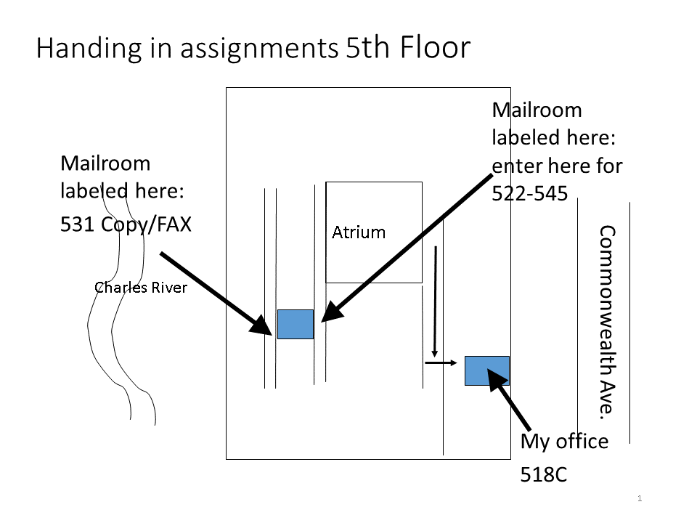
NOTE: My office 518C and Room 531 are inaccessible after 6:15 p.m. and before 7:30 a.m. on weekdays, and are not accessible at all on Saturday and Sunday.

G. Office Hours

I encourage you to come to my office hours. If you can’t make my scheduled office hours, talk or email me to set up an alternative meeting time. But please come!

We have two TA’s to help you, especially with Stata and data. We will notify you of their office hours.

If you send me an email, please include the phrase “QM222A1” in the subject line. During the semester, I’ll do my best to answer your email (with QM222A1 in the subject line) within 1 business day.

DO NOT get behind because you are having problems (e.g. in finding data etc.) yet avoid speaking to me or the TAs. We are here to help you along.

Final Project
Due December 15, 6 pm
Hard copy (and an updated Project Description if revised from Assignment 7) handed to Prof. Kahn, put under Prof. Kahn’s door (518C) or in Prof. Kahn’s mailbox (531)
On-line copy of Final Project posted on Questrom Tools →Final Project file by that time
Re-post your final dataset at https://tinyurl.com/qm222a1 (with your name in the file name) if changed

Your project should use regression and any other relevant statistics to answer a question of your choice, whose answer will be useful to your client. The regression(s) will be measuring relationships between variables in order to answer the question. Your topic must be approved by Prof. Kahn.
Your final project should be written in the form of a report to a client who would be interested in knowing your results. The client can be one or more people at a company, governmental unit, or other organization.
The final project should include a 1 page executive summary* and an 8-20 page report (including tables or graphs.) More is not better. You don’t need 20 pages to get an A, but you do need a well-written motivation, data description, and appropriate statistical analyasis where the answer to the question is developed and elaborated on.
You will also need to include at least one graph created by Excel.
Please either single space these pages or use 1.15 line spacing, with spaces between paragraphs.
You will be judged on the following criteria:
- Does your project use statistics, including (but not limited to) multiple regression, that are most appropriate to answer your question? Does it demonstrate a deep understanding of the statistics taught in the course?
- Is your data set appropriate to answering the question? Have you made mistakes in handling missing data, generating variables, or interpreting coefficients?
- Does the writing develop the ideas in logical order and clearly?
- If I were the client, would I feel that this project answered a question I am interested in?
- Can an executive who knows little statistics understand what you did and what you found from reading the executive summary?
- Does your report either control for and/or discuss possible biases e.g. due to confounding factors?
- Are regressions presented in an easy-to-read table?
- Are the graphics you use appropriate and clearly convey information to the reader?
- Is the report well-written? Are there English and spelling mistakes?
- Does the report look professional?
*An executive summary summarizes the project, telling an executive what the project is about, why it is useful for them, a very brief description of the data source and methods used, and the main conclusions. The project itself should start on a new page, with the title of the project on top, and should assume that the reader has not read the executive summary. You should write the executive summary AFTER you finish the project. You will probably repeat some sentences in the project and the executive summary.

Ungraded Research Obligation (URO) Memo
Dear QM222 Students,

As mentioned in your syllabus, one of the requirements for QM222 is an Ungraded Research Obligation (URO). The URO consists of participation in two 45-minute research sessions.
All research studies are purely for academic purposes and have been approved by the Institutional Review Board at BU (i.e. the studies are harmless and you will not be required to do anything that makes you uncomfortable). If you would prefer not to participate in the research, you may instead hand in a written assignment (email your professor for details).

Questrom has a research management software program which will be used to sign-up for research sessions. The software called SONA will send emails informing you when studies are being run in addition to keeping track of participation and assigning participation credits.

You must register and open a new participant account (even if you participated last semester). You must be registered in order to sign up for studies and receive reminder notifications. If you do not sign up for studies, you will not have the opportunity to participate.

Requesting a new participant account is easy:
1) Go to http://bu-smg.sona-systems.com (notice there is no www!)
NOTE: Should you forget this address, you can also log into SONA by navigating the business school's main page (go to www.bu.edu/questrom, scroll over Faculty & Research, click Research Centers & Labs, click Behavioral Lab, click Register here link).
2) Request a new account by clicking Request Account on the right of the SONA Welcome Page.
3) Complete the account information form and select your course QM 222.
4) SONA will then email you your login information (username and password).
****** Once you have registered you will be able to sign up for studies *********
We will be running sessions on the hour every Friday starting September 8th and ending December 1st (running from 8 am to 4:59 pm each of these days). Sessions will take place in the Behavioral Lab (Basement, 143 Bay State Road).

Studies will be broken up into RED (September 8—October 13) and SOX (October 20—December 1) sessions. You must complete one RED session and one SOX session.

You will be able to sign up for sessions starting September 5th on a first-come first-serve basis.
- Slots fill up quickly. There is no excuse for failing to register.
- Sessions begin precisely at the time listed, so show up 10 minutes BEFORE the session starts.
- You may not be able to participate in the session if you are late.
- If you do not show up for an experiment, you will be penalized.
If you have any questions or concerns, please e-mail Sarah Whitley (questromblab@bu.edu) or Remi Trudel (rtrudel@bu.edu).
Thank you in advance for your participation!

Recapping Due Dates

Assignment 1 Monday September 18
First Required Meeting w. Prof. Kahn Monday September 11-Wednesday September 20
Assignment 2 Wednesday September 27
Assignment 3 Tuesday October 10
Assignment 4 Monday October 16
Assignment 5 Monday October 23
Test TBD October 30-November 1
Assignment 6 Monday November 6
Second Required Meeting w. Prof. Kahn Monday November 6-Monday November 13
Assignment 7 (first draft) Monday November 20
Final Project Friday December 15

