A Statistical Analysis of Net Income on Stock Price

Chien Justin Padilla
QM222 D1
Prof. Shulamit Kahn
December 14, 2015
EXECUTIVE SUMMARY
To potential investors and existing shareholders of S&P 500 stock:
Like a casino, the stock market is seen as a place to generate sizeable returns on investments. However, the reality of achieving a short-term or long-term return is uncertain, stressful, and more importantly, risky. This risk is caused by the multitude of internal and external factors and conditions, which lead to volatility and unpredictability. Because of this, not one theory has been able to explain everything about the behavior of a stock. Nevertheless, this has kept stock analysts and investors keen on finding methods to calculate and forecast future values of a stock. Of such methods, one critical measure used time and time again is the net income.
Net income is the most important measure of profitability, as it is the very reason why companies exist in the first place. It is a measure that investors are interested in all the time because it allows them to look at the profitability history of a company and assess risks of investing in that company.
This study looks at whether a relationship can be found between net income and share price growth. Specifically, its main question answers how quarterly changes in net income affect the quarterly percentage changes in stock price for twenty blue-chip stocks listed on the S&P 500 over a twenty-year period.
Data was retrieved from Compustat, a financial database of active and inactive companies around the world. The twenty companies selected were based on the top two stocks of each Global Industry Classification Standard (GICS) sector by market capitalization using data at 31 March 2015. The dates for the regressions started from the first quarter of 1995 to the first quarter of 2015.
There were a total of six regressions in this study. The first two regressions looked at how percentage changes in net income affected percentage changes in share price. Regressions 3 and 4 analyzed how a net income loss affected a share price fall. Regression 5 explored the effects of change in net income per market value (profit rate) on share price. Regression 6 studied whether a lagging net income loss indicator had any effect on following quarter share price fall.
The results from the first two regressions show little to no significance between net income percentage changes and share price percentage changes. This leaves to a conclusion that it is very difficult to determine solely from a net income percentage change perspective the direct effect it has on share price. Regressions 3 and 4 reveal more promising information, deducing that a net income loss does correspond to a share price fall on average, and the same goes for a net income profit on share price gain. This points out that net income is still an important factor for influencing stock price even when its direct causes may not be entirely apparent. Regression 5 on the other hand concludes that an increase in the change in net income per market value actually decreases share price percentage change. Finally, regression 6 reveals the likely possibility that past net incomes have more influence on current share price because the true effect of the profits or losses are not yet realized until later periods.
Based on this data, it can be concluded that net income has some noticeable effect on share price. Although is not comprehensive enough to predict a stock’s price, it serves a useful purpose and should still be a part of every investor’s investment strategy.

INTRODUCTION

For centuries since the inception of the first stock exchange, determining the future value of any company stock has been a difficult task for investors. This is in large part due to the number of direct and indirect forces that trigger price fluctuations, which render it impossible for a single theory to clearly explain everything about a stock’s behavior. These factors range from the performance of the specific company to external conditions such as world news, economic strength, inflation, and market sentiment. However, of the many factors and events that affect a stock to rise or fall, one important indicator used time and time again by investors and stock analysts is the net income of a company.

Net income, sometimes called the bottom line, is a company’s net earnings, which is calculated by subtracting all the costs including depreciation, interest, and taxes, from its total revenues. This quantitative measure is essential in fundamental analysis, a technique used to predict a stock’s value. Through net income, valuable fundamentals and performance ratios can be calculated such as the earnings per share and the P/E ratio. By itself, net income is a good overall gauge of the economic well being of a company. If a company cannot sustain a positive net income in the long run, it will not be able to survive.

By observing and analyzing the net income and share price of different companies stocks, this study investigates whether changes in net income can be directly correlated to changes in share price.

DATA DESCRIPTION
The dataset used for this study was retrieved from Compustat (North America – Fundamentals Quarterly), a database of financial, statistical, and market information on active and inactive global companies. The data is longitudinal data, or sometimes referred to as panel data, as it follows different company stocks at different points in time. Each observation represents a company stock in a given quarter.
The criterion for the 20 companies analyzed was through a selection of the top two stocks of each Global Industry Classification Standard (GICS) sector by market capitalization using data at 31 March 2015. There are a total of ten industry sectors: Consumer Discretionary, Consumer Staples, Energy, Financials, Health Care, Industrials, Information Technology, Materials, Telecom, and Utilities. Market capitalization was calculated by multiplying the number of shares outstanding with the price per share at the aforementioned date. Each company’s net income and share price are reported quarterly. The data used in this study starts from the first quarter of 1995 and ends at the first quarter of 2015.
GICS SECTORS | COMPANY STOCK (TICKER) | MARKET VALUE ($MN)  At 31 March 2015
Consumer Discretionary | 1. Amazon (AMZN)  2. Walt Disney (DIS) | 1. 172,797.3  2. 178,267.1
Consumer Staples | 1. Wal-Mart Stores (WMT)  2. Procter & Gamble (PG) | 1. 265,107.3  2. 221,279.6
Energy | 1. Exxon Mobil (XON)  2. Chevron (CVX | 1. 356,548.7  2. 197,381.3
Financials | 1. Berkshire Hathaway (BRK-B)  2. Wells Fargo (WFC) | 1. 356,510.7  2. 279,919.7
Healthcare | 1. Johnson & Johnson (JNJ)  2. Pfizer (PFE) | 1. 279,723.9  2. 213,621.9
Industrials | 1. General Electric (GE)  2. United Technologies (UTX) | 1. 249,774.4  2. 106,470.3
Information Technology | 1. Apple (AAPL)  2. Alphabet Inc Class A (GOOGL) | 1. 724,773.1  2. 345,849.2
Materials | 1. Du Pont (DD)  2. Dow Chemical (DOW) | 1. 64,709.9  2. 55,274.0
Telecom | 1. Verizon (VZ)  2. AT&T (T) | 1. 198,035.3  2. 169,458.8
Utilities | 1. Nextera Energy (NEE)  2. Dominion Resources (D) | 1. 46,211.0  2. 41,698.2
Originally, there were supposed to be a total of 1,620 observations (20 companies x 81 quarters per company), but only 1,591 observations were available in the dataset. This is because Google’s stock, which trades under the name Alphabet, did not have data until the first quarter of 2002, removing 28 of the observations. The one other missing observation came from Wal-Mart’s stock due to their fiscal quarter ending in January as opposed to March, which omitted the first quarter of 1995. After removing stock splits, which are decisions made by a company’s board of directors to increase the number of shares outstanding by issuing more shares to existing shareholders, and determining usable percentage changes for net income and share price, a total of 1,519 observations were analyzed.
In order to capture a comprehensive and significant analysis, four more types of regressions were added in addition to the original question being tested. The regressions and the variables used in each regression are:
Regressions 1 and 2 (Original Simple Regression and Original Multiple Regression): How a percentage change in net income affects a percentage change in share price
- Dependent variable: pricepctchg (percentage change in share price from the previous quarter to the current quarter)
- Explanatory variable: netincpch (percentage change in net income from the previous quarter to the current quarter)
- Market Index: snp500pctchg (percentage change in the overall S&P 500 market index from the previous quarter to the current quarter)
In Regression 2, holding the S&P 500 market constant is important since these companies are a part of this index, and large companies’ share prices tend to move together.
Regression 3 and 4: How a net income loss affects a share price fall
- Dependent Variable: pricefall (an indicator variable (dummy) that equals one if share price percentage change is less than zero)
- Explanatory Variable: niqloss (an indicator variable (dummy) that equals one if the net income is less than zero)
- Market Index: snp500pctchg (percentage change in the overall S&P 500 market index from the previous quarter to the current quarter)
The main difference between this type of regression and the original regressions are that percentage changes are not involved, as the actual values of net income and share price are used to make these dummies. Also, regressions 3 and 4 focus on losses by examining what net income loss does to share price. Compared to the first two regressions, the findings from these regressions are less specific since the independent and dependent variables are indicator variables, which only classify values from zero to one. This model is better because it is able to show a general trend and can provide more consistency and reliability in a highly uncertain market.
Regression 5: How a profit rate (change in net income as a proportion of market value) affects a share price
- Added variable: netincchgpermktval (the change in net income from a previous quarter to the current quarter divided by the market value, also can be interpreted as a type of profit rate)
- Other variables: pricepctchg and market index (same as Regression 2)
Adding this variable meant we lost half of the observations in the dataset because market value was not given for the first ten years of the study (from 1995 to 2005). This seeks to understand how the changes in net income per market value influences share price percentage changes per quarter.
Regression 6: How a lagging net income loss indicator affects a share price fall
- Dependent variable: niqloss (same as Regression 3)
- Explanatory variable: lagniqloss (a lagging indicator added to the previous variable niqloss to reflect a previous quarter’s net income loss affect on the current quarter)
- Other variables: pricefall and the market index (same as Regression 4)
Lagging indicators helps measure an output or an event that is about to occur. By incorporating a lag to an explanatory variable, this serves to explain the change in the probability of a fall in share price from a result of past performance, in this case, a previous net income loss.
RESULTS
MAIN REGRESSIONS 1 & 2
The results for both regressions found in Table 1 are not significant enough to prove strong relationships between net income and share price percentage changes. The t-statistic in Regression 1 clearly shows no relationship or correlation between the quarterly percentage changes of net income and share price from these company stocks.
Regression 2 in Table 1 provides more valuable information in that it removes some of the bias from net income percentage change from Regression 1, and increases the t-statistic of the net income percentage change to an absolute value of 0.96. However, there is still only approximately 66% certainty that net income percentage change has an effect on share price percentage change, which is not enough to prove statistical significance. Also, the -0.022 percentage point coefficient for net income percentage change is so low that it does not help to use this regression to predict share price changes. The more important takeaway is learning that the confounding variable, S&P 500 market index percentage change, has a defining impact on the share price percentage change. It increased the R-squared and now 17.33% of the variation in share price percentage change can be explained by the net income and S&P 500 variables.
Table 1. Dependent Variable: Share price percentage change (pricepctchg)
 | Regression 1 | Regression 2
Intercept  Net income % change (netincpch)  S&P 500 % change (snp500pctchg) | 0.033986**  (8.30)  -0.0000857  (-0.36) | 0.0177029**  (4.62)  -0.00022074  (-0.96)  0.7908635**  (17.82)
N | 1,519 | 1,519
R² | 0.0001 | 0.1733
Adjusted R² | -0.0006 | 0.1722
Values in parentheses are t-statistics.
**Indicates significance at the 95% confidence interval (5% significance level)

ALTERNATIVE REGRESSIONS 3 & 4
The results from regressions 3 & 4 in Table 2 show a positive relationship between net income loss and share price fall. The t-statistic on the coefficient for net income loss in regression 3 guarantees with 98.2% certainty that net income loss has an effect on share price fall. Hence, when there is a net income loss in a particular quarter, there are 12.44 percentage points higher chance that share price will fall on average.
Even after controlling for the market index in Regression 4, the coefficient for net income loss remains high and significant. This shows how news related to each company changes its share price relative to the general market. Adding the S&P 500 variable increases the adjusted R-squared to 14.24%. Holding S&P 500 constant, a net income loss leads to 11.32 percentage point higher likelihood share price will fall on average.
Table 2. Dependent Variable: Share price fall (pricefall)
 | Regression 3 | Regression 4
Intercept  Net income loss (niqloss)  S&P 500 % change (snp500pctchg) | 0.3917309**  (30.25)  0.1243981**  (2.38) | 0.4378182**  (35.42)  0.1132253**  (2.33)  -2.185002**  (-15.74)
N | 1,520 | 1,520
R² | 0.0037 | 0.1436
Adjusted R² | 0.0030 | 0.1424
Values in parentheses are t-statistics.
**Indicates significance at the 95% confidence interval (5% significance level)

ALTERNATIVE REGRESSION 5
The results from Regression 5 in Table 3 show a negative relationship between net income change per market value (profit rate) and share price percentage change. The t-statistic on the coefficient for this profit rate has a roughly 93% certainty that the change in net income per market value effects share price percentage change. This indicates that when holding the market index constant, for every $1 million increase in the change in net income per market value, the share price of a stock will actually decrease share price by 46.0% on average. The adjusted r-squared signifies that 26.08% of the variation in share price percentage change is explained by the variation in net income change per market value. A reason why this relationship could be happening is because as profit rates go up, dividends may be distributed or existing shareholders may no longer want to hold onto their stocks, thus causing stock price to fall.
Table 3. Dependent Variable: Share Price Percentage Change (pricepctchg)
 | Regression 7
Intercept  Net income change per market value (netincchgpermktval)  S&P 500 % change (snp500pctchg) | 0.0148769**  (3.46)  -0.4599574*  (-1.77)  0.8252247**  (16.16)
N | 738
R² | 0.2628
Adjusted R² | 0.2608
Values in parentheses are t-statistics.
*Indicates significance at the 90% confidence interval (10% significance level)
**Indicates significance at the 95% confidence interval (5% significance level)

ALTERNATIVE REGRESSION 6
A lagging indicator in this regression shows how the effect of the news of a net income loss may occur in the following quarter. Holding the market index constant, combining lag net income loss and net income loss leads to an increase in share price fall by 14.54 percentage points. In other words, a previous quarter’s net income loss further increases the likelihood that share price will fall in the current quarter by 4.40 percentage points.
Table 4. Dependent Variable: Share price fall (pricefall)
 | Regression 8
Intercept  Lag net income loss (lagniqloss)  Net income loss (niqloss)  S&P 500 % change (snp500pctchg) | 0.4358433**  (34.67)  0.0439877  (0.87)  0.1014587**  (2.01)  -2.183443**  (-15.73)
N | 1,520
R² | 0.1440
Adjusted R² | 0.1423
Values in parentheses are t-statistics.
**Indicates significance at the 95% confidence interval (5% significance level)

CONCLUSION
It is already a generally accepted belief that stocks are highly unpredictable and subject to volatility due to a list of internal and external factors. That is why a few of regressions in this statistical analysis prove no relationships and even a negative relationship between share price and net income. As shown from Regressions 1 and 2, it is very difficult to determine solely how a change in net income results in a change in share price of a company stock. Regression 5 even shows how the share price percentage change decreases as a result of an increase in the change in net income per market value. An investment theory, the efficient-market hypothesis, could support this thinking as its main idea maintains that share prices are always priced to reflect all available information, making stocks impossible to predict.
However, even if this theory was to be true, many investment theorists and stock analysts disagree with it because investors perceive information differently and a lot of weight is still relied on fundamental factors like net income. As shown from Regressions 3 and 4, a net income loss does correspond to share price fall on average, which also means that net income profit would result in share price gain. This points out that net income is still an important factor for influencing stock price even when its direct causes may not be entirely apparent.
Finally, Regression 6 reveals the possibility that past net incomes may have more influence on current share price because the true effect of the profits or losses are not yet realized until later periods.
Although net income by itself is not comprehensive enough to predict a stock’s price, it serves a useful purpose and should still be a part of every investor’s investment strategy.

APPENDIX
EXHIBIT 1
A summary of all variables used in my regressions
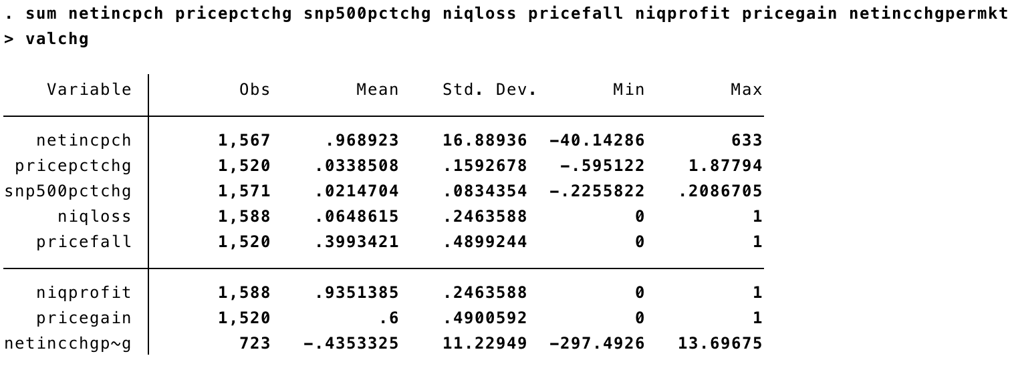
EXHIBIT 2
Percentiles of my main dependent variable, share price percentage change
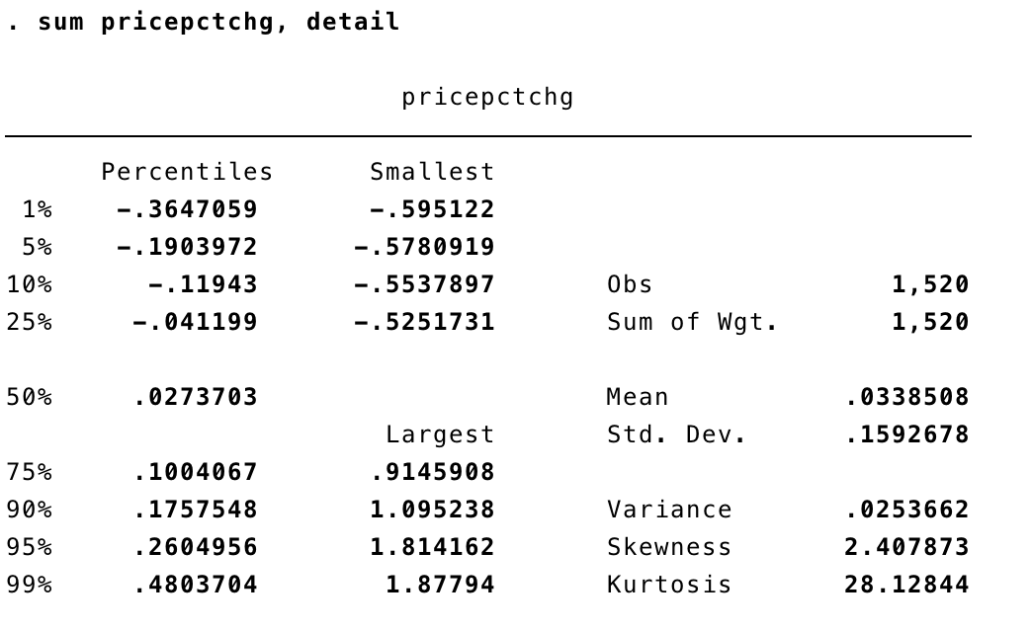

SOURCES

Brain, Marshall, and Dave Roos. "How Stocks and the Stock Market Work." HowStuffWorks. Blucora, 05 July 2011. Web. 13 Dec. 2015.

Harper, Dave. "Forces That Move Stock Prices." Investopedia. IAC, 05 Oct. 2004. Web. 14 Dec. 2015.

Mitchell, Cory. "How the Stock Market Works." Investopedia. IAC, 26 Aug. 2014. Web. 13 Dec. 2015.

Percentage changes between net income and share price are only possible when data is available for both quarters. The equation used to calculate percentage changes is: (current quarter value – previous quarter value)/ previous quarter value

