The effect of the expenses of Blizzard Entertainment on World of Warcraft Online MMORPG subscriber numbers.

Michael Kramarovskiy
Modelling Business Decisions
Professor S. Kahn
11/30/15
Executive Summary

To the Board of Directors of Blizzard Entertainment Company:

World of Warcraft, commonly abbreviated as WoW, was developed by Blizzard Entertainment as a continuation of their popular game series “Warcraft.” WoW is a subscription-based online game, where players must pay to maintain a playing account. This subscription price, which was set at a monthly rate of 14.99 $ in 2004, is the main source of income. Considering the fact that WoW still remains the most popular MMO, Blizzard’s annual revenue has fluctuated from 2.5 billion in 2010 to 1.1 billion dollars in the year 2015. This fluctuation is the result of the declining player base, which went down from 12 million players in the end of 2009 to 5.5 million as of November 2015.

Even though WoW has lost almost 55% of its peak subscriber audience, it still is a profitable business model, with Blizzard recently announcing a new installment to the game. Every two years, Blizzard Entertainment refreshes the game content with extensive expansion packs, adding more story and characters from the original 1994 series. These new chapters of the story appeal to the fans of the original game series, as well as serve a powerful marketing tool to attract new players.

Looking at the Figure 1, a lot can be implied about the last three expansions. There are a few components which make “Cataclysm”, “Mist of Pandaria” and “Warlords of Draenor” expansions different from the successful installments before. These components lack iconic figures from the original series, and they are abundant in innovations in terms of gameplay. Characters that were introduced in these expansions do not have enough weight in terms of background history and importance. In easier terms, sidekick characters suddenly became major protagonists or villains. Moreover, in “Cataclysm”, an expansion based on a war between all kingdoms and a dragon, a lot of iconic and admired game characters were redesigned or killed. This report will investigate the decline in subscribers after these installments, and the decline in numbers of fictional heroes and antagonists who exist in the WoW universe.

Even though World of Warcraft has shown the tendency to lose the player base after the series of unpopular expansion packs, it holds the title of the most recognized MMORPG in the market of video games. Evidently, it is in Blizzard’s interest to attract new audiences by staying competitive in this market. Blizzard Entertainment may have to rethink its strategy of appealing to new audiences and therefore, attaining new profit bottom lines. Nonetheless, does Blizzard Entertainment need to invest more in its marketing, research and development departments or is there another strategy of attracting new subscribers? To answer this question, Stata, statistical and data analysis software, was used in this research.

This report specifically investigates the relationship between the expenses on these departments and the subscribed player base, controlling for other factors and variables. This study uses data from various sources, such as mmo-champion.com (number one source for World of Warcraft news and data), Blizzard Entertainment’s 10K reports and press releases. This study analyses the size of subscriber base from November 2004 to November 2015. This report is splitting the time frame by months, to determine whether the expenses in marketing and research resulted in attracting new subscribers to the game.

Within the time frame studied, which is totaling 134 months, we see that there is a positive lagged trend between the expenses and the subscriber numbers. This data is implying that after significant investment in development, marketing, and research, player base will go up immediately or after 1 to 2-month delay. This lagged trend may be a result of the players hearing reviews through the grapevine about the changes implemented in the game.

The project observed the relationship between marketing expenses and the number of subscribers. The research revealed that marketing is the most effective tool of attracting new subscribers to World of Warcraft. Keeping other variables constant, marketing related variables on average increase the number of subscribers by 3.3781 million. Using the regression and subsequent formula we derived from the research, we can predict that, given marketing budget for the current month of December, there are approximately 5.1036 million subscribed players in World of Warcraft. However due to the unknown factors not included in the regression and our lack of information about detailed allocated marketing, research and development budget, the number calculated should be used only as an approximation. The advice of this report, Blizzard can utilize, is that in the end, modern graphics innovations are more attractive to players than other factors. However, holding every other variable constant, monthly aging of the game will decrease the number of subscribers. Therefore, Blizzard should utilize the system of constant systematic innovations to attract the audiences.

- Introduction
This report investigates whether Blizzard Entertainment, video game publisher and developer company, should invest more in its project, World of Warcraft, to gain subscribers, or adapt another strategy. This project is statistically measuring the impact on subscriptions in World of Warcraft of Blizzard Entertainment’s decisions about marketing expenses and new releases. The hypothesis of this paper is that marketing and research costs are the most effective tool of increasing subscriber base. To prove or reject this hypothesis, Stata, statistical and data analysis software, was used in this research. The goal of this project is to be able to statistically predict the number of the subscribed players in World of Warcraft, given marketing budget.

World of Warcraft is a massively multiplayer online role-playing game (MMORPG), which came out in November 2004. It quickly acquired a reputation of a worthy successor to a Warcraft universe, introduced in 1994 thorough a game series called “Warcraft: Orcs & Humans.”

World of Warcraft, commonly abbreviated as WoW, is a subscription-based online game, where players must pay to maintain a playing account. This subscription price, which was set at a monthly rate of 14.99 $ in 2004, is the main source of income. Considering the fact that WoW still remains the most popular MMO, Blizzard’s annual revenue has fluctuated from 2.5 billion in 2010 to 1.1 billion dollars in the year 2015. This fluctuation is the result of the declining player base, that went down from 12 million players in the end of 2009 to 5.5 million as of November 2015.

Even though WoW has lost almost 55% of its peak subscriber audience, it still is a profitable business model, with Blizzard recently announcing a new installment to the game. Every two years, Blizzard Entertainment refreshes the game content with extensive expansion packs, adding more story and characters from the original 1994 series. These new chapters of the story appeal to the fans of the original game series, as well as serve a powerful marketing tool to attract new players.

Every expansion release used to be followed or preempted by the substantial permanent increase in the player base, while in today’s environment this increase is temporary. Past few expansions starting from the installment called “Cataclysm” were not as successful as the ones before. As can be seen from the Figure 1, the transition from the expansion “Wrath of the Lich King” to the expansion “Cataclysm” did not result in the increase in the player base. Moreover, throughout the expansion, the number of subscribed players began to decline. Even though every expansion release before “Cataclysm” brought long lasting subscribers, the following expansions increased the player base only temporary. Understanding possible reasons behind this downward-sloping trend can be utilized by Blizzard to achieve the profit-maximizing strategy it held in 2010.

- Data Analysis
The analysis applied in this project utilized Stata, statistical and data analysis software. Vast pool of information was gathered through Blizzard’s 10K reports, monthly releases and mmo-champion.com, official World of Warcraft news website. A number of variables was generated in Stata to analyze their impact on the number of subscribers. The graphs were created in Stata to visually represent project’s findings. The results are based on the regression analysis of the dependent and independent variables, and several models were used to achieve the highest explanatory power of the effect of independent and explanatory variables on the dependent variable.

- Variables
Number of subscribers
This is a dependent numeric variable. It represents number of active players. This number changes monthly. It was taken from Blizzard’s monthly press releases.

Marketing expenses
Marketing expenses is a numeric independent variable. This variable measures the budget which is allocated to the marketing, research and development department in Blizzard Entertainment. This number can change monthly. It was taken from Blizzard’s 10K report. This number directly affects the number of subscribers, which can be seen in Figure 2 and Figure 3. Marketing, research and development department focuses on advertising to the target audience on TV and on the internet (see Appendix 3) as well as implementing new in-game changes.
Variable “MarSq” was generated to see whether the relationship between the number of subscribers and marketing expenditures was nonlinear with the dependent variable. It is possible that abundant innovations in terms of gameplay can draw audience away from the game. For example, in the expansion “Mists of Pandaria,” Blizzard introduced “pet battles”, which were inspired by the Pokémon franchise. This element of the game contradicts the style of the game and was not well accepted by the target audience. As can be observed in Figure 3 and Figure 2, “Mists of Pandaria” was accompanied by a substantial increase in marketing, development and research costs, while the number of subscribers decreased. Gameplay in WoW was alternated, including various changes to in-game characters and game locations. WoW developers saw these changes as ground-breaking innovations, while many players disapproved of them as of unnecessary alterations of the game design. In this case, these expenses could have negatively affected the player base, resulting in plenty of WoW customers cancelling the subscription.

Lagged marketing (1 month) and lagged marketing (2 months)
This is budget which is allocated to marketing, research and development department in Blizzard Entertainment. This number can change monthly. It was taken from Blizzard’s 10K report. However, this variable is different from Marketing. Marketing affects sales after a short period of time (1-2 months). This lagged effect is a combination of several factors. WoW, being an online game with a monthly subscription, depends on the reaction of its gaming community to the new changes. If the changes are considered good, people are likely to keep their subscription for another month or to renew subscription if they stopped playing prior to that.

Number of iconic characters
This is a numeric independent variable, which stands for the number of characters that existed in original 1994 series and now exist in World of Warcraft universe. In the original 1994 game “Warcraft: Orcs & Humans”, which was an offline game and a predecessor of “World of Warcraft”, existed a large number of characters. These characters this report refers to as “iconic characters.” At first, some portion of these characters was transferred to World of Warcraft. Later, Blizzard adopted a practice of introducing these characters with new expansions and killing some of them as the game progresses. This number can decrease or increase, as can be seen in Figure 4, depending on Blizzard’s decision to kill off a hero or add one from an old storyline. This number was taken from mmo-champion.com.
Additional variables (Iconic Characters Squared and Iconic Characters Cubed) were added in order to represent the nonlinear relationship between the number of iconic characters in a specific month in a game and the number of subscribers, as can be seen in Figure 5. If Blizzard decides to add a large number of characters from the original 1994 game with the new expansion, it is difficult for players to focus on the key figures, because the storyline is overcomplicated with these new characters. Theoretically, this abundance leads to in-game characters being indistinguishable from one another.

Number of bad iconic characters
This is a numeric independent variable, which stands for the number of iconic villains that existed in original 1994 series and now exist in World of Warcraft universe. This number was taken from mmo-champion.com. This variable has a quadratic nonlinear effect on the number of subscribers. Theoretically, too many bad characters in the game make it less exciting to play, creating fewer conflicts and less tension. Therefore, an additional variable “Bad Characters Squared” was generated.

Age of the game or lifespan of the game
World of Warcraft came out in November 2004, eleven years ago, therefore, there are 132 (11*12) observations. As the Figure 6 shows, effect of the age of the game on number of subscribers resembles a negative parabola. Therefore, an additional variable AgeSq was generated in order to represent a nonlinear relationship between the variables. It is reasonable, because as the gaming market develops, many games become outdated, and therefore lose their audience to their competitors with better graphics and story. WoW graphics are fairly outdated and cannot be compared to more recent games (see Appendix 2).

Lagged marketing (by two months) multiplied by the age of the game
This interaction term was added to test the relationship between expenses and number of subscribed players in WoW, and how it varies through time. This interaction term means that the effect of lagged marketing on number of subscribers is different for different values of age of the game. This means that effect of LagMar2 was not the same throughout the lifespan of the game. Therefore, the unique effect of lagged marketing on subscribers is not limited to the coefficient of LagMar2. The slopes of the regression lines between subscribers and lagged marketing are different at different points in time.

Release effect
This is an independent dummy variable, that represents whether this month was accompanied by an expansion. Every expansion is often followed by an increase in subscriber base, being temporary or permanent. Players who cancelled their subscription usually return to the game by purchasing a month of gaming time to experience major changes in-game. If players enjoy the changes and new storylines, they will renew their subscription. In addition, announcements of the new expansion are often published and advertised in media, attracting more players to the game.

Lagged release effect (1 month) and lagged release effect (2 months)
This variable is different from Release. It seems that Release affects players after a short period of time (1-2 months). This lagged effect is a combination of several factors. WoW, being an online game with a monthly subscription, depends on the reaction of its gaming community to the new changes. If the changes are considered good, more people are likely to keep their subscription for another month or to renew their subscription if they stopped playing prior to that.
Short summary
Stata: | Name:
Subs | Number of subscribers
Mar | Marketing, research, and development expenses
MarSq | (Marketing, research, and development expenses)^2
LagMar | Lagged marketing (1 month lag)
LagMar2 | Lagged marketing (2 months lag)
LagMar2Age | Lagged marketing (2 months lag) * Age of the game
IconCh | Number of iconic characters
IconChSq | (Number of iconic characters)^2
IconCubed | (Number of iconic characters)^3
BadCh | Number of bad characters
BadChSq | (Number of bad characters)^2
Age | Age of the game
AgeSq | (Age of the game)^2
Release | Release effect
LagRelease | Lagged release effect (1 month lag)
LagRelease2 | Lagged release effect (2 months lag)
- Models
After a thorough investigation of other possible factors that could have an effect on the number of subscribers, five models were chosen to be analyzed in this report. Each regression model itself demonstrates an important fact. In terms of the process to get the best model, here are some principles which were established as a benchmark.
- Variables with |t|>1 improve the model’s adjusted R-squared, which is a statistical measure of how close the data is to the fitted regression line
- To tell the effect of the change, only one variable was changed at once

Model 1
The first model explained how marketing affected the number of subscriptions in World of Warcraft if we controlled for the following variables: iconic characters (IconCh), iconic bad characters (BadCh), age or lifespan of the game (Age), and release effect (Release). This model served as a foundation for the subsequent models. The choice of the control variables came from the experience and preferences of gamers, and also from the natural conditions such as aging of the game and the novelty of the game’s releases. This model had an Adjusted R-Squared of 0.7239. This means that this model explained 72.39% of variability in number of subscribers. This number was fairly low, considering that this report used time-series data analysis. In addition, it is important to state that coefficient for Release was not significant at the 90% level. However, looking at expansion release dates, which are marked with black vertical lines in the Figure 1, it is clear that usually new release does increase the number of subscribers, the only exception being “Cataclysm”. We, therefore, experimented with alternative specifications.

Model 2
The second model was more advanced, we utilized lags and polynomials to explain the how marketing affects the number of subscriptions. 10 new variables were derived from the existing ones to figure out the best functional form. Overall adjusted R-Squared increased significantly from 0.7239 to 0.9715. This model explained much more of the the variability in number of subscribed players. To figure out the best functional form for marketing (Mar), we included some standard values of other variables plus Mar, MarSq, LagMar, LagMar2 and interaction term LagMar2Age. We observed the T values and noticed, that out of marketing related variables only LagMar had a |t|<1, which meant that it did not improve the model’s adjusted R-squared. In the Model 3, we dropped this variable.

Model 3
As we observed in the Model 2, LagMar was not significant at 90% level and had a |t|<1. In the third model, we dropped LagMar. The explanatory power of the model went up by .02%, adjusted R-squared equaled .9717, (.9715 in Model 2). Model 3 provided better Adj R-Squared than Model 2 as well as reasonable SE. We observed the T values of marketing related variables and noticed that the rest of them are important in the model (had a |t|>1). However, some more improvements could have been done. We did a similar process with character related variables (IconCh, IconChSq, IconCubed, BadCh, BadChSq) as we did with marketing variables. Iconic bad characters (BadCh) and iconic bad characters squared (BadChSq) had a |t|<1.
Model 4
In the fourth model, we dropped BadCh variable and therefore, excluded BadChSq as well. The explanatory power of the model went up by .02%, adjusted R-squared equaled .9719, (.9717 in Model 3). This regression has the highest explaining power of the variability, which is 97.17% (See Appendix 1). This model should be used in order to predict the future number of the subscribed players.
Table 1
 | Model 1 | Model 2 | Model 3 | Model 4
Intercept | 1.490229  (1.13) | 24.44033  (0.96) | 23.94767  (0.94) | 34.91634  (1.54)
Mar | -.0460357  (-2.65)** | .0376354  (1.09) | .0412151  (1.22) | .0433992  (1.35)
MarSq |  | -.0006886  (-1.58) | -.0006899  (-1.59) | -.0006861  (-1.62)
LagMar |  | .0068512  (0.47)
LagMar2 |  | -.0819696  (-4.63)** | -.0788194  (-4.83)** | -.0763388  (-4.78)**
LagMar2Age |  | .0010586  (5.47)** | .0010564  (5.48)** | .0010809  (5.95)**
IconCh | -.0124209  (-1.91)* | -.2837215  (-1.02) | -.2781042  (1.00) | -.4048325  (-1.65)*
IconChSq |  | .0011584  (1.16) | .001138  (1.15) | .001592  (1.82)*
IconCubed |  | -1.45e-06  (-1.24) | -1.43e-06  (-1.22) | -1.96e-06  (-1.90)*
BadCh | .0934707  (11.80)** | -.010526  (-0.44) | -.0107293  (-0.45)
BadChSq |  | .0000492  (0.59) | .0000507  (0.61)
Age | .0112752  (2.25)** | .2291254  (17.56)** | .2290571  (17.61)** | .2271949  (31.66)**
AgeSq |  | -.0018033  (-20.85)** | -.0018019  (-20.92)** | -.0018058  (-47.85)**
Release | .0380769  (0.06) | .5197886  (2.45)** | .5216169  (2.46)** | .5068484  (2.41)**
LagRelease |  | .8451755  (3.98)** | .845551  (3.99)** | .8313103  (3.95)**
LagRelease2 |  | .5422625  (2.74)** | .5620487  (2.92)** | .5743126  (3.01)**
N | 133 | 131 | 131 | 131
R^2 | 0.7344 | 0.9748 | 0.9747 | 0.9745
Adj. R^2 | 0.7239 | 0.9715 | 0.9717 | 0.9719
Root MSE | 1.4803 | .44681 | .4453 | .44335

Dependent variable is number of subscribers (Subs). Number in parentheses is T statistic.
*indicates significance at 90% confidence level
**indicates significance at 95% confidence level
We checked this regression for abnormalities and it can be seen that OLS assumptions were followed, since no heteroskedacity or other problems were found according to the Figure 7. In Model 4 there were no pattern to the residuals plotted against the fitted values – our model was true, normally distributed. There was not any pattern whatsoever that would have indicated a violation of the least-squares assumptions. The interaction term’s (LagMar2Age) coefficient was .0010809, which means that as the game gets older, same marketing budget will bring more subscribers each month.

- Conclusion
This project observed the relationship between marketing expenses and the number of subscribers. The research revealed that marketing is the most effective tool of attracting new subscribers to World of Warcraft. Keeping other variables constant, marketing related variables (marketing, marketing squared, lagged marketing (by two months), and interaction term LagMar2Age) on average increase the number of subscribers by 3.3781 million. Using the regression and subsequent formula from the Model 4, we can assume that, given marketing budget for the current month of December, there are approximately 5.1036 million subscribed players in World of Warcraft. However due to the unknown factors not included in the regression and our lack of information about detailed allocated marketing, research and development budget, the number calculated should be used only as an approximation. Below (Table 2) is a table which shows both actual subscribed players and our predicted numbers. As can be seen, predicted values derived from the formula lie within the relevant range.
Table 2

Time period | Actual number of subscribed players | Model 4 predictions
January 2015 | 9600000 | 8647539
February 2015 | 7600000 | 7913842
March 2015 | 7100000 | 6751675
April 2015 | 6600000 | 6566692
May 2015 | 6100000 | 6378098
Jun 2015 | 5600000 | 6185893
July 2015 | 5500000 | 5990075
August 2015 | 5300000 | 5790646
September 2015 | 5400000 | 5567369
October 2015 | 5400000 | 5360717
November 2015 | 5500000 | 5285298
December 2015 | Blizzard have not released yet | 5073585
The advice of this report, Blizzard can utilize, is that in the end, modern graphics innovations are more attractive to players than other factors. Moreover, holding every other variable constant, monthly aging of the game will decrease the number of subscribers. Therefore, Blizzard should utilize the system of constant systematic innovations to attract new audiences.
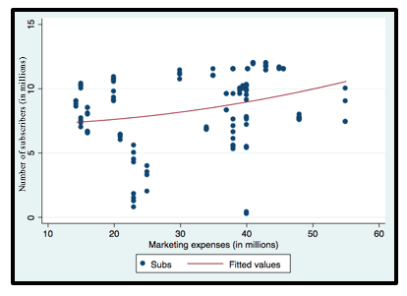
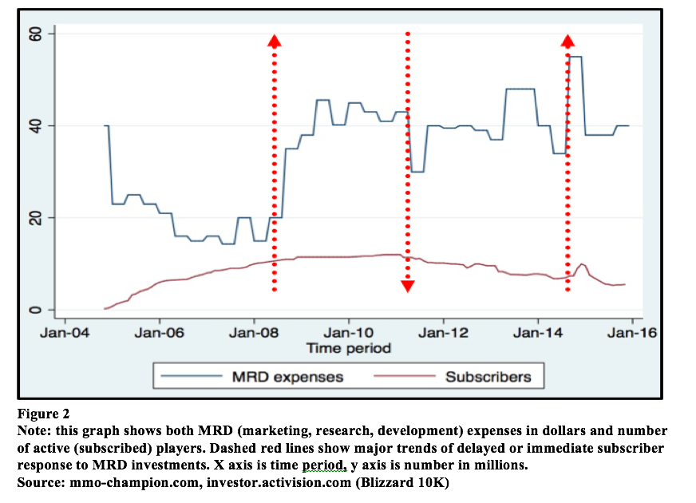
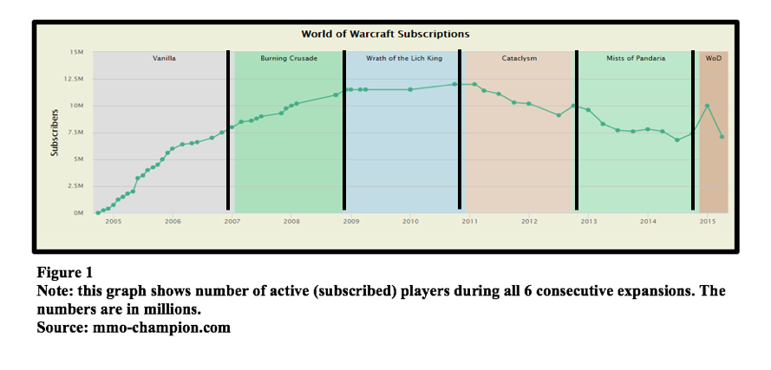
Figure 3
Note: this is a scatter graph, which shows both MRD (marketing, research and development) expenses on the x axis and number of active players (subscribers) on the y axis.
Source: mmo-champion.com, investor.activision.com (Blizzard’s 10K)

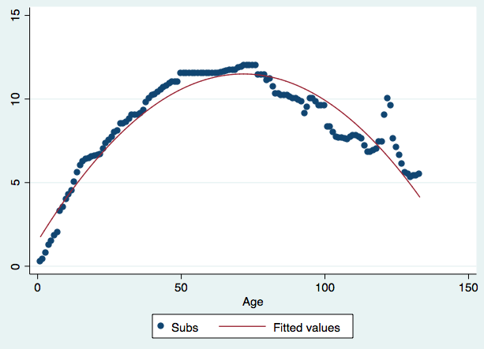
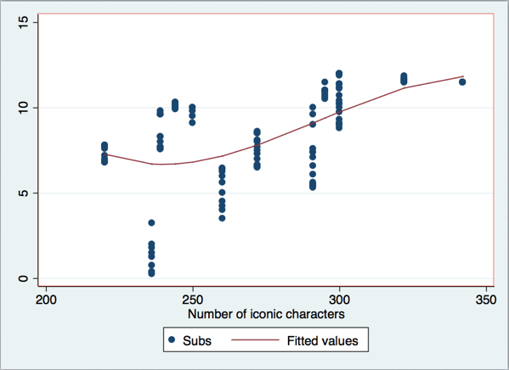
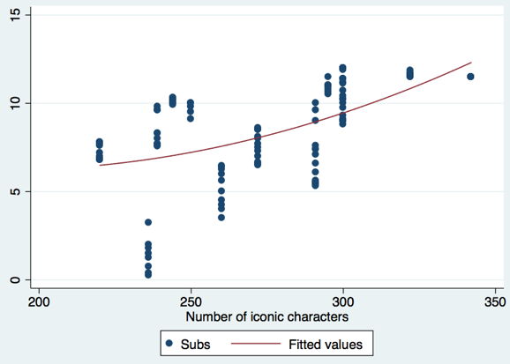
Figure 6
Note: this is a scatter graph, which shows both age of the game in months on the x axis and number of active players (subscribers) on the y axis. Fitted line follows the shape of a graph of a quadratic formula.
Source: mmo-champion.com

Number of subscribers (in millions)
Number of subscribers (in millions)
Figure 5
Note: this is a scatter graph, which shows both number of iconic characters on the x axis and number of active players (subscribers) on the y axis. Fitted line follows the shape of a graph of a cubic formula.
Source: mmo-champion.com, investor.activision.com (Blizzard’s 10K),
wowwiki.wikia.com

Figure 4
Note: this is a scatter graph, which shows both number of iconic characters on the x axis and number of active players (subscribers) on the y axis.
Source: mmo-champion.com, investor.activision.com (Blizzard’s 10K),
wowwiki.wikia.com

Number of subscribers (in millions)

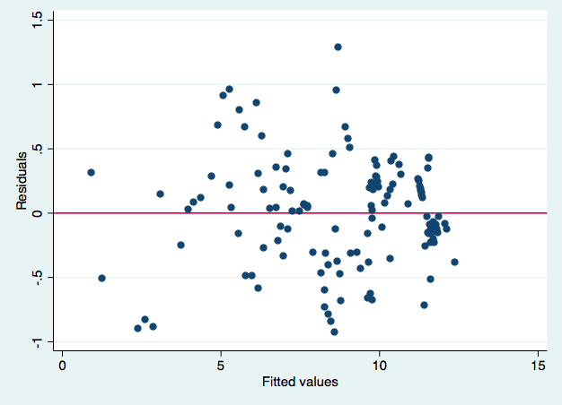
Figure 7
Note: this is a scatter graph, which shows the residuals plotted against the fitted values. This graph shows normal distribution.
Source: mmo-champion.com

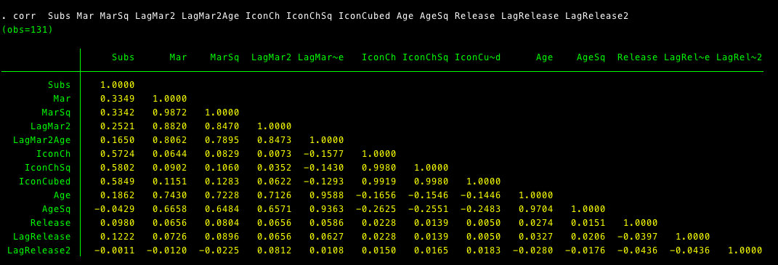
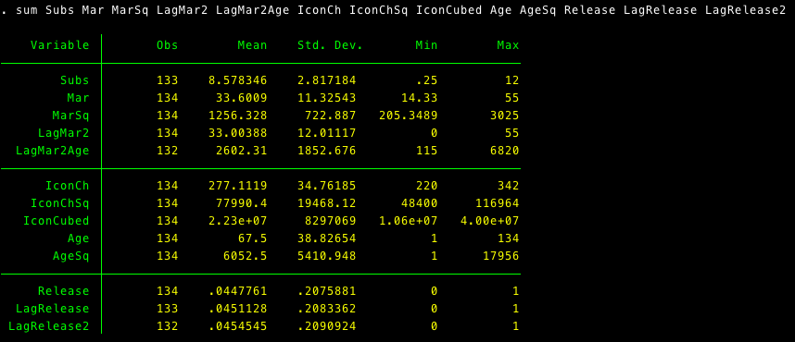
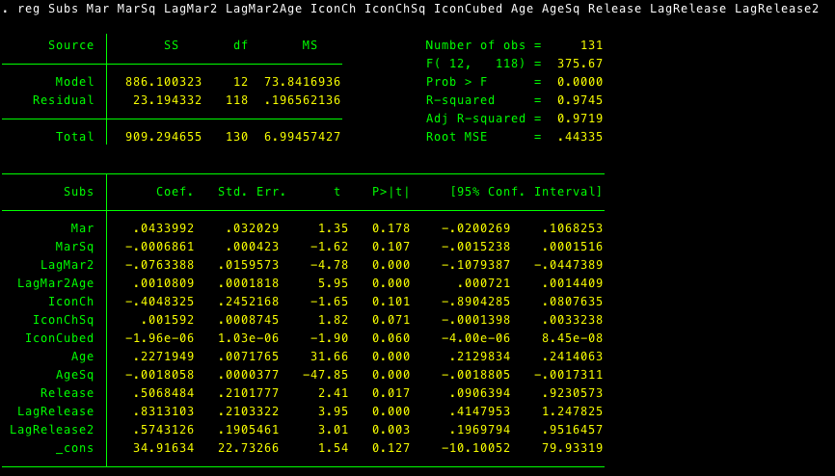
Appendix 1

Appendix 2
Current game graphics comparison.
WoW graphics and Witcher 3 (released in 2015) side to side.
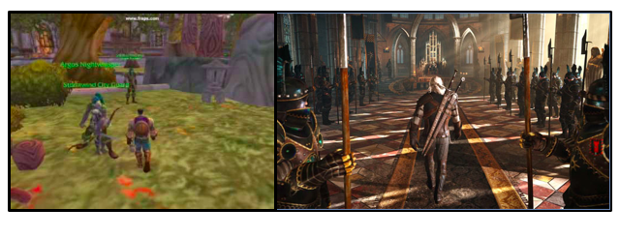
Appendix 3
- Example of WoW advertisement on youtube.com

- Example of Blizzard's appeal to a new audience by cooperating with Ozzy Osbourne
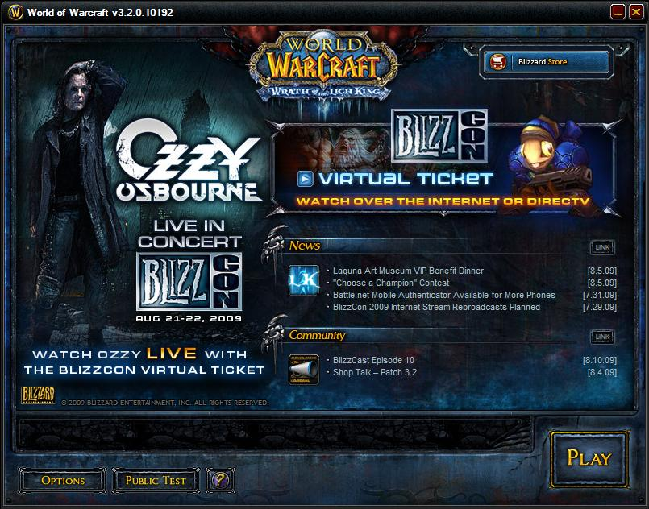

Appendix 4
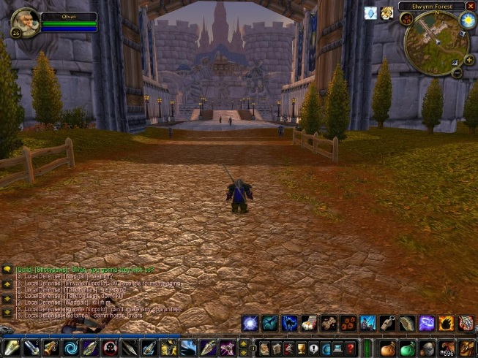
Pet battles and WoW gameplay.
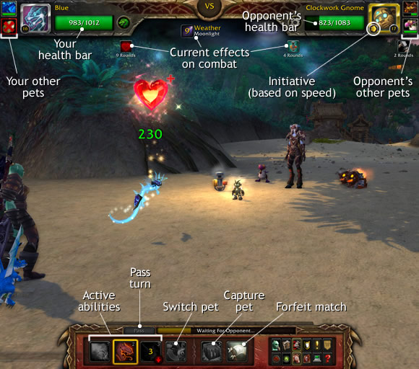
Sources:
- SEC FILINGS. Activision Blizzard, n.d. Web.
- http://investor.activision.com/sec.cfm?view=all
- "World of Warcraft News and Raiding Strategies." MMO-Champion -. N.p., n.d. Web.
- http://www.mmo-champion.com/content/
- http://wowwiki.wikia.com/wiki/Major_characters

See Sources
Monthly releases are regularly published on mmo-champion.com. 10K reports were available on SEC Filings website. See Sources.
“Pokémon is a media franchise owned by The Pokémon Company, and created by Satoshi Tajiri in 1995. It is centered on fictional creatures called "Pokémon", which humans capture and train to fight each other for sport.” (Source: https://en.wikipedia.org/wiki/ Pok%Cmon)
Pet battles were implemented into the interface of the game as well as various minor changes to graphics. See Appendix 4.
These numbers were taken from official press releases. See Sources
These numbers were calculated in Stata using the command “predict”

