SBIRT in Public Schools

Background Information for SD 808

Adapted from MA SBIRT (www.masbirt.org)

What is SBIRT?
- Universal, annual Screening (S) identifies unhealthy use. 75-85% of patients will screen negative. For those who screen positive, further assessment is needed.
- Brief Intervention (BI) provides feedback about unhealthy substance use. It also focuses on education, increasing patient insight and awareness about risks related to unhealthy substance use, and enhances motivation toward healthy behavioral change.
- Referral to Treatment (RT) helps facilitate access to addiction assessment and treatment. A referral is usually indicated for only about 5% of people screened.

1. Screening
There are several official guidelines and screening tools, some of which include the AUDIT, DAST-10, CAGE-AID, and other single-item alcohol & drug screens.
The most commonly used screens are the AUDIT and DAST-10:
- AUDIT (Alcohol Use Disorders Test) may be administered either as an oral interview or as a self-report questionnaire and takes 2-4 minutes to complete. Below is a sample AUDIT:
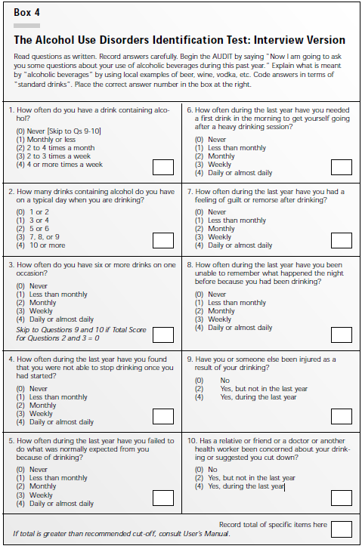

- DAST-10 (Drug-Use Questionnarie) takes approximately 5 minutes to administer and may be given in either a self-report or interview format. Below is a sample DAST-10:

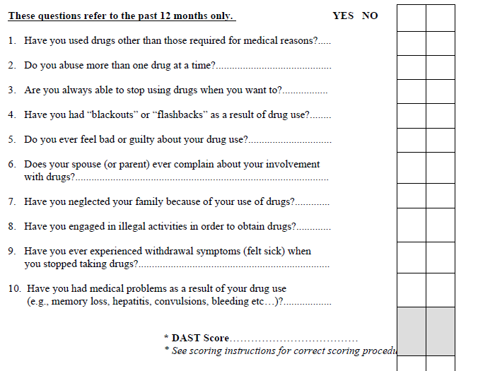

Useful Links:
MA SBIRT Basics: http://www.masbirt.org/sbirt-information/sbirt-basics
AUDIT Manual: http://www.integration.samhsa.gov/clinical-practice/sbirt/AUDIT_Manual,_2.pdf
DAST-10 Test: http://smchealth.org/sites/default/files/docs/1309587937DRUGUSEQUESTIONNAIRE.pdf
SBIRT Screening Tools: http://www.integration.samhsa.gov/clinical-practice/sbirt/screening-page
SBIRT in Public Schools: http://www.wishschools.org/resources/schoolsbirt.cfm

