MEMORANDUM

Re: Legislative History Project
Date: December 30, 2017

Bill Number: H.3749 / Chapter 57, 2017 Session Laws
Title: An Act protecting sunlight and promoting economic development in the City of Boston
Sponsors: Rep. Aaron Michlewitz & Senator Joseph A. Boncore
Committee: Joint Committee on Municipalities and Regional Government
Hearing Date: June 27, 2017
Enacted: July 24, 2017

Procedural History: This bill was submitted by Aaron Michlewitz and Joseph A. Boncore on behalf of the Mayor of Boston and the City Council. This petition was promulgated by the Law Department for the City of Boston (the Corporate Counsel) – primarily, Adam Cederbaum, Chief Governmental Services Division. After the petition was filed, the procedural history is accurately described on the Legislature’s website in the bill’s history.
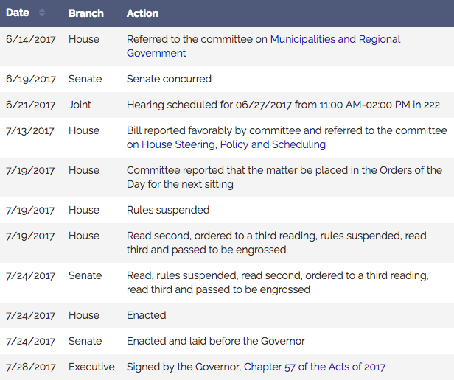

House and Senate Journals:
The Senate Journal only reflects treatment of H.3749 on July 24, 2017 (attached). On this day, the Senate performed the first, second, and third reads of the bill with no objections and on motion for suspension of the rules. The bill was passed to be enacted and signed by the Acting President (Mr. Pacheco). The bill was presented to the Governor for his approbation.

The House Journal reflects treatment of H.3749 on three dates – July 13, July 19, and July 24 (attached). On July 13 the bill was read and referred. On July 19 the bill was read the second time and on motion to suspend the rules, read the third time. The bill was passed to be engrossed and sent to the Senate for concurrence. On July 24, was certified for final passage by the Clerk signed by the acting Speaker, and sent to the Senate.

Materials collected during the legislative process and oral & written testimony given:
I contacted both Rep. Michlewitz and Senator Boncore’s offices both in person and by telephone to secure materials that they collected during the legislative process; however, both offices directed me to the Joint Committee on Municipalities and Regional Government as they had passed on all materials they collected to the Joint Committee. Therefore, I contacted the Joint Committee by phone regarding information that they had pertaining to this bill and I reached Zachary Tsetsos, the Legislative and Policy Advisor for the office of Sen. Michael O. Moore, who is the Senate Chair of the Joint Committee. Mr. Tsetsos sent me eight pieces of information pertaining to the bill (attached):
- Sec. Galvin letter, dated June 27 & July 11;
- Friends of the Public Gardens Testimony, dated June 27;
- Franklin Park Coalition Testimony, dated June 27;
- Boston Preservation Alliance Testimony, dated June 27;
- The Green Testimony, not dated;
- New York Times article, dated July 12, 2017;
- Boston Globe Article, dated July 12, 2017.

Mr. Tsetsos informed me the project developer, Millennium Partners, also submitted a spiral portfolio of material in support of H.3749 but the information cannot be scanned. Mr. Tsetsos also informed me that both the House and Senate members of the committee had the same information, and I contacted the House chair to confirm that they had no additional information. According to MassTrac, the testimony that Mr. Tsetsos provided my is comprehensive.

I tried to contact each of the parties who submitted oral or written testimony to see if they had any additional material to provide, but did not hear back from any of the parties even after multiple attempts.

I also tried to contact Adam Cederbaum from Boston’s Corporate Council to see if he had any additional information regarding the bill since the petition originated in his department; however, I was also unsuccessful in hearing back from the Corpoate Council despite multiple calls and emails.

Floor Debate: State House News reported the House floor debate regarding H.3749 on July 19, 2017 (attached), but there is no video available, but there is audio available (attached).
Amendments: There were no amendments proposed for H.3749.

Conference Committee: There was no conference committee for H.3749.

Governor’s Materials: I attempted to contact the governor’s office many times both via phone calls and emails and was unsuccessful in getting any response. When I went into the office to request materials, I was informed that the office does not have a bill folder and they have nothing available that isn’t already available online. Fortunately, there was no amendments or vetoes on this bill.

State House News: State House News published two very brief notices from the House and Senate sessions on July 24, 2017 mentioning that the bill was passed (attached).

