A New Algorithm for Finding Minimal Cycle-Breaking
Sets of Turns in a Graph*

Lev Levitin, Mark Karpovsky, Mehmet Mustafa, Lev Zakrevski
Dept. of Computer Engineering, Boston University,
8 St. Mary's Street, Boston, MA 02215
levitin@bu.edu, markkar@bu.edu, mehmet.mustafa@verizon.com, zakr@njit.adm.edu

Abstract
In this paper we consider the problem of constructing a minimal cycle-breaking set of turns for a given non-directed graph. This problem is important for deadlock-free wormhole routing in computer and communication networks with irregular topologies, such as Networks of Workstations or NOWs. In a graph 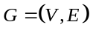, triple of vertices 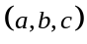is a turn if 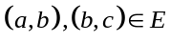. The proposed Cycle Breaking algorithm, or CB-algorithm, guarantees that the constructed set of prohibited turns is minimal (irreducible) and that the fraction of the prohibited turns will not exceed 1/3 for any graph. The computational complexity of the proposed algorithm is 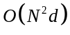, where is the number of vertices, and d is the maximum node degree. Memory complexity of the algorithm is . As far as authors know, this is the first algorithm providing a minimal solution of the problem and a meaningful upper bound on the minimal number of turns, which should be prohibited to break all cycles in a given graph without loss of connectivity.
We provide general lower bounds on minimum size of cycle-breaking sets for connected graphs. Further, we construct minimal cycle-breaking sets and establish upper and lower bounds on the minimum fraction of prohibited turns for two important classes of graphs, namely, t-partite graphs and graphs with small degrees
We also present results of computer simulations for the proposed CB-algorithm. These results illustrate the superiority of the proposed CB-algorithm as compared to the well-known and widely used Up/Down techniques.

Keywords: networks of workstations, NOWs, wormhole routing, turn model, deadlock prevention

1. Introduction
Recently, Networks of Workstations, NOWs [1, 3, 6, 9, 10], have emerged as an inexpensive alternative to massively parallel multiprocessors [2, 3]. NOWs comprise a collection of routing switches, communication links and workstations interconnected in an ad hoc manner resulting in a graph of irregular topology. In order to minimize network latency and achieve high bandwidth communications, recent experimental and commercial switches for NOWs implement wormhole routing [3, 4]. However, because packets are allowed to hold many resources while requesting others, wormhole routing is very susceptible to deadlocks [3, 5, 6]. Thus, deadlock prevention has become an important problem in the theory of communication networks.
It was proved [13] that the absence of cycles in the channel dependency graph is a sufficient condition for deadlock-free routing. It was later shown [15] that this is also a necessary condition for deadlock-free coherent routing algorithms. The elimination of cycles in the channel dependency graph is equivalent to elimination of all cycles in the sense of Definition 3 (see Section 2, below) in the graph of original communication network. This can be accomplished by prohibition of a carefully selected set of turns in the graph.
A turn in a graph is a three-tuple of nodes,, such that and 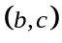 are edges in . In order to model existing switch-based networks we assume that is non-directed. Several routing methods using turn prohibition currently exist for regular topologies, such as 2-dimensional meshes, tori or hypercubes [2, 3, 7].
It was shown in [7] for meshes and tori and in [9, 10] for irregular topologies that reduction in the number of prohibited turns results in a decrease of average path lengths of messages and in a reduction of average delivery time, thereby increasing throughput.
For a general topology, most of the existing routing strategies are based on the spanning tree approach [1]. According to this strategy, a spanning tree is constructed which is subsequently used for communication, thereby guaranteeing deadlock freedom. The main shortcomings of this approach are long message paths and congestion on the edges near the root node [1]. This approach is also very inefficient since a large number of links are not used. This method can be improved by allowing shortcuts using cross-edges that do not belong to the spanning tree. For example, for the widely used the Up/Down routing [1], after a spanning tree is constructed for , nodes are labeled preserving the partial order defined by the tree with the root having label 1. If we denote the label of a node as , then turn is prohibited if and .
For the Up/Down approach [1, 10], given a network topology, the fraction of prohibited turns for deadlock-free routing, depends not only on the selection of a spanning tree but also on the root of the spanning tree, and could be very close to one. The problem of construction of an optimal spanning tree is NP-hard.
In [16] authors used a simple turn prohibition algorithm to generalize the application of Network Calculus to arbitrary topologies in which cycles of independent packet flows were eliminated. Ordinarily, Network Calculus applies to feed-forward topologies in which packets do not create cyclic dependencies. Set of prohibited turns generated by this simpler algorithm is not necessarily irreducible. This means that if a turn is deleted from this set, the graph may still be acyclic.
In this paper, we introduce the mathematical model in Section 2, followed by establishing lower bounds on the fraction of prohibited turns in Section 3. In Section 4 we describe the CB-algorithm for construction of minimal (irreducible) sets of prohibited turns with the fraction of prohibited turns not exceeding 1/3 for any graph. Then we prove that the set of prohibited turns is irreducible. Next in Section 5, we list the main properties of the CB-algorithm followed by determination of the upper and lower bounds on fractions of prohibited turns for complete bipartite and t-partite graphs in Section 6 and for graphs with small degrees in Section 7. Finally, we present experimental results for randomly generated topologies and offer our conclusions. Our simulation results for topologies with 64 nodes show that the proposed CB-algorithm reduces the number of prohibited turns significantly when compared with the Up/Down approach.
The complexity of the developed algorithm isand the required memory complexity is , where is the number of nodes, and is the maximum node degree of the graph .

2. Mathematical model
Let us consider a non-directed graph , with vertices or nodes, denoted by, and edges, denoted by , etc. We assume that graph is connected, i.e. there is a path between any two nodes in G. If this is not the case, we consider individual components separately.
- A turn in a graph is a 3-tuple of nodes if and are edges in and .
We note that denotes the same turn as . If the degree of node is denoted as , and the total number of turns in as , we have
.
- A path from node “” to node “” in is a sequence of nodes 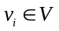 such that, , every two consecutive nodes are connected by an edge, and that does not include subsequences of the type .
Nodes and edges in the path are not necessarily all different.
- Path in is called a cycle of length k, if any directed edge, appears at most once in P, except that appears exactly twice.
If no proper subset of nodes of cycle forms a cycle, we call a simple cycle.
Examples of cycles for the graph depicted in Fig. 1 are, , 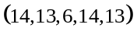, 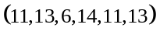, , . Note that our definitions of a path and a cycle are somewhat different than the conventional definitions [8, 17-19]. It can be said that we consider “cycles of directed edges”, rather than “cycles of nodes”. The reason is that such cycles result in deadlocks in networks of workstations with computing nodes being vertices of graph G and communication links are edges of G. Breaking all cycles in G results in preventing deadlocks in the corresponding network.
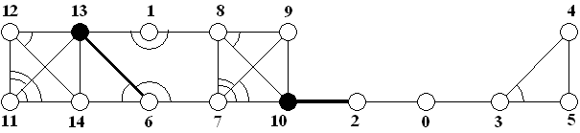
Fig. 1 Construction of Prohibited Turns Using CB-algorithm
In Fig. 1, we show the prohibited turns constructed using the CB-algorithm. Turns that are prohibited are shown as arcs. For example, turns 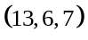and 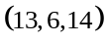 are prohibited, but turn 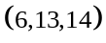 is permitted. Special edges and delayed nodes are shown in bold. Delayed nodes are privileged since no turns are prohibited at these nodes. Definitions of special edges, delayed and forcing nodes are given in Section 4.
- If edges 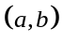 and adjacent and belong to path such that, , 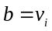, 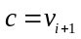, 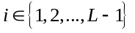, then turn covers , i.e., 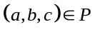.

- A set 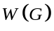 of turns in is called cycle-breaking if every cycle in is covered by at least one turn from . Elements of are called prohibited turns.
The set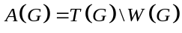 is called the set of permitted turns. A path in is called permitted if all turns covering belong to , otherwise path is prohibited.
For the topology in Fig. 1, cycle 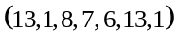 is covered by turn . As an example, one cycle-breaking set of prohibited turns for the topology presented in Fig. 1 is
.
We say that the cycle-breaking set of prohibited turns preserves connectivity if for any two nodes , there exist at least one permitted path from to .
Given graph representing a connected network topology, we shall consider in Section 4 the problem of finding a minimal cycle-breaking set of turns for G, which preserves connectivity of the graph. This problem was first formulated and solved for meshes by Glass and Ni [7].
- Path in is called a halfloop if it is permitted under a given set for prohibited turns .
For example, for the topology and the set of prohibited turns shown in Fig. 1, is a halfloop.
The number of turns in a minimum cycle-breaking set is denoted by .
- Cycle-breaking set of turns is minimal (irreducible), if there are no cycle-breaking proper subsets of . In other words, deletion of any turn from a minimal set of prohibited turns will introduce a cycle in the graph.
We note that a minimal cycle-breaking set is not necessarily a minimum cycle-breaking set.

3. Lower Bounds on Minimal Cycle-Breaking Sets of Turns
In this section we present two lower bounds of fractions of turns to be prohibited to break all cycles without loss of connectivity in any connected graph where and .
- If is a set of cycles in a graph with nodes and edges and is the maximum number of cycles in covered by the same turn, then the fraction of prohibited turns satisfies the following inequalities:
,
and
.
Proof. Bound follows from the fact that any cycle-breaking set of edges should contain at least elements, where is the cyclomatic number for [8], and each cycle-breaking set of turns generates a cycle-breaking set of edges with a smaller or equal number of elements. Bound follows from the fact thatcycles should be covered by at least turns. 
For example, for complete graphs with and selecting triangle cycles we have and by .
- Consider a connected graph with a minimum cycle-breaking set of turns 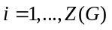. If there exits an edge that belongs to t prohibited turns, then
.
Proof. After removing the edge we obtain a graph consisting of one or two connected graphs with total number of edges and nodes. By Theorem 1, the number of turns to be prohibited in to break all cycles is . Thus,
. 
- Let be a connected graph with minimum degree . Then
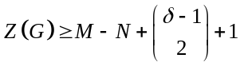.
Proof. Assume that, in graph with cycle-breaking set of turns , there is no edge such that all turns are prohibited. This means that, arriving to a node along the edge , one can always find an edge to leave the node. In other words, there exists paths of unlimited lengths in . Since the number of edges in is finite, the same edge in the same direction will be repeated in a path, thereby forming a cycle. This contradiction proves that there should exist an edge with all the turns prohibited. The number of such turns is at least 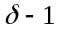. By Lemma 1, we obtain . Thus, for , the lower bound is valid:
.
Now assume that the lower bound is valid for all graphs with minimum degree . Consider a connected graph with minimum degree . After removing edge with all prohibited turns we obtain a graph 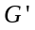 with minimum degree at least , and the number of edges . By Assumption,
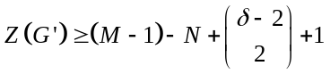.
Hence,
. 
As shown below in Theorem 8 and Corollary 6, bound is attained for 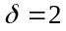 and 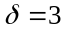. However, we believe that a stronger lower bound is valid.
Conjecture. 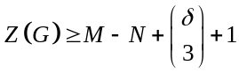.
- If is a connected graph and 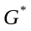is a homeomorphic graph obtained by adding a node of degree 2 in the middle of one of the edges in , then
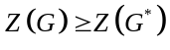
Proof. Any set of turns that breaks all cycles in is obviously a cycle-breaking set in as well, which proves theorem. 
- For any connected graph with edges and 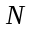 nodes there exists a homeomorphic graph such that
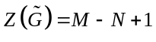
Proof. Consider a spanning tree in . There are 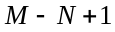edges that do not belong to the spanning tree. By adding a node of degree 2 at each of these edges and prohibiting turns at these edges, all cycles will be broken, which proves corollary. 

4. CB-algorithm for Constructing Irreducible Sets of Prohibited Turns
In this section we describe the Cycle Breaking or CB-algorithm. Given a connected graph with 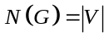 nodes, the CB-algorithm constructs a minimal set of prohibited turns, breaking all cycles and preserving connectivity of . Furthermore, the CB-algorithm guarantees that the fraction of prohibited turns will not exceed 1/3. As far as we know, this is the first algorithm providing a nontrivial upper bound for the fraction of prohibited turns breaking all cycles.
The algorithm is recursive. At each run of the algorithm one node is selected and every turn at the selected node is either permitted or prohibited. For example, if, after deleting a node with degree 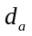 and all its edges from, the remaining graph 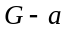 is still connected, then we prohibit all 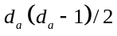 turns 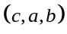 and permit all turns. Then, the CB-algorithm is invoked recursively. At every run of the algorithm labeling of a node to be deleted is done by using the smallest natural number not used at the previous runs as its label. We label a node by assigning a natural number to the node that indicates the order in which the node has been selected. Initially, all nodes are unlabelled. In the course of the algorithm, a node can also be marked as forcing or delayed. Nodes that have never been marked forcing or delayed are called ordinary nodes. An edge can be marked as special. The variable called HALFLOOP is initially cleared by assigning a value of 0 to it. When it is set, its value becomes 1 and remains set.
CB-algorithm is invoked by a call 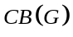 where the argument is the graph for which we seek to construct a minimal set of prohibited turns. Prior to the invoking the algorithm, two sets and 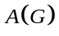 are initialized to be empty, HALFLOOP is cleared, all nodes are marked unlabeled, and all nodes and edges of the graph are marked ordinary. Steps 1-7, 9a, and 9b comprise one run of the algorithm. Thus, at each run, exactly one node is selected, and this run can be numbered by the label of the node 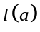. At step 1, algorithm tests for completion. If there is just one node left, then node is labeled and algorithm returns with the sets and containing the set of prohibited and permitted turns respectively. At step 2, if there exists a forcing node in , we select the forcing node and label it. This run is called forced. Note that there exists either at most one forcing node, or at most one delayed node, but not both of them simultaneously in each connected component at each run of the algorithm. The given condition assures that the selected node of minimum degree has neighbors with largest sum of their degrees, i.e., the number of permitted turns. The denominator selects nodes that maximize the number of permitted turns in step 5 of the algorithm. At next step 3, we delete the selected node and its edges and index the remaining connected components. In particular, if there is a delayed node it must belong to component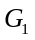. We then index the remaining components based on the number of edges connecting them to the selected node. Component with a smaller number of edges connecting to the selected node has a larger index. At step 4, one edge connecting the selected node to each component, excluding, is marked special. (It is beneficial to choose special edge ending at the node of largest available degree). At step 5 of the algorithm, we identify all turns at the selected node that will be prohibited and make them members of the prohibited set . If the selected node is not a cut node, all turns at the node are prohibited. Similarly, all permitted turns are made members of the permitted set. Step 6 is executed only when is a forcing node. Then the node 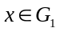connected to (there exists exactly one such node) is marked either forcing (if it is of degree 1, or a cut node of degree 2 in ), or delayed. At step 7, if the delayed node, after deletion of the selected node a, turns out to be of degree 1, or a cut node of degree 2, it is transformed into a forcing node. Thus, any delayed node becomes, sooner or later, a forcing node. Then, the algorithm recurses by invoking itself with the component at step 8. Remaining step 9 is executed k-1 times whenever there are k connected components in. If the flag HALFLOOP = 0, we determine if there is any halfloop in each component. When a halfloop is detected involving the selected node and nodes in the component 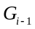, HALFLOOP is set. Once the HALFLOOP flag is set, it remains set until the completion of the algorithm. Therefore, after it has been set HALFLOOP = 1, there is no need to execute step 9a (in fact, k-1 steps) in all following runs, and step 9b can be executed immediately after step 7. The algorithm then checks again if HALFLOOP flag is set, and if so we mark one node in each component 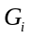 (i is larger than the index of the component where a halfloop has been found) connecting to the selected node as either forcing or delayed. Note that forcing nodes have the smallest labels in their components. Subsequently, we invoke the CB-algorithm for each component 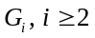. Note that each node is selected exactly once in the course of the algorithm. Note also that no turns are ever prohibited at delayed or forcing nodes.
We note that CB-algorithm results in labeling of nodes such that:
- All nodes have different values of .
- All nodes of componentwill have larger value , than any node of component, if 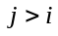.
- If node in component is forcing, then 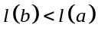for all other nodes 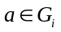.
- If node b in component is delayed, then 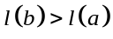 for all that have been selected prior to b becoming a forcing node.

It can be shown [20] that by use of the depth first search algorithm one can identify all cut nodes and the connected components of a graph in 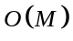 time. It follows that, for a graph with a maximum node degree d, the time complexity of the CB-algorithm is and required memory is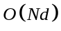.

A. Formal Description of CB-algorithm.
We assume that we are given a connected graph with nodes. Before the algorithm starts, we initialize the sets for prohibited and permitted turns,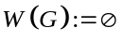, 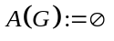, and the variable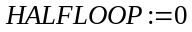, mark all nodes and edges as ordinary and all nodes as unlabeled.
- If , label the node and RETURN
- If there exists a forcing node in , select the forcing node and label it. Otherwise, select an ordinary node with minimum degree 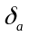 such that 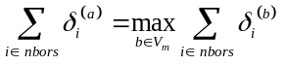, where the summation is taken over all neighbors of the node considered, and 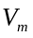is the set of all nodes of minimum degree. If there are non cut nodes in 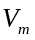 that satisfy this condition, we select such a node. Label the node.
- Connected components of graph , obtained by deleting the selected node and all its edges, are indexed as 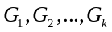using the following criteria:
  - If there is a delayed or a forcing node in, it should be in.
  - Otherwise, component connected to the selected node with smaller number of edges should have a larger index i.
- For 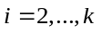, one edge that connects component to is marked special.
- All turns 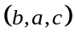 in which is special and 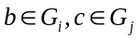 with 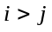 belong to the permitted set, 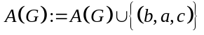. Otherwise, they belong to the prohibited set 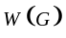, 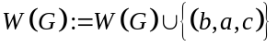. All turns starting with the selected node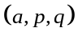, where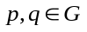, are permitted and belong to set , .
- If 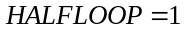 then node connected to is marked forcing, provided that is of degree 1 in or a cut node (articulation point) of degree 2 in ; otherwise, (if x is of degree 2 but is not a cut node or if it has a degree larger than 2) is marked delayed.
- If has a delayed node b, and, after the deletion of the selected node a, node b has degree 1 or it is a cut node of degree 2, then node b becomes a forcing node.
- 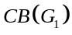
- For
  - If 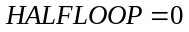 and, after CB-algorithm has been applied to , there exists a halfloop 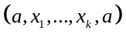, where 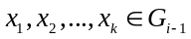(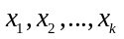are not necessarily all distinct) then 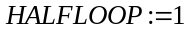
  - If then node in connected to with special edge is marked forcing, provided that it is of degree 1, or a cut node of degree 2. Otherwise it is marked delayed.
  - 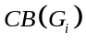
- RETURN

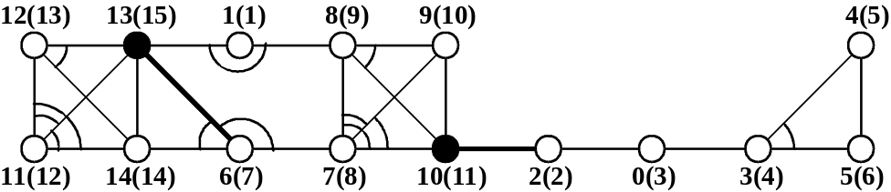
Fig. 2 Prohibited Turns Generated by the CB-algorithm Showing Delayed (Solid Black) Nodes.
We now illustrate the operation of the CB-algorithm with reference to graph in Fig. 2. In the figure, we show node labels in parentheses after the node numbers. Labels show the order in which nodes are selected by the CB-algorithm. At the first run, we select the ordinary node 1 of degree 2, delete it and its edges (1, 13), (1, 8), and prohibit one turn. Note that all turns such as 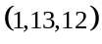starting with node 1 are permitted. We next select node 2, which is a cut node. We prohibit no turns at node 2, and node 2 and its edges are deleted, two connected components are created. The first component includes three nodes 0, 3, 4, and 5. We mark the edge (10, 2), which connects the selected node 2 to 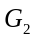as special, shown bold in the figure. We then apply the CB-algorithm to . Node 0 is selected without prohibiting any turns. After deleting node 0 and its edges, we are left with a subgraph in which all three nodes are of minimum degree 2 and neither one is a cut node. Arbitrarily, CB-algorithm selects node 3, prohibits the turn 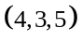, and deletes edges (3,4) and (3,4). Nodes 4 and 5 are then selected with no prohibited turns completing the handling of. When we consider, we discover a halfloop 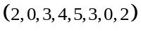in, set HALFLOOP, and mark node 10 as Delayed. We are now ready to handle subgraph. When we apply CB to, we find out that there is no any forcing node and therefore select node 6, which satisfies the selection criterion. Since this is a cut node we prohibit only the two turns as shown, thus maintaining the connectivity between the two components. After deleting the node and its edges, we discover two new components. The first one comprised by nodes 7, 8, 9, and a delayed node 10. The other component comprised by nodes 11, 12, 13, and 14. The first component with a delayed node becomes the new , which is handled first. We see that, since node 10 is delayed, its selection is deferred until there are no other nodes left in the component.
After a total of 15 iterations, a minimal set of prohibited turns for is constructed. In this case, 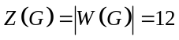 turns are prohibited out of 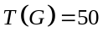. We note that if the initial selection order were 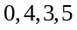, or 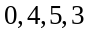, or 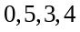, or 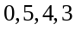, the halfloop flag would not have been set at the label 4 step. All of these alternate selection orders would not have created any halfloop in the first connected component. In the following table we demonstrate the operation of the algorithm, showing the status of the nodes and any related edges, their labels, and the number of prohibited turns at every step of the algorithm. Note that when the HALFLOOP flag is set when node 5 is selected, it remains set for the duration of the algorithm.

Table 1 Step-by-Step Operation of the CB-algorithm for Topology in Fig. 2
Selected  Node | Node  Label | Node  Attribute | Special  Edge | Delayed  Node | HALFLOOP | Set of Prohibited Turns
1 | 1 | Ordinary | None | None | 0 | {(13,1,8)}
2 | 2 | Cut | (10, 2) | None | 0 | {}
0 | 3 | Ordinary | None | None | 0 | {}
3 | 4 | Ordinary | None | None | 0 | {(4,3,5)}
4 | 5 | Ordinary | None | None | 0 | {}
5 | 6 | Ordinary | None | 10 | 1 | {}
6 | 7 | Cut | (6, 13) | None | 1 | {(13,6,14),(7,6,13)}
7 | 8 | Ordinary | None | None | 1 | {(8,7,9),(8,7,10),(9,7,10)}
8 | 9 | Ordinary | None | None | 1 | {(9,8,10)}
9 | 10 | Ordinary | None | None | 1 | {}
10 | 11 | Delayed | None | None | 1 | {}
11 | 12 | Ordinary | None | 13 | 1 | {(12,11,13),(12,11,14),(13,11,14)}
12 | 13 | Ordinary | None | None | 1 | {(13,12,14)}
14 | 14 | Ordinary | None | None | 1 | {}
13 | 15 | Delayed | None | None | 1 | {}

5. Main Properties of CB-algorithm
- CB-algorithm has the following four properties.
Property 1. Any cycle in contains at least one turn from .
Property 2. For any two nodes and , if there exists a path between and in , then there exists a path between and , with no turns from along the path, after the CB-algorithm is applied.
Property 3. 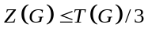, where 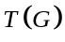 is the total number of turns in graph .
Property 4. Set of prohibited turns generated by CB-algorithm is minimal (irreducible).
Proof of Property 1. First we will prove the following lemma.
- If x is a forcing or delayed node in a connected component , then, after application of the CB algorithm to , there is no permitted closed path (halfloop)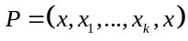in, where 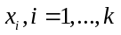are not necessarily distinct, but are different from .
We will prove the lemma by induction. For 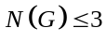the lemma is obviously true. Assume that the lemma is valid for any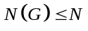. Consider with 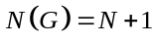, and let be a closed path in . If is a forcing node then, after this node is selected and deleted, in each connected component of graph 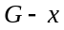 there is a forcing or a delayed node connected to . Let be such a node belonging to . Then has a form 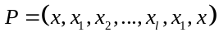, where 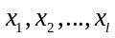 belong to one of the connected components of . Hence, in , there must be a closed path 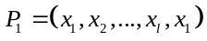. However, since 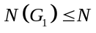, such a permitted path does not exist. Therefore, is not permitted either, which proves the lemma.
Consider now the case when is a delayed node. Let 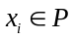be the node with the smallest label 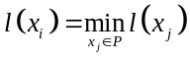. At the run of the algorithm, when is selected, the entire path belongs to the same connected component that includes delayed node . Two cases are possible.
1. After deleting , the remaining part of belongs to the same connected component. Then the turn at that covers must be prohibited, thereby prohibiting path .
2. After deleting , path breaks into at least two parts, that includes , and 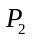, the parts belonging to different connected components. If is connected to with at least two edges, then at least one of the turns at that covers , namely, the turn to a non-special edge, must be prohibited. If is connected to with just one edge, then this edge is special, and the node 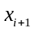 connected to with this edge is either forcing, or delayed. Thus, by inductive assumption, there is no permitted path 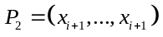, and, therefore, there is not permitted path in , which proves the lemma.
Return now to the proof of Property 1. We will also use induction over the number of nodes in . For , Property 1 is trivial. Assume the property is true for all , and consider a graph with . Let 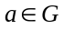 be the node selected at the first run 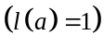. First, consider cycles in that include nodes from only one of the connected components of . Since all turns at between edges connecting to the same component are prohibited, all such cycles that include are also prohibited. All cycles in one of the components that do not include are prohibited by the inductive assumption.
Consider now cycles that include nodes from different connected components, and 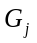, where . According to the CB-algorithm only turns to the special edge, connecting to are permitted. Therefore, a cycle that includes nodes from and must include the edge 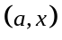 twice, where 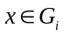 is the end point of the special edge. To form a cycle, there should be a closed path (halfloop) 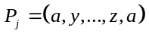, where 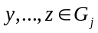, and a path 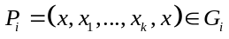. However, if 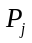 is permitted, then the node is either forcing or delayed, and no permitted path exists. Thus, Property 1 is proved. 

Proof of Property 2. We use induction over the number of nodes 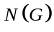 in . For 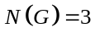the property is trivial. Let the property be true for all . Consider a graph with . Select a node and perform steps 2-5 of the algorithm. We obtain one or more connected components 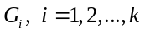. Any two nodes in the same component are connected. If one node belongs to one connected component and the other one is either , or belongs to another component, they are connected with special edges, since all turns between special edges are permitted, as well as turns between edges connecting node with and special edges. Hence, this run of the algorithm does not affect connectivity. Since 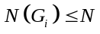 for all 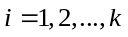, the property is proved. 

Proof of Property 3. At run of CB-algorithm we prohibit a subset of the set of all turns with 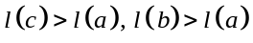and permit all turns with 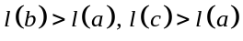. The number of prohibited turns at run is 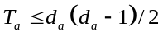 and the number of permitted turns is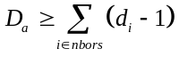, where summation is made over all nodes adjacent to node . If node has a minimal degree in the remaining graph at run or if it is not connected with a delayed node, which has a degree smaller than , then, since 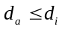 for all neighbors of , 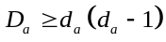. The only remaining case is when all ordinary nodes of minimal (among ordinary nodes) degree are connected with a delayed node of degree 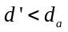. Then, at node, at most 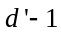 edges end at nodes of degree , while at least 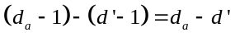edges end at nodes with degrees at least 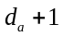. Thus, the number of permitted turns
Hence, in all cases, the number of permitted turns is larger than the number of prohibited turns by at least a factor of two. Since this is true for each run of the algorithm, it follows that . 
Note that the only graph with 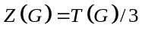 is the complete graph 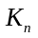, with an edge between any two nodes.

Proof of Property 4. The proof uses induction over number of nodes 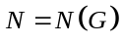. For the property is trivial. Assume that the property is true for 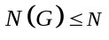. Consider a graph with . Let be the first selected node, 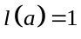. It is sufficient to prove that deleting a prohibited turn from creates a cycle.
If and belong to the same connected component , then, by Property 1, after completion of the CB-algorithm, there exists a permitted path from to that belongs to component , and, therefore, permitting the turn creates a cycle 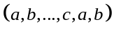.
Let now 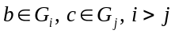. Then the edge is non-special, there exists a special edge 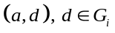, and there exists at least one more edge 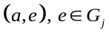. Since turns and 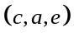are prohibited, but connectivity is preserved (Property 1), there exist paths 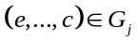 and 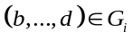. Hence, permitting turn creates a cycle 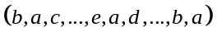. (Note that turn 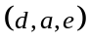 is permitted by the CB-algorithm). Hence Property 4 is proved. 

We will illustrate operation of the CB-algorithm by applying it to the important class of full bipartite graphs 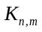 [8]. For class graphs the set of nodes consists of two disjoint subsets 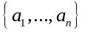, 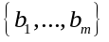and set of edges 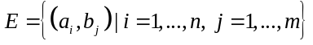. Thus, 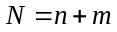, 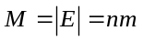 and 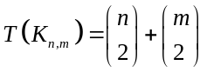.
For bipartite graph 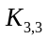 in Fig. 2, 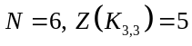, and an irreducible set of prohibited turns is . By Theorem 1 this is the minimal cycle-breaking set of turns for.
For 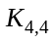, CB-algorithm results in a cycle-breaking set of 14 turns out of a total of 48 turns, which is by Theorem 1 the minimal number of prohibited turns for 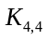.
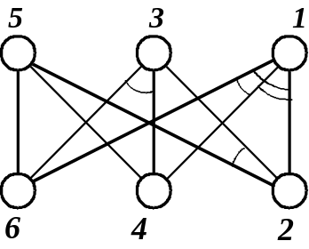
Fig. 2 Bipartite Graph
For arbitrary n, minimum degree nodes will be selected alternatively from two parts of the bipartite graph. Denoting the required number of prohibited turns as 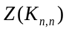, we have the following recursive equation
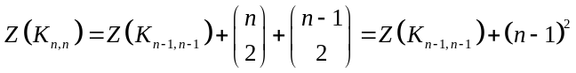.
Hence
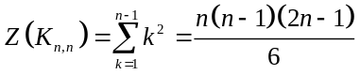 .
If , at the first stage 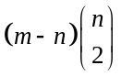 turns around nodes of the larger part containing nodes will be prohibited, thus
.

6. Minimal Cycle-Breaking Sets of Turns for t-partite Graphs
In this section we shall use the CB-algorithm for determining the upper bounds on minimal cycle-breaking sets for bipartite and t-partite graphs. For the complete bipartite topology and the symmetric bipartite topology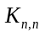, we obtain a lower bound for the fraction of prohibited turns by means of the following theorem and its corollaries.
- For complete bipartite graphs with 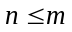
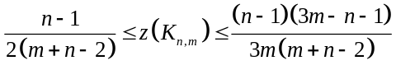.
Proof. To prove the upper bound, we use the set of prohibited turns constructed by CB-algorithm with given by . The total number of turns in is equal to
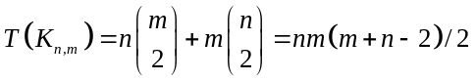.
Hence, 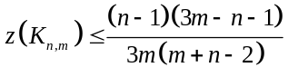.
To prove the lower bound, consider the bound given by . If the set of cycles is taken to contain only cycles of length four, then there are 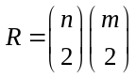 of such cycles and each turn can cover no more than 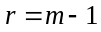 cycles. Hence,
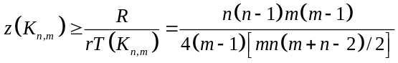.
Simplifying, we get 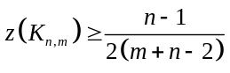. 
- For bipartite graphs , bounds for fraction of prohibited turns is given by
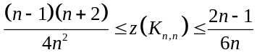.
Proof. The upper bound follows directly from .
For the lower bound, note that for we have and no more than turns can be selected in such a way that no two or more turns cover the same cycles of length four. These turns cover 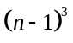cycles. All other turns cover at most 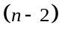 additional cycles. Thus, we have for the total number of prohibited turns
. 
- For bipartite graphs , an alternate lower bound for fraction of prohibited turns is given by
.
Proof. Note that for we have . Consider the set of cycles of length four. We split all prohibited turns in the minimum cycle-breaking turn set into groups, putting any two turns and in one group if and only if 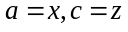. Denote the number of turns in these groups as 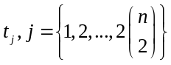. Then, the number of prohibited turns is 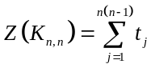. Now, we consider the number of cycles of length four, covered by turns from group j, . The total number of cycles of length four we obtain,
.
Since, Solving this inequality, we obtain
. 
Hence, the . Therefore, asymptotically, bound gives better results, then . The bounds for 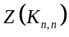 are given in Table 2 for 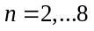.

Table 2. Bounds for the number of prohibited turns
n | 2 | 3 | 4 | 5 | 6 | 7 | 8
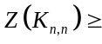 | 1 | 5 | 14 | 28 | 50 | 81 | 123
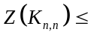 | 1 | 5 | 14 | 30 | 55 | 91 | 140

We conjecture that the CB-algorithm generates a minimum cycle-breaking set for any complete bipartite graph.
Now we consider complete t-partite graphs , with nodes and edges.
- For complete t-partite graphs ,
.
Proof. To prove the upper bound, we estimate the number of prohibited turns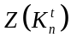, generated by the CB-algorithm. Number of prohibited turns can be calculated as
.
Equation follows from since total number of turns is 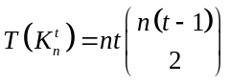.
To prove the lower bound, consider all cycles of length three, containing nodes from three different parts, and all cycles of length four, containing nodes from two different parts. There are 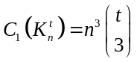cycles of the first type and 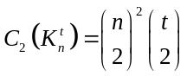cycles of the second type. To cover all cycles of the second type, by Corollary 1, 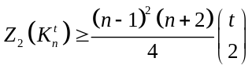turns are needed. Since no cycles of the first type have common turns with each other and with cycles of the second type, using Theorem 1, we have
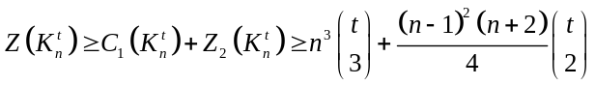,
.
Note that , thus
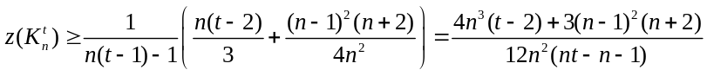. 
For example, for 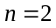 and 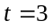, by Theorem 4 we have 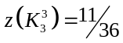.
- If , then 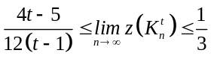. If also 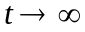, then 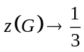.

7. Graphs With Small Degree Nodes
Now we consider an arbitrary graph , which is constrained to have nodes of small degrees. This corresponds to the practical case where the number of possible point-to-point connections at each node is restricted by the number of output buffers in the router [2]. Assume that degrees of all nodes do not exceed 3. As shown below, in this case the upper bound on the fraction of prohibited turns given in Section 5 can be substantially improved.
Consider first the case when initially graph G includes a node of degree smaller than 3. Then, at each run of the algorithm, each connected component will have a node of degree smaller than 3. If the component is not a simple cycle or a path without repeating nodes it includes also nodes of degree 3. Since runs that select nodes of degree 1 do not prohibit any turns, we assume that there are no nodes of degree 1 in the initial graph. Note that if there are at least two nodes of degree 2 in a component, then at least one of them is not a delayed node and is a neighbor of a node of degree 3. Also, there is only one possibility that a node of degree 3 will be selected, namely, if the component includes exactly one delayed node of degree 2. It is easy to show by contradiction that in this case there exists a non-cut node of degree 3 that is not a neighbor of the delayed node. Therefore, only a non-cut node of degree 3 can be selected. Let be such a connected graph with edges and 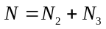 nodes, where 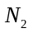 and 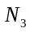 are the number of nodes of degree 2 and 3, respectively. Furthermore, assume that CB algorithm is applied to this graph until the remaining subgraph becomes a collection of simple disjoint cycles of length 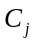, 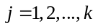. Denote by 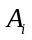 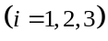 the number of nodes of degree selected during the execution of the algorithm up to the point when a collection of cycles is obtained. Then 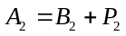, where we 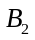 and denote the number of non cut nodes and number of cut nodes of degree 2, respectively. Obviously, exactly one turn in each of k simple cycles need to be prohibited. (Nodes selected in these cycles are not counted in 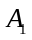 or 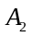) Hence, the total number of prohibited turns is
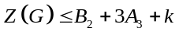.
It is readily seen that 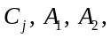 and 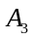 satisfy the following equations
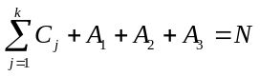
and
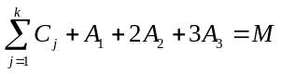.
Since each cut node increases the number of components by one we have
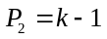,
and since the minimum length of a cycle is 3
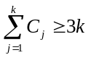.
Inequality can be strengthened. First note that at every step of the algorithm there exists a component without a delayed or a forcing node. If the initial graph is not a cycle of length 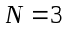, it is easy to see that at least one non-cut node of degree 2 will be selected in this component, in the course of the algorithm, before this component turns into a cycle. Thus,
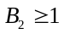
provided that 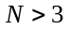 and there exists anode of degree 2 in the initial graph. (Note that the same is true in the case when the initial graph has nodes of degree 3, provided that 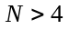.)
Consider now components with delayed nodes.

- If a component has a delayed node and all other nodes are of degree 3, then either a cycle of length 4 appears or a non-cut node of degree 2 is selected in the course of the algorithm.
Proof. After a node of degree 3 is selected in this component, three more nodes of degree 2 will appear. Together with the delayed node, they may form a cycle of length four as shown in Fig. 3(a). Suppose now that this is not the case and consider the component to which the delayed node belongs after selection of node of degree 3. Note that henceforth only nodes of degree 2 will be selected in this component. Two cases can can take place in the course of the algorithm:
i. The delayed node becomes a node in a simple cycle.
- The delayed node becomes a forcing node.
Consider the case i. Since in addition to the delayed node, at least two nodes must become simultaneously of degree 2 to form a cycle, it follows that when it occurs, a non-cut node of degree 2 was selected as in Fig. 3(b).
Case ii includes two sub cases. First sub case takes place if the delayed node becomes a cut node of degree 2. Then the node whose selection caused this result must be a non-cut node, as shown in Fig. 4(a). The second sub case occurs if the delayed node becomes a node of degree 1. Then the selected node is a neighbor of the delayed node, Fig. 4(b). Node must be a non-cut one, since otherwise the delayed node must have been turned into a forcing node (a cut node) already, Fig. 4(c). 
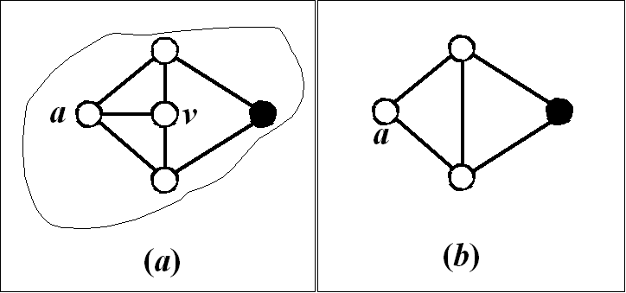
Fig. 3 Graphs illustrating the cases where the only node of degree two is a delayed node, showing delayed nodes as solid.
It follows from Lemma 3 that every selection of node of degree 3 either creates a cycle of length 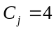, or leads to a selection of non-cut node of degree 2, increasing by 1. These considerations, together with and imply the following inequality
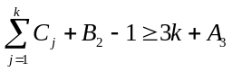.
Finally, since at most one node of degree 3 can be selected in each component, except the component without a delayed node, it follows that
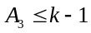.
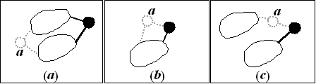
Fig. 4 Graphs illustrating the runs that would make a node of degree 2 a forcing node in (a), a node of degree 1 forcing node in (b), and node that should have been a forcing node rather than a delayed node in (c)
- Let be a connected graph with edges and nodes, where all nodes have degrees not exceeding 3 and at least one node is of degree smaller than 3. Then
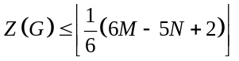
and
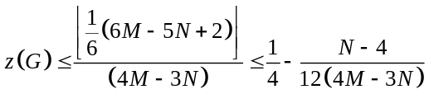.
Proof. The proof follows from the system of equations - and inequalities ,-. Subtracting from and substituting from we get , we get
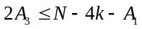.
Multiplying by 4 and adding yields
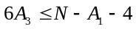.
Subtracting from , we obtain
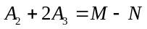.
From and:
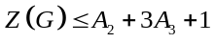.
Taking into account that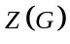is an integer and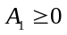, from,, and, we obtain:
. 
Since the total number of turns is 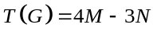, the fraction of prohibited turns is upper bounded by
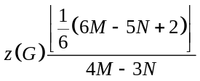. 

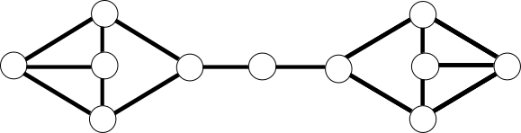
Fig. 5 An Example Graph With 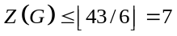 and 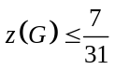
- For any 3-regular graph G with ,
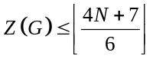,
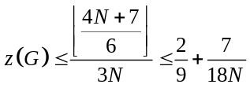.
Proof. After selecting the first node (which is a non-cut node of degree 3), prohibiting 3 turns, permitting 6 turns, deleting the node and its edges, we obtain a graph considered in Theorem 5, with 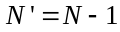 nodes and 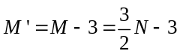 edges. Hence the number of prohibited turns becomes
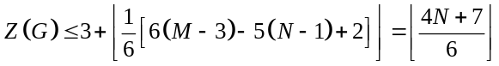,
where we used 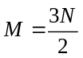. With the total number of turns given by 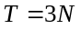, follows immediately. 
Bounds and are tight. The first is achieved, e.g., for the graph shown in Fig. 5, and the second is achieved, for example for the Peterson graph and , among many others. Bound is also achieved when the number of repeated groups of six nodes tends to infinity in as in a graph shown in Fig. 6.
There is a gap between the upper bounds, , and the lower bound , in spite of the fact that both the upper and lower bounds are tight. This variation is due to the effect of nodes of degree 3 to be selected in the course of the algorithm, as the following theorem shows.
- For graphs described in Theorem 5, if no nodes of degree 3 are selected in the course of the algorithm, then
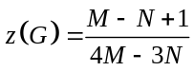.
Proof. If 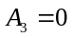, then from , , , and Theorem 1 we obtain:
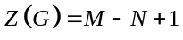
which gives . 
Thus in this case the upper and the lower bounds coincide and the CB algorithm is optimal.
A similar result holds for a 3-regular graph if the number of connected components remains equal to 1 throughout the execution of the algorithm.
- If graph is a 3-regular graph and 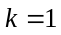, then
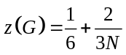.
Proof. Since 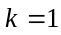, then 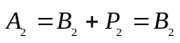, and 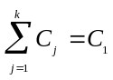. Total number of turns 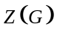 then becomes
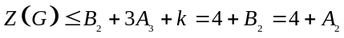.
Number of nodes and number of edges are equal to 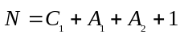 and 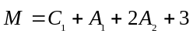 we obtain
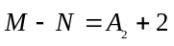.
It follows from , and Theorem 2 that
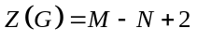.
Since 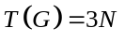, we obtain
. 
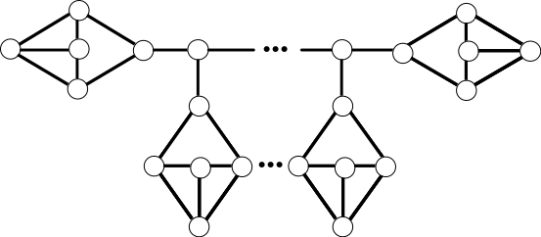
Fig. 6 The example of a topology which attains the upper bound asymptotically for 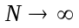

8. Experimental Results
To illustrate the effectiveness of CB-algorithm we compared it with the Up/Down approach [1] by means of simulation experiments. In Fig. 3, we show the histograms of the fraction of prohibited turns obtained using these two algorithms. We generated a family of graphs with a given minimum bisection width B. Minimum bisection width is the number of edges that when deleted separates the graph into two connected components with equal number of nodes. In Fig. 3a, b, c, and d we show the results of our simulation experiments for topologies of minimum bisection widths 2, 4, 6, and 8 respectively. For each distribution in Fig. 7, we generated 100 random graphs with the given bisection width, and 64 nodes of fixed node degree of 4. We then applied both algorithms to the same set of topologies, determining the mean and the variance for the fraction of prohibited turns. In Fig. 8, we plotted the mean of the fraction of prohibited turns versus the bisection width B. It can be seen that the Up/Down approach appears to have a larger variance than the CB-algorithm. The mean fraction of prohibited turns in the Up/Down approach are consistently larger by about 15% than those generated by the CB-algorithm.
In next set of experiments we analyzed the average distance as a function of bisection width in a large number of topologies. Given a randomly generated topology of interconnected nodes of a given average degree and a given minimum bisection width, we first computed the average distance in this topology without any turn prohibition. We then applied turn prohibitions using the Up/Down algorithm and computed the average distance to determine the effect of prohibitions on the average distance. Subsequently we applied the CB algorithm to prohibit turns to the same original topology and computed the average distance after the CB algorithm is applied. We repeated these set of experiments for 100 different randomly generated topologies, and computed the mean of average distances. We repeated the set of experiments, varying the bisection width between 2 and 30. In all topologies, the average node degree was 4, and the number of nodes was 64. Our results are shown in Fig. 9. Surprisingly, as can be seen in Fig. 9(a), for the 64 node topologies that we studied, the Up/Down algorithm has smaller average distance values than CB algorithm when bisection width values are in [2,10] and the CB algorithm has smaller average distance values than CB algorithm when minimum bisection width values are in [16, 30]. When the Bisection width is in [12, 14] both algorithms perform approximately the same. As expected, in all cases, both CB and the Up/Down algorithms increase the average distance of the original topology. Defining the average distance dilation as the ratio of the average distance with a given prohibition scheme to the average distance with no prohibition, we obtain the plot in Fig. 9(b). For the topologies that we studied, CB algorithm introduces approximately the same dilation in topologies with bisection width of 2 as does the Up/Down algorithm at bisection width of 30. For bisection widths 12 and 14 both algorithms cause approximately same dilation. For topologies with bisection widths greater than 14, the dilation introduced by the CB algorithm is always less than the dilation introduced by the Up/Down algorithm.

9. Conclusions
In this paper we analyzed the problem of constructing minimal cycle-breaking sets of turns in a given graph. This problem is important in networks with irregular topologies in which wormhole routing is used. We developed an algorithm, which we called the CB-algorithm, with complexity. This algorithm generates irreducible sets of prohibited turns, the size of which is no more than one third of the total number of turns for any graph. Furthermore, this set breaks all cycles and maintains connectivity in the original graph. The results of computer simulations illustrate that the proposed approach performs consistently and considerably better than the existing Up/Down approach. With randomly generated 64-node topologies with nodes of fixed degree four, using CB-algorithm based approach outperformed the Up/Down approach by approximately 15%.
The results presented in this paper can be easily generalized to multigraphs with several edges between any two nodes and for directed graphs.
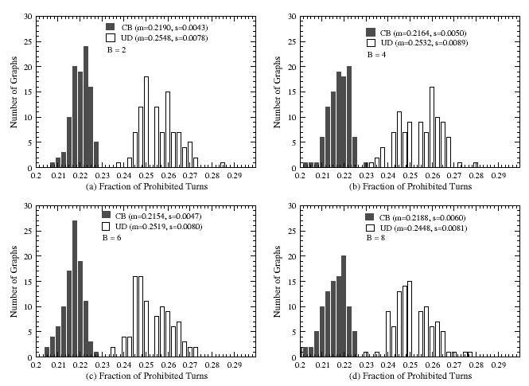
Fig. 7 Experimental Comparison of Up/Down and CB-algorithms

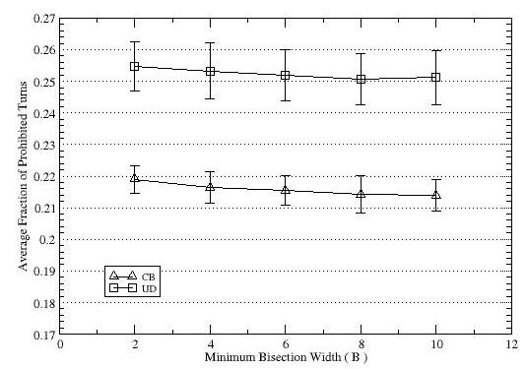
Fig. 8 Average Fraction of Prohibited Turns vs. Minimum Bisection Width B (N =64, d=4)

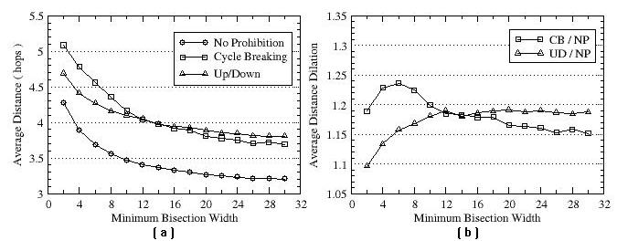
Fig. 9 (a)-Average Distance and (b)-Average Distance Dilation vs. Minimum Bisection Width

References
[1] R. Libeskind-Hadas, D. Mazzoni and R. Rajagopalan "Tree-Based Multicasting in Wormhole-Routed Irregular Topologies," Proceedings of the Merged 12th International Parallel Processing Symposium and the 9th Symposium on Parallel and Distributed Processing pp. 244-249, 1998.
[2] J. Duato, S. Yalamanchili and L. Ni, M. "Interconnection Networks: An Engineering Approach," 1997.
[3] L. Ni, M. and P. McKinley, K. "A Survey of Wormhole Routing Techniques in Directed Networks," Computer vol. 26, pp. 62-76, 1993.
[4] P. Kermani and L. Kleinrock "Virtual Cut-Through: A new Computer Communication Switching Technique," Computer Networks vol. 3, pp. 267-86, 1979.
[5] J. Duato "A New Theory of Deadlock-Free Adaptive Routing in Wormhole Networks," IEEE Trans. on Parallel and Distributed Systems vol. 4, pp. 1320-1331, 1993.
[6] E. Fleury and P. Fraigniaud "A General Theory for Deadlock Avoidance in Wormhole-Routed Networks," IEEE Trans. on Parallel and Distributed Systems vol. 9, pp. 626-638, 1998.
[7] C. Glass and L. Ni "The Turn Model for Adaptive Routing," Journal of ACM vol. 5, pp. 874-902, 1994.
[8] F. Harary "Graph Theory," Addison-Wesley Series in Mathematics -p46, 1998.
[9] L. Zakrevski, S. Jaiswal, L. Levitin and M. Karpovsky "A New Method for Deadlock Elimination in Computer Networks With Irregular Topologies," Proc. of the IASTED Conf. PDCS-99 vol. 1, pp. 396-402, 1999.
[10] L. Zakrevski and M. Karpovsky, G. "Fault-Tolerant Message Routing for Multiprocessors," Parallel and Distributed Processing pp. 714-731, 1998.
[11] B. Ciciani and M. Colajanni, Paolucci, C. "Performance Evaluation of Deterministic Routing in k-ary n-cubes," Parallel Computing no. 24, pp. 2053-2075, 1998.
[12] W. Dally and H. Aoki "Deadlock-Free Adaptive Routing in Multiprocessor Networks Using Virtual Channels," IEEE Trans. on Parallel and Distributed Systems vol. 8, pp. 466-475, 1997.
[13] W. Dally and C. Seitz, L. "Deadlock-Free Message Routing in Multiprocessor Interconnection Networks," IEEE Trans. on Comput. vol. 36, pp. 547-553, 1987.
[14] R. Sivaram, D. Panda and C. Stunkel "Multicasting in Irregular Networks With Cut-Through Switches Using Tree-Based Multidestination Worms," Proc. of the 2nd Parallel Computing, Routing and Communication Workshop , June 1997.
[15] L. Schwiebert "Deadlock-Free Oblivious Wormhole Routing With Cyclic Dependencies," IEEE Trans. on Computers vol. 50, no. 9, pp. 865-876, 2001.
[16] D. Starobinski, M. Karpovsky, and L. Zakrevski “Application of Network Calculus to General Topologies Using Turn-Prohibition,” IEEE/ACM Transactions on Networking, vol. 11, no. 3, June 2003.
[17] N. Christofides "Graph Theory An Algorithmic Approach", 1975.
[18] B. Bollobas "Modern Graph Theory," Graduate Texts in Mathematics vol. 184, 1998.
[19] R. Diestel "Graph Theory", Graduate Texts in Mathematics vol. 173, 2000.
[20] T. H. Cormen, C. E. Leiserson, R. L. Rivest “Introduction to Algorithms”, 1992.

* This work was supported by the NSF under Grant MIP 9630096

