Geophysical Research Letters
Supporting Information for
Large Eddies Regulate Turbulent Flux Gradients in Coupled Stable Boundary Layer
Changxing Lan¹, Heping Liu¹, Gabriel G. Katul^{2,3}, Dan Li⁴, Dennis Finn⁵
1 Laboratory for Atmospheric Research, Department of Civil and Environmental Engineering, Washington State University, Pullman, Washington, USA
2 Nicholas School of the Environment, Duke University, Durham, North Carolina, USA
3 Department of Civil and Environmental Engineering, Duke University, Durham, North Carolina, USA
4 Department of Earth and Environment, Boston University, Boston, Massachusetts, USA
5 NOAA, Air Resources Laboratory, Idaho Falls, Idaho, USA

Contents of this file
Text S1 to S2
Figure S1 to S10
Tables S1 to S3

Introduction
In this document, an example is provided to show how phase difference between two time series variables influence their covariance (i.e., turbulent fluxes). The method used to quantify the phase difference is then introduced. This supplementary also includes maps showing the field site, additional tables and figures about cross-layer differences in variances and fluxes, and additional details about the relations between flux gradients and the phase difference associated with large eddies.

Text S1. Influence of Phase Difference on Turbulent Fluxes

To illustrate the influence of phase difference between two variables on their covariance (i.e., fluxes), we define the fluctuations of the vertical velocity ($w'$) and potential temperature ($θ'$) at two levels to be expressed as:

Level 1: $\left\{\begin{aligned}{w'}_{1}=cos(x) \\ {θ'}_{1}=2cos(x+π/2)\end{aligned}\right.$, (S1)

Level 2: $\left\{\begin{aligned}{w'}_{2}=cos(x) \\ {θ'}_{2}=2cos(x)\end{aligned}\right.$, (S2)

where the subscripts ‘1’ and ‘2’ represent level 1 (Figure S2, a) and level 2 (Figure S2, b), respectively. Equations (S1) and (S2) indicate that the phase difference between ${w'}_{1}$ and ${θ'}_{1}$ equals ${90}^{o}$ (or $\frac{1}{2}π$), whereas ${w'}_{2}$ and ${θ'}_{2}$ are perfectly in-phase (i.e., a zero phase difference). Even though the variances for ${w'}_{1}$ (${θ'}_{1}$) and ${w'}_{2}$ (${θ'}_{2}$) in this example are comparable (i.e., ${σ_{w_{1}}}^{2}=0.51$, ${σ_{w_{2}}}^{2}=0.51$,${σ_{θ_{1}}}^{2}=2.03$, ${σ_{θ_{2}}}^{2}=2.04$), the covariance between ${w'}_{1}$ and ${θ'}_{1}$ is much smaller than that between ${w'}_{2}$ and ${θ'}_{2}$ ($\overline{{w'}_{1}{θ'}_{1}}=-0.23*{10}^{-3}$, $\overline{{w'}_{2}{θ'}_{2}}=1.02$) simply because the phase difference between ${w'}_{1}$ and ${θ'}_{1}$ is larger than that between ${w'}_{2}$ and ${θ'}_{2}$, leading to flux gradients. This result indicates that flux gradients would become larger as the time-series have different fluctuation patterns between layers (i.e., ${w'}_{1}$ and ${θ'}_{1}$ have different phase differences from ${w'}_{2}$ and ${θ'}_{2}$) despite that the magnitudes of their corresponding variances are comparable. Therefore, we employ the phase difference associated with large eddies to quantify the degree of difference in time-series fluctuation patterns across layers and examine their influence on flux gradients.

Text S2. Calculation of Phase Difference Based on Hilbert Transform (HT)

To quantify the phase difference between two different quantities, Hilbert transform (HT) is deemed better suited for processing non-linear and non-stationary turbulence time-series (Huang et al., 1998; Wei et al., 2017). For a time-series $x(t)$, its Hilbert transform may be written as

$\hat{x}(t)=\frac{1}{π}\int_{-∞}^{∞}{\frac{x(τ)}{t-τ}dτ}$. (S3)

In addition, the analytical signal ($x^{A}(t)$) is constructed from the original signal and its Hilbert transform is expressed as

$x^{A}\left(t\right)=x\left(t\right)+i\hat{x}\left(t\right)=A(t)e^{iΦ(t)}$, (S4)

$A(t)={({x\left(t\right)}^{2}+{\hat{x}\left(t\right)}^{2})}^{\frac{1}{2}}$, (S5)

$ϕ(t)=\tan^{-1}(\frac{\hat{x}\left(t\right)}{x(t)})$, (S6)

where $i=\sqrt{-1}$, $A(t)$ and $ϕ(t)$ are the instantaneous amplitude and phase, respectively. Analogous to Fourier and wavelet cross spectrum, the Hilbert cross-spectrum of two series $x\left(t\right)$ and $y\left(t\right)$ is defined as

${HCS}^{xy}\left(t\right)=x^{A*}\left(t\right)*y^{A}\left(t\right)$, (S7)

where the superscript * denotes complex conjugation. The instantaneous phase difference between these two time-series is calculated as

$Φ(t)=\tan^{-1}(\frac{Im[{HCS}^{xy}\left(t\right)]}{Re[{HCS}^{xy}\left(t\right)]})$, (S8)

where $Re$ and $Im$ represent the real and imaginary parts of the Hilbert cross-spectrum, respectively.

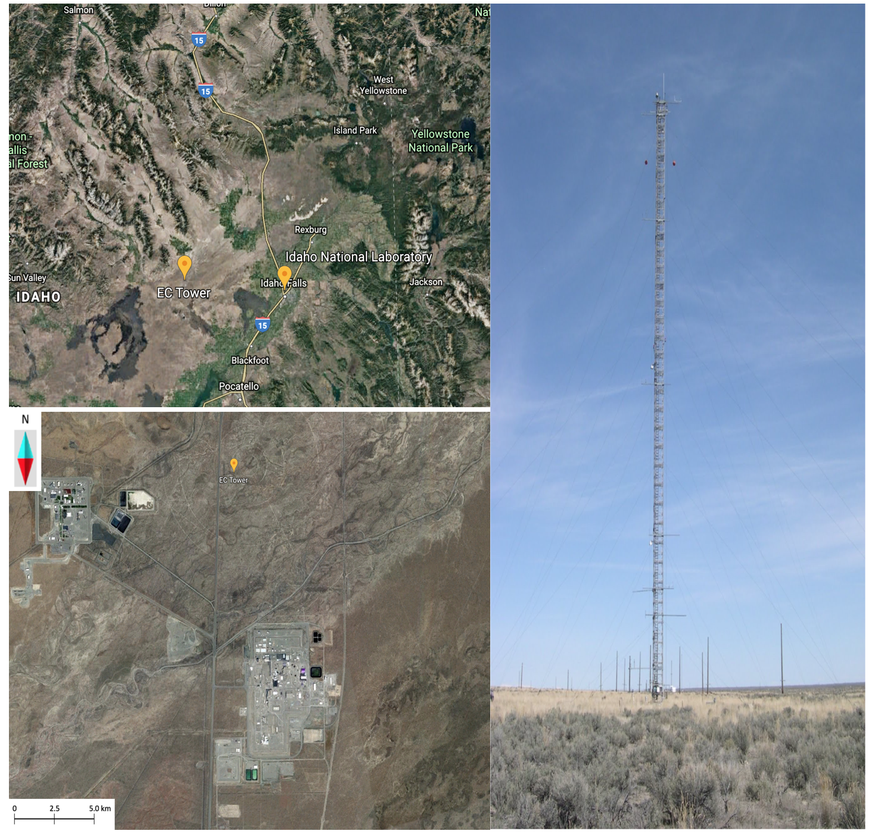

Figure S1. Google Earth map of the Project Sagebrush experiment site at Idaho National Laboratory (INL). The picture in the upper left panel shows an overview of the surrounding topography with the resolution of 50 km, the picture in the lower left panel shows the condition of the underlying surface, and the picture in the right panel shows the 62-m meteorological tower looking from the east.

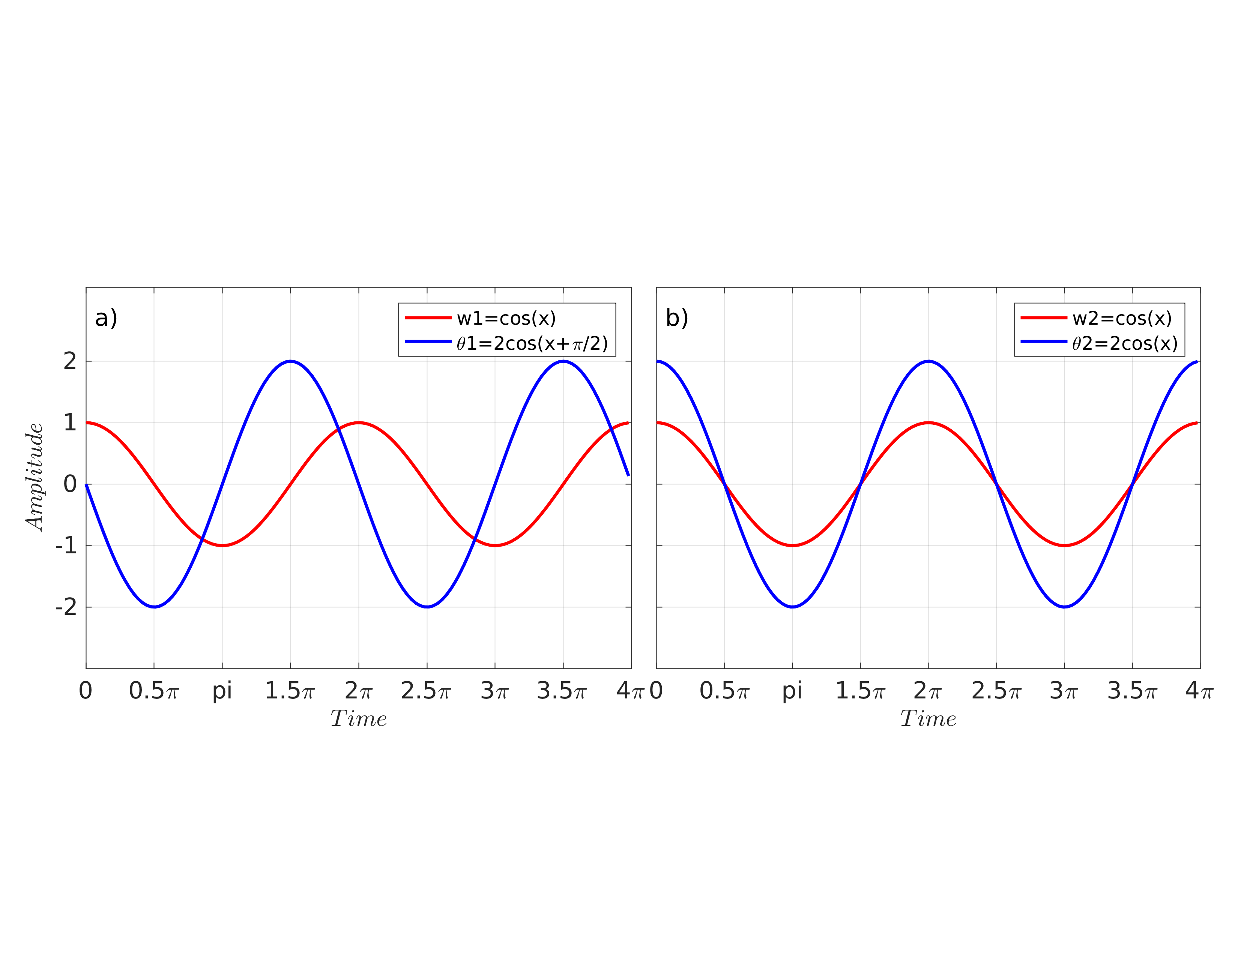

Figure S2. An example showing how the phase difference between vertical velocity ($w$) and potential temperature ($θ$) influences covariance. a) and b) represent observation level 1 and level 2, respectively.

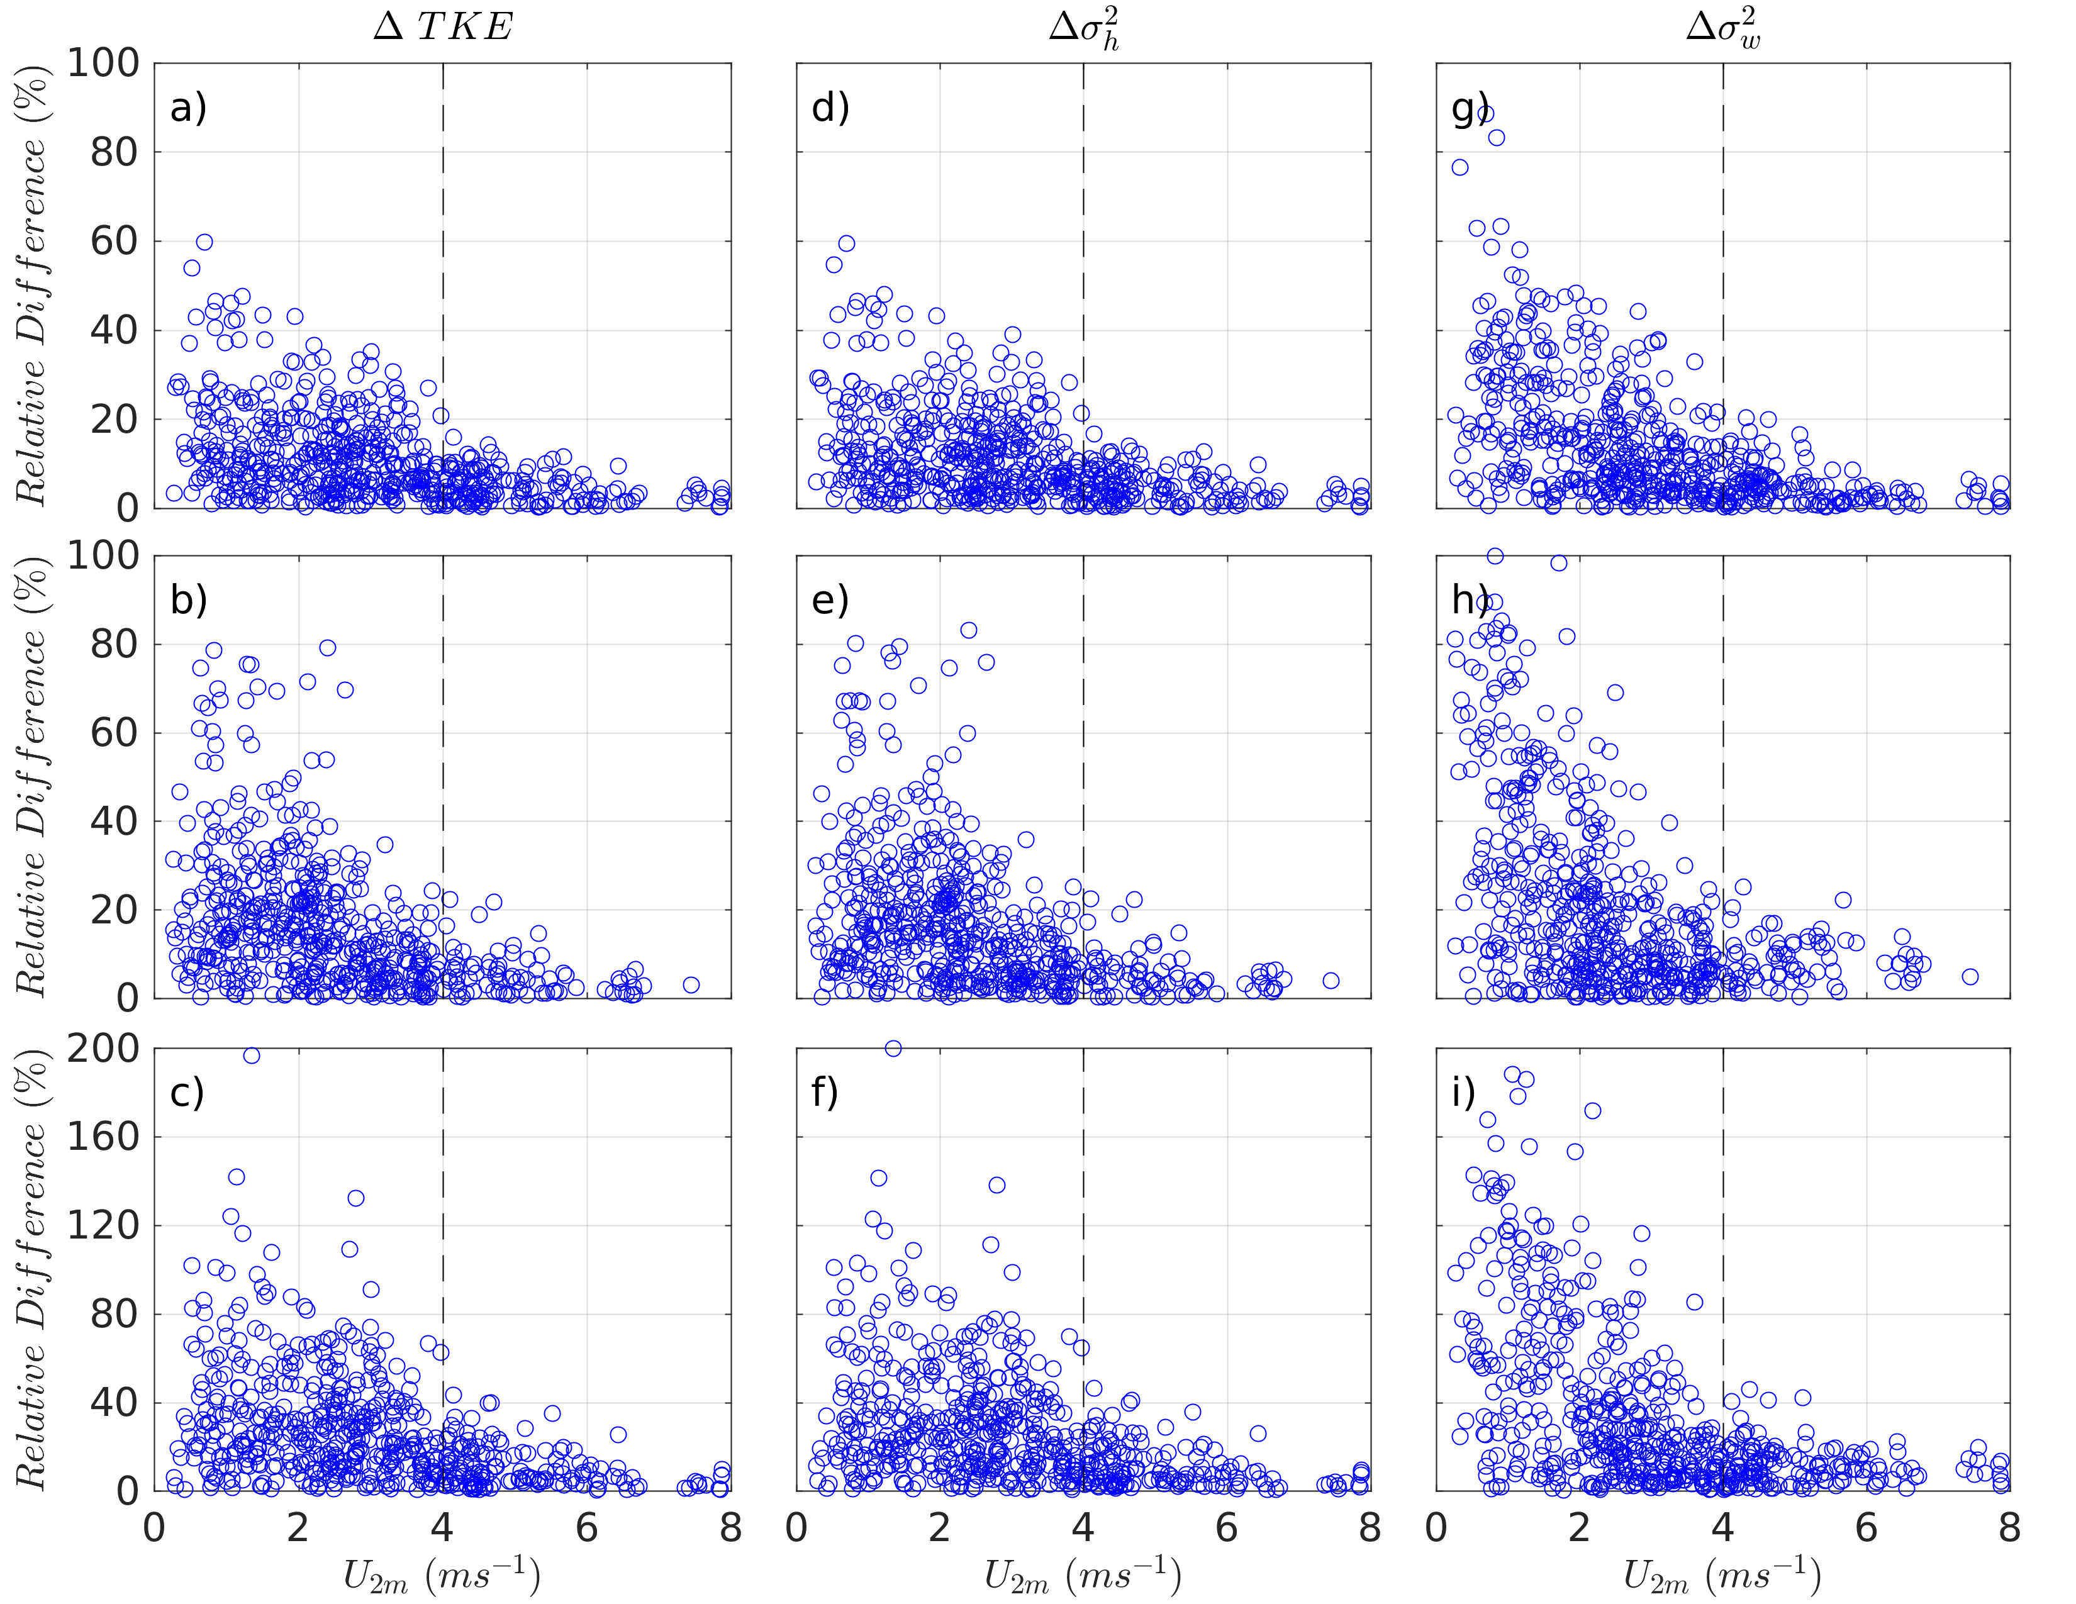

Figure S3. Cross-layer relative difference of TKE (a, b, c), horizontal component of TKE (${σ_{h}}^{2}$) (d, e, f), and vertical component of TKE (${σ_{w}}^{2}$) (g, h, i) as a function of mean wind speed at 2 m in the SBL with different coupling states. Panels from top to bottom correspond to results between 16 and 8 m, 8 and 2 m, and 16 and 2 m, respectively. The vertical dash lines denote the wind speed threshold separating the coupled and decoupled SBL states.

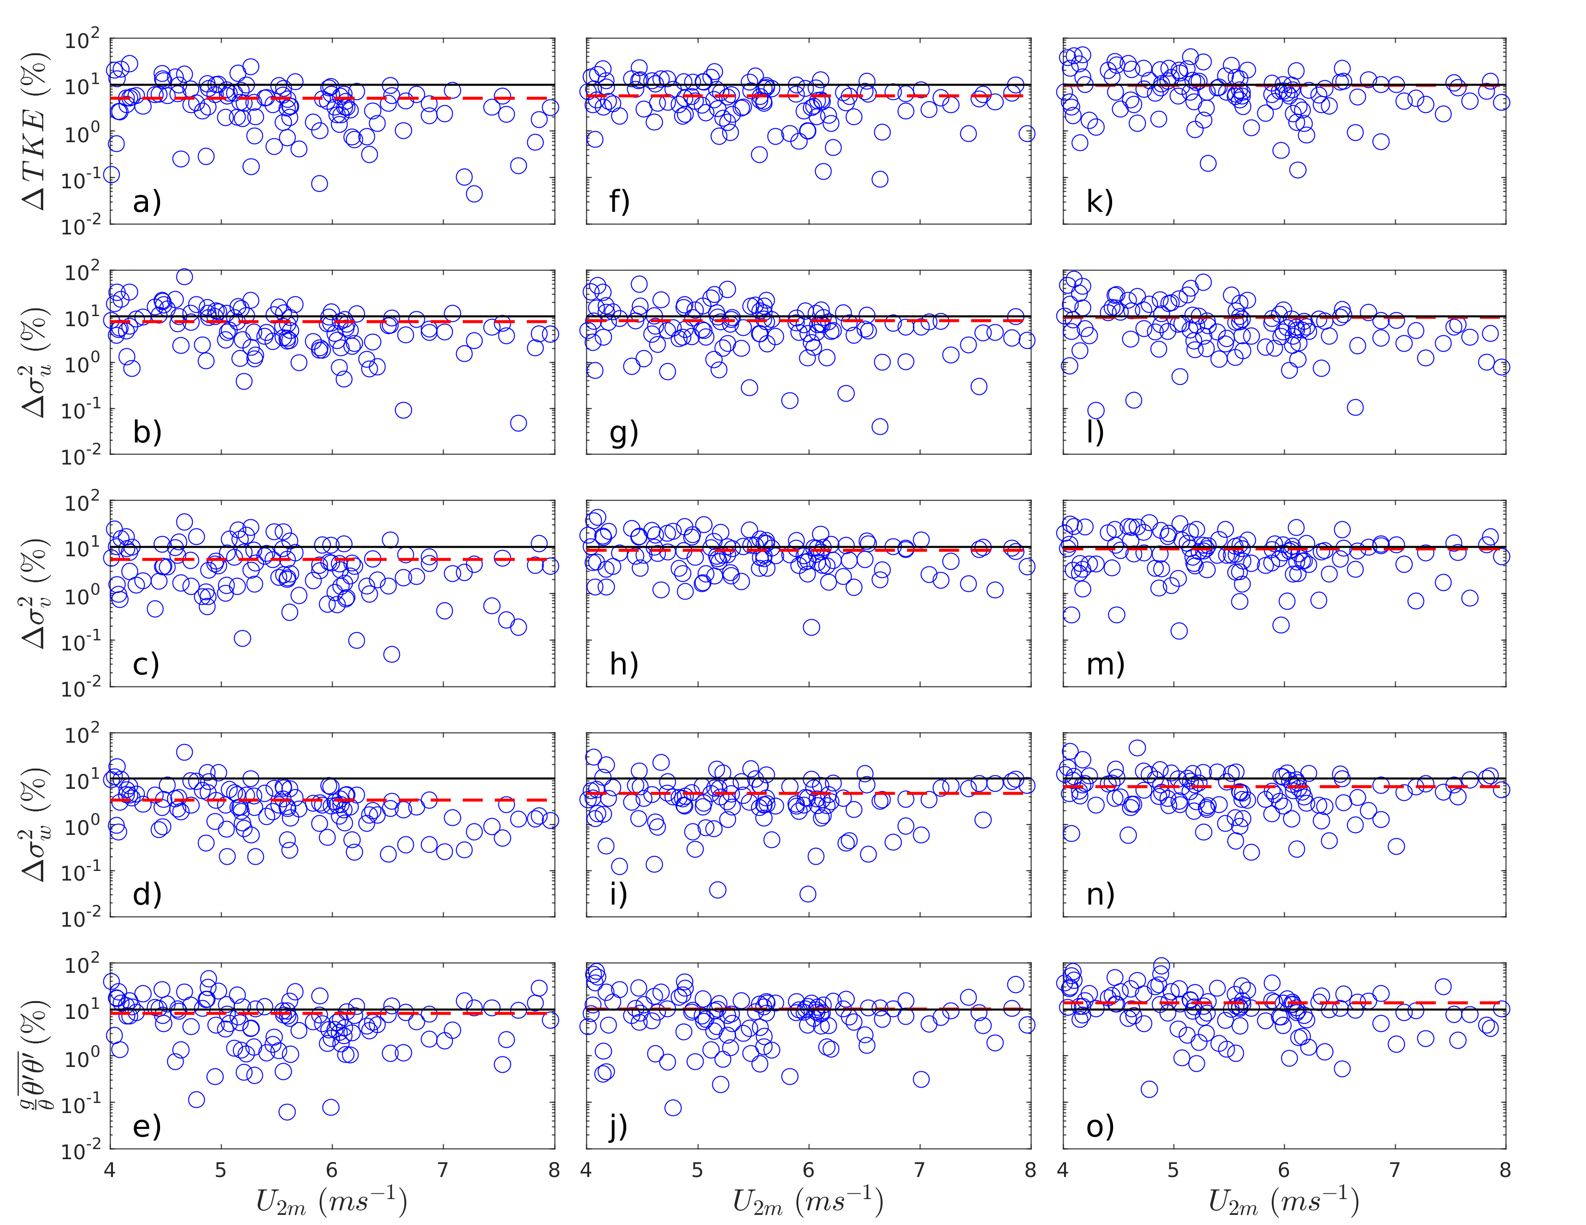

Figure S4. Cross-layer relative difference in the second-order turbulence statistics as a function of mean wind speed at 2 m ($U_{2m}$) in the coupled SBL. Panels from leftmost to rightmost correspond to results between 16 and 8 m (a ~ e), 8 and 2 m (f ~ j), and 16 and 2 m (k ~ o), respectively. The horizontal black solid lines represent the 10 % reference line associated with the conventional threshold value of flux divergence (or convergence). The red horizontal dash lines denote the mean relative difference in the coupled SBL.

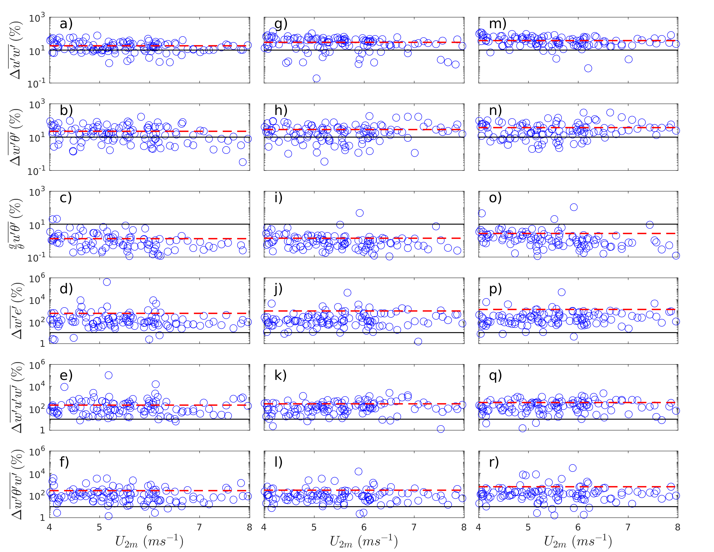

Figure S5. Cross-layer relative difference in the third-order turbulence statistics as a function of mean wind speed at 2 m ($U_{2m}$) in the coupled SBL. Panels from leftmost to rightmost correspond to results between 16 and 8 m (a ~ f), 8 and 2 m (g ~ l), and 16 and 2 m (m ~ r), respectively. The horizontal black solid lines represent the 0.1 reference line taken as the threshold value of flux divergence (or convergence). The horizontal red dash lines denote the mean relative differences in the coupled SBL.

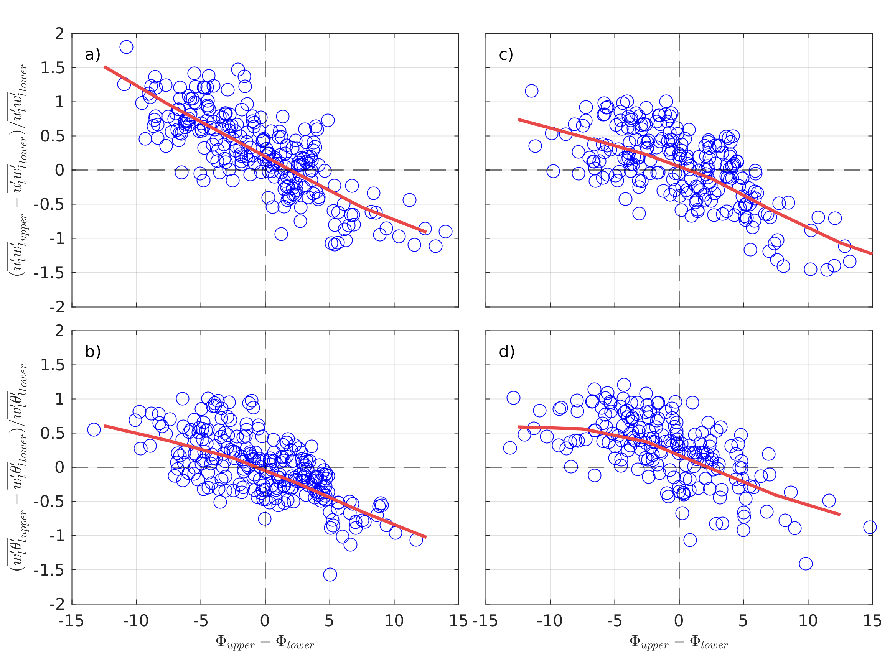

Figure S6. Variations of divergence (or convergence) of momentum flux (a and c) and kinematic heat fluxes (b and d) with cross-layer differences in the phase between vertical velocity ($w'$) and horizontal velocity ($u'$) or potential temperature ($θ'$). Left (a and b) and right (c and d) panels correspond to the results between 16 and 8 m (a and b) and 8 and 2 m (c and d), respectively. The red fitting curves are calculated with the unweighted bin-averaged method with a bin-width of 1 degree.

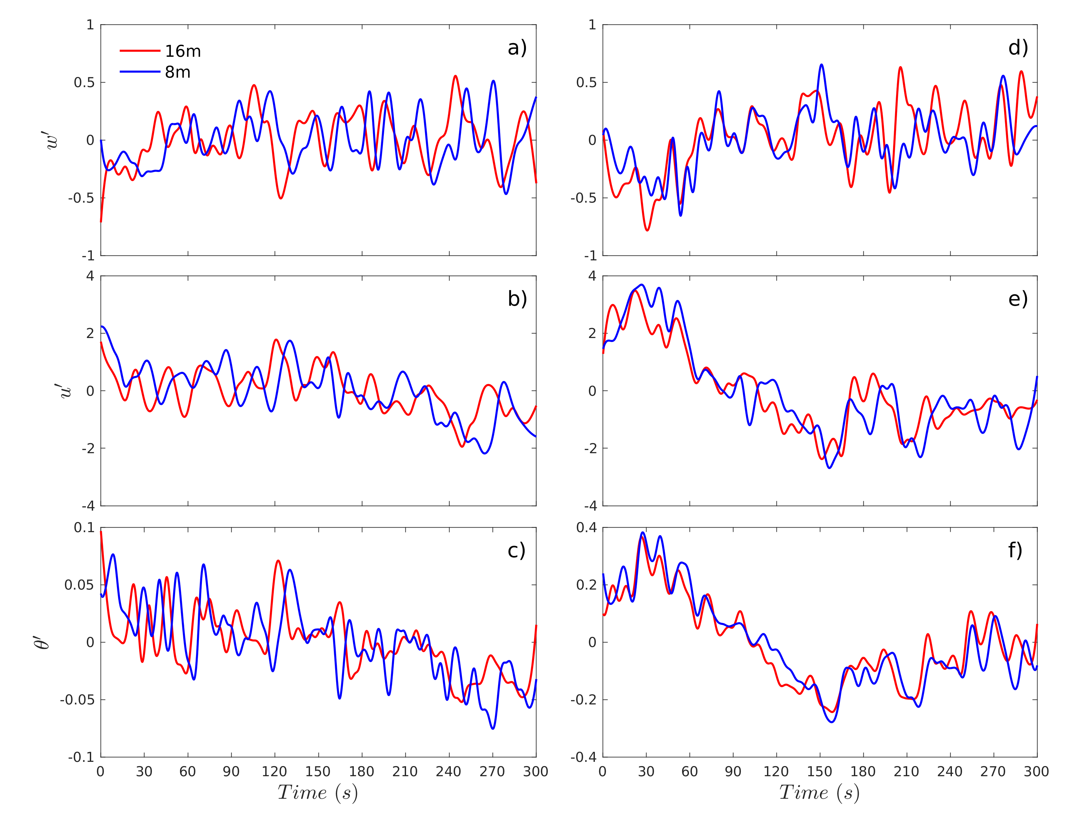

Figure S7. The 5-min, time series of $w^{'}$ (a, d), $u^{'}$ (b, e), and $θ^{'}$ (c, f) caused by large eddies for the flux divergence case (FD, left panels; 1955 - 2005 MST on October 30, $U_{2m}=6.4 m s^{-1}$) and no flux divergence case (NFD, right panels; 1930 - 1935 MST on October 3, $U_{2m}=4.5 m s^{-1}$) in the coupled SBL. Red and blue lines represent 16 and 8 m, respectively. In both cases, the cross-layer differences of $σ_{u}$, $σ_{w}$, and $σ_{θ}$ are less than 0.1, indicating a coupled SBL. For both the FD and NFD case, the fluctuation patterns of $w'$ at the two heights are similar, as indicated by the similar peaks and valleys given some time lags caused by the downward travels of large eddies. However, the cross-layer fluctuation patterns for $u'$ and $θ'$ differ in the FD case (e.g., the even opposite fluctuations around 120 ~ 160 s). It suggests that although different layers are subjected to the influence of same large eddies, the fluctuation patterns can still be distinct due to the height-varying wind and temperature profiles. For the NFD case, not only the fluctuation patterns of $w'$ but also the fluctuation patterns of $u'$ and $θ'$ are similar between layers, resulting in the negligible flux divergence and thus a “perfectly” coupled SBL. As summarized at Table S2, the signs for the mean fluctuation intensities of $u'$ and $θ'$ ($\overline{u'}$ and $\overline{θ'}$) are opposite in the FD case, caused by the possibly distorted wind and temperature profiles, leading to a great magnitude of flux divergence.

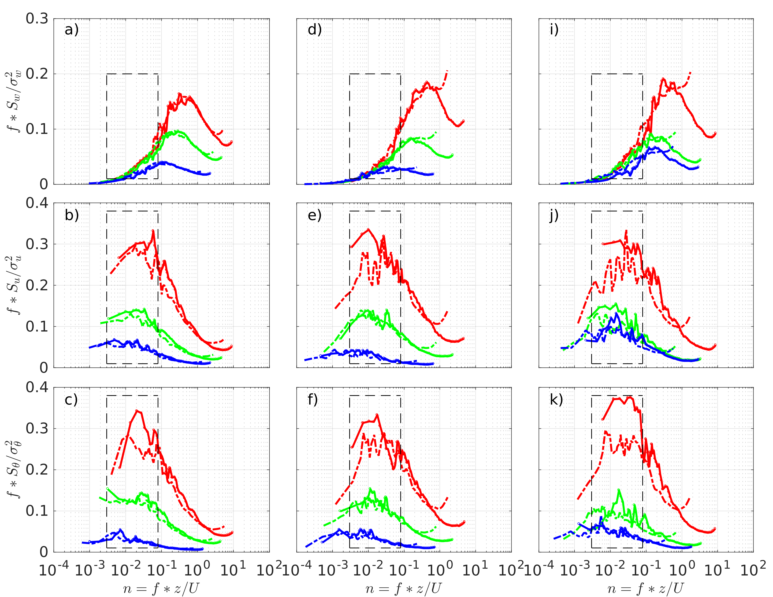

Figure S8. Normalized averaged spectra and cospectra of $w'$, $u'$, and $θ'$ for different ranges of the cross-layer phase angle difference ($\left|∆Φ\right|$). To provide a manageable and representative analysis of the link between the cross-layer phase difference and the fluctuation pattern of large eddies, the data are divided into three groups according to the ranges of the cross-layer phase angle difference (($\left|ΔΦ\right|=$0 ~ 4, 4 ~ 8, and 8 ~ 15 degrees, respectively). Blue, green, and red lines represent the cross-layer phase angle difference ranging from 0 ~ 4, 4 ~ 8, and 8 ~ 15 degrees, respectively. Solid and dash lines represent the upper and lower levels, respectively (i.e., a ~ c, d ~ f, and g ~ i correspond to 16 and 8 m, 8 and 2 m, and 16 and 2 m, respectively). Spectrum for each 5-min run is normalized by its variance at the corresponding height before averaging. With the comparable values for the variance of $σ_{w}$ between layers, the $w'$ spectra at two heights are almost overlapped even though $\left|ΔΦ\right|$ is large, indicating that these two layers are under the influence of same downward penetrating eddies. For $u'$ and $θ'$, the spectra between two layers show large differences with an increased $\left|ΔΦ\right|$, especially in the low-frequency range (emphasized by rectangles). It confirms that the different fluctuation patterns in $u'$ and $θ'$ between layers have influence on the cross-layer phase differences, thus leading to the flux divergence (or convergence) in the coupled SBL.

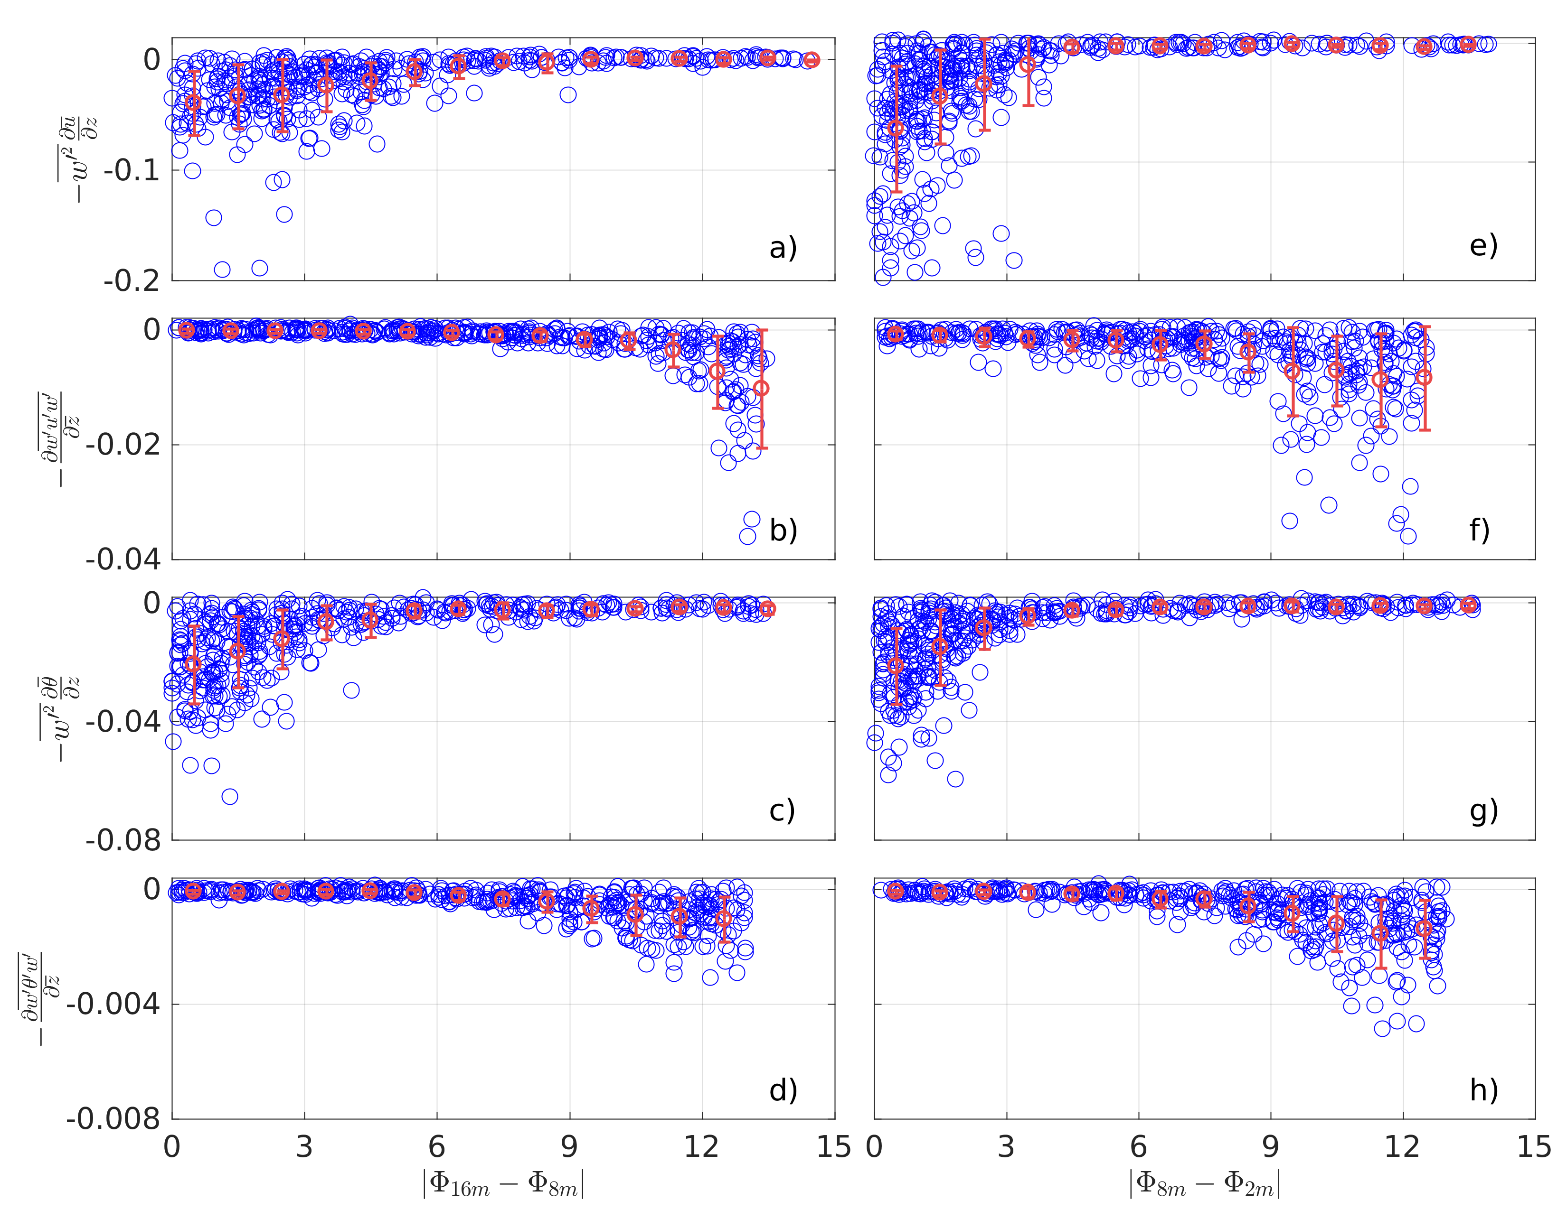

Figure S9. Variations of the turbulent production term (a, c, e, and g) and flux transport term (b, d, f, and h) with the cross-layer differences in phase between vertical velocity ($w'$) and horizontal velocity ($u'$) or potential temperature ($θ'$). Left (a ~ d) and right (e ~ h) panels show the terms associated with momentum and kinematic heat fluxes, respectively. The red circles and error bars refer to the bin averages and corresponding standard deviations, respectively. To emphasize the influence of large eddies on cross-layer transport, the time series associated large eddies are used for calculating the third-order terms in equations (7) and (8) (i.e., $\frac{∂\overline{{w_{l}}^{'}{u_{l}}^{'}{w_{l}}^{'}}}{∂z}$ and $\frac{∂\overline{{w_{l}}^{'}{θ_{l}}^{'}{w_{l}}^{'}}}{∂z}$), while the original time series are used for calculating the turbulence production term.

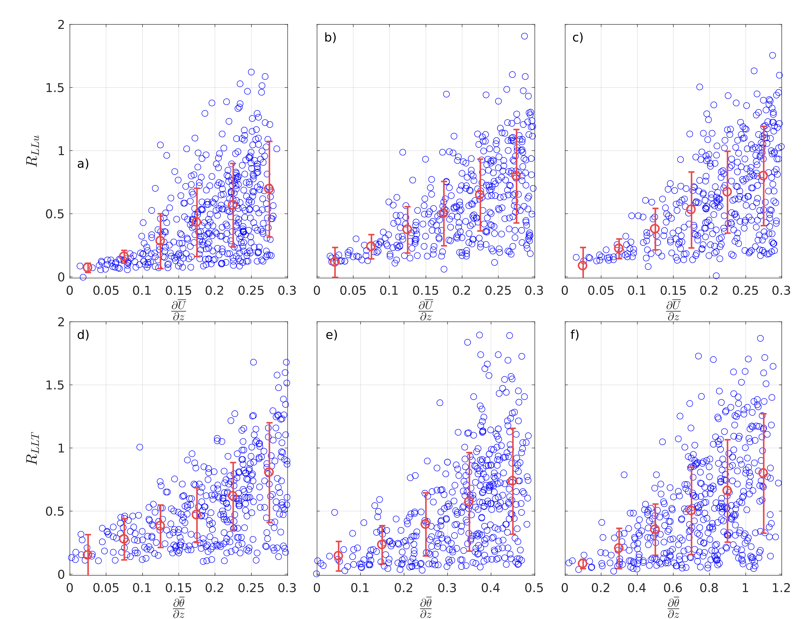

Figure S10. Variations of the ratios of momentum (a, b, c) and kinematic heat flux (d, e, f) transport and production terms ($R_{LLu}=-\frac{∂\overline{w^{'}u^{'}w^{'}}}{∂z}/(-\overline{{w^{'}}^{2}}\frac{∂\overline{u}}{∂z})$, $R_{LLT}=-\frac{∂\overline{w^{'}θ^{'}w^{'}}}{∂z}/(-\overline{{w^{'}}^{2}}\frac{∂\overline{θ}}{∂z}$)) with the vertical gradients of mean wind speed and temperature, respectively. Panels from leftmost to rightmost represent the results between 16 and 8 m, between 8 and 2 m, and between 16 and 2 m, respectively. The red circles and error bars refer to the bin averages and corresponding standard deviations, respectively.

 | $$∆TKE$$ | $$∆\overline{{u'}^{2}}$$ | $$∆\overline{{v'}^{2}}$$ | $$∆\overline{{w'}^{2}}$$ | $$∆\overline{\frac{g}{θ}{θ'}^{2}}$$ | $$∆\overline{u'w'}$$ | $$∆\overline{w'θ'}$$ | $$∆\overline{\frac{g}{θ}u'θ'}$$ | $$∆\overline{w'e'}$$ | $$∆\overline{w'u'w'}$$ | $$∆\overline{w'θ'w'}$$
16~8 | 5 | 6 | 5 | 3 | 8 | 18 | 22 | 1 | 279 | 197 | 944
8~2 | 6 | 8 | 8 | 5 | 10 | 30 | 28 | 1 | 295 | 253 | 944
16~2 | 10 | 9 | 9 | 7 | 14 | 37 | 39 | 3 | 603 | 328 | 1308

Table S1. Mean values of relative difference of second-order and third-order turbulence statistics between 16 and 8 m, 8 and 2 m, and 16 and 2 m.

 |  | $$σ_{w}^{2}$$ | $$σ_{u}^{2}$$ | $$σ_{T}^{2}$$ | $$\overline{{u'w}^{'}}$$ | $$\overline{w'θ'}$$
Flux Divergence Case (FD) | 16 m | 0.51 | 1.01 | 0.05 | -0.40 | -0.04
 | 8 m | 0.53 | 1.09 | 0.06 | -0.19 | -0.03
 | $$diff\left(16,8\right)$$ | 4 | 7 | 7 | 110 | 66
No Flux Divergence Case (NFD) | 16 m | 0.77 | 1.54 | 0.20 | -0.21 | -0.01
 | 8 m | 0.71 | 1.44 | 0.20 | -0.22 | -0.01
 | $$diff(16,8)$$ | 9 | 7 | 5 | 6 | 8

Table S2. Variances of vertical velocity ($σ_{w}^{2}$), horizontal velocity ($σ_{u}^{2}$), temperature ($σ_{T}^{2}$), momentum flux ($\overline{{u'w}^{'}}$), and kinematic heat flux ($\overline{w'T'}$) at 16 and 8 m for the flux divergence case (FD) and no flux divergence case (NFD). $diff$ represents cross-layer relative difference calculated by equation (4).

 | $${u_{l}}^{'}$$ | $${w_{l}}^{'}$$ | $${θ_{l}}^{'}$$ | $${u_{l}}^{'}{w_{l}}^{'}$$ | $${w_{l}}^{'}{θ_{l}}^{'}$$
$Tlag(16,08)$ (s) | -45.3 | -12.1 | -41.3 | -23.4 | -16.5
$Tlag(08,02)$ (s) | -11.3 | -6.2 | -16.8 | -8.0 | -12.7
$Tlag(16,02)$ (s) | -58.3 | -16.5 | -53.2 | -29.2 | -37.8

Table S3. Mean values of the largest time lag between turbulence fluctuation times series across layers.

