Supporting Information for
Attribution of local temperature response to deforestation
Weilin Liao^{1,2}, Angela J. Rigden³, Dan Li²
¹School of Geography and Planning, Sun Yat-sen University, Guangzhou, China
²Department of Earth and Environment, Boston University, Boston, Massachusetts, USA
³Department of Earth and Planetary Sciences, Harvard University, Cambridge, Massachusetts, USA

Contents of this file
Test S1
Figures S1-S10

Text S1: Sensitivity to the emissivity value of grassland
We explore the sensitivity of the attribution results to the emissivity value of grassland at the four pairs. With an increase of the emissivity value of grassland from 0.92 to 0.96, the LST change induced by deforestation decreases (c.f. Figure S9 and Figure 3, Figure S10 and Figure 4). We find that this change of emissivity value leads to no valid data points at the Duke sites during the nighttime in summer because all the inferred ($T_{s}-T_{a}$) have the opposite sign as the measured sensible heat flux. Thus, the inferred aerodynamic resistance becomes negative and physically meaningless. However, the conclusions related to the attribution still hold, suggesting that although the inferred LSTs are sensitive to the emissivity value, the conclusions about the attribution are not.

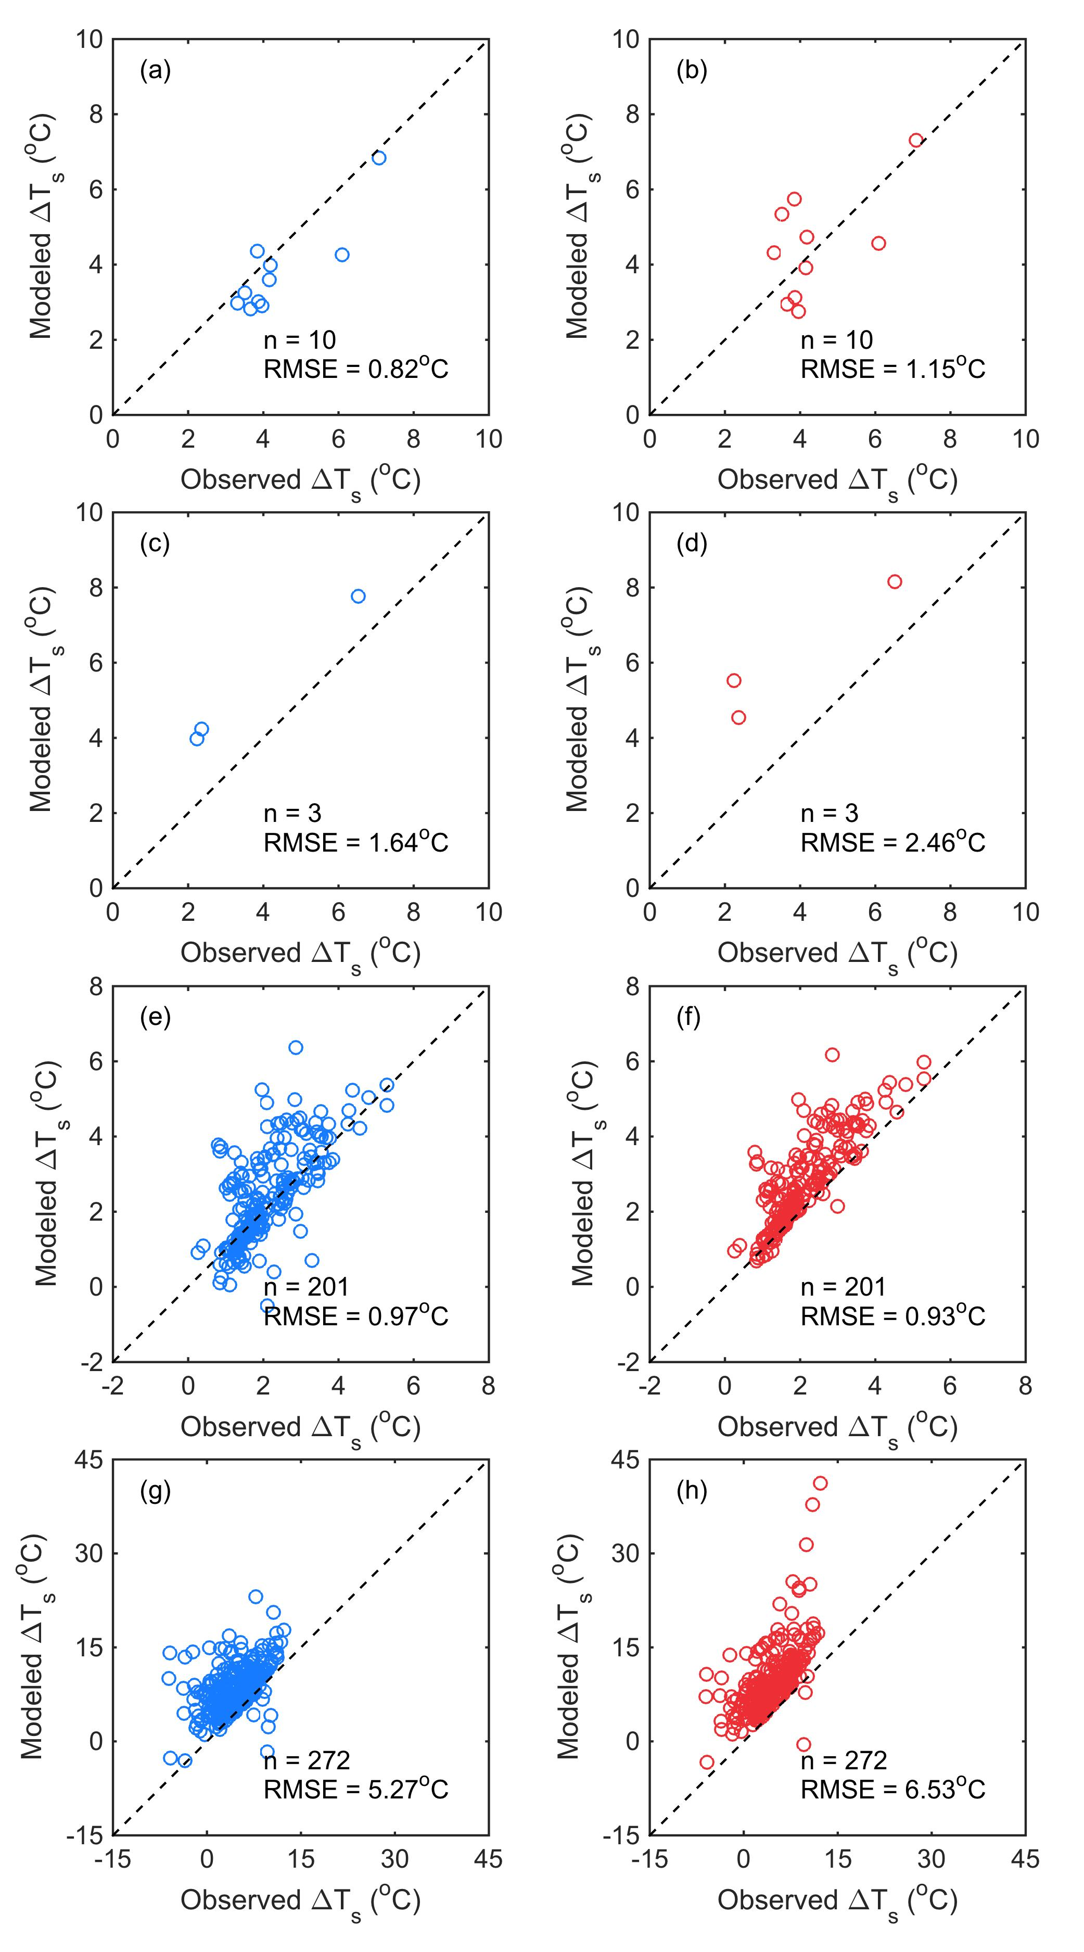

Figure S1. Comparisons between the observed ${∆T}_{s}$ and the modeled ${∆T}_{s}$ during the daytime in summer at (a, b) pair 1, (c, d) pair 2, (e, f) pair 3, and (g, h) pair 4 when applying the models at the half-hourly scale and then aggregating the attribution results to the daily scale. The left panels use the IBM method, and the right panels use the TRM method. RMSE donates the root-mean-square error between the observed ${∆T}_{s}$ and the modeled ${∆T}_{s}$ at the daily scale, while n denotes the number of valid points used to attribution. The dashed lines are 1:1 lines.
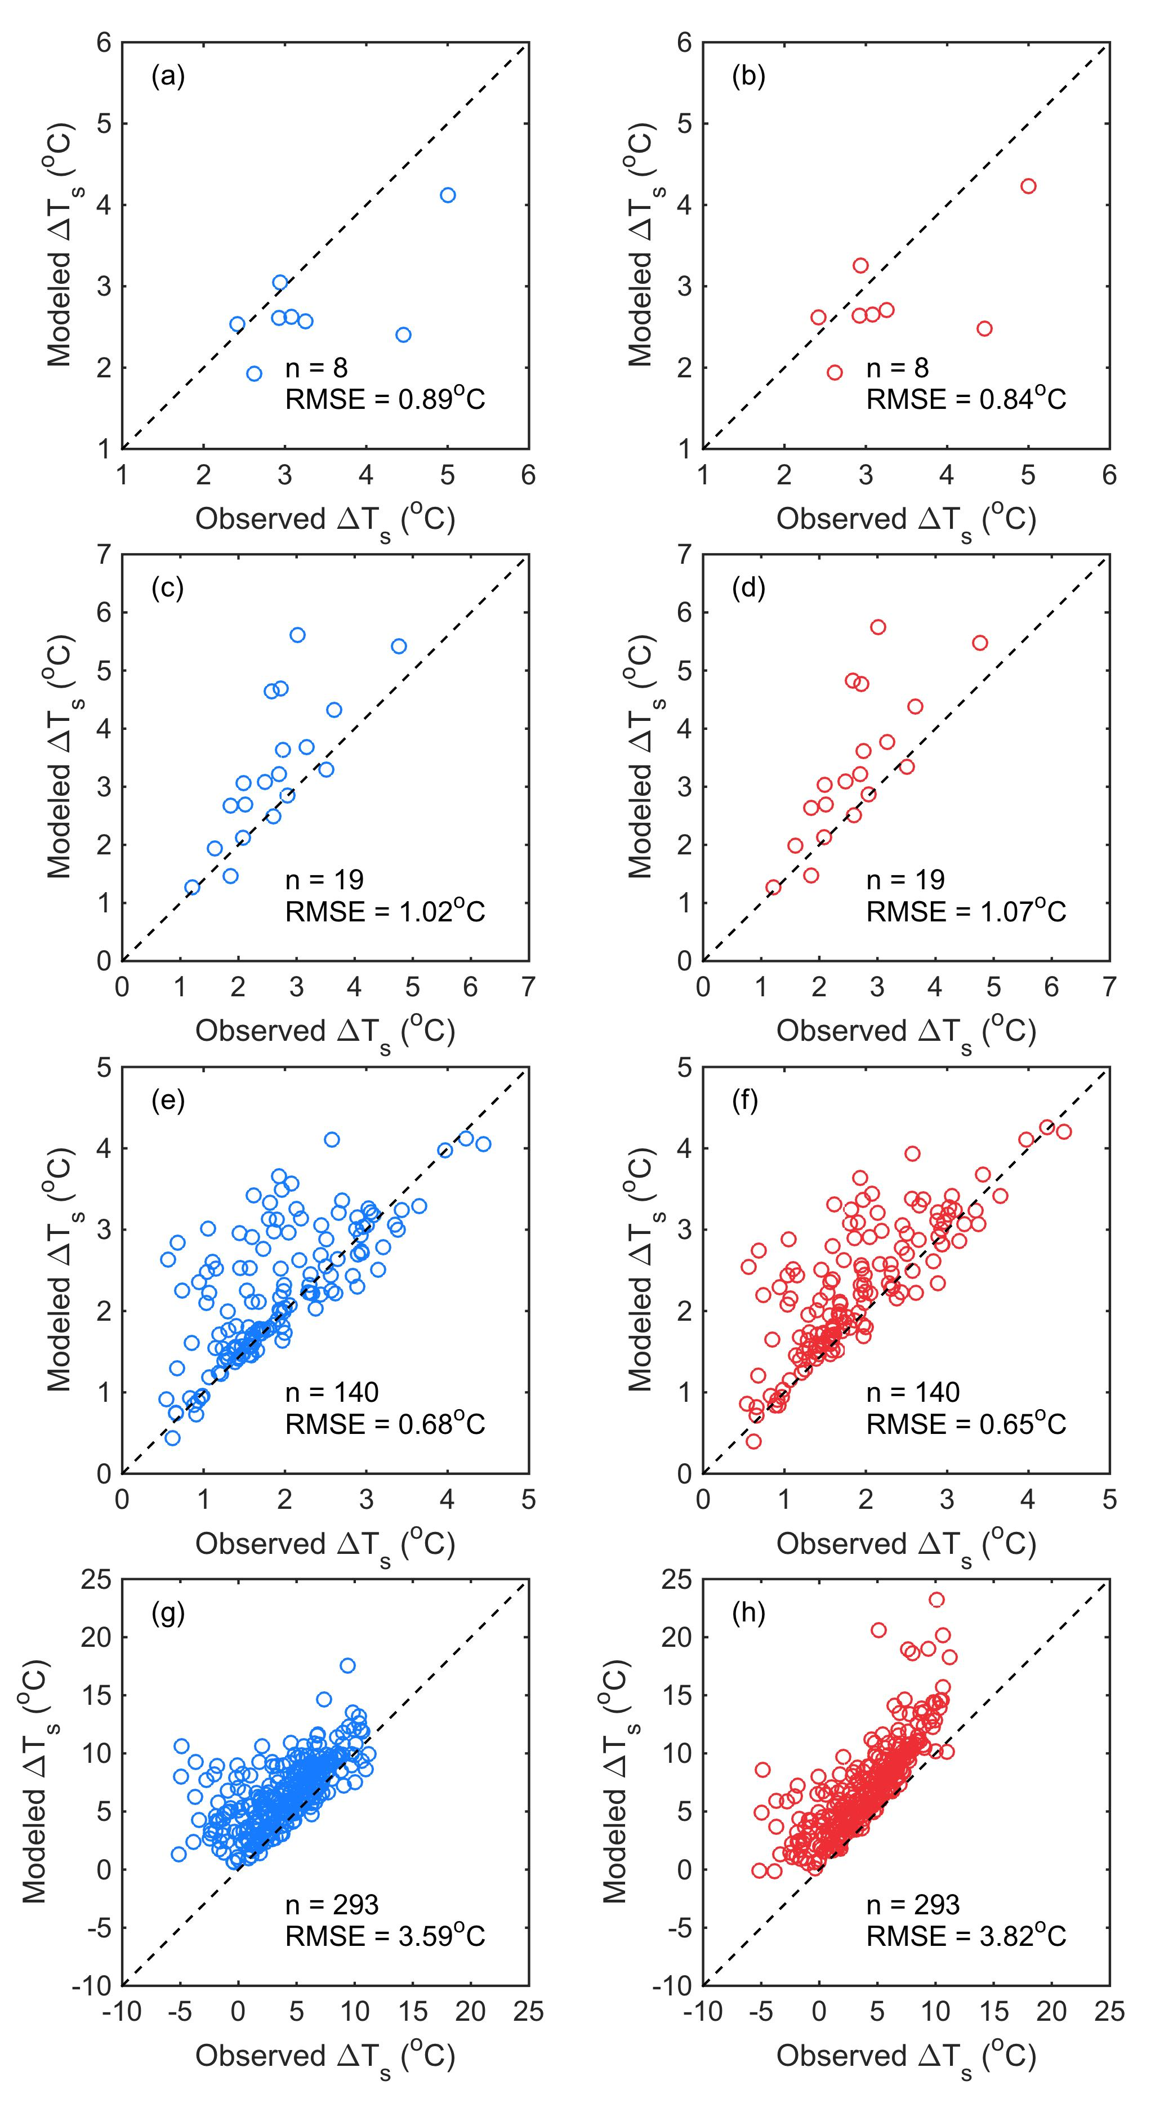

Figure S2. Same as figure S1 but applying the models at the daily scale by first aggregating the input variables.
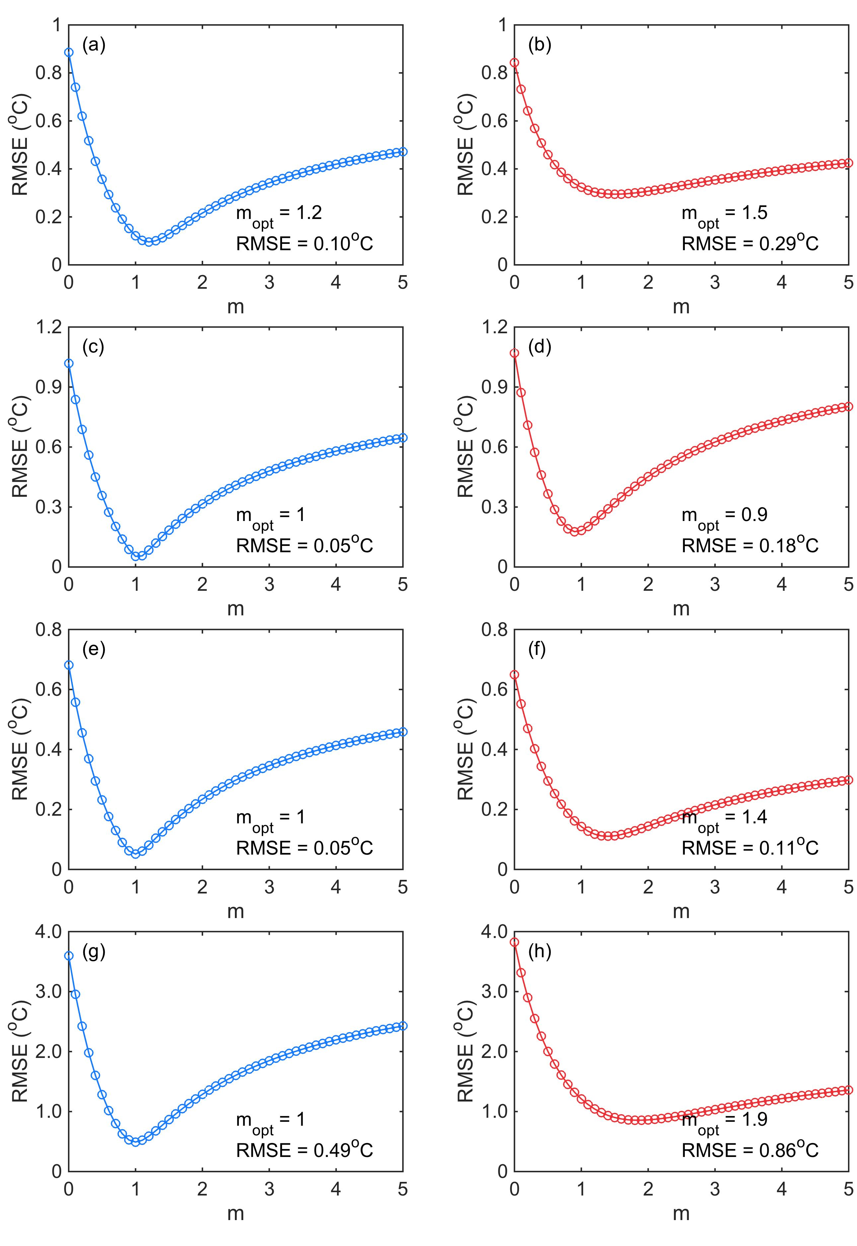
Figure S3. The optimization of m to calculate the derivative terms in the models during the daytime in summer at (a, b) pair 1, (c, d) pair 2, (e, f) pair 3, and (g, h) pair 4. The left panels use the IBM method, and the right panels use the TRM method. $m_{opt}$ is the optimal value for m.

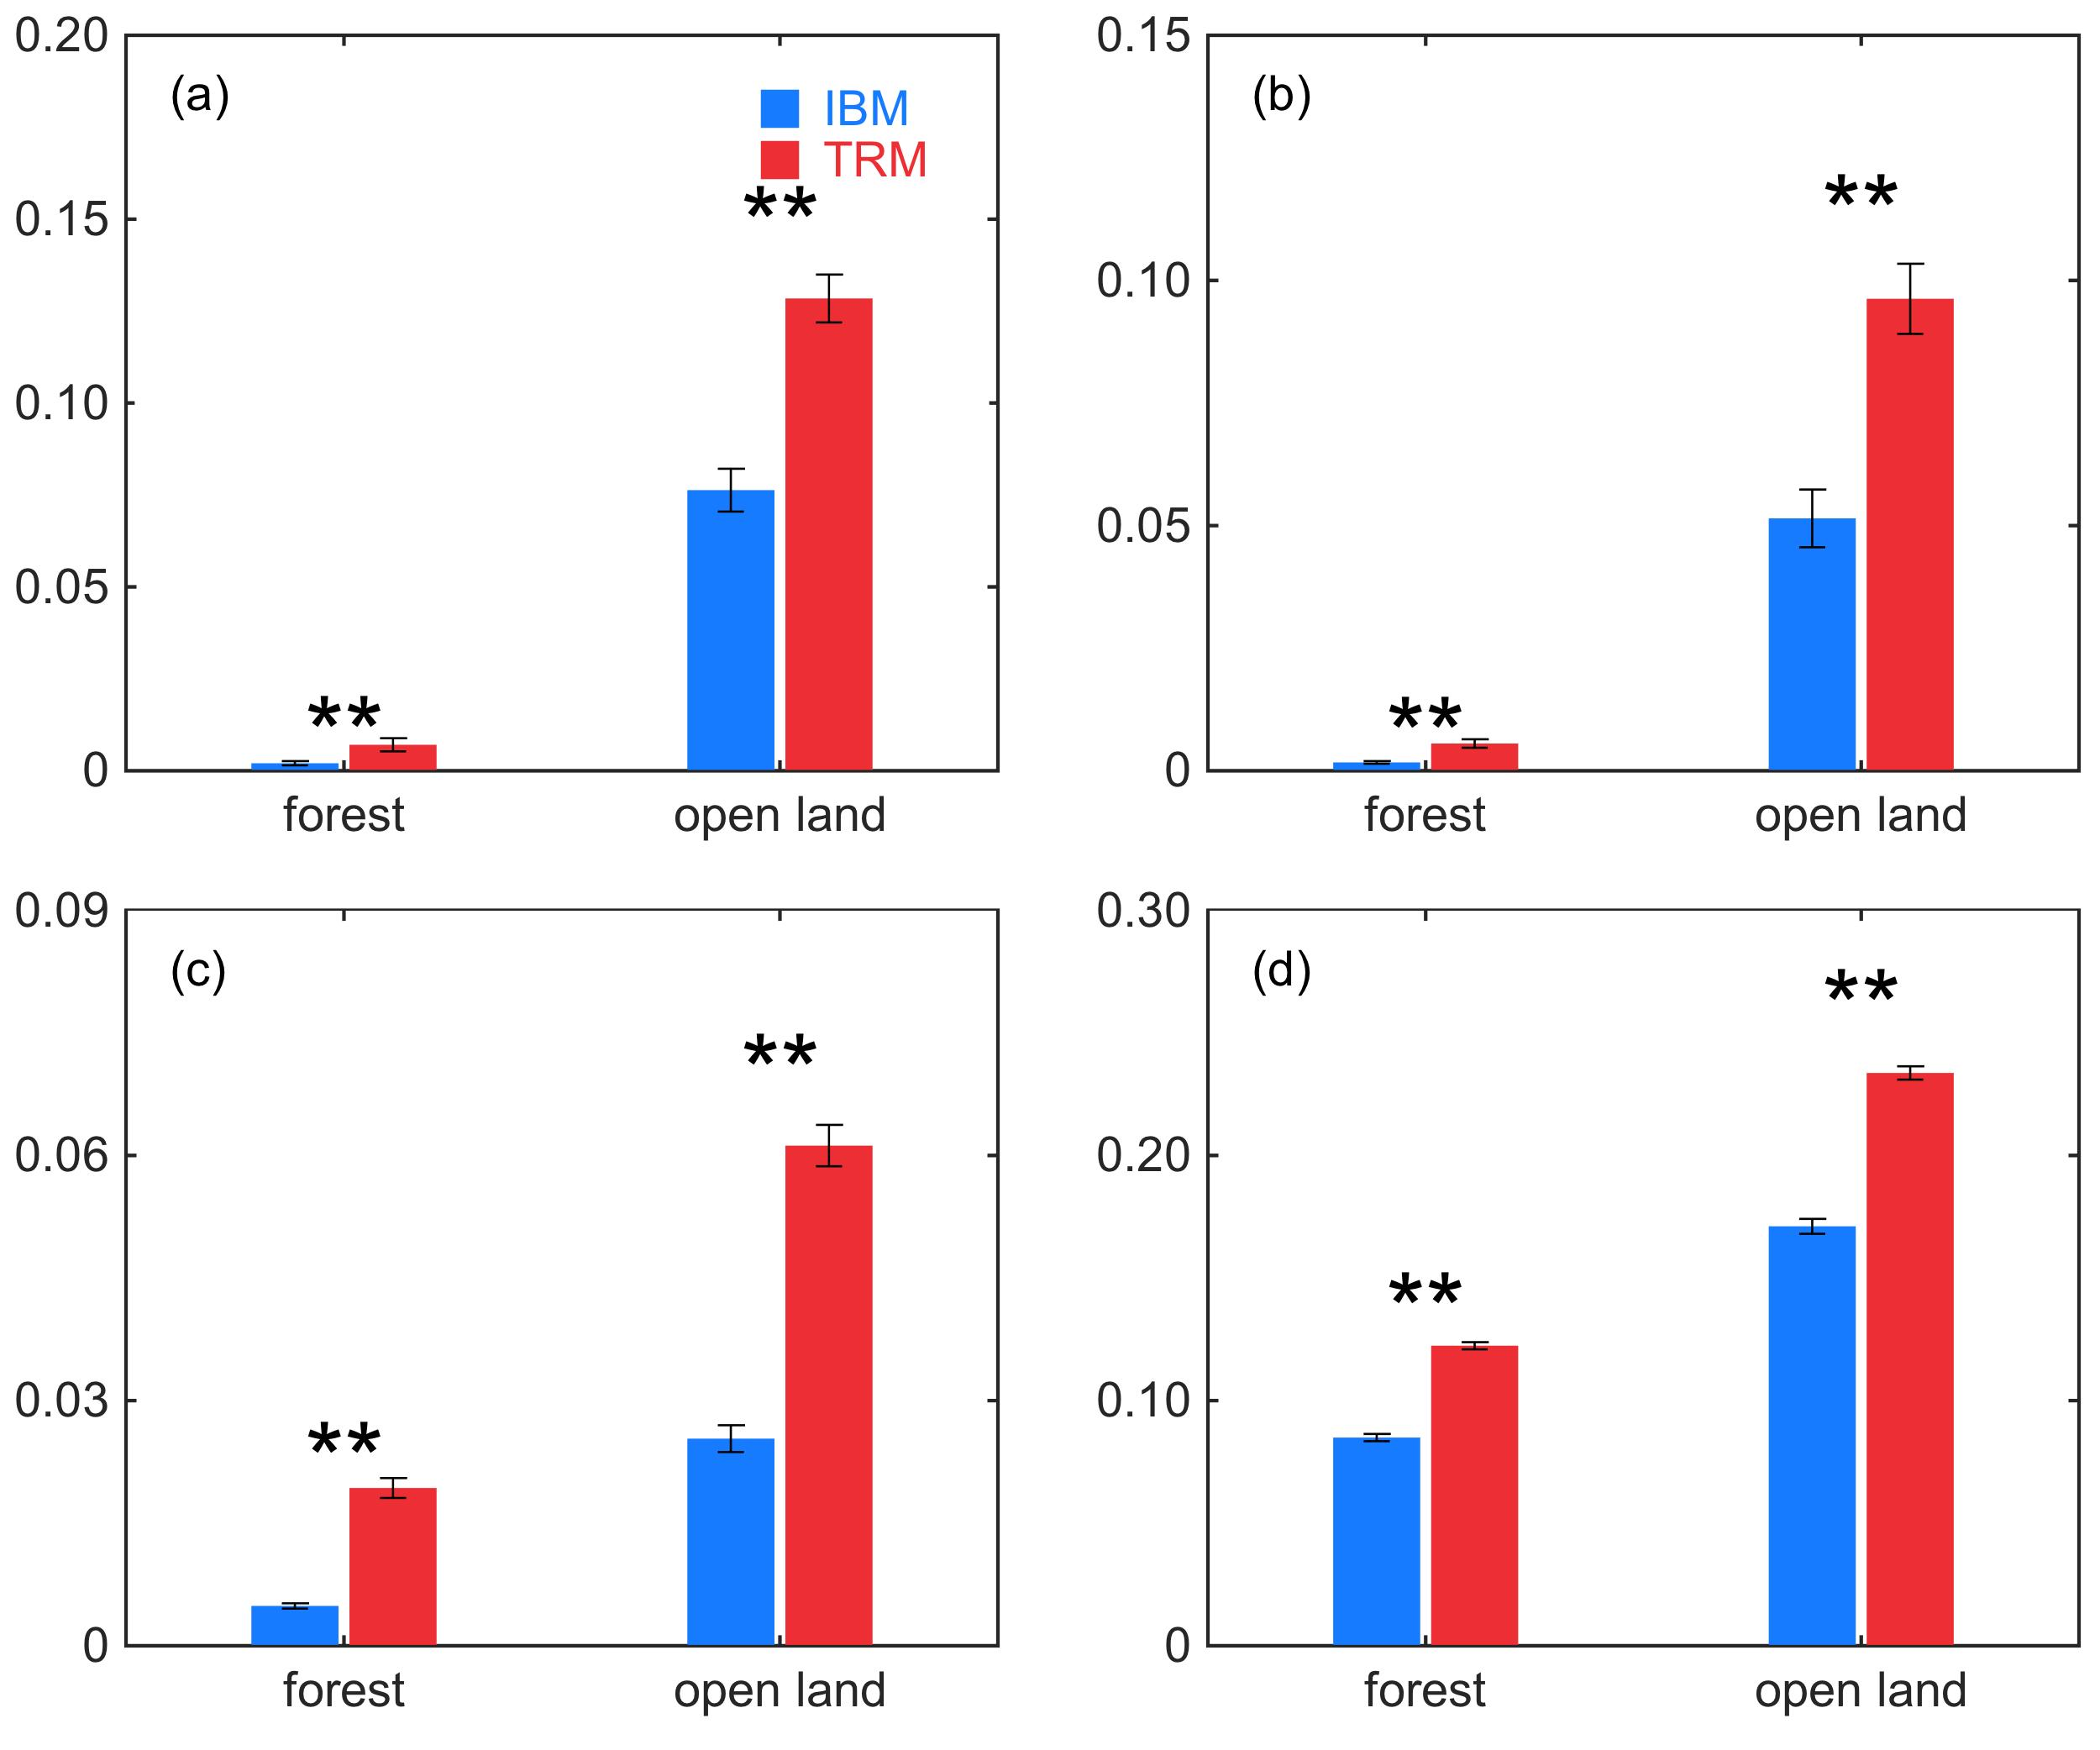
Figure S4. The value of $1/\left(1+f\right)$ for the forest site and the open land site at (a) pair 1, (b) pair 2, (c) pair 3, and (d) pair 4 during the daytime in summer. The blue bars denote values calculated by the IBM method, whereas the red bars denote values calculated by the TRM method. Error bars are given as the standard deviation of the mean. The ** indicates that the mean values of $1/\left(1+f\right)$ calculated by the two methods are significantly different at the 95% confidence level in a two-sample t-test.

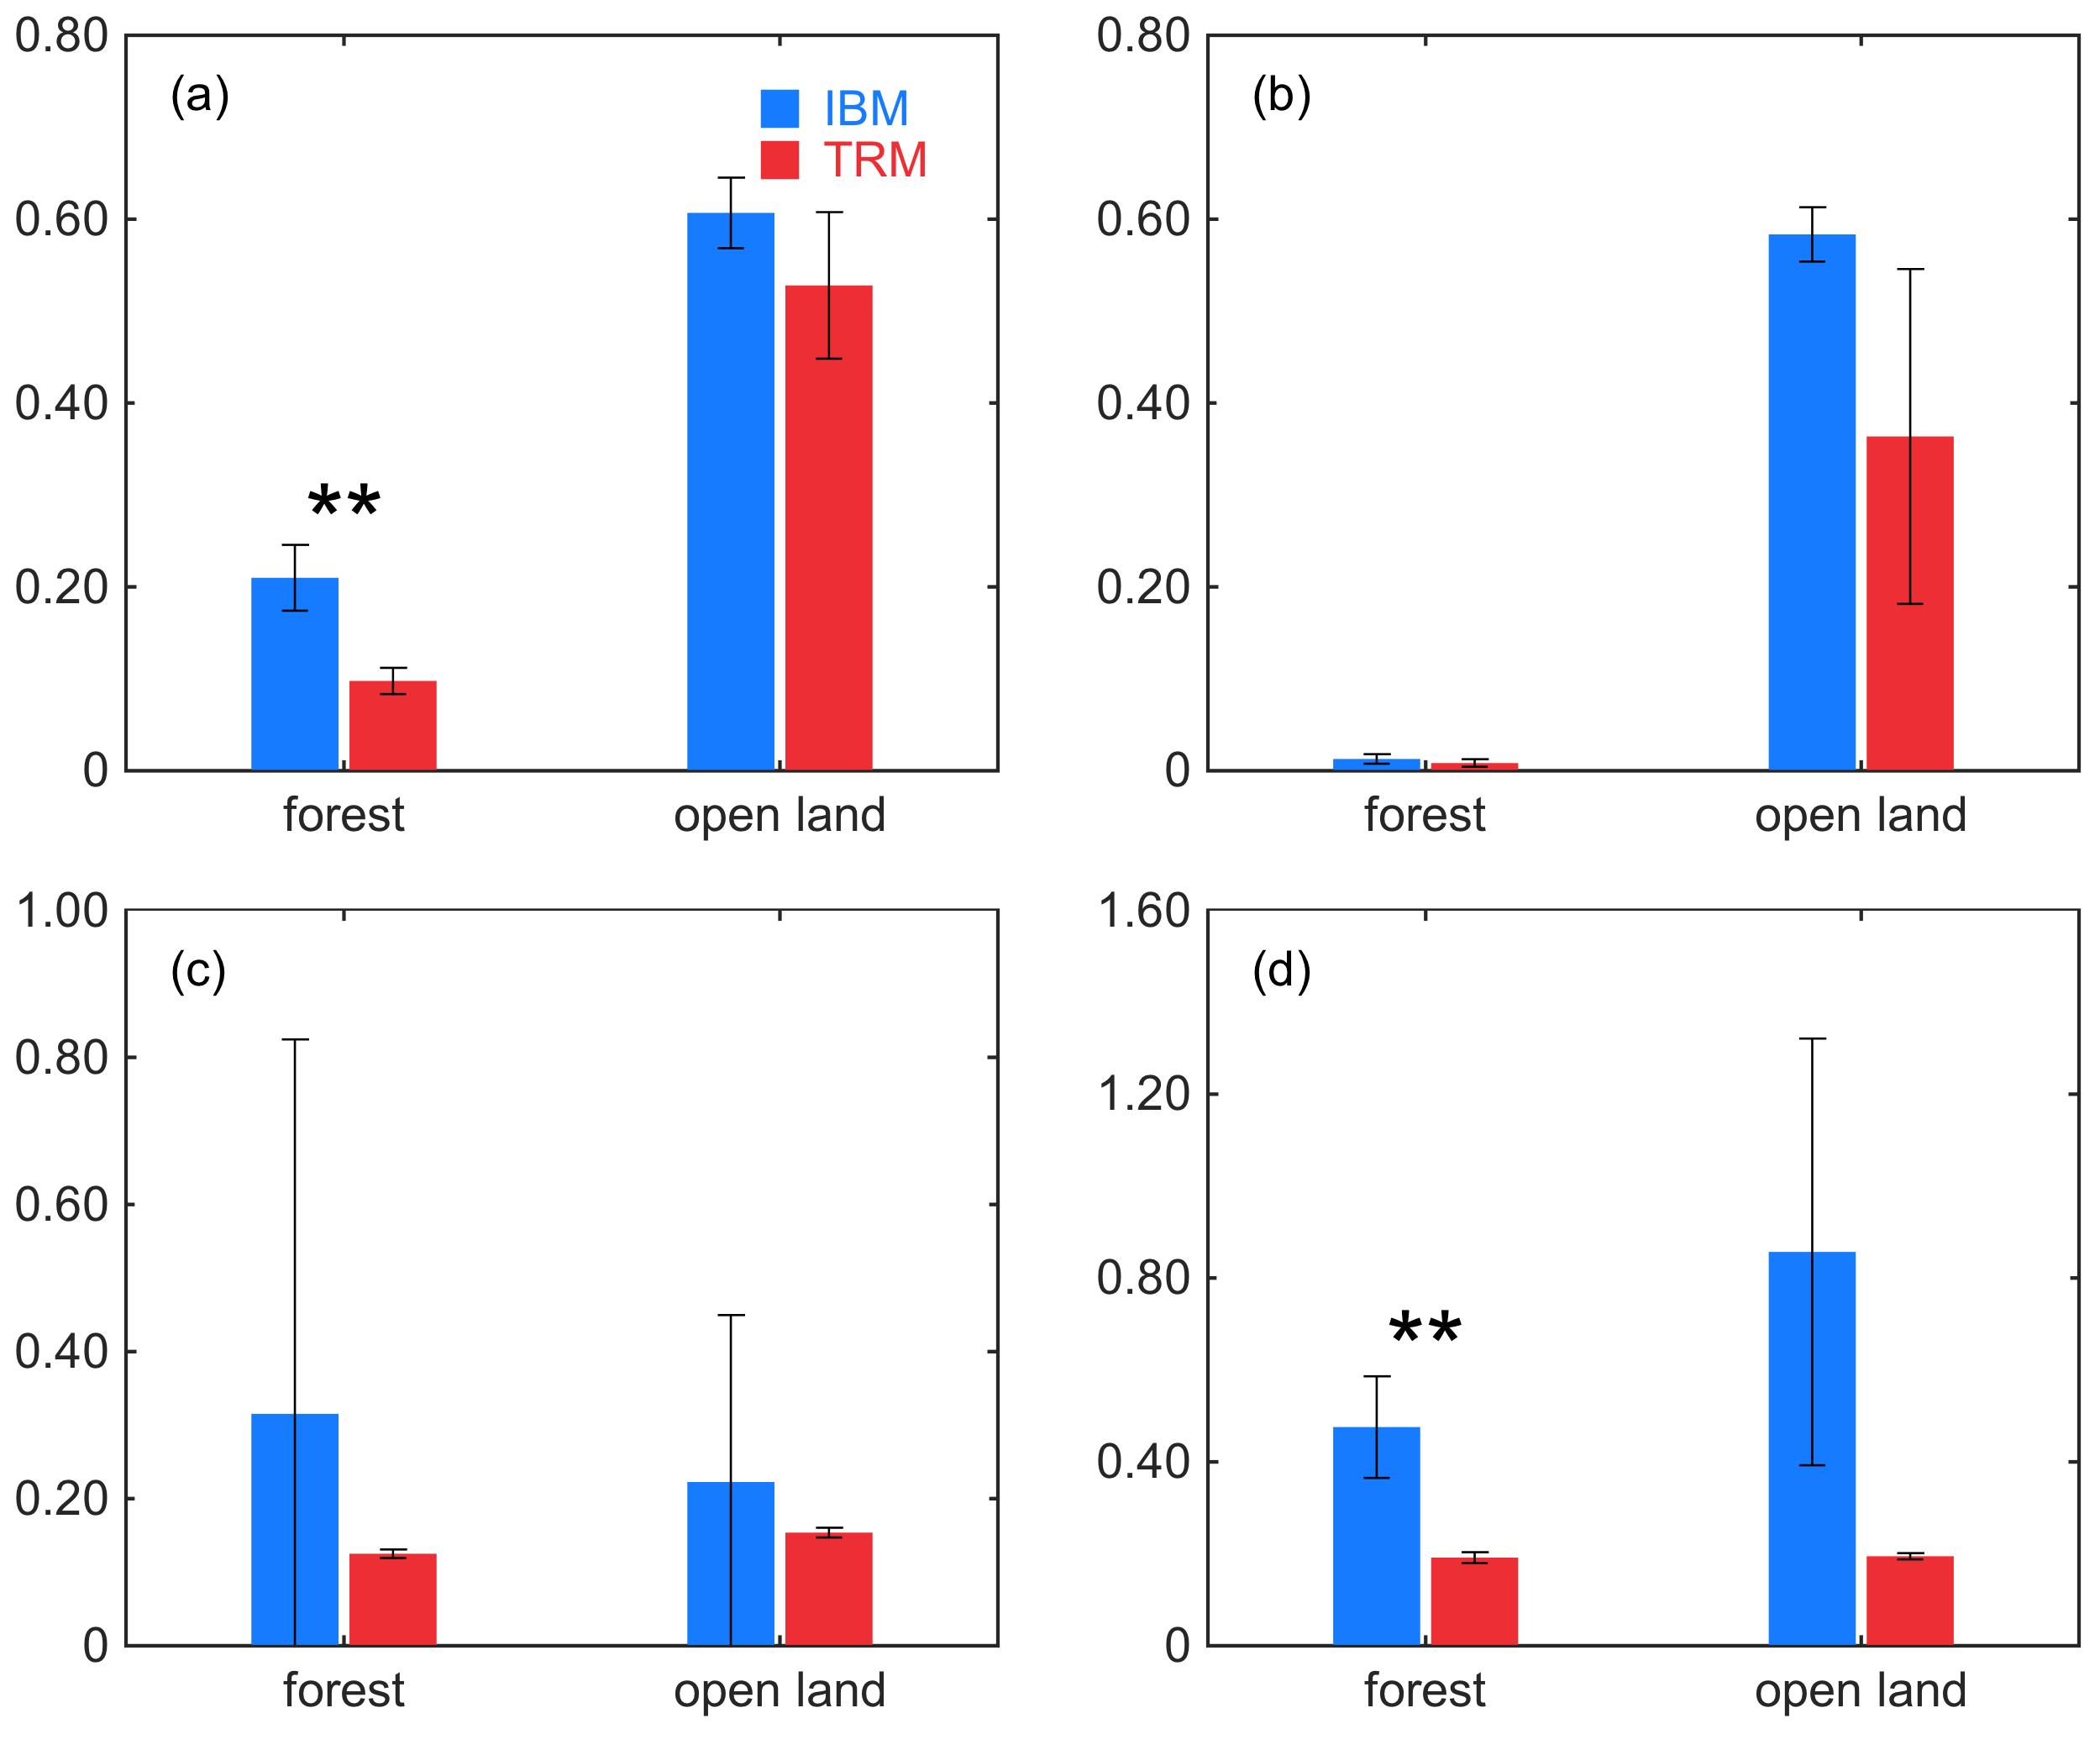
Figure S5. Same as Figure S4 but for the nighttime in summer.

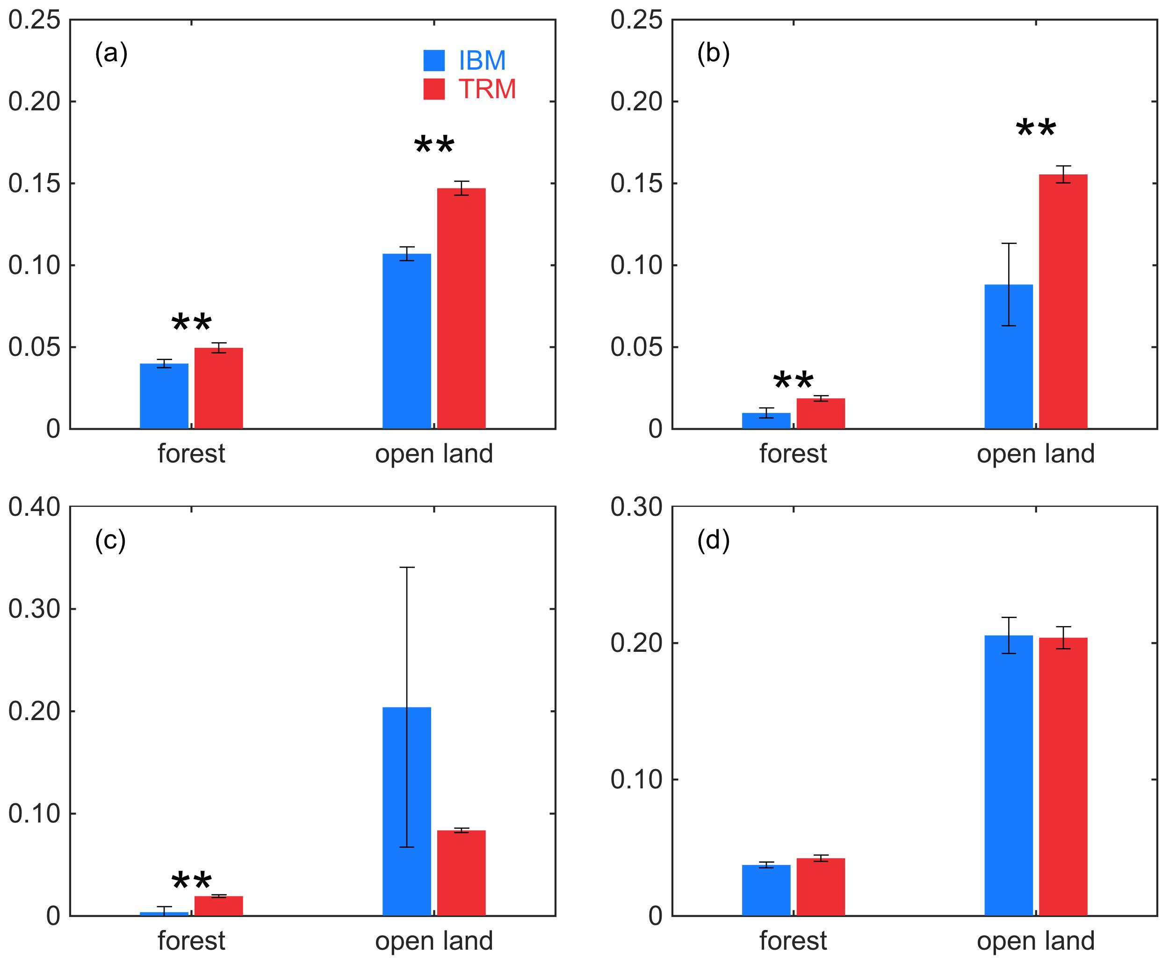
Figure S6. Same as Figure S4 but for the daytime in winter.

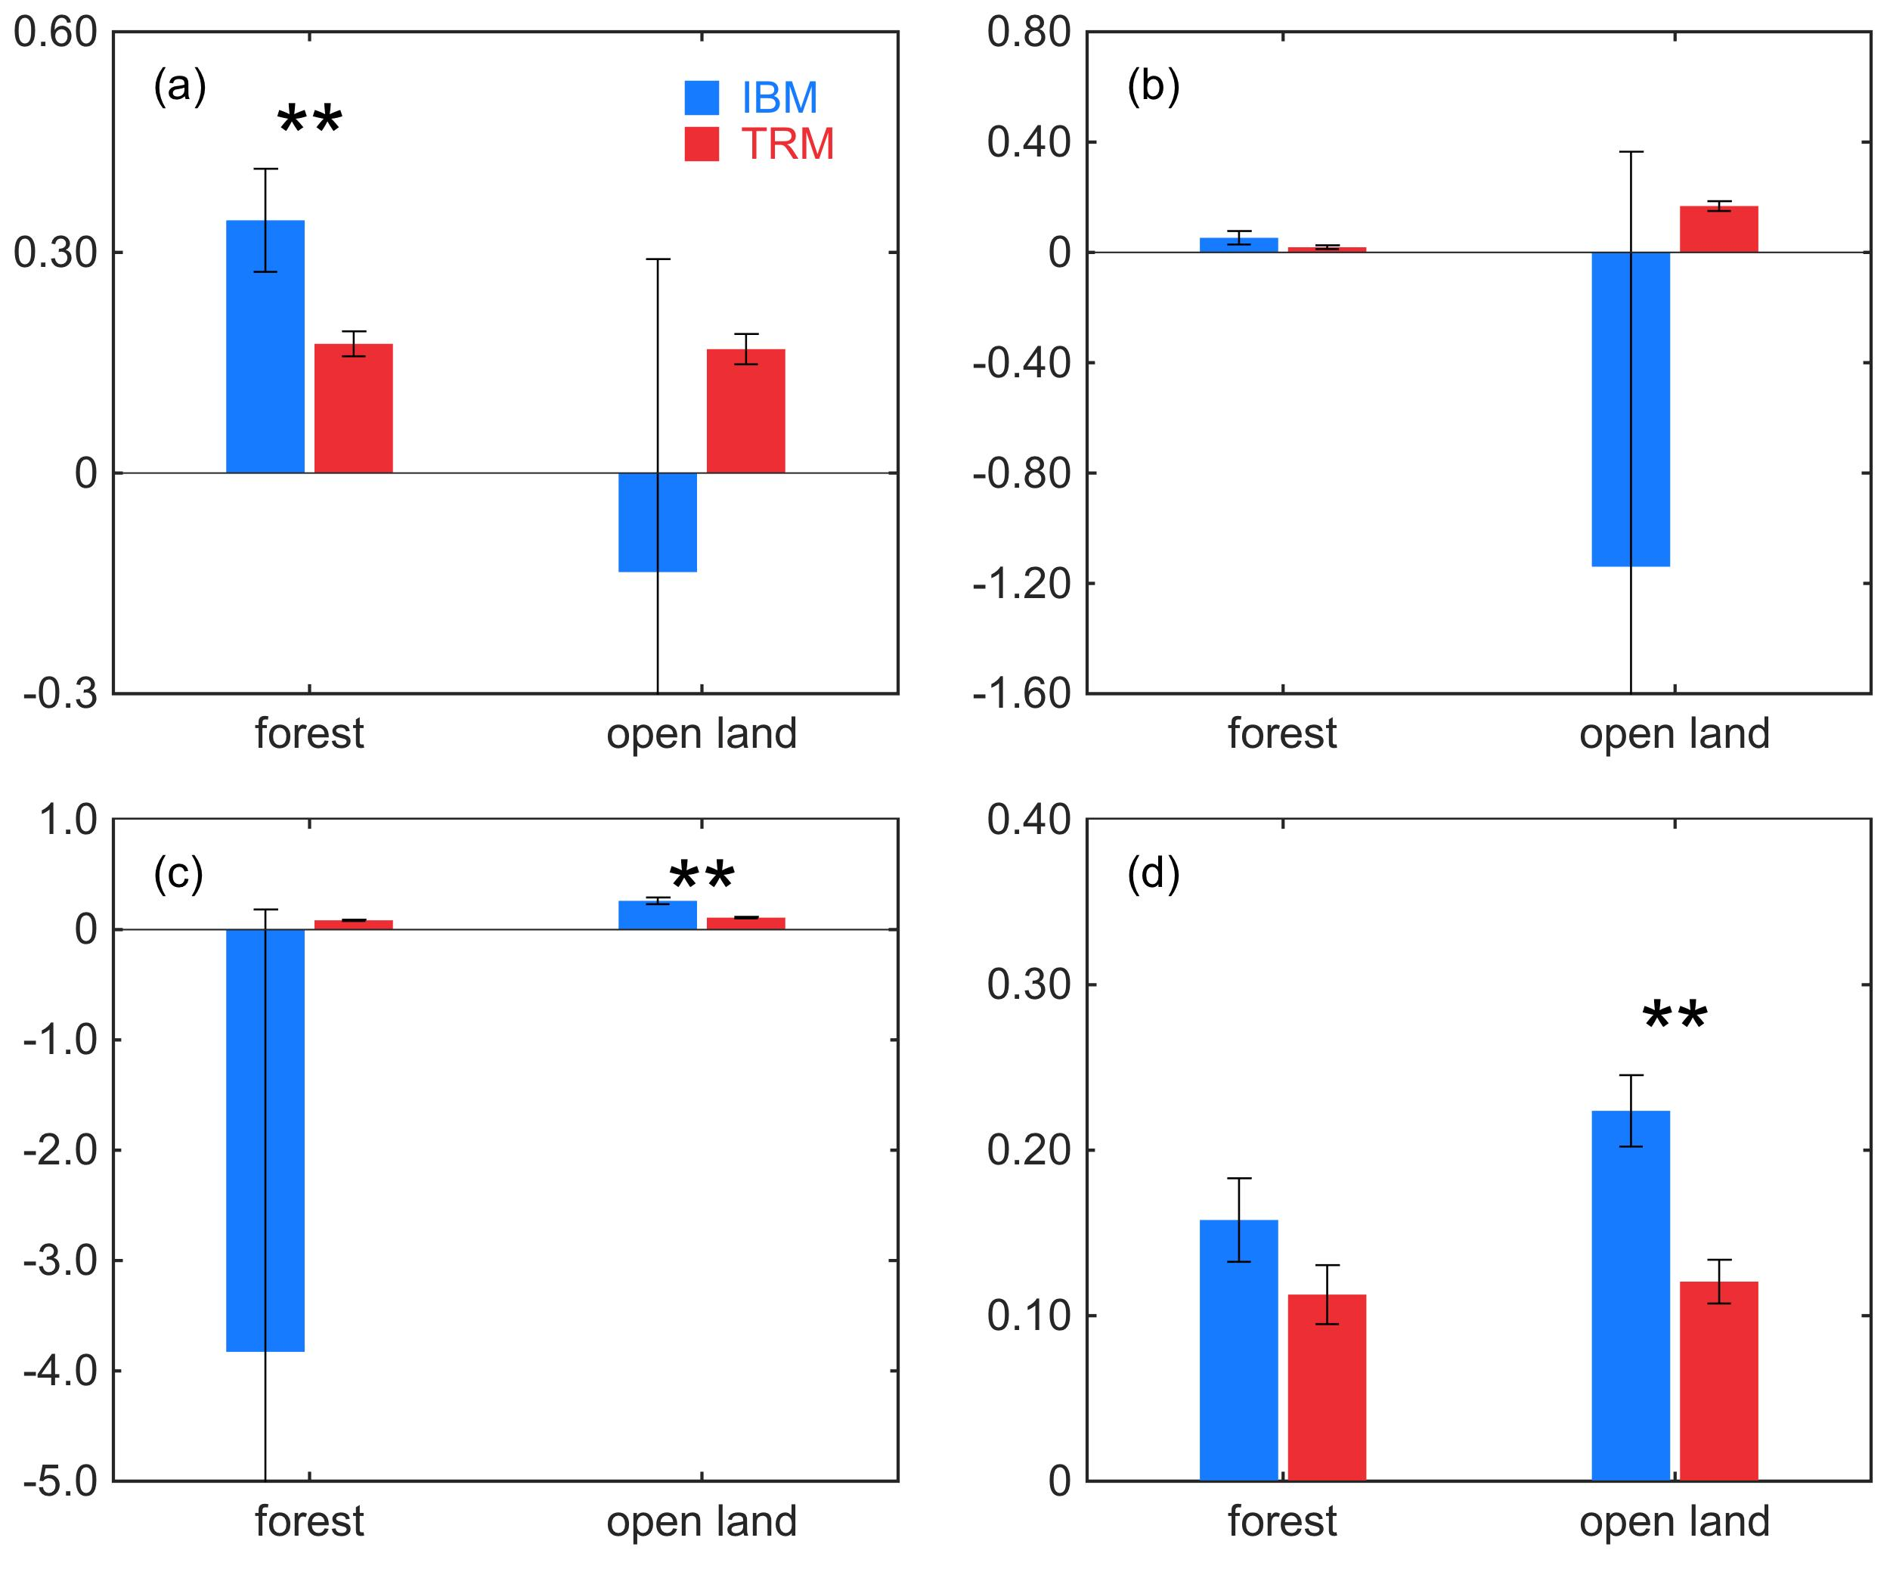
Figure S7. Same as Figure S4 but for the nighttime in winter.

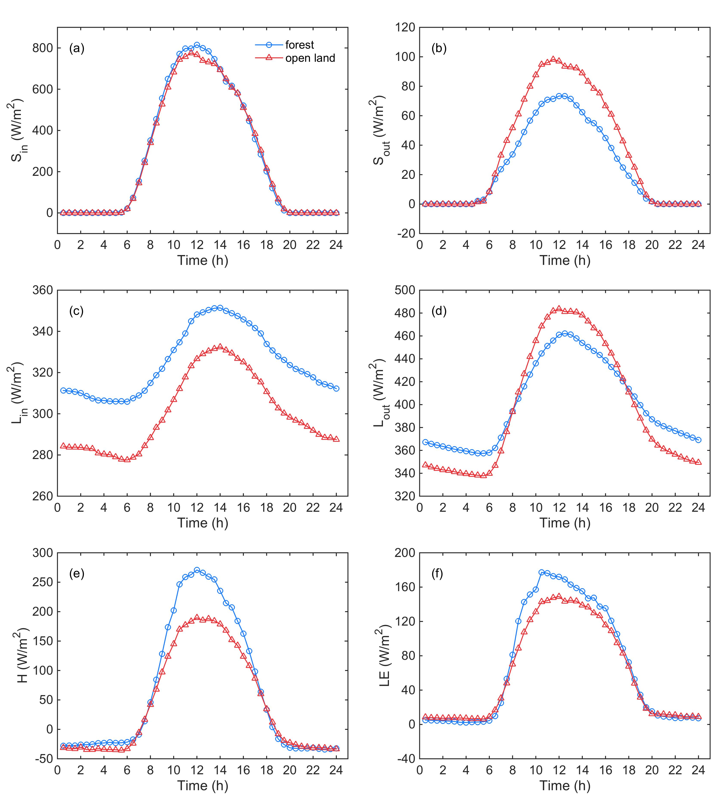
Figure S8. The averaged diurnal cycles of (a) incoming shortwave radiation ($S_{in }$), (b) outgoing shortwave radiation ($S_{out }$), (c) incoming longwave radiation ($L_{in }$), (d) outgoing longwave radiation ($L_{out}$), (e) sensible heat flux (H), and (f) latent heat flux (LE) over the forest (evergreen needleleaf, US-Fmf) site and the open land (grassland, US-Fwf) site of pair 4 in summer.

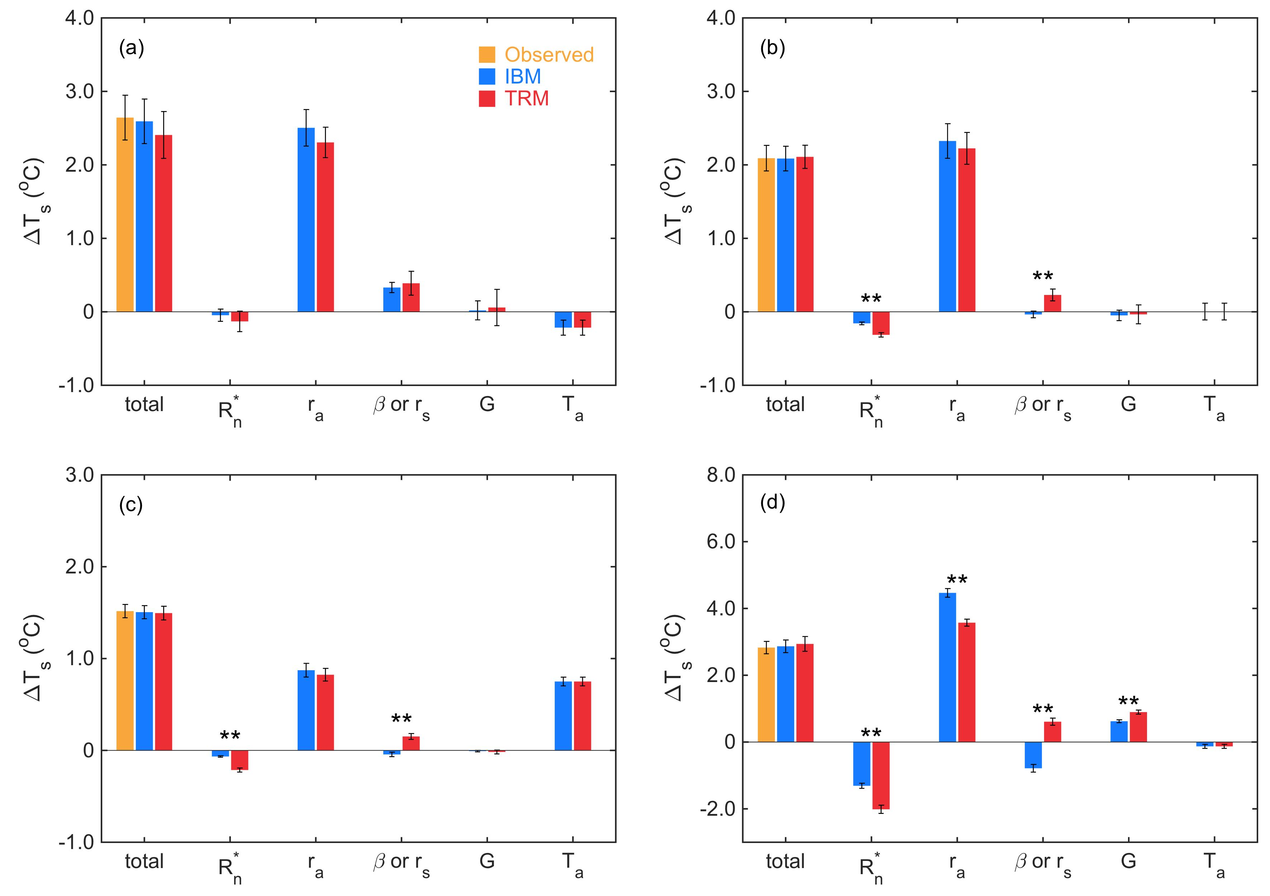
Figure S9. Same as Figure 3 but the emissivity of grassland is changed from 0.92 to 0.96 at all four paired sites.

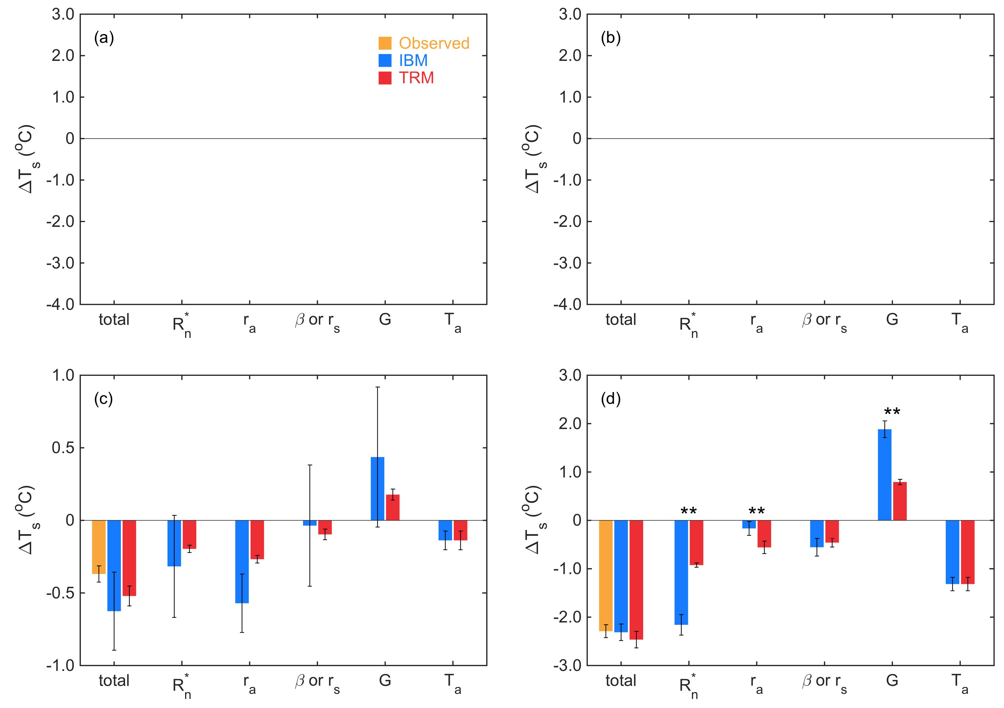
Figure S10. Same as Figure 4 but the emissivity of grassland is changed from 0.92 to 0.96 at all four paired sites.

