**2020 WHAT A BLAST!**

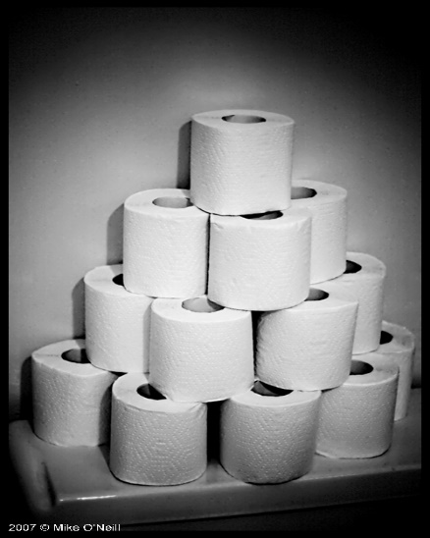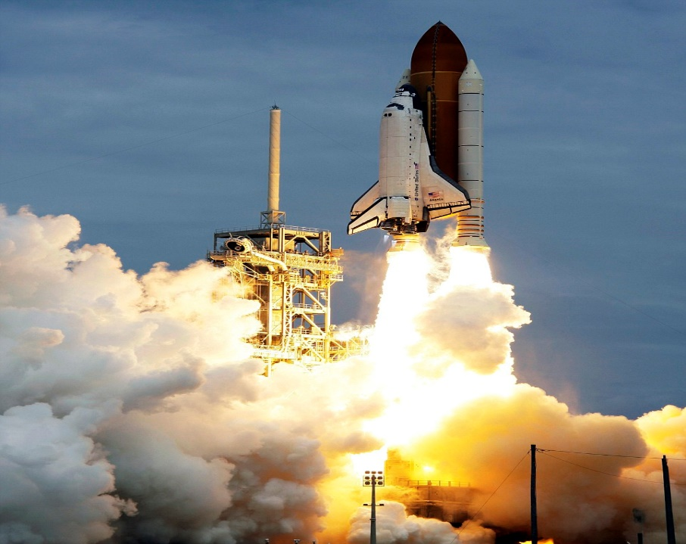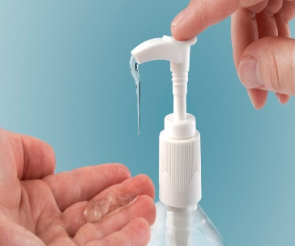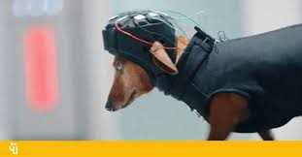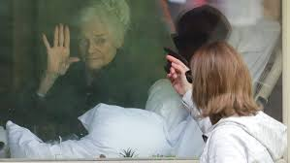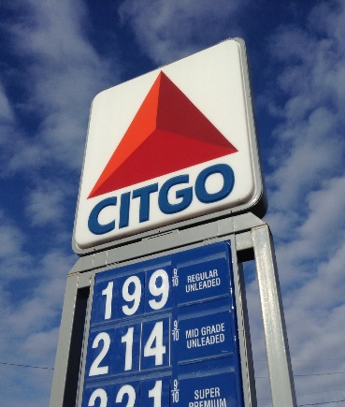

[This Photo](https://www.flickr.com/photos/39160147@N03/15723181043) by Unknown Author is licensed under [CC BY](https://creativecommons.org/licenses/by/3.0/)

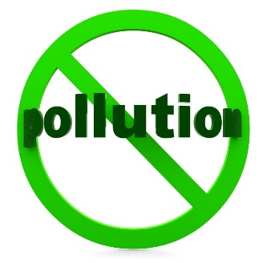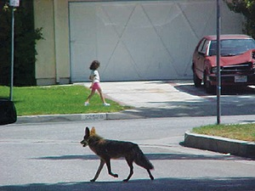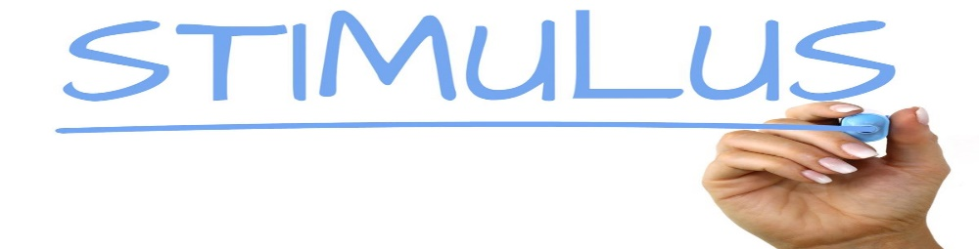

[This Photo](http://www.thebluediamondgallery.com/handwriting/s/stimulus.html) by Unknown Author is licensed under [CC BY-SA](https://creativecommons.org/licenses/by-sa/3.0/)



[This Photo](http://dimland.blogspot.com/2011_02_01_archive.html) by Unknown Author is licensed under [CC BY-NC-ND](https://creativecommons.org/licenses/by-nc-nd/3.0/)

