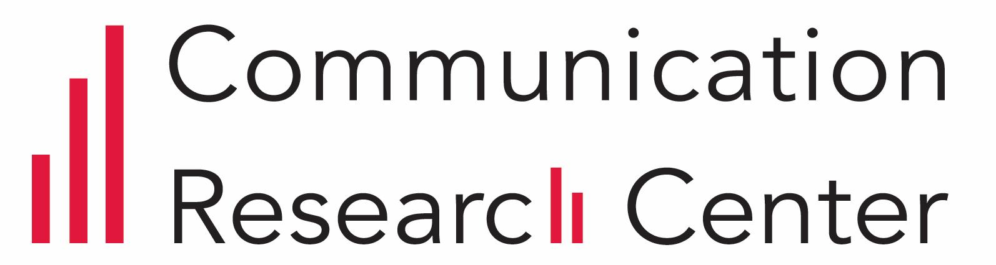STUDY CONSEnt FORM

Information and Consent Document

Please read this form carefully and ask any questions you may have before agreeing to take part in the study. You must be at least 18 years old to participate in this research.

**Summary:** This study will investigate your attitudes, perceptions, and biometric responses to different videos and/or visual prompts. The purpose of this research is to gain a deeper understanding of how people engage with media messages. Specifically, this research study seeks to observe the role actors and non-actors play in climate change messaging. Participation is completely voluntary; the entire study will take approximately 30 minutes to complete. Taking part in this study presents no more than minimal risk. However, you will be asked to remove any face mask. There is a potential risk of loss of confidentiality and a risk of discomfort from wearing sensors. The sensors will be non-invasive, are not expected to cause any pain, and are commercially available. In addition to measuring your biometric responses through sensors, we will also ask you to answer a brief questionnaire before or after you view the prompts.

**The study:** During the lab session, we will assign you by chance (like a coin toss) to one of 4 video conditions with 2 video options. All video conditions are similar in content and duration. You and the researcher cannot choose your study group. You will have an equal chance of being assigned to each study condition.

Your physiological reactions will be captured using iMotions, a biometric research platform. You will be asked to place sensors on specific areas of your body; specifically, you will be asked to wear skin conductance sensors on the index and middle fingers of your non-dominant hand and wear a wrist sensor on the arm of your non-dominant hand. If assistance is requested, the researcher will help adjust the equipment, however, you will be initially instructed to comfortably place these sensors on yourself.

Another measurement will be facial expression analysis and requires participants to not wear anything that obstructs their face throughout the duration of the experiment.

Another measurement will be eye-tracking and requires participants to not wear anything that obstructs their face throughout the duration of the experiment.

Following the pre survey questions and video, you will then be asked to respond to a series of questions about your reaction to the video content.

**Risks and benefits:**

Your participation in the study will contribute to the field of communication in furthering our understanding of how people respond to media. You as a subject will receive no direct benefits from participating in the study.

Participation in this study will award you 1 research credit. Participation is expected to total 30 minutes. You can then apply to any of your classes registered in the COM SONA system this semester.

This research presents no more than minimal risk, although there is a potential risk of loss of confidentiality and a risk of discomfort from wearing sensors. In addition, there are potential and inherent risks associated with the removal of masks during the experiment procedure such as exposure to COVID-19.The sensors will be non-invasive, are not expected to cause any pain, and are commercially available. Taking part in this study is completely voluntary. You are free to refuse to answer any questions or to withdraw from this study at any time and doing so will not affect your eligibility for compensation. Participation or non-participation in this study will not affect your standing at Boston University.

**Privacy and confidentiality:** Your questionnaire responses, physiological data, and all other study records will be considered private and confidential. Study records will be associated with a randomly assigned Participant ID and will not contain any other identifying information. During the data collection phase of the study, records will be stored on a password-protected computer in the Communication Research Center. Questionnaire responses may be stored on a password-protected account on the Qualtrics cloud survey platform. Access to these records will be restricted to the research staff of the study. At the conclusion of the data collection phase of the study all records will be transferred to an encrypted hard drive in a locked cabinet accessible only to the principal researchers on this study and the staff of the Communication Research Center. Access to study records may additionally be given to BU Institutional Review Board and Boston University Offices personnel upon request.

Private information collected from you during this study will NOT be used for future research studies or shared with other researchers for future research, even if the information identifying you is removed from the private information.

**If you have questions:** The principal researchers conducting this study are Team Member1, Team Member2, Team Member3, and Team Member4, MA Students in the College of Communication, and Dr. James Cummings, Assistant Professor of Emerging Media. If you have questions after today, you may contact Team Member1 at Team Member1’s email address or Dr. James Cummings at [cummingj@bu.edu](mailto:cummingj@bu.edu). If you have any questions or concerns regarding your rights as a participant in this study, you may contact the Institutional Review Board (IRB) at [irb@bu.edu](mailto:irb@bu.edu) or 617-358-6115.

**I have read the above information including risks and possible benefits of my participation in this study. I have been given the chance to ask questions, and my questions have been answered to my satisfaction. I consent to take part in the study.**

**SIGNATURE**

______________________________________

Name of Study Participant

______________________________________ ____________________

Signature of Study Participant Date

I have explained the research to the research participant and answered all their questions. I will give a copy of the signed consent form to the participant.

________________________________________

Name of Person Obtaining Consent

______________________________________ ____________________

Signature of Person Obtaining Consent Date