Supplementary Information for

Non-genetic photoacoustic stimulation of single neurons by a tapered fiber optoacoustic emitter

Linli Shi^{1#}, Ying Jiang^{2#}, Fernando R. Fernandez^{2,5,6}, Lu Lan³, Guo Chen³, Heng-ye Man^{4,5}, John A. White^{2,5,6}, Ji-Xin Cheng^{2,3*}, Chen Yang^{1, 3*}

¹ Department of Chemistry, Boston University, 580 Commonwealth Avenue, Boston, MA 02215, USA
² Department of Biomedical Engineering, Boston University, 44 Cummington Mall, Boston, MA 02215, USA
³ Department of Electrical and Computer Engineering, 8 St. Mary’s Street, Boston, MA 02215, USA
⁴ Department of Biology, Boston University, 5 Cummington Mall, Boston, MA, 02215, USA
⁵ Center for Systems Neuroscience, Boston University, 610 Commonwealth Ave, Boston, MA 02215, USA
⁶ Neurophotonics Center, Photonics Center, Boston University, 8 St. Mary’s Street, Boston MA 02215, USA
# equal contributions.
* Corresponding author: jxcheng@bu.edu, cheyang@bu.edu

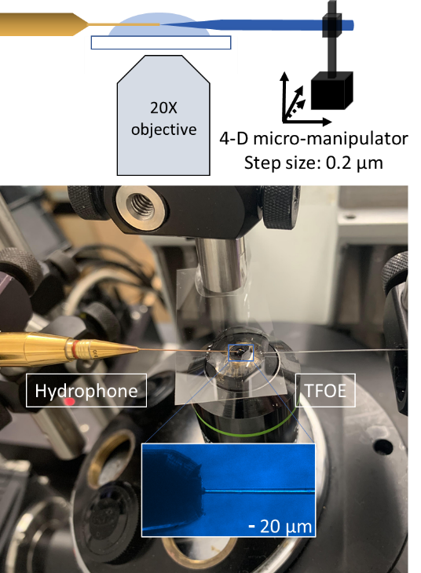
Fig. S1. Experimental set up for optoacoustic characterization. Inset: optical image of the hydrophone and TFOE.

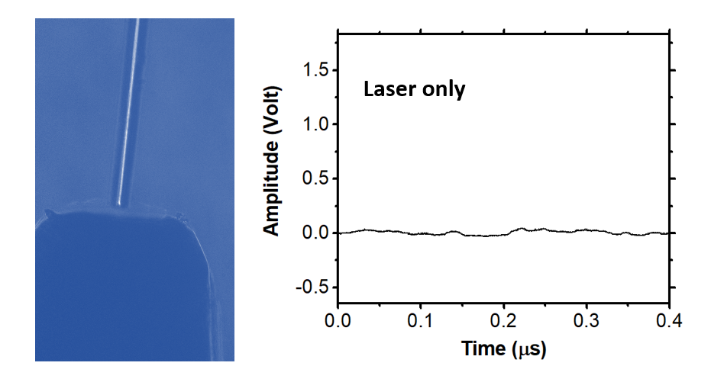
Fig. S2. Influence of laser on the hydrophone using a bare tapered fiber. Laser pulse energy: 6.7 µJ.

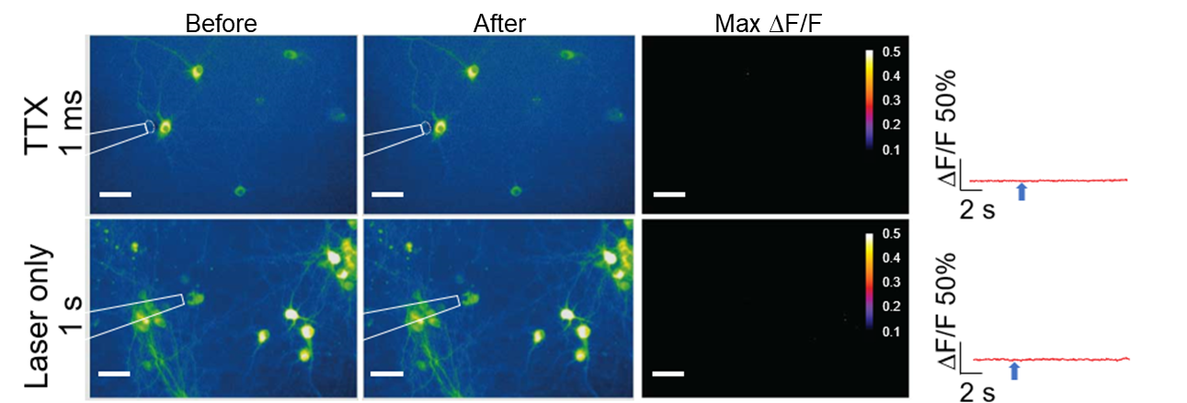
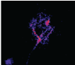
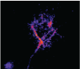
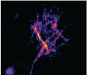
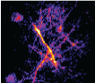
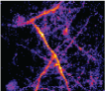
Fig. S3. Fluorescence images and calcium traces of single neurons in sparse population stimulated by TFOE (1 millisecond) with TTX and laser only (1 s). Laser repetition rate: 1.7 kHz; average power: 11.4 mW. Scale bars: 50 µm. Blue arrows: laser onset.
0
.
0
0
s
0
.
1
5
s
0
.
3
0
s
0
.
45
s
0
.
6
0
s
0
.
7
5
s
1
.
00
s
2
.
00
s
9
.
00
s
0
1
Fig. S4. TFOE evoked axon stimulation with calcium wave propagating along neuron network. Fluorescence contrast images (ΔF/F) were taken at varied time points. White circles: the position of TFOE tip. Laser duration: 1 ms; repetition rate: 1.7 kHz; average power: 11.4 mW. Scale bars: 50 µm.
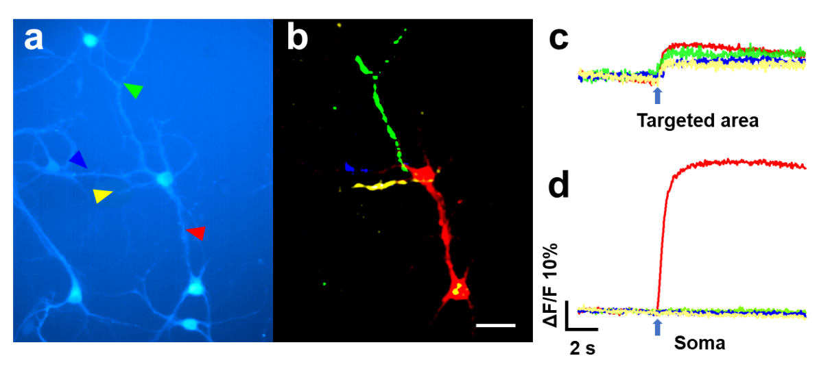
Fig. S5. Subcellular spatial precision of TFOE targeting axon and dendrites. (a) Another multipolar neuron with TFOE targeting axon (red) and dendrites (green, blue and yellow). (b) Maximum ΔF of calcium signal upon stimulation of different areas. (c) Calcium traces of targeted areas upon stimulation. (d) Calcium traces of the soma of targeted neuron upon stimulation of different neurites. Scale bar: 50 µm.

