Liquid Helium Setup: Using the Cryostat

Safety:
- Always wear protective cryogen gloves when working with liquid Helium.
- Always wear protective eyeglasses when handling cryogens as well as taking samples in and out of the cavity.

NOTICE: This procedure is best done with two people for safety reasons and also to minimize damage to the various parts of the set up.

Prep work:

- Disconnect the iris motor from the iris screw.
- Disconnect the coax cable from the front of the cavity.
- Next, remove the black waveguide stabilizers
- Disconnect the resonator from the microwave bridge at the junction of the wave-guide and the microwave bridge.
- Remove the caps from the top and bottom of the cavity by unscrewing the black lock-rings. Keep the cavity clean.

Opening and Installing the Cryostat:
- Before opening the cryostat, open the vacuum valve on the cryostat to make sure that the vacuum has been released.
- Slowly unscrew the caps off the sample arm including the o-rings and the brass spacer until you get to the cavity adapter with the female thread.
- Screw on the cavity to the last piece removed in 2 above.
- Do not touch any of the quartz material inside with bare hands. You must use non-powdered latex or nitrile gloves to remove this part.
- Carefully slide the cavity over the quartz tube and screw on the cavity to the female thread adapter. Do not over tighten.
- Screw the upper black cover back on to the cavity. Make sure that all the o-rings are in place.
- Hold the cryostat at the base of the Helium arm and sample arm as indicated in the diagram below and mount the cryostat into the mounting plate on the magnet.
- Adjust and align the cryostat, the waveguide and the bridge very carefully to match everything and then tighten the screws. Connect the wave-guide to the bridge.
- Connect the iris motor back onto the cavity.
- Reconnect the coax cable to the cavity.
- Attach the pumping station to the black-red valve on the cryostat. Put the valve on the pump in the 1 position, start the main power and pump the cryostat to a pressure of ~10⁻³ Torr (10⁻⁶ mBar). Pump overnight.

Day of Experiment:
- Close the black-red valve on the cryostat and turn the yellow know to the 0 position on the pump. Turn the power to the pump off.
- Disconnect the cryostat from the pumping station.
- Purge the cryostat with N2 gas to remove any excess water or air from the cryostat. Attach the nitrogen purge line to the waveguide and turn it on.
- When purging the cryostat assembly, carefully listen for a “gurgling” sound. A “gurgling” sound would indicate water in the helium transfer coils. Continue to purge the cryostat until the “gurgling” disappears.
- Connect the temperature controller to the transfer line (the motor that drives the needle valve) and then turn on the controller (Note: only connect and disconnect the transfer line from the controller when it is turned off). The Gas flow light will blink indicating that the transfer line is initializing. Turn on the He pump.
- Open the needle valve to 100%. On the controller press and hold Gas auto and press the up position until the meter reads 100. It may take a minute for the needle valve to open 100%.
- Unscrew the protective steel covering from the end of the Helium transfer line.
- Open the safety valve on the He dewar.
- Slowly open the top valve of the He dewar. Insert the transfer line into the liquid helium Dewar slowly (3 mins) to purge air out of the transfer line and at the same time cool the transfer line. The assembly of the He-transfer line requires two persons, as excessive bending of the transfer line will cause permanent damage. ALSO WEAR SAFETY GLASSES and cryogen gloves.
- Test the transfer line to make sure that helium is flowing out of the line by dipping the tip into some alcohol and watch for bubbles.
- Slowly lower the He transfer line further down into the dewar and tighten the brass ferrule.
- Remove the black cap of the cryostat.
- Turn off the vacuum pump and slowly insert the transfer line into the cryostat, however, do not tighten the screw between the transfer line and the cryostat.
- Turn on the vacuum and precool the transfer line until liquid helium starts to come out (about 5 mins). You will hear a change in the vacuum pump sound and the pressure in the vacuum gauge will go up.
- Now tighten the screw connecting the transfer line to the cryostat. You will see the pressure in the vacuum gauge decrease (if the pressure doesn’t drop than the seal between the transfer line and the cryostat is not good). Turn PID to auto.
- Set your temperature and wait for the system to cool down before starting your runs. After a few minutes the temperature will start to go down. Cooling down from room temperature to 4 K typically takes between 20 and 45 minutes. Keep the needle valve at 100% until the temp stabilizes. Once the temperature starts to drop, close the He flow even further (i.e. the smallest flow necessary) once the temperature has reached 4 K.
Temperature control:
Start by adjusting the flow manually so that a temperature is reached which is ~ 25% below that of the desired temperature (i.e., 4 K for 5 K, 8 K for 10 K, etc.). Under the display, press the set button and use the raise/lower buttons to set the desired temperature. Once that is set, press the auto button under the heater settings. When the temperature is reached adjust the flow rate manually until the temp stabilizes and then turn on the gas auto.

At temperatures below 5 K, the temperature is controlled by the He-flow only in the manual mode (i.e. no heater). Put in the desired temperature and switch from manual to automatic temperature control. The heater output and flow are now automatically adjusted to reach the desired temperature. Let the sample equilibrate a few minutes after the desired temperature is reached before taking spectra. When changing a sample, make sure to switch the temperature controller to manual and manually set the heater output to 0V before changing a sample. If this is not done, the temperature will rapidly jump to a higher temperature wasting both He and time, as it will take a long time to cool the sample back down. Also, don’t forget to put the Microwave Bridge in stand-by mode.

VERY IMPORTANT:
Before you insert your sample into the resonator you must turn off the vacuum and make sure that there is positive pressure in the cryostat before opening the inlet to insert your sample. This is to ensure that no air or moisture is sucked into the resonator and cause ice to form.

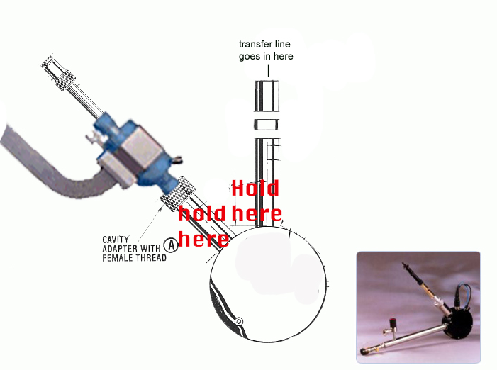

Sample preparations for cryostat run hints:
- Back fill sample tube with He gas. He gas will not freeze in the cryostat and will not cause rapid change in pressure in sample tubes when removing samples after a cryogen run.
- Put parafilm around cap to prevent cap from popping out when removing samples after run. When taking samples out after a cryogen run the rapid change in temperature can sometimes pop the caps off. Parafilm prevents this from happening.
- Precool samples in liquid nitrogen before your runs.
- Keep sample top (collet) loose while inserting sample into a cold cryostat to minimize sample breaking inside the cavity. Tighten the sample top after you have finished inserting your sample tube into the cavity.
- When ready and there is positive pressure in the cryostat, open sample hole and slowly insert sample into the cryostat until it rests in place. Do not force your sample in.
- When run is finished, if sample gets stuck in cryostat, warm system up to about 70K and then remove your sample. Do not force your sample out and always pull your samples out in a straight line as opposed to an arc.

Changing a sample tips:
- First verify that the Microwave Bridge is in the stand-by mode and that the temperature control is on manual with no heater-output.
- Clean the tube from ice by rubbing it repeatedly with a Kimwipes® or a paper towel. Slide the black sample stabilizing cap and o-ring over the EPR tube.
- Switch the pump off and wait until atmospheric pressure is reached (watch for the He-flow meter to jump).
- Remove the cap from the top of the cryostat (or remove the previous sample) and gently put the new tube / cap assembly into the cryostat. Start the pump immediately after securing the black cap.
- Lower the EPR tube all the way down into the cavity and cap the tube with a rubber stopper to prevent O2 and water from condensing on the sample. Keep the time that the cavity is open to the air as short as possible, either by closing it with a finger or having the sample already prepared, before swapping samples. This minimizes the build-up of ice inside the cryostat and obstruction of the He-flow.
- It sometimes happens that the temperature does not decrease after replacing the sample. Most of the time the bottom of the EPR tube is then frozen to the cryostat and the He-flow is blocked. Do not try the remove the EPR tube with force, as it will break. Instead increase the temperature to ~60-110 K. Once the sample tube is loose, gently slide the tube a little higher and quickly decrease the temperature with a nice flow of He. This procedure often cleans out any blockage.

Shutdown and disassembly of the liquid-helium EPR cryostat
- Remove your sample tube from the cryostat and close the top of the cryostat with the black cap.
- Switch on the He-pump and let He flow for at least 5 minutes. Switch off the He-pump and let the pressure reach atmospheric pressure. Close the needle valve fully (0%).
- Loosen the connection that links the He-transfer line to the cryostat slightly. The temperature within the cryostat will increase to room temperature in about 60 minutes.
- Turn off the temperature controller. If you want to continue the next day and nobody else needs the EPR in between, provided you have the instrument reserved, you can leave the He-transfer-line and the cryostat assembled in this state. The next day, you can simply open the needle valve and start the He-pump to cool down the cryostat again.
- If not, wait until the temperature in the cryostat has almost reached room temperature.
- Switch off the nitrogen purge.
- Disconnect the cable between the temp controller and the needle-valve motor.
- Unscrew the “arm” of the He-transfer line from the cryostat and slide it out.
- Close this end of the cryostat with the black cap to prevent dust/water from entering.
- Unscrew the brass ferrule that connects the leg with the He-dewar and quickly remove the He-transfer line leg from the dewar. Close the upper valve of the He-dewar to prevent condensation of water/oxygen/nitrogen.
- Place the He-transfer line back on the shelf in back of the room, and cover the tip of the arm with the steel protective cover.
- Remove the cryostat / cavity assembly from the EPR machine and disassemble.
- Reinstall the cavity back into the EPR including the teflon® plugs to prevent dirt and dust from entering the cavity. Place the brass and black plastic protective covers back on the cryostat. Place the cryostat in the cabinet and lock the cabinet

