Note: All of the formatting in this document is done using the Styles pane. The styles that are being used are RUME Title, RUME Author, RUME Abstract, etc. Using these styles will ensure that your paper meets the formatting guidelines for the proceedings.

The Title is Written in APA Title Case and is Centered but Not Boldface

Author (style “RUME Author”, centered & single spaced)
Affiliation
OR (for 2 or 4 authors —for 4 authors use format below twice)
Author 1 Author 2
Affiliation 1 Affiliation 2
OR (for 3 or 6 authors — for 6 authors use format below twice)
Author 1 Author 2 Author 3
Affiliation 1 Affiliation 2 Affiliation 3
The abstract goes here, and should not exceed 150 words. The style is called “RUME Abstract.” It is not indented, it is left-justified, and it is preceded and followed by a 12-point space, and it is in italics. Please make sure the abstract accurately describes your paper.
Keywords: list 3-5 keywords here, Times New Roman 12-point, no italics
Begin your paper here. All text is to be in Times New Roman 12-point, 1-inch margins, left justified, and single spacing. You should use the ruler tool or the style sheet to indent the first line of each paragraph 1/4 of an inch. DO NOT use the space bar or tab key to indent.
To begin your second paragraph, do not leave a blank line. Be sure to indent again. Indenting should happen automatically if you are using the style sheet or the ruler bar correctly. What follows are heading instructions: Follow APA formatting for headings except noting that first- and second-level headings include a skipped line before the heading in order to improve readability. Third level headings include no skipped lines.

First Level Heading; Centered, Bold, and “Title Case”
You might have a line of text here. It could talk about something interesting and important. Note that there is a skipped line before the heading; in this document it was part of the “RUME Heading 1” style. Note that there is not a skipped line after the heading.

This Heading is a Second Level Heading; Bold, Left-Aligned and “Title Case”
Here is some more text that follows a heading. Notice that there is a skipped line before the title, here it was accomplished via “space before” formatting. Notice that no lines were skipped after the title. This is again the “RUME Paragraph” style.
Third level heading in boldface, indented, and “sentence case.” Again, notice that there is a 1/4” indent and the section begins immediately following a period at the end of the title. Notice that there are no skipped lines. This entire paragraph is written in “RUME Paragraph” style and the heading is manually boldfaced because MS word only lets you use one style in each paragraph.
Fourth level heading in italics, boldface, indented, and “sentence case.” Again, notice that there is a 1/4” indent and the section begins immediately following a period at the end of the title. Notice that there are no skipped lines. This entire paragraph is written in “RUME Paragraph” style and the heading is manually italicized and boldfaced because MS word only lets you use one style in each paragraph. In a paper this short, you should try to avoid using more than 3 levels of headings.
Repeat these as needed …

Example of a Block Quotation

This is an example of the “RUME Blockquote” style. Use this style when quoting more than 40 (or so) words from one person or one source. Notice that the style is indented ¼” for both margins. If you are using a quote from dialogue between two people, you should use the “RUME Interview” style (shown below).

Example of an Interview Excerpt
Interviewer: You would use the “RUME Interview” style for including quotations from a discussion between two or more people. Notice that the name of the speaker is manually italicized and the section has a ¼” hanging indent.
Participant: This is where you would write an interesting response to what the interviewer said.

Lists
In a paragraph or sentence, identify elements in a series by lowercase letters in parentheses: (a) the first item in the series, (b) the second item, and (c) the third item. Use semicolons instead of commas if the series elements contain commas. If the listed items are separate paragraphs, use Arabic numerals followed by a period or bullets. Use the automated numbering or bullets in Microsoft Word, which will provide the appropriate indentation of each line [use RUME Paragraph style].
- The first enumerated paragraph should be presented in this manner.
- The second paragraph …
- The third paragraph …

Example of a Figure
Figures should appear in their own line(s) of the paper, rather than being placed to the left or right of text.
Below is an example of a figure, shown in Figure 1. Notice that Figure 1 is referenced in both this sentence and the previous one and there is an italicized caption below the figure that describes what the figure shows. You can add the caption by clicking on the picture and using the Insert > Caption menu; you can add the reference by using the Insert > Cross-Reference menu.
If you have any writing within a Figure (not the caption), then you should use 12–point font size.

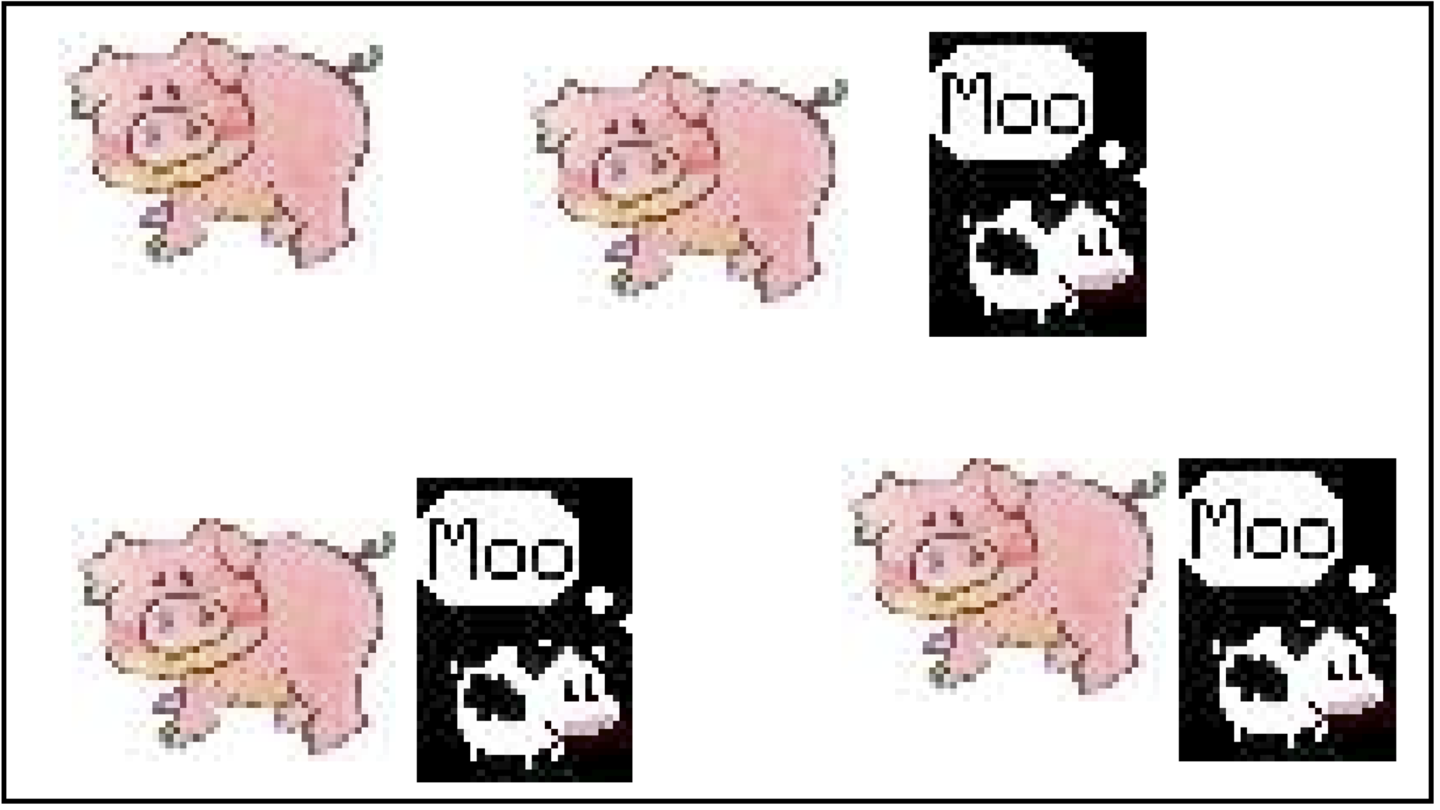
Figure 1. A picture of cows and pigs. This uses “RUME Figure Caption” style which is italicized, centered, 10 point font.

Example of a Table
Below, shown in Table 1, is an example of a table in APA format. Note that the caption appears above the table in its own table cell (so it’s left-justified but aligned with the left side of the table) and includes a bit of vertical space to separate it from the rest of the text. You can add the caption and cross-reference the same way you added them for the figure. The text within the table should use “RUME Table” style and should use a 12-point font size.

Table 1. A table showing some data. This uses the “RUME Table Caption” style.
Header
Subheading  Category 1  Category 2  Category 3 | Column Head  Data 1  Data 2  Data 3 | Column Head  Data 1  Data 2  Data 3 | Column Head  Data 1  Data 2  Data 3
Another Subheading  More categories | Another Head  Even more data | Yet Another Head  You guessed it, more data! | Yup  Why not?

Acknowledgments
Any necessary acknowledgments should immediately precede the References. The heading should be treated as a First Level Heading. Do not include identifying information in the Acknowledgments in a blinded proposal (add it later, for submitting an accepted proposal). Do not put blank lines between multiple acknowledgments.

References
Here are some references, written in APA format. You can use the “RUME Reference” style, which has a ¼” hanging indent.
Erlwanger, S. H. (1973). Benny’s conception of rules and answers in IPI mathematics. Journal of Children’s Mathematical Behavior, 1(2), 7-26.
Schoenfeld, A. H. (1992). Learning to think mathematically: Problem solving, metacognition, and sense-making in mathematics. In D. Grouws (Ed.), Handbook for Research on Mathematics Teaching and Learning (pp. 334-370). New York: MacMillan.
Strauss, A., & Corbin, J. (1994). Grounded theory methodology: An overview. In N. K. Denzin & Y. S. Lincoln (Eds.), Handbook of qualitative research (pp. 273 – 285). Thousand Oaks: Sage Publications.

Additional Instructions & Check list
- You may use this document as a template.
- All papers should be submitted as .pdf or .docx documents
- The MAXIMUM page length for PROPOSALS is 5 for Preliminary Reports, 7 for Contributed Reports and Theoretical Reports, and 1 for Poster. Though the limit does not include references, the limit does include: (a) title, (b) abstract, (c) author list (after the paper is un-blinded), (d) keywords, (e) tables, and (f) figures. Papers that are over the length will not be reviewed and will be returned to the author.
- If you’re using MS Word to write your paper, please use the RUME styles (available in the Styles pane). Otherwise, please use the formatting tools of your word processing program to set margins and indentations, avoiding any extraneous spaces or tabs.
- All margins should be one inch.
- The title, abstract, headings, body text, endnotes, figure captions, and references (i.e., ALL TEXT except figure/table captions) should all be in Times New Roman 12-point font.
- All paragraphs should be indented 1/4 inch. Please use the word processing program settings to set margins and paragraph indentations; do not use spaces or tabs to align text or make indentations.
- All text should be single-spaced with no extra lines between consecutive paragraphs.
- Use footnotes. Do not use endnotes.
- Do not use headers, footers, or page numbers.
- All tables, figures, and graphics should be placed in the document as appropriate. As necessary, resize large tables or graphics so your document, when printed, does not exceed the maximum number of pages allowed for your paper. Use APA style for captions of Figures, Graphics, and Tables.
- Citations and references must follow the guidelines of APA.

