 | A Toolkit To Start Substance Use Prevention In Elementary Schools
2018 | Caitlin Pettengill, BSN, RN
DNP in Public Health Nurse Leadership Capstone Project, UMass Amherst

Special Thanks to Mary Ann Gapinski, BU SHIELD, the Regional Consultants, the School Nurse Leaders, and the elementary school nurses of Belmont, Framingham, Natick, Hudson, Plymouth, Hadley, Billerica, Ware, Stoughton, Marlborough, Springfield and Haverill.

Table of Contents
Introduction 2
The purpose of the toolkit 3
DESE Recommendations 3
Statewide study 3
Why Elementary School Aged Children? 4
Starting the conversation 4
Talking to Administrators 5
Talking to co-workers 5
Talking to Parents 6
Talking to students 7
The Money 8
Federal Grants 8
Local Grants 8
The Return on Investment argument 10
Informing Parents 11
Parent notification sample form (English) 11
Dealing with opt-outs 12
Resources on home prevention education 12
Resources for Parent Education 12
The educator 13
Resourses 13
Free Wallet Card 13
Free Books 13
Free Posters 13
Selecting a curriculum 14
Brain Power! 15
Generation Rx 16
The PAX Good Behavior Game 17
Measuring Outcomes 18
The Research 19
ReferenceS 22
Appendix A 25
Ohio Joint Study Committee on Drug Use Prevention Education 25
Appendix B 26
Stanford University Vaping Guide 26
Appendix C 27
More Vaping information 27

Introduction

The purpose of the toolkit
This toolkit is designed to assist school nurses, school nurse leaders, health teachers, science teachers and physical education teachers in starting substance use prevention education in early elementary school. Who uses the toolkit will depend largely on the funding and professional job descriptions of your district.
The toolkit is meant to be an all-inclusive guide for implementing a substance use prevention education program at your school. There is information on current research, grants, curricula, and talking points to lead discussions in your schools. The toolkit is intended to endorse the use of the curriculum Brain Power! from the National Institute of Health. The Generation Rx curriculum is meant to supplement the Brain Power! curriculum with games and activities about safe prescription drug use. And the social-emotional health curriculum, PAX Good Behavior Game, is also suggested for use because it assists with the vulnerable population of girls with low self-esteem. Research shows that even with early substance use prevention education, this special population needs additional support in order to avoid drug use in high school.

DESE Recommendations
The only substance use prevention education programs recommended by the Massachusetts Department of Education and Secondary Education (DESE) for use in schools are found in the Substance Abuse and Mental Health Services Administration (SAMHSA) database. But SAMHSA’s National Registry of Evidence-Based Programs and Practices (NREPP) currently only offers substance use prevention curricula starting in fourth grade. If you use curricula in this toolkit treat it as a pilot study.

Statewide study
The creator of this toolkit will be conducting a statewide longitudinal study on the effects of high school students drug use when substance use prevention education is started in Kindergarten or first grade. If your school or district decides to start an elementary school substance use prevention education program in the 2019-2021 school years, please email cmcavanaugh@umass.edu to get involved in the study.
D.A.R.E. is not an evidence-based program, and it’s not in the SAMHSA NREPP database.
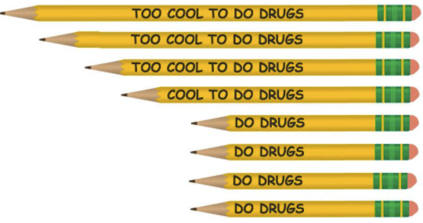

Why Elementary School Aged Children?
Current research demonstrates that early prevention education is the only effective deterrence of substance use in high school students. For decades society has relied on programs that are not evidence-based and delayed implementation until middle school. The cost of this non-research driven decision has been catastrophic to our communities and society at large. Implementing evidence-based curricula in early elementary school will reduce the impact of the opioid epidemic in future generations. Research shows that starting structured in-school substance use prevention education in Kindergarten is best practice, supported by ongoing booster education in first, second and third grade. Once children start being influenced by their peers (fourth-fifth grade) prevention education starts to lose its effect in deterring substance use in high school. This is why waiting until middle school is simply no longer an option.
“Soon after teaching our children to cross the street, it’s time to start protecting them from substance use.” – Massachusetts Department of Public Health, Bureau of Substance Abuse Services

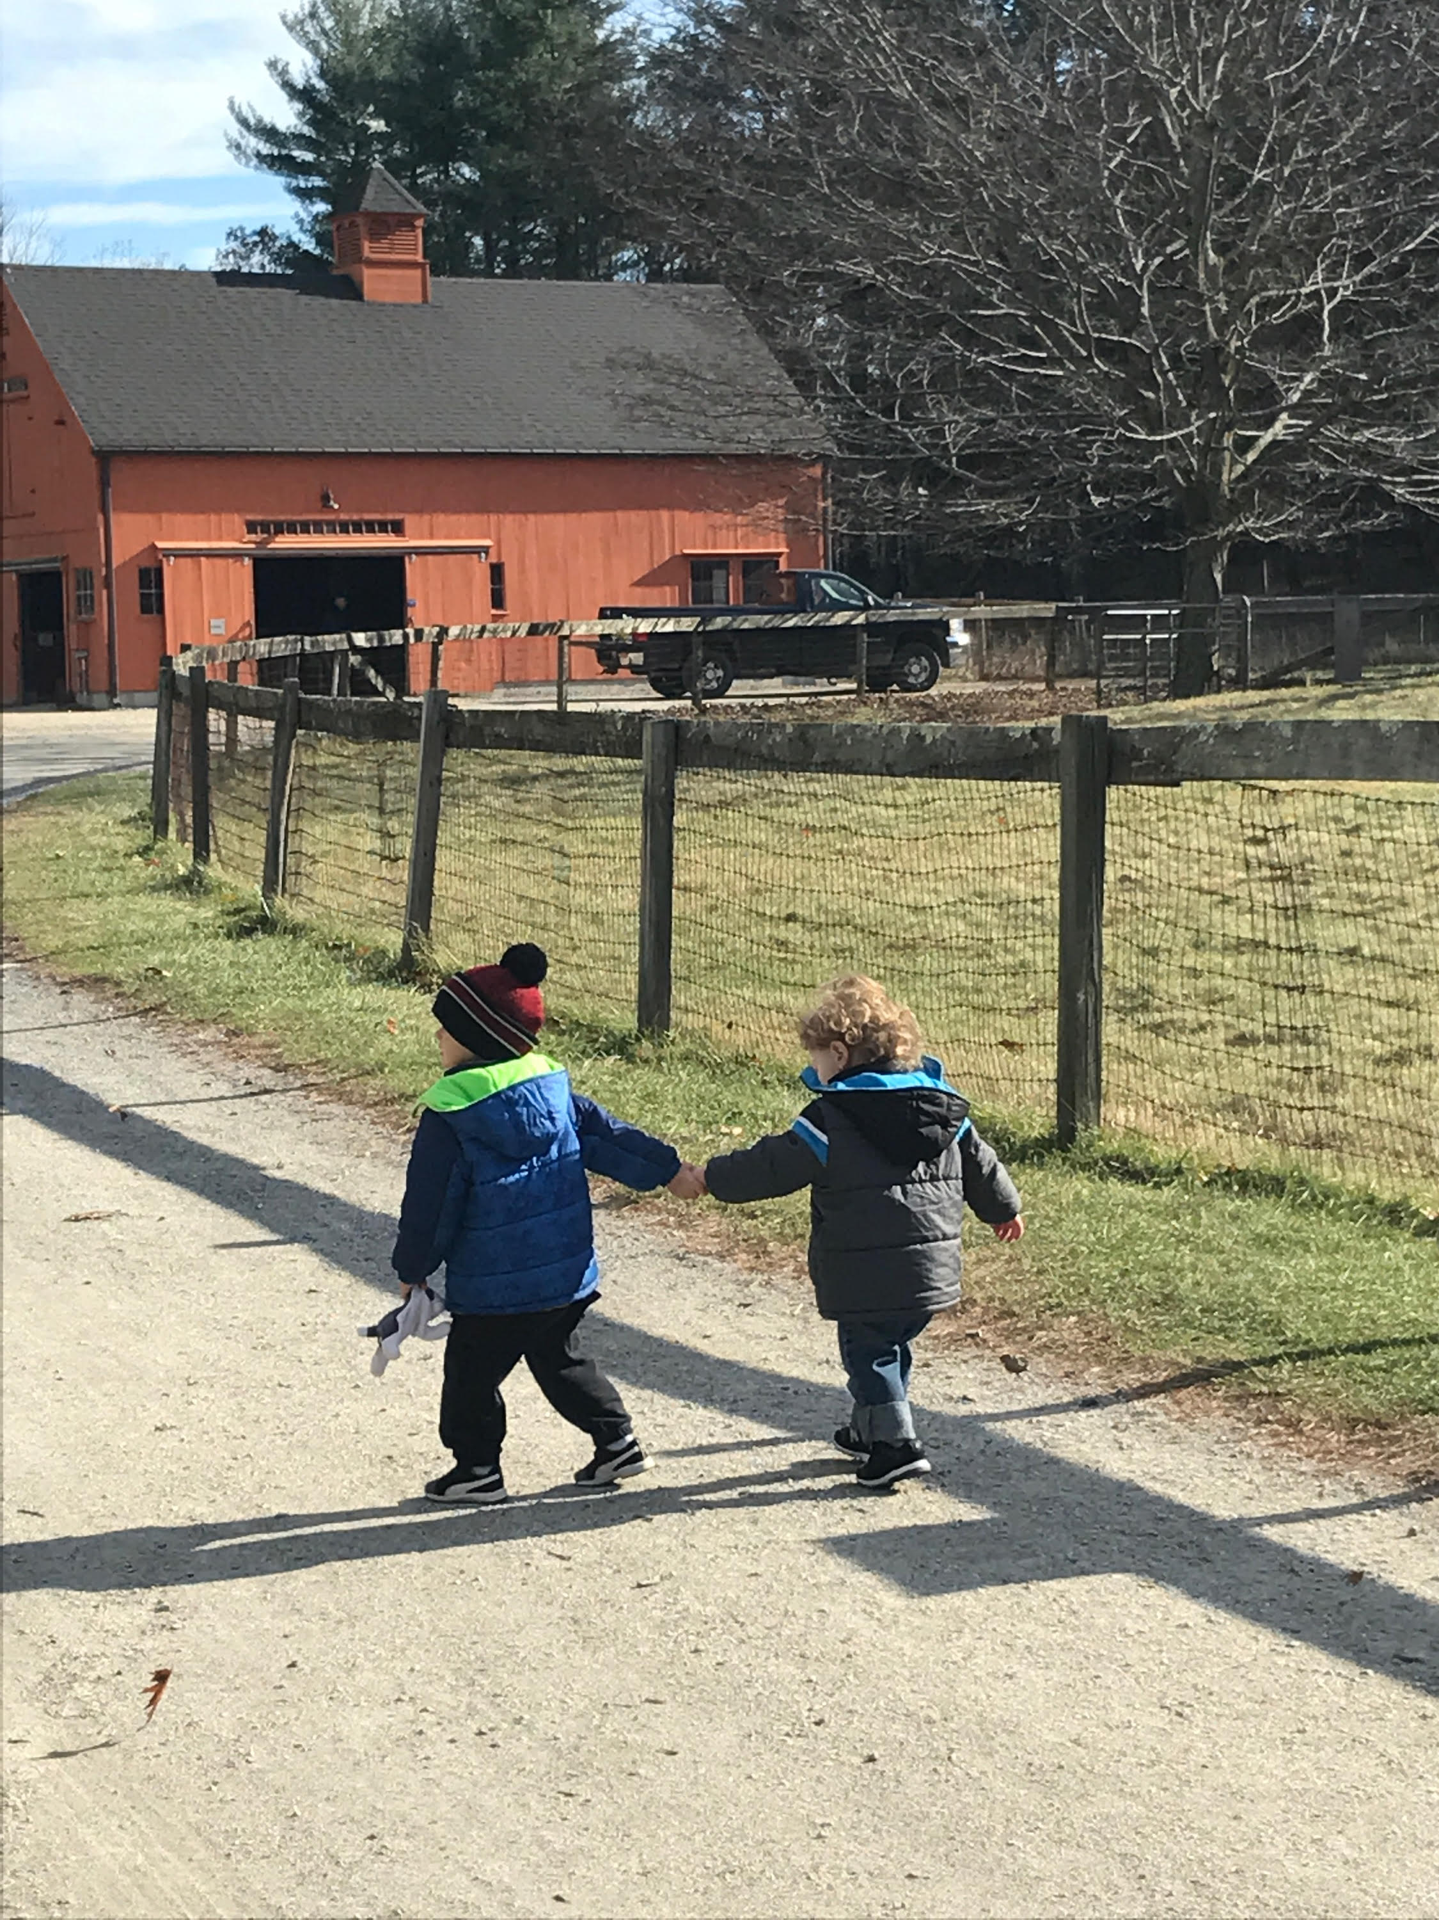

Starting the conversation

Talking to Administrators
Informed administrators will be grateful the school nurse is interested in starting an early elementary school substance use prevention education program. This is a hot issue in school administration. More traditional administrators may need some persuasion. The important points to discuss with them are bulleted below:

- States are starting to enforce Kindergarten through 12th grade substance use prevention education. Check out this document of recommendations from the Ohio Attorney General, Ohio State Senate and House of Representatives. To highlight the important parts, Ohio is recommending that evidence-based substance use prevention education start in kindergarten. They mention a school district that is successfully integrated NIH’s Brain Power! into their science curriculum. They also mention the other two curriculums’ provided in this toolkit, Generation Rx and PAX Good Behavior Game. Ohio did an analysis of the costs savings of providing substance use prevention education, and concluded that it was an economically sound investment to save money in the future.

- Waiting until 4th or 5th grade misses the once-in-a-lifetime window of opportunity to prevent chronic substance use. This is accomplished by teaching young children about their bodies, and the affects different substances have on their bodies. Specifically, the brain and all of its neurotransmitters. Once little girls start brushing their own hair it’s too late, and the window of opportunity is lost.

- Make sure your administrators understand that there are two options when it comes to substance use prevention education. The old way (D.A.R.E. in middle and high school) and the evidence-based way (K-12 curricula). Stress the fact that some states, like Kentucky and Arkansas, are rejecting research, and decided to keep D.A.R.E. for middle school and high school prevention. These states are experiencing the biggest prescription drug epidemic this country has ever seen. The “same old” way of delivering substance use prevention education does not work. Give your administrator the two scholarly research articles in the Research section that show that D.A.R.E. doesn’t work. And show them all the evidence that early elementary school prevention does work.
“Substance use prevention education should start in Kindergarten.” –Ohio Attorney General, Mike DeWine

Talking to co-workers
This is a difficult group to convince in some cases. And with just cause, talking to young children about substance use will be difficult.
Curricula are designed to keep lessons clear, concise and to the point. Lessons are tailored to the age of the children and introduced in a manor to enlighten students about their bodies, not the societal issues. If an elementary school teacher does a unit on human anatomy, no matter how basic, it’s actually evidence-based substance use prevention education.
Every moment we spend educating children about their bodies, and the effects of toxins in their bodies, is time invested in preventing future drug use. In early elementary school aged children you aren’t even required to mention drugs. Simply teaching a unit on the lungs, and explaining what smoke does to the lungs is enough. Later in their education specific toxins can be mentioned (cigarettes, joints, etc.).
Additionally, lessons on social-emotional health have been proven to provide protective factors to future drug use. A program like PAX Good Behavior Game never mentions drugs, but does contribute toward preventing high school drug use.
SUSBTANCE USE PREVENTION EDUCATION IN EARLY ELEMENTARY SCHOOLS DOES NOT HAVE TO INCLUDE DRUG TOPICS – ESPECIALLY IF IT IS THE ONLY BARRIER IN STAFF BUY-IN!!
How classroom teachers (not doing the formal curricula teaching) should handle questions from students:
- Be honest and clear with your answers.
- Don’t make references to personal consequences, police officers and the criminal justice system.
- Relate questions to basic human anatomy and how it affects the body.
- It’s okay to say, “I’m not sure, I’ll ask the nurse and get back to you.”

Talking to Parents
This maybe the most difficult group to convince. And be aware that you will most likely not have the buy-in of every parent. The author of this toolkit talked to dozens of Massachusetts Elementary School Nurses about this topic. A few of their recommendations:
- When sending home letters to parents have an opt-out box, not an opt-in box.
- Have a saved, generic email in the school office ready to be sent out to parents voicing concerns. The email should include references to scholarly literature, and outline the evidence-based curriculum your school has selected. List a contact for further information.
- Have a school “point person” for parents to be directed to on this topic. The “point person” should have access to scholarly literature and be aware of recommendations and practices in Massachusetts and around the country. Most likely this is a school nurse, administrator, health teacher, physical education teacher or science teacher.
- Reinforce to parents the importance of continuing the conversation at home. And if they choose to opt-out, having a conversation at home.
- Try to win the support of the PTA/PTO before the planning begins.

“The only way to end this epidemic is to start substance use prevention education in Kindergarten, it’s the only intervention with any evidence to show it works.” –Former Presidential Candidate, Governor of Ohio, John Kasich

Talking to students
Students know more than you think about alcohol and drugs. The author of this toolkit performed a study on 150 Massachusetts third graders. Over 95% were aware that alcohol and cigarettes are dangerous. While only 68% knew prescription drugs could be dangerous. It’s important to close the gaps in knowledge and discuss these issues with our children.
Some elementary school students have already experimented with drugs and alcohol. While others have witnessed their parents, spouses or family friends misuse drugs and alcohol. Some may have seen the effects of alcohol and drugs in their neighborhoods. And other students may have no prior experience or exposure to drugs and alcohol at all.
An issue with the D.A.R.E. program is that it assumes that every child will respect the opinion of a Police Officer. It’s important to remember that children bring their own experiences to the classroom. Some children have experienced a traumatic event involving a Police Officer. Maybe they were removed from their home with a DCF worker and a Police Officer. Or maybe they were evicted from their family home by a Police Officer. Perhaps they witnessed a family member, family friend or neighbor being physically apprehended by a Police Officer. When we ignore this reality it creates health inequities in substance use prevention education.
If administrators or parents in your district insist on having uniformed individuals present for substance use prevention education programs select a Paramedic Firefighter. A Paramedic Firefighter has firsthand experience of the effects of alcohol and drugs on HEALTH, which can be useful in supporting evidence-based curricula. And doesn’t create health inequities.

The Money

Federal Grants

- Title: Multi-Site Studies for System-Level Implementation of Substance Use Prevention and Treatment Services
Source: National Institute of Health (NIH) – see www.grants.gov #PAR-18-222
Award: $500,000
Summary: This grant is looking for an entire school district to make a system wide substance use prevention education intervention and then study the long-term effects. Nurse Leaders take notice!

- Title: Brooks Brothers Grant
Source: Brooks Brothers Corporate
Award: $5,000 - $1,000,000
Summary: Brooks Brothers will make a charitable donation to a fund raising event in your district. Simple visit the website above and fill out the one page document. You will receive determination within two weeks. They are specifically looking to donate to an existing fund raising event (auction, raffle, bake sale, walkathon, run, etc.).

- Title: Ford Foundation Grants
Source: The Ford Foundation
Award: $5,000-$1,000,000
Summary: Fill out a short online form and hear back from Ford Corporate within 45 days. Ford has seven domains for grants. The Youth Opportunity and Learning domain would be the most appropriate for public schools. They are looking for holistic, inclusive education policies and practices that provide young people with the skills they need to strive.

- Title: CVS Community Grant
Source: CVS Corporate; Email andrea.frey@cvshealth.com
Award: Full Funding of Program
Summary: CVS offers full funding of educational programs that prevent prescription drug abuse. The grants are invitation only. Email Andrea Frey a short description of your substance use prevention education program to receive an invitation.

Local Grants

- Title: Youth Opioid Prevention Grant
Source: Attorney General Maura Healey
Award: $5,000
Summary: The YOP grant is designed to support school-based prevention education initiatives to address opioid dependence and addiction in Massachusetts. The AGO is accepting grant applications from entities that will implement either a sustainable prevention curriculum or prevention programming within a public school or public school district in Massachusetts.

- Title: Whole Foods Community Giving Days
Source: Whole Foods Grocery Store
Award: 5% of net sales from a day of sales at your local Whole Foods Market
Summary: During Community Giving Days, individual Whole Foods stores donate 5% of that day's net sales to local nonprofits and educational organizations. Interested organizations should consult the Whole Foods website to see if their local store offers an online request form, or reach out to that store's Marketing Director.

- Title: The Brown Rudnick Charitable Foundation Corp. Community Grant
Source: The Brown Rudnick Center for the Public Interest
Award: $2,000
Summary: The purposes of the Community Grant Program are to simultaneously (1) encourage those involved broadly with the Brown Rudnick Center for the Public Interest to actively think about the educational needs in the community of Boston (2) recognize, encourage and collaborate with the front-line workers within the educational system who often do not have a voice in funding decisions; and (3) provide funding to assist with small, concrete projects or needs which will make an improvement in inner city education in Boston.

- Title: Heroin and Opioid Crime Reduction State Initiative
Source: The Massachusetts Executive Office of Public Safety and Security
Award: Counties in Massachusetts were distributed the following awards. Connect with the stated agency in your county to inquire about the funds for substance use prevention education in your school/district.

- Barnstable County Sheriff's Department-$178,841.00
- Berkshire County Sheriff's Office-$108,657.00
- Bristol County Sheriff's Office-$237,820.00
- Essex County District Attorney's Office-$145,743.00
- Essex County Sheriff's Department-$157,134.00
- Franklin County Sheriff's Department-$133,000.00
- Hampden County Sheriff's Department-$188,841.00
- Hampshire Sheriff's Department-$120,812.00
- Massachusetts Department of State Police-$46,000.00
- Middlesex County Sheriff's Office-$139,647.00
- Norfolk County District Attorney's Office-$39,310.00
- Norfolk County Sheriff's Department-$112,882.00
- Northwestern District Attorney's Office-$86,860.00
- Plymouth County District Attorney's Office-$165,904.00
- Suffolk County Sheriff's Department-$100,883.00
- Worcester County-Middle District Attorney's Office-$105,981.00
- Worcester County Sheriff's Department-$189,968.00

The Return on Investment argument
If your district/school is unable to secure a grant the next step is to request funding for the following school year. Preventing chronic substance use in local residents increases productivity and potential taxed income. While we don’t want to think of our kids as dollar signs it maybe a way to motivate decision makers to invest in early elementary school substance use prevention. If your town/city is already investing substantial funds in substance use treatment or costs associated with chronic substance use then present the idea of investing in prevention. Point out to decision makers that this small investment in early elementary school substance use prevention education could be how your town/city stops over-spending on chronic substance use.

Informing Parents

Parent notification sample form (English)
Cut and paste the below sample form to a Word Document. Add your schools name, emblem and print on your districts letter head.

Dear Parents and/or Guardians,
Our school district will be implementing elementary school substance use prevention education programs starting __________________________________________.
Research shows that starting preventative education in early elementary school aged children reduces chronic substance use in high school. Our hope is to support your child’s healthy growth and learning throughout the course of their education.
Below is a link to U.S. Department of Justice and the U.S. Department of Education brochure, Growing Up Drug Free - A Parent’s Guide To Prevention. This document outlines the research and importance of starting early elementary school substance use prevention education. The education program will focus on the anatomy and physiology of the brain and lungs, as well as socio-emotional health. The education will be age appropriate and will use terms/language your child is already familiar with.
https://www.dea.gov/pr/multimedia-library/publications/growing-up-drug-free.pdf

To have your child opt out of this education program return this form signed below.
☐ I do not want my child to receive the preventative education

Child’s Name _________________________________________________________________________

Parent’s Signature _________________________________________________________________________

Dealing with opt-outs
Parents have a right to decide what their children learn. The research indicates that opt-outs should be expected, maybe even in large numbers. New concepts are hard for some people to deal with. Similar to when sexual health was introduced to schools, early elementary school substance use prevention education will most likely face adversity early on. Sexual health was under a lens until teen pregnancy rates drastically dropped which took years to come to fruition. The literature projects that early elementary school substance use prevention education will have a similar history - it will be questioned until high school drug use drastically drops.
Parents that want to air on the side of tradition, and opt-out their children should be encouraged to have discussions with their children at home. The Growing Up Drug Free Parents Guide to Prevention from the U.S. Department of Education and the U.S. Department of Justice is a great resource to provide to parents who have decided to opt-out their children. It discusses educating your children at home and is updated annually. Check the U.S. Department of Education website for future annual publications.

Resources on home prevention education
How Alcohol Advertising Affects our Youth - Massachusetts Department of Public Health, Bureau of Substance Abuse Services
Injury Management: A Key Component of Prescription Opioid Misuse Prevention - Massachusetts Department of Public Health, Bureau of Substance Abuse Services
A Parent’s Guide: Preventing Inhalant Misuse Among Children – Massachusetts Department of Public Health, Bureau of Substance Abuse Services
Daddy Used to Be Sick, But He’s Much Better Now – Greater Lawrence Family Health Center Office-based Opioid Treatment Program. Written by kids with parents in the program. This is a great resource to talk to your child about recovery.

Resources for Parent Education
Dangers of Vaping – Stanford University Tobacco Prevention Toolkit
Drugs of Abuse 2017 – U.S. Department of Justice, DEA Resource Guide
Family Checkup: Positive Parenting Prevents Drug Abuse – National Institute on Drug Abuse, National Institutes of Health, U.S. Department of Health and Human Services
Big Tobacco Targets Kids - Massachusetts Department of Public Health

The educator

A lot of Massachusetts’s elementary schools do not have health teachers. But some do. An individual knowledgeable about health, pharmacology, long-term effects of exposure to chemicals/toxins, and trained in health education is the best educator. A science teacher formally trained in pharmacology would be a good candidate. It may also be a health teacher, but at the elementary school level it will most likely be the school nurse.
Traditional drug education is not appropriate for this age, so in depth education on anatomy and pharmacology is used instead. It’s imperative that the educator be able to answer questions about the human body and the physiological effects of smoking, chemical ingestion/absorption/metabolism and drinking. This role requires a lot of preparation with the curricula. Which is why funding is explored in this toolkit. The educator will require days, if not weeks, of preparation and reading time. A substitute school nurse can be paid through grants/funding.

Resourses

Free Wallet Card
Drugs & The Brain – National Institute on Drug Abuse, National Institutes of Health, U.S. Department of Health and Human Services

Free Books
Daddy Used to Be Sick, But He’s Much Better Now – Greater Lawrence Family Health Center Office-based Opioid Treatment Program. Written by kids with parents in the program. This is a great resource to talk to your child about recovery.
Principles of Substance Abuse Prevention for Early Childhood: A Research-Based Guide – National Institute on Drug Abuse, National Institutes of Health, U.S. Department of Health and Human Services

Free Posters
Big Tobacco Targets Kids - Massachusetts Department of Public Health
Second Hand Smoke: It’s Bad for Everybody! - Massachusetts Department of Public Health
Drugs & Your Body: It Isn’t Pretty – National Institute on Drug Abuse, National Institutes of Health, U.S. Department of Health and Human Services
Prescription Drugs – National Institute on Drug Abuse, National Institutes of Health, U.S. Department of Health and Human Services
Alcohol & The Brain – Ask, Listen, Learn, Foundation for Advancing Alcohol Responsibility
Dangers of Vaping – Stanford University Tobacco Prevention Toolkit

Selecting a curriculum

There are currently only three evidence-based curricula offered for early elementary school substance use prevention (K-2nd grade). Brain Power! and Generation Rx are offered free of charge and provide ample resources for implementation. Both curriculums offer the academic standards codes each lesson meets. Both curriculums offer full versions in Spanish.
The PAX Good Behavior Game does have a cost to implement. And requires more extensive training for the educators. The PAX Good Behavior Game is designed to be taught by a classroom teacher. After they have received training from the vendor. This may work out well for districts that just can’t find substitute school nurses.

“In a study of 1,563 schools 72% were offering substance use prevention education, but only 14% were using an evidence-based curriculum.” –Hanley (see references for article)

Brain Power!
The National Institute of Health (NIH) Brain Power! curriculum is the gold standard of early elementary school substance use prevention education. Brain Power! was researched by the NIH in multi-state randomized controlled longitudinal studies with excellent outcomes.
Brain Power! is multiple science lessons that are designed to be taught as part of science curriculum by a science teacher. The curriculum has five to six modules for each age group (grade): K-1, 2-3, 4-5, 6-9.
The modules can be completed over a two-year span or over a couple of weeks. Whatever timetable works for your district. Each module includes a lesson plan featuring resources, introduction to the module, list of learning objectives, materials list, any preparation that the teacher must do before teaching the module, step-by-step procedures on how to complete the investigation, and discussion questions. As well as a letter to send home to parents outlining exactly what was taught in the module. These letters to parents are meant to continue the conversation at home.
Brain Power! Website • Curriculum Guide K-1 • Curriculum Guide 2-3 • Curriculum Guide 4-5

Below is an outline of the module titles. As you can see evidence-based early elementary school substance use prevention education focuses is on the human body. There is no mention of criminal consequences or end-all ultimatums (“if you do drugs you’ll ruin your future”). This type of threat education doesn’t work, and can actually have a boomerang affect. Evidence-based practice emphasizes educating children on their bodies and explaining the effects of chemicals/toxins on their body. Once they know the information making a healthy decision will be easy.
Grades 2-3
Module 1: Ooey Gooey! Making Sense of Scientific Inquiry
Module 2: Brains in a Box – What Your Brain Can Do
Module 3: Sending and Receiving Messages
Module 4: Medicines and Drugs – What’s Helpful, What’s Harmful
Module 5: The Science Behind Smoking
Module 6: How Drugs Affect the Brain
Grades K-1
Module 1: You Could Be A Scientist
Module 2: Meet the Scientists
Module 3: Your Amazing Brain
Module 4: Keeping Your Brain Healthy
Module 5: Protecting Your Brain
Grades 4-5
Module 1: Drugs in Society
Module 2: Your Amazing Brain
Module 3: Neurotransmission
Module 4: Stimulants
Module 5: Alcohol, Marijuana and Inhalants
Module 6: What is Addiction?

Generation Rx
The Generation Rx curriculum is part of an educational program series designed for different groups within the community (elementary school, teen, college, adult, senior, patient, workplace). Generation Rx was developed by Pharmacists to combat the issue of prescription drug misuse and abuse. Some of the activities are geared toward K-2nd grade, and others for 3rd-5th grade.

Medication Safety Principles Taught:
1. Only take medicine from individuals that a parent (or guardian) gives permission.
2. Do not share medication or take someone else’s medication.
3. Keep medications in their original containers to avoid confusion with candy or other medicines.
4. Always store medicine in a safe place, such as a locked cabinet or a high shelf that children can’t reach.
Teaching Modules/Activities

Active Stations
- Q&A Safety Rounds: Define common medication terms and safe medication taking practices.
- Prescription Label Lookouts: Identify the different parts of the prescription medication label.
- Medicine Hideouts - Safe or Unsafe?: Determine safe places to store medications.
- Medication Safety Skits: Analyze scenarios to determine if children followed safe mediation-taking practices.
Games
- Good Choice or Bad Choice?: Participants work as individuals to decide if the individual in the presented scenario makes a good or poor decision. Participants will raise their “green smiley face” to indicate good decisions or “red sad face” for poor decisions.
- Trivia: Participants work in teams to solve a variety of trivia questions related to pharmacy and safe medication-taking practices.
- Is it Candy or Medicine?: Participants will match and classify photos as medicine or candy. Following the game, participants answer and discuss questions about the importance of keeping medicines in their original containers.
Supplemental Worksheets
Pharmacy Crossword Puzzle •  Prescription Puzzlers • Patrol Drawings • Safe Sharing Worksheet

The PAX Good Behavior Game
The PAX Good Behavior Game is an evidence-based social-emotional health program that teaches self-regulation, self-control and self-management in context of collaborating with others for peace, productivity, health and happiness. A study from John Hopkins University states that PAX Good Behavior Game can reduce future substance use by 25-50%.

Implementing PAX Good Behavior Game
PAX can be launched in a single classroom, in a few grades, in a whole school, in several schools, in a district, across a county or region or even in a whole state.
PAX is only available from the PAXIS Institute. PAXIS (877) 467-2947 or email gbgorders@paxis.org.
In order to teach the PAX Good Behavior Game educators will be required to attend an 8-hour on-site training. The cost is $2,900 for up to 40 educators. The 8-hours can be done in one day or broken up into two-three days by request. Once an educator is trained the PAX Good Behavior Game kit costs $300 per educator. While the cost is high, it is the proven to show instant results in children’s behavior.
The Massachusetts Department of Public Health will pay for this program. Contact the Division of School Health for more information on funding.

Measuring Outcomes
Once your school starts an early elementary school substance use prevention education program it is essential to collect data on your programs outcomes. This can be accomplished with longitudinal data collection that starts in elementary school and is concluded when the child is in high school.
The creator of this toolkit will be conducting a statewide longitudinal study on the effects of high school students drug use when substance use prevention education is started in Kindergarten or first grade. If your school or district decides to start an elementary school substance use prevention education program in the 2019-2021 school years, please email cmcavanaugh@umass.edu to get involved in the study
Always remember to follow the Massachusetts Department of Education and Secondary Education guidelines for research in schools. And get your research approved by an Institutional Review Board.

“Every moment we spend educating children about their bodies is time invested in preventing future drug use. Give children the information, not the answers”

The Research
This section summarizes scholarly literature on substance use prevention education for early elementary school students. The titles of the articles are provided. See the reference section for additional information on the article.

A Preliminary Evaluation of The Effects Of A Science Education Curriculum on Changes in Knowledge of Drugs in Youth
Quasi-experimental controlled study on two Washington D.C. elementary schools. The intervention group had 112 students. These students went through the Brain Power! curriculum from the NIH and demonstrated significantly less intention to use drugs in the future. And had increased levels of knowledge about science/anatomy. Overall demonstrating that the Brain Power! curriculum had effective substance use deterrence effects.

A Short-term Quasi-Experimental Evaluation of D.A.R.E’s Revised Elementary School Curriculum
A quasi-experimental controlled study of 1,980 elementary school students from 17 different schools, with 1,490 students receiving the intervention, and 1,450 serving as controls. The revised D.A.R.E. curriculum shows no evidence of deterrence of substance use. And actually demonstrates a boomerang affect that encourages students to act out, as evidence by a significant increase in suspension in the intervention schools. This is thought to be caused by the association of the criminal justice system and the lack of health education in D.A.R.E.

Immediate and short-term effects of the 5th grade version of the Keepin’ it REAL substance use prevention intervention
A randomized controlled study examines the D.A.R.E. Keepin’ it Real curriculum in 23 different schools. The 1,566 students from the 13 intervention schools compared to the 10 control schools showed no differences in substance use intentions, normative beliefs, or students’ resiliency/decision-making skills. The D.A.R.E. program continues to show no evidence of success.

Media Literacy Education for Elementary School Substance Use Prevention: Study of Media Detective
Randomized controlled study of 679 elementary schools participated in study. The 344 intervention schools used the Media Detective curriculum. While 335 control schools were kept on a ‘wait list’ and had no intervention during the time of the study. The Media Detective curriculum was found to significantly reduce the interest in alcohol-branded merchandise. And significantly reduced the intention to use alcohol and substances in the future and increased the self-efficacy to refuse substances. Media Detective is an online homework assignment that can be completed with parents.

Use of a Social and Character Development Program to Prevent Substance Use, Violent Behaviors, and Sexual Activity Among Elementary-School Students in Hawaii
Randomized controlled study using matched pairs and randomized-clusters in 10 intervention schools and 10 control schools. The prevention education intervention started in first and second grade grade and continued till fifth grade. In fifth grade, three-four years after the initial intervention, 1,714 fifth graders self-reported survey results, and 1,225 teachers of participant students reported on students’ risk of substance use and violence. The three-four year intervention significantly reduced negative behaviors, substance use risk and violence.

A Review of Elementary School-Based Substance Use Prevention Programs: Identifying Program Attributes
Systematic review of elementary school substance use prevention programs (K–6th grade). Thirty published evaluation studies of 24 elementary school-based substance use prevention programs were reviewed. Among 27 evaluation studies that examined program effects on substance use, 56% (n = 15) found significant decreases. In addition, programs most often demonstrated effects on increasing negative substance use attitudes, increasing knowledge, decreasing perceptions of prevalence rates, and improving resistance skills.

Promoting Mental Health and Preventing Substance Abuse and Violence in Elementary Students: A Randomized Control Study of the Michigan Model of Health
Randomized controlled study of 52 randomly assigned schools. The 2,512 students in the intervention group were self-reporting significantly less intention to use drugs in the future. This was a state-wide initiative in Michigan. Longitudinal studies are to follow in coming years.

Life Skills Interventions to Improve Social Confidence, Self-Management, and Protection against Drug Use in Rural Elementary School Aged Children
Quasi-experimental study used a one-group pretest and posttest design of eight to ten year olds at an after-school Boys and Girls club. Evaluation of pretest and posttest results showed increases in the knowledge, attitudes, and behavior skills of children related to self-confidence, self-management, and general social and drug resistance skills.

Effectiveness of a universal classroom-based preventive intervention (PAX GBG): a research protocol for a matched-pair cluster-randomized controlled trial
An on-going, two-year, matched-pair clustered randomized controlled trial. 42 schools were matched into pairs based on their geographical location and number of students per classroom. One school in each pair was randomly selected to receive the PAX Good Behavior Game intervention. The results showed significant increases in students’ mental health and prosocial skills, teacher’s sense of efficacy, classroom behavior, and response inhibition.

Promoting Afterschool Quality and Positive Youth Development: Cluster Randomized Trial of the PAX Good Behavior Game
Matched pair, controlled randomized trial of 76 after-school programs serving 811 five-twelve year olds. Results demonstrated that the best practices fostered by PAX GBG results in higher quality afterschool programs due to more positive youth development. This was thought to be partly due to the PAX GBG training the afterschool staff participated in and because of the impact on students.

ReferenceS
Anderson, S., Moore, P. (2009). The impact of education and school-based counseling on children’s and adolescents’ views of substance abuse. Journal of Child & Adolescent Substance Abuse, 18(1), 16-23.
Beets, M., Flay, B., Vuchinich, S., Snyder, F., Acock, A., Li, K., Durlak, J. (2009). Use of a social and character development program to prevent substance use, violent behaviors, and sexual activity among elementary-school students in Hawaii. American Journal of Public Health, 99(8), 1438-1445.
Botven, G., Griffin, K. (2007). School-based programs to prevent alcohol, tobacco and other drug use. International Review of Psychiatry, 19(6), 607-615.
Center for Disease Control and Prevention (2016). Sortable Risk Factors and Health Indicators. Sortable Stats. Retrieved from https://sortablestats.cdc.gov/#/map
Centers for Disease Control and Prevention (2015). Youth Risk Behavior Surveillance System. Adolescent School Health. Retrieved from http://www.cdc.gov/healthyyouth/data/yrbs/index.htm
Collins, D., Abadi, M., Johnson, K., Shamblem, S., Thompson, K. (2011). Non-medical Use of Prescription Drugs Among Youth in an Appalachian Population: Prevalence, Predictors, and Implications for Prevention. Journal of Drug Education, 41(3), 309-326.
Fertman, C., Primack, B. (2009). Elementary student self-efficacy scale development and validation focused on student learning, peer relations, and resisting drug use. Journal of Drug Education, 39(1), 23-39.
Hanley, S., Ringwalt, C., Ennett, S., Vincus, A., Bowling, J., Haws, S., Rohrboch, L. (2010) The Prevalence of Evidence-Based Substance Use Prevention Curricula in the Nation’s Elementary Schools. Journal of Drug Education, 40(1), 51-60.
Hansen, W. (2010). Current and Future Directions in Elementary School Drug Prevention. Journal of Drug Education, 40(1), 91-98.
Hecht, M., Elek, E., Wagstaff, D., Kam, J., Marsiglia, F., Dustman, P., Harthun, M. (2008). Immediate and short-term effects of the 5th grade version of the Keepin’ it REAL substance use prevention intervention. Journal of Drug Education, 38(3), 225-251.
Holtz, K., Twomby, E. (2007). A Preliminary Evaluation of The Effects Of A Science Education Curriculum on Changes in Knowledge of Drugs in Youth. Journal of Drug Education, 37(3), 317-333
Hopfer, S., Davis, D., Kam, J., Shin, Y., Elek, E., Hecht, M. (2010). A Review of Elementary School-Based Substance Use Prevention Programs: Identifying Program Attributes. Journal of Drug Education, 40(1), 11-36.
Johnson, K., Shamblen, S., Ogilvie, K., Collins, D., Saylor, B. (2009). Preventing Youths’ Use of Inhalants and Other Harmful Legal Products in Frontier Alaskan Communities: A Randomized Trial. Prevention Science: The Official Journal of the Society for Prevention Research, 10(4), 298–312.
Kurpersmidt, J., Scull, T., Austin, E. (2010). Media literacy education for elementary school substance use prevention: study of media detective. Pediatrics, 126(3), 525-531.
Lewis, T., Hession, C. (2012). Alcohol Use: From Childhood Through Adolescence. Journal of Pediatric Nursing, 27(5), 5-8.
Little, M., Pokhrel, P., Sussman, S., Rohrbach, L. (2015). The process of adoption of evidence-based tobacco use prevention programs in California schools. Prevention Science, 16(1), 80-89.
Massachusetts Department of Public Health (January 2016). Data Brief: Opioid Related Overdoses Deaths Among Massachusetts Residents. Retrieved from: http://www.mass.gov/eohhs/docs/dph/quality/drugcontrol/county-level-pmp/data-brief-overdose-deaths-ma-residents-january-2016.pdf
Massachusetts Department of Public Health (May 2016). Massachusetts Data Brief: Special Emphasis Report: Drug Overdose Deaths, 1999-2013. Retrieved from: http://www.mass.gov/eohhs/docs/dph/quality/drugcontrol/county-level-pmp/ser-ma-drug-od-deaths-2016.pdf
Mueller, M. (2011, January). A Community-Based Approach to Planning Implementation of a Drug Abuse Curriculum for Elementary Schools. A Community-Based Approach to Planning Implementation of a Drug, 86 p.
National Institutes of Health (2016). The Science of Drug Abuse & Addiction. National Institute of Drug Abuse. Retrieved from https://archives.drugabuse.gov/about/welcome/aboutdrugabuse/magnitude/
Norton, A. (2008). Drinking prevention needed in grade school: study. Journal of Health Education and Behavior, 26(2), 20-28.
Office of Disease Prevention and Health Promotion (2016). Healthy People 2020. Retrieved from https://www.healthypeople.gov/2020/topics-objectives/topic/educational-and-community-based-programs/objectives.
O’Neill, J., Clark, J., Jones, J. (2011). Promoting Mental Health and Preventing Substance Abuse and Violence in Elementary Students: A Randomized Control Study of the Michigan Model of Health. Journal of School Health, 81(6), 320-330.
Parker, A., Kupersmidt, J., Mathis, E., Scull, T., Sims, C. (2014). The impact of mindfulness education on elementary school students: Evaluation of the Master Mind program. Advances In School Mental Health Promotion, 7(3), 184-204.
Ringwalt, C., Hecht, M., Hopfer, S. (2010). Drug Prevention in Elementary Schools: An Introduction to the Special Issue. Journal of Drug Education, 40(1), 1-9.
Sale, E., Weil, V., Kryah, R. (2012). An Exploratory Investigation of the Promoting Responsibility through Education and Prevention (PREP) after School Program for African American At-Risk Elementary School Students. School Social Work Journal, 36(2), 56-72.
Scull, T., Kupersmidt, J., Erausquin, J. (2014). The impact of media-related cognitions on children’s substance use outcomes in the context of parental and peer substance use. Journal of Youth and Adolescences, 43(5), 717-728.
Substance Abuse and Mental Health Services Administration (2016). Programs & Campaigns. Retrieved from http://www.samhsa.gov/nrepp.
Smith, E., Osgood, D., Oh, W., Caldwell, L. (2017). Promoting Afterschool Quality and Positive Youth Development: Cluster Randomized Trial of the PAX Good Behavior Game. Prevention Science, 18(6), N.PAG.
Snyder, F., Acock, A., Vuchinich, S., Beets, M., Washburn, I., & Flay, B. (2013). Preventing Negative Behaviors Among Elementary-School Students Through Enhancing Students’ Social-Emotional and Character Development. American Journal of Health Promotion: AJHP, 28(1), 50–58.
Stephens, P., Sloboda, Z., Grey, S., Stephens, R., Hammond, A., Howthorne, R., Teasdale, B., Williams, J. (2009) Is the receptivity of substance abuse prevention programming affected by students' perceptions of the instructor? Health Education Behavior, 36(4), 724-745.
Streimann, K., Trummal, A, Klandorf, K., Akkermann, K., Sisask, M., Toros, K., Selart, A. (2017). Effectiveness of a universal classroom-based preventive intervention (PAX GBG): A research protocol for a matched-pair cluster-randomized controlled trial. Contemporary Clinical Trials Communications, 8(2017), 75-84.
Tymes, D., Outlaw, L., Hamilton, K. (2016). Life Skills Interventions to Improve Social Confidence, Self-Management, and Protection against Drug Use in Rural Elementary School Aged Children. Journal of Community Health Nursing, 33(1), 11-19.
The National Center on Addiction and Substance Abuse (2011, June 29). National Study Reveals: Teen Substance Use America’s #1 Public Health Problem. Retrieved from http://www.centeronaddiction.org/newsroom/press-releases/national-study-reveals-teen-substance-use-americas-1-public-health-problem.
Vincus, A., Ringwalt, C., Harris, M., Shamblem, S. (2010). A Short-term Quasi-Experimental Evaluation of D.A.R.E’s Revised Elementary School Curriculum. Journal of Drug Education, 40(1), 37-39.
World Health Organization (2011). Global Status Report on Alcohol and Health. Retrieved from: http://www.who.int/substance_abuse/publications/global_alcohol_report/ msbgsruprofiles.pdf

Appendix A

Ohio Joint Study Committee on Drug Use Prevention Education
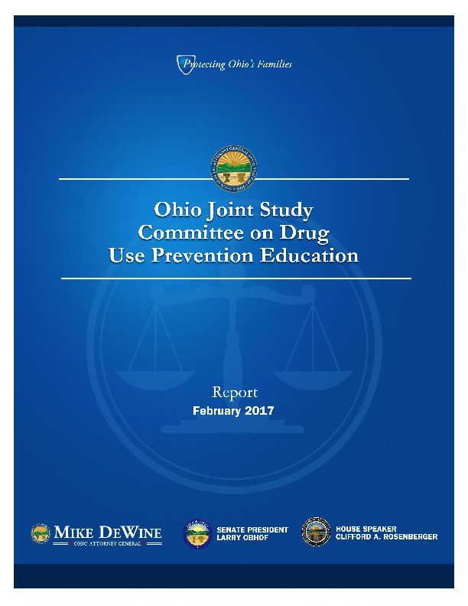
Remember to check out this document from the state of Ohio. It outlines the new mandate that all Kindergarten students receive substance use prevention education. Document Link.

Appendix B

Stanford University Vaping Guide

Feedback from School Nurse Leaders revealed that more information on vaping was needed. This Stanford University Tobacco Prevention Toolkit is an outstanding resource for nurses, educators, parents and students. The toolkit is full of information about e-cigarettes and vape pens. Make sure to check it out! Website link.

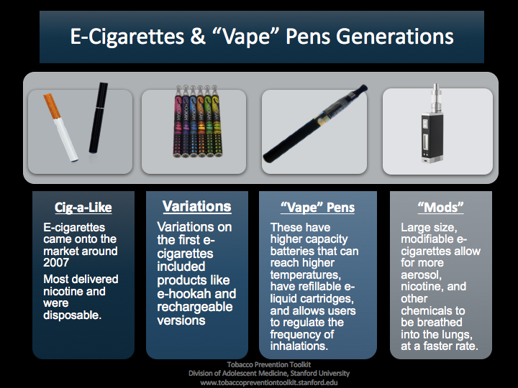

Appendix C

More Vaping information

Feedback from School Nurse Leaders revealed a need to inform educators, school nurses and parents about the JUUL vaporizer. This vaporizer is troubling because of its small packaging, and its ability to be disguised as a USB port. School Nurse Leaders also discussed how vaporizers could be disguised as a marker or lipstick/lip gloss container.

Check out this NPR article. And this warning for the CDC. This is a fact sheet and parent’s guide from the U.S. Surgeon General. And information on the health/brain risks associated with vaping.

