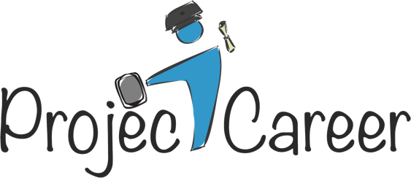
Providing services to college students who have experienced a traumatic brain injury

- Have you had a traumatic brain injury (TBI) or mTBI/concussion?
- Are you experiencing cognitive difficulties because of this brain injury?
- Are you currently enrolled in undergraduate university classes?
If so, then a new federally-funded program is available that can help you identify and maintain career goals, improve job readiness, and effectively transition to a job after graduation through the use of assistive technology and rehabilitation counseling practices.
What does Project Career do?
Project Career provides the individual support, equipment (iPad), and technology designed to help postsecondary students. If you are accepted into the program, you will receive assessment services to determine your specific needs, as well as an iPad and customized applications (apps) designed to help support your cognitive functioning.
Project Career personnel will assist you in obtaining a summer internship and other employment-related prospects that will increase your career opportunities. In addition, participants will be paired with a mentor from their chosen field of study who will provide support, encouragement, and real world experiences from the field.
The program’s Technology and Employment Coordinator will provide ongoing training on the use of technology supports, conduct periodic assessments to ensure you are achieving your full academic potential, and help you in identifying and accessing other needed resources.
How do I know if I qualify?
You are qualified to receive Project Career services if you have been diagnosed with a traumatic brain injury, are currently enrolled and/or enrolling in postsecondary courses.
How much will it cost if I choose to participate?
ALL Project Career services are FREE. The program is funded by the U.S. Department of Education’s National Institute on Disability, Independent Living, and Rehabilitation Research (NIDILRR).
Additional information regarding Project Career?
- All information regarding your participation is confidential
- Your participation is completely voluntary and you may choose to drop-out of the program at any time
OK, I’m interested! How do I apply?
Contact Amanda Nardone at 617-353-7521 or via email at projectcareerbu@gmail.com. We are looking forward to helping you achieve your academic and career goals!

