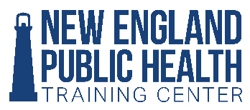
NEPHTC Health Equity Internship Program
Agency Project Proposal for Summer/Fall 2020

The New England Public Health Training Center invites public and nonprofit health agencies and organizations in New England, particularly those serving underserved areas and populations, to submit health equity internship project opportunities for public health students by filling out the following proposal form. Students selected to work on approved projects will receive a $3,500 stipend from NEPHTC.

What is a health equity project? Health equity means that everyone has a fair and just opportunity to be as healthy as possible. Health equity projects focus on removing or reducing barriers to health caused by race or ethnicity, education, income, location or other social factors. Proposed projects benefit medically underserved populations and may address any health or social problem. Highly desired are projects for agencies located in medically underserved areas or rural areas.

General Overview
Organization Name
Primary Contact Name
Primary Contact Title
Primary Contact Email
Street Address
City, State, ZIP Code
Primary Contact Phone

1. Organization description, including service area, services and population(s) served

Project Overview

2. Internship project title

3. Project description
Describe the project fully. Include scope of desired/expected activities, any specialized skills needed, list those who will be involved (units, departments, etc.) and expected outcomes/deliverables.

4. What kind of student might be a good fit for this project? Note: If you have already identified a student, please provide student information here, including degree bring pursued and home academic institution.
Describe the types of background, skills, aptitudes most desired.

5. How does this project help your organization to improve health equity?

6. Project location if not the same as organization address (include complete address with zip code)

7. Project timeline (start and end date with any deadlines)

8. Project supervisor name, academic credentials and description of public health practice experience

9. Please feel free to share any additional information on your project that might be helpful to us.

Return to
Kathi Traugh, MPH
NEPHTC Student Intern Manager
Yale School of Public Health
Kathi.traugh@yale.edu
203-785-2868

