Geophysical Research Letters
Supporting Information for
Amplified Increases of Compound Hot Extremes over Urban Land in China
Weilin Liao¹, Dan Li², Sergey Malyshev³, Elena Shevliakova³, Honghui Zhang^{4,5}, and Xiaoping Liu^{1,6}
¹Guangdong Key Laboratory for Urbanization and Geo-simulation, School of Geography and Planning, Sun Yat-sen University, Guangzhou, China.
²Department of Earth and Environment, Boston University, Boston, MA, USA.
³NOAA/Geophysical Fluid Dynamics Laboratory, Princeton, NJ, USA.
⁴College of Resources and Environmental Sciences, Hunan Normal University, China.
⁵Guangdong Guodi Planning Science Technology Co., ltd, China.
⁶Southern Marine Science and Engineering Guangdong Laboratory (Zhuhai), Zhuhai, China.

Corresponding author: Xiaoping Liu (liuxip3@mail.sysu.edu.cn)

Contents of this file

Figures S1 to S12
Tables S1 to S5

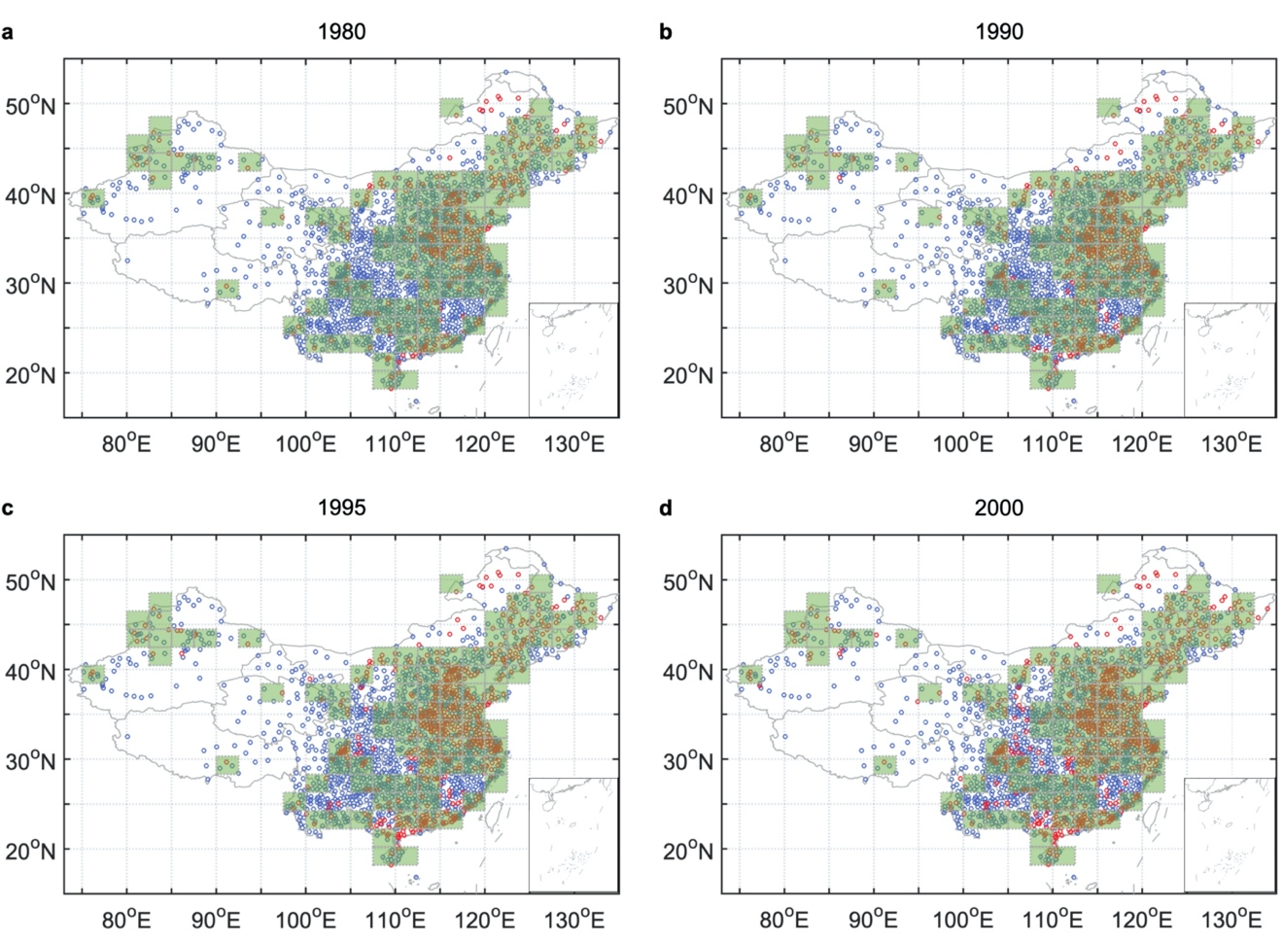

Figure S1. Spatial distribution of urban and rural stations in different periods. (a)-(d), stations are classified into urban and rural types based on the land-use/land-cover data in 1980, 1990, 1995, and 2000, respectively. Red dots denote urban stations, and blue denote rural stations. The 2°2.5° latitude-longitude grid is shaded green when at least one urban station and one rural station are contained within the relevant grid for all periods 1980-2000.

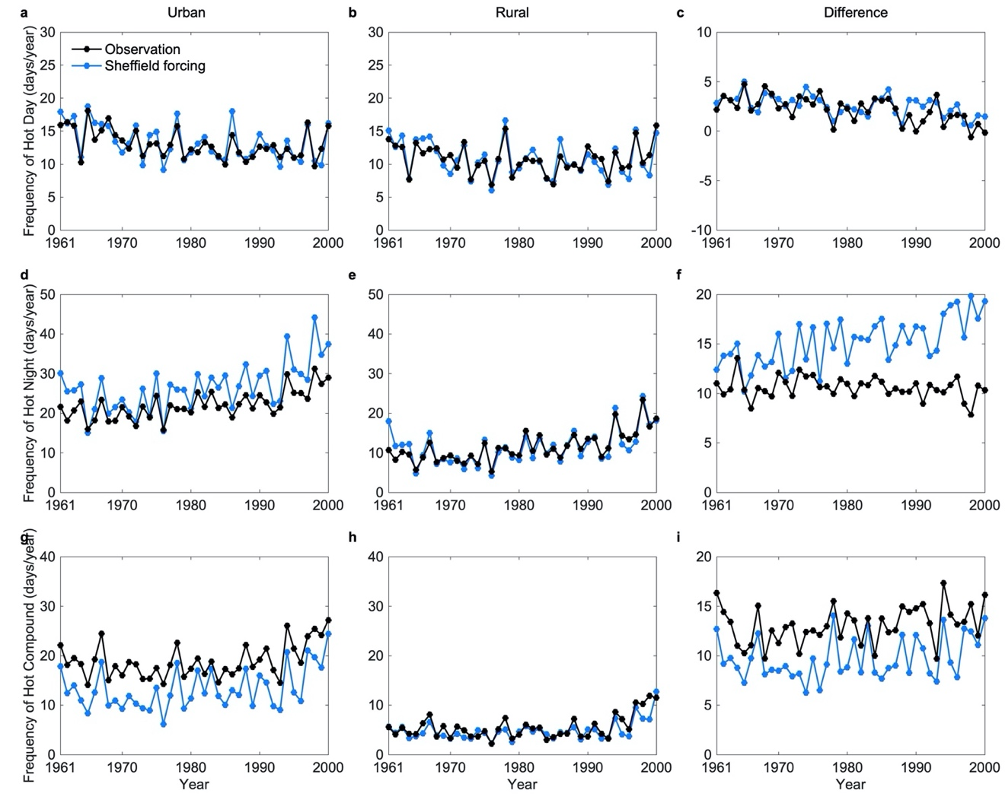

Figure S2. Urban and rural occurrences of summertime hot extremes during the historical periods. (a)-(c) Frequency of independent hot days in urban, rural, and their difference. (d)-(f) Frequency of independent hot nights in urban, rural, and their difference. (g)-(i) Frequency of compound hot events in urban, rural, and their difference. The first column shows the frequency in urban land, the second column shows the frequency in rural land, and the third column shows their differences. The black curves show results calculated by meteorological observations, and the blue curves show simulated results with the Sheffield forcing.

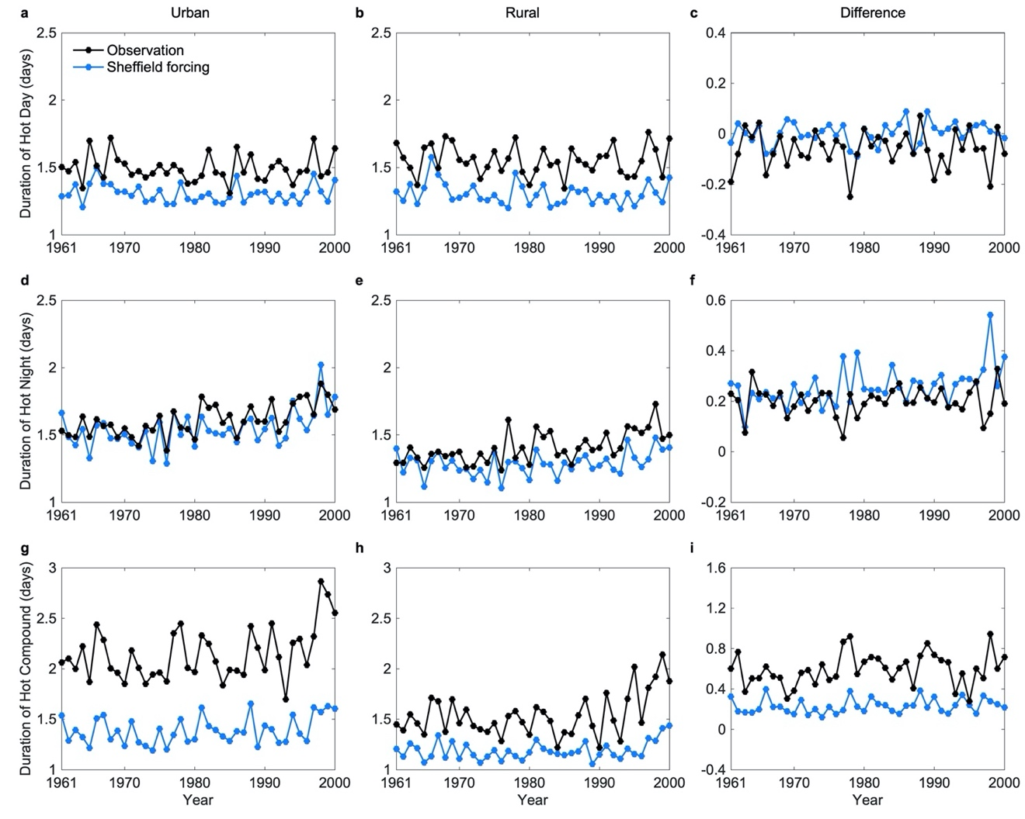

Figure S3. Similar to Figure S2 but for the duration.

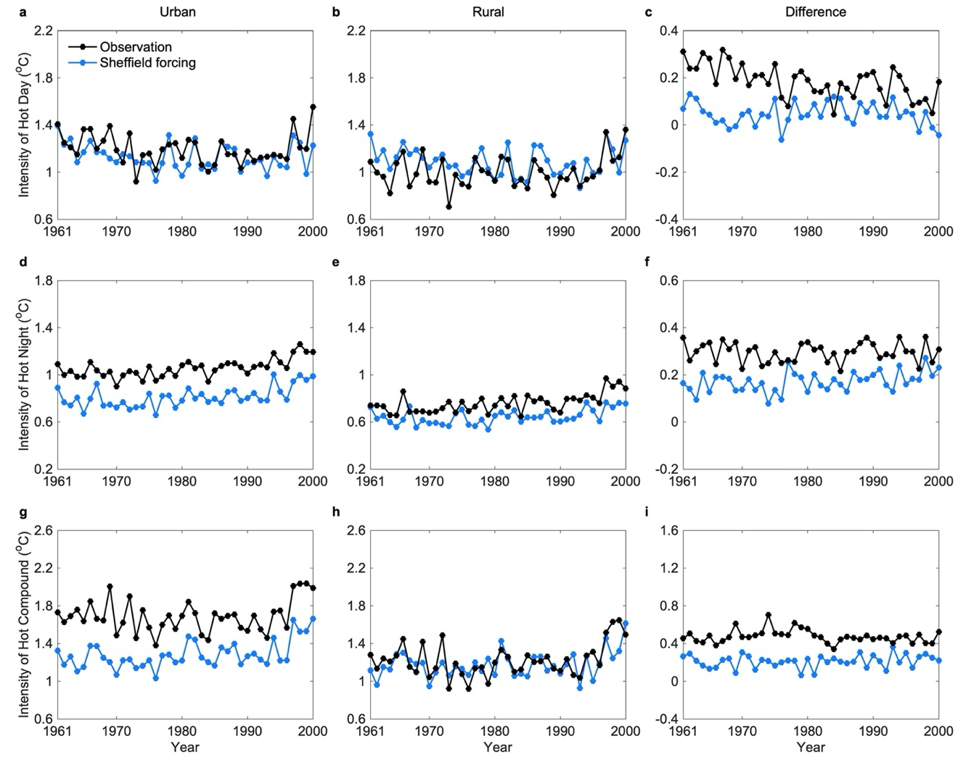

Figure S4. Similar to Figure S2 but for the intensity.

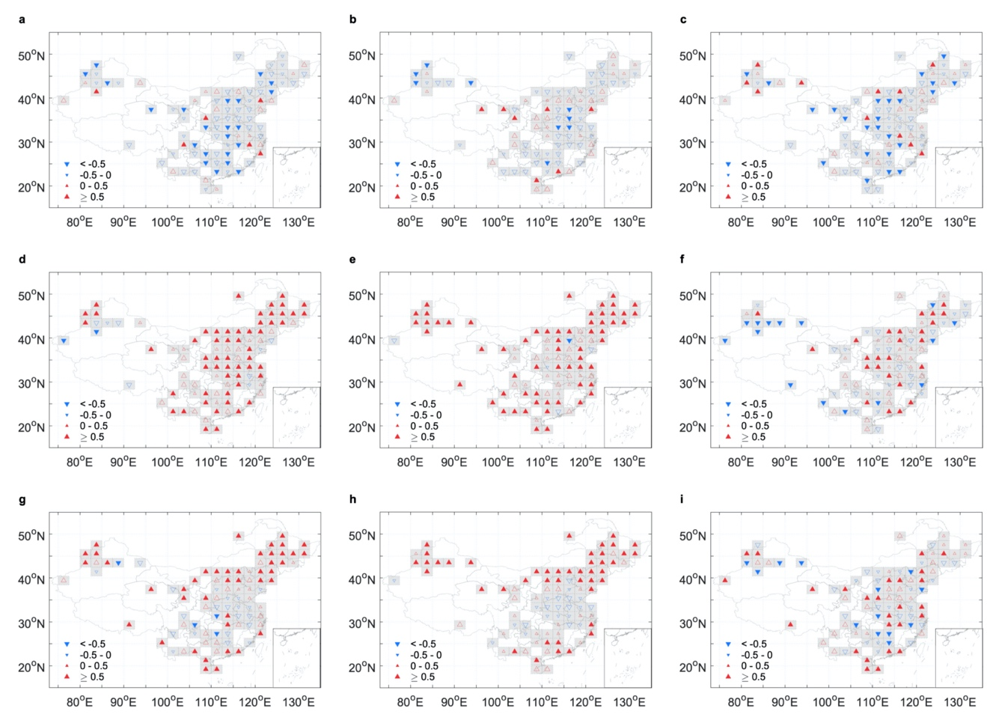

Figure S5. Spatial patterns of the trends of urban and rural occurrences of summertime hot extremes during the historical periods (1961-2000) calculated by meteorological observations. (a)-(c) The trends of frequency for independent hot days in urban, rural, and their difference. (d)-(f) The trends of frequency for independent hot nights in urban, rural, and their difference. (g)-(i) The trends of frequency for compound hot events in urban, rural, and their difference. The first column shows the trends in urban land, the second column shows the trends in rural land, and the third column shows the trends of their differences. Solid triangles represent statistical significance at 0.05. The unit is days/year/decade.

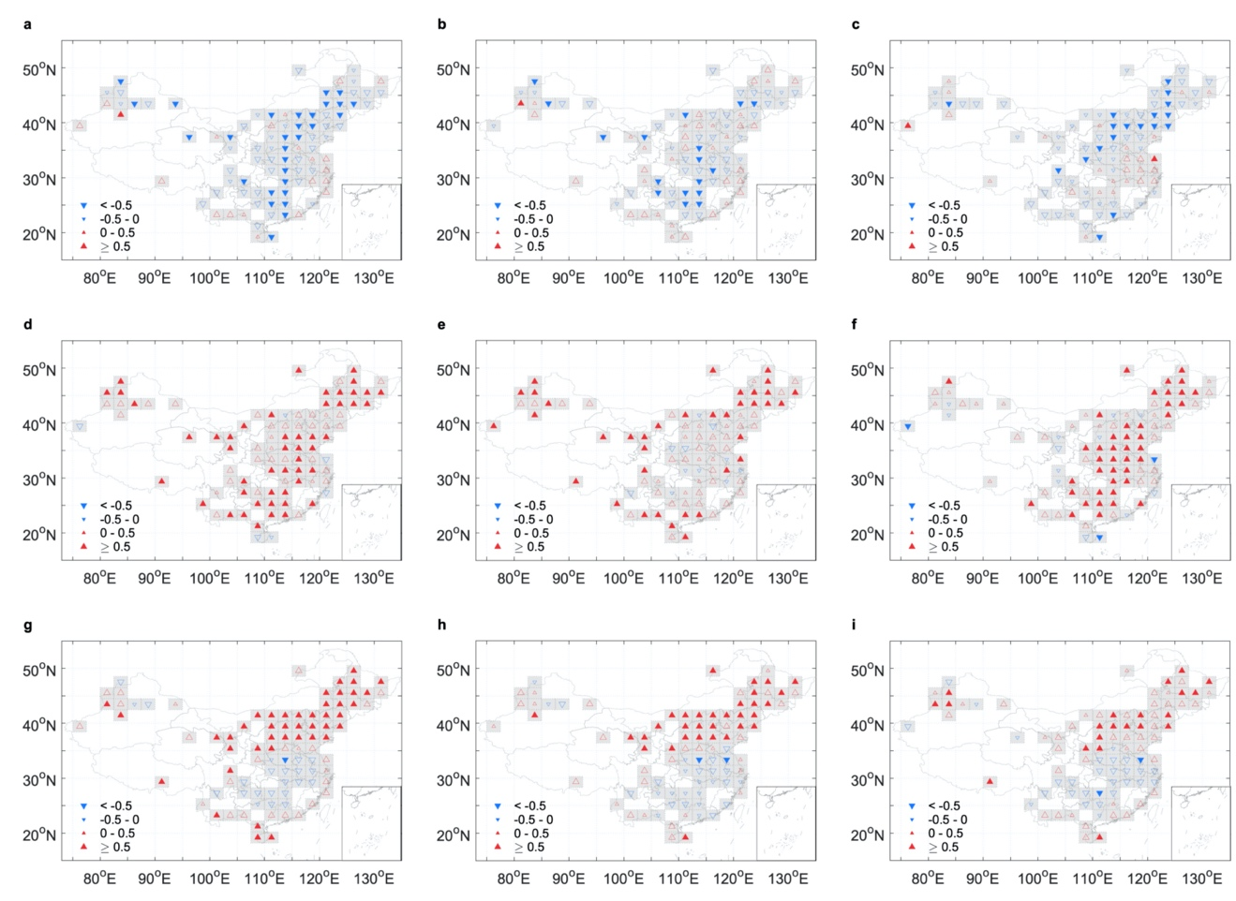

Figure S6. Similar to Figure S5 but for the simulated results with the Sheffield forcing.

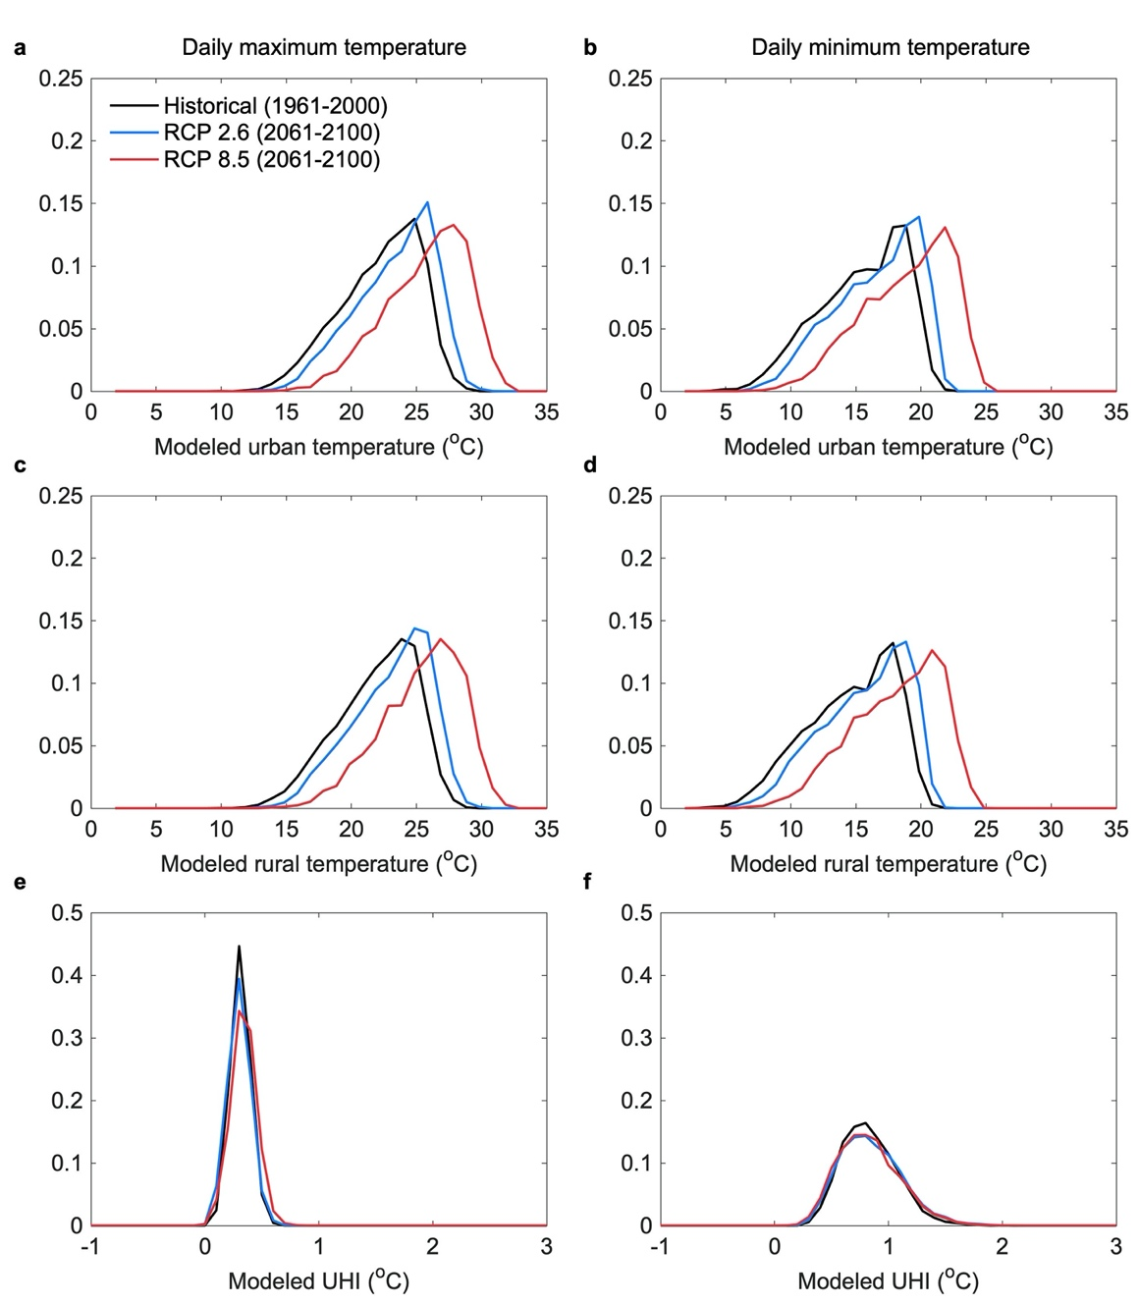

Figure S7. Probability density functions of spatially averaged daily maximum (left panels) and minimum (right panels) temperatures simulated by the GFDL forcing during summertime in different periods. (a) and (b) are results in urban areas and (c) and (d) are results in rural areas. (e) and (f) show probability density functions of urban heat island (UHI) intensities. These temperature variables are spatially averaged over China during the historical period of 1961-2000 (black) and the future period of 2061-2100 under RCP 2.6 (blue) and RCP 8.5 (red) scenarios.

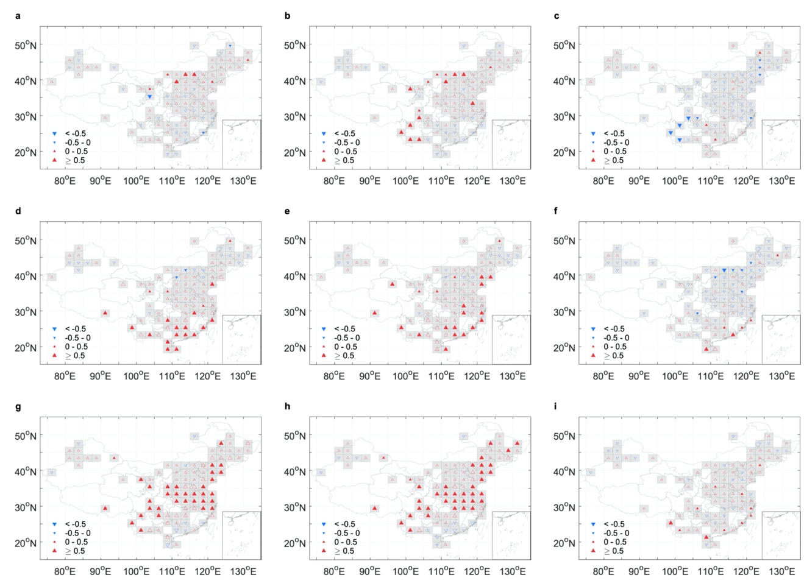

Figure S8. Spatial patterns of the trends of urban and rural occurrences of summertime hot extremes under RCP 2.6 scenario (2001-2100). (a)-(c) The trends of frequency for independent hot days in urban, rural, and their difference. (d)-(f) The trends of frequency for independent hot nights in urban, rural, and their difference. (g)-(i) The trends of frequency for compound hot events in urban, rural, and their difference. The first column shows the trends in urban land, the second column shows the trends in rural land, and the third column shows the trends of their differences. Solid triangles represent statistical significance at 0.05. The unit is days/year/decade.

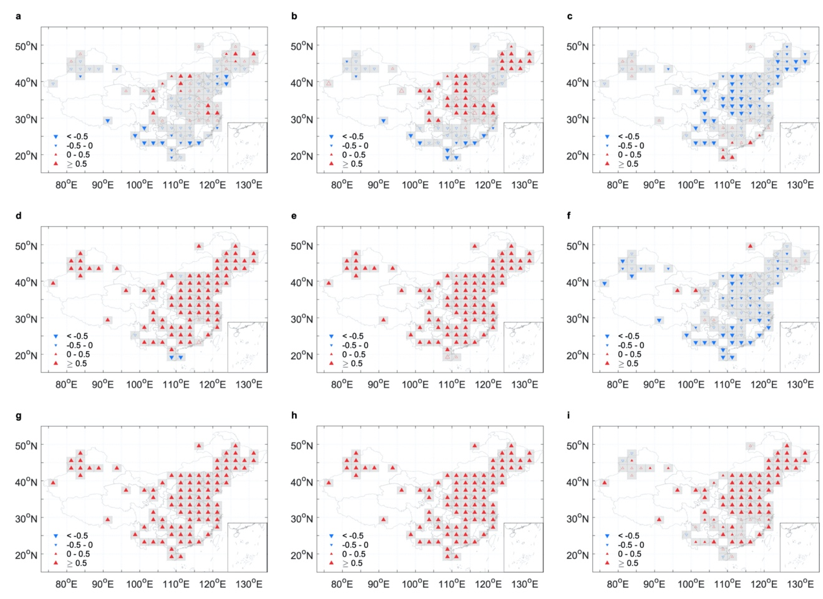

Figure S9. Similar to Figure S8 but for the results under RCP 8.5 scenario (2001-2100).

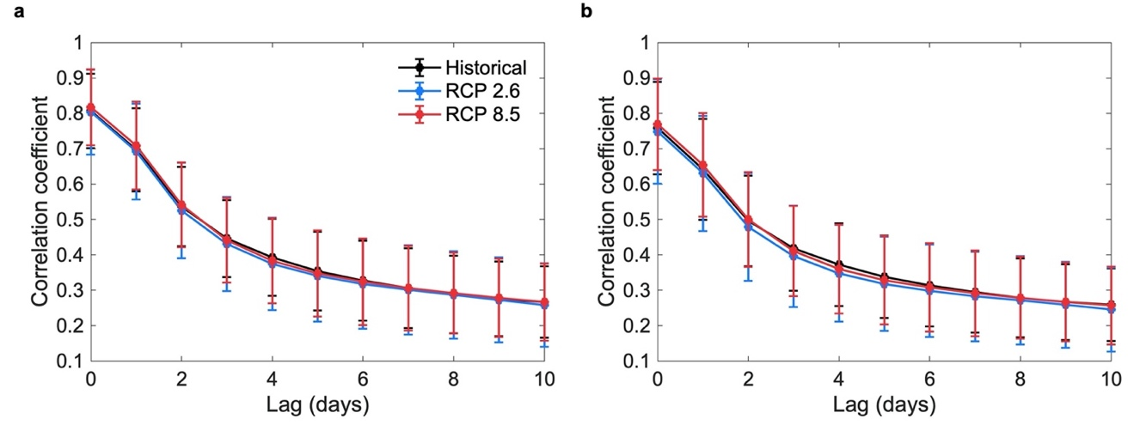

Figure S10. The cross-correlation of daily maximum temperature with daily minimum temperature. Panel (a) shows the cross-correlation spatially averaged over 1961-2000 in the historical period (black) and over 2061-2100 under the RCP 2.6 scenario (blue) and the RCP 8.5 scenario (red) in urban, while panel (b) shows results in rural. The error bars are given as the standard deviation of the mean in space.

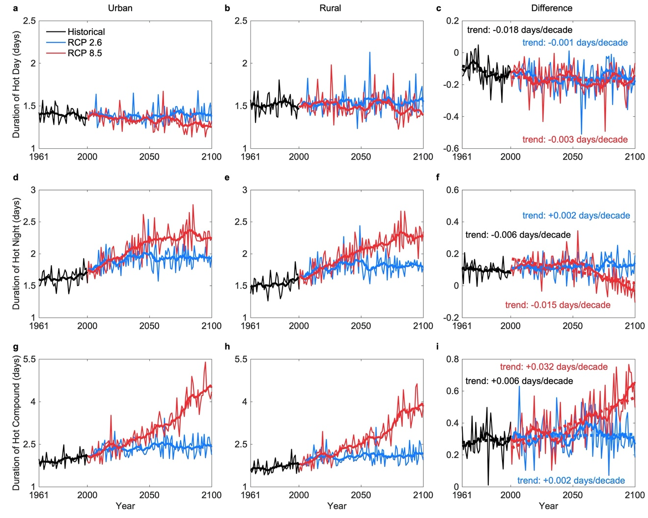

Figure S11. The duration of summertime hot extremes under RCP 2.6 and RCP 8.5 scenarios in China. (a)-(c) Duration of independent hot day in urban, rural, and their difference. (d)-(f) Duration of independent hot night in urban, rural, and their difference. (g)-(i) Duration of compound hot event in urban, rural, and their difference. The first column shows the duration in urban land, the second column shows the duration in rural land, and the third column shows their differences. The solid curves denote the 10-yr moving averages, and the dashed lines in the third column are linear regression fits.

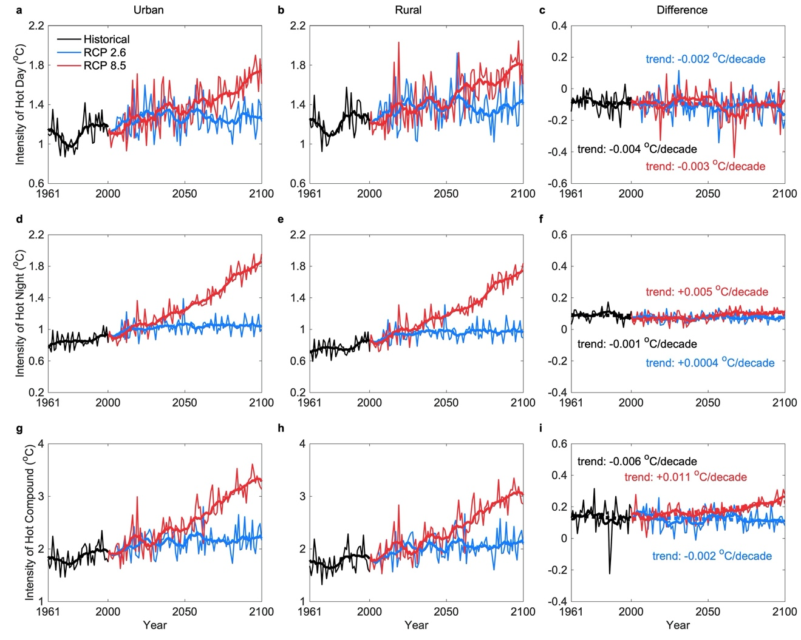

Figure S12. Similar to Figure S11 but for the intensity.

Table S1. The trends of urban and rural temperatures in summer.
 | Urban |  |  | Rural |  |  | UHI
 | Historical | RCP 2.6 | RCP 8.5 | Historical | RCP 2.6 | RCP 8.5 | Historical | RCP 2.6 | RCP 8.5
Daily Maximum Temperature | +0.129* | +0.064** | +0.441** | +0.124 | +0.066** | +0.438** | +0.005 | -0.002* | +0.003**
Daily Minimum Temperature | +0.142** | +0.050** | +0.413** | +0.138** | +0.046** | +0.415** | +0.004 | +0.004 | -0.002
Note: *Represents statistical significance at 0.05; **Represents statistical significance at 0.01; The unit of measure is °C/decade.

Table S2. The changes of urban and rural temperature in different periods.
 | Daily maximum temperature |  |  | Daily minimum temperature
 | Historical  (1961-2000) | RCP 2.6  (2061-2100) | RCP 8.5  (2061-2100) | Historical  (1961-2000) | RCP 2.6  (2061-2100) | RCP 8.5  (2061-2100)
Urban | 22.21 ± 3.07 | 23.33 ± 3.02 | 25.70 ± 3.14 | 15.44 ± 3.30 | 16.51 ± 3.23 | 18.87 ± 3.38
Rural | 21.90 ± 3.04 | 23.03 ± 2.98 | 25.36 ± 3.09 | 14.60 ± 3.33 | 15.66 ± 3.24 | 18.04 ± 3.39
UHI | 0.31 ± 0.08 | 0.30 ± 0.10 | 0.34 ± 0.11 | 0.83 ± 0.24 | 0.85 ± 0.27 | 0.83 ± 0.27
Note: The value donates the mean ± standard deviation; The unit of measure is °C.

Table S3. The trends of frequency of summertime hot extremes.
 | Urban |  |  | Rural |  |  | Urban-rural Difference
 | Historical | RCP 2.6 | RCP 8.5 | Historical | RCP 2.6 | RCP 8.5 | Historical | RCP 2.6 | RCP 8.5
Independent hot day | +0.162 | +0.098 | +0.012 | +0.221 | +0.171* | +0.344** | -0.104 | -0.081* | -0.375**
Independent hot night | +1.244** | +0.358** | +1.921** | +0.999** | +0.336** | +2.317** | +0.235** | +0.022 | -0.398**
Compound hot event | +1.155** | +0.581** | +5.984** | +0.808* | +0.459** | +5.271** | +0.253* | +0.120** | +0.667**
Note: *Represents statistical significance at 0.05; **Represents statistical significance at 0.01; The unit of measure is days/year/decade.

Table S4. The trends of duration of summertime hot extremes.
 | Urban |  |  | Rural |  |  | Urban-rural Difference
 | Historical | RCP 2.6 | RCP 8.5 | Historical | RCP 2.6 | RCP 8.5 | Historical | RCP 2.6 | RCP 8.5
Independent hot day | -0.012 | +0.002 | -0.012** | +0.001 | +0.004 | -0.009* | -0.018 | -0.001 | -0.003
Independent hot night | +0.026 | +0.012* | +0.059** | +0.031 | +0.010 | +0.074** | -0.006 | +0.002 | -0.015**
Compound hot event | +0.064* | +0.022* | +0.252** | +0.051 | +0.019* | +0.217** | +0.006 | +0.002 | +0.032**
Note: *Represents statistical significance at 0.05; **Represents statistical significance at 0.01; The unit of measure is days/decade.

Table S5. The trends of intensity of summertime hot extremes.
 | Urban |  |  | Rural |  |  | Urban-rural Difference
 | Historical | RCP 2.6 | RCP 8.5 | Historical | RCP 2.6 | RCP 8.5 | Historical | RCP 2.6 | RCP 8.5
Independent hot day | +0.039* | +0.005 | +0.057** | +0.035 | +0.007 | +0.057** | -0.004 | -0.002 | -0.003
Independent hot night | +0.030* | +0.009** | +0.099** | +0.030* | +0.009** | +0.094** | -0.001 | +0.0004 | +0.005**
Compound hot event | +0.060* | +0.023** | +0.150** | +0.049 | +0.025** | +0.134** | -0.006 | -0.002 | +0.011**
Note: *Represents statistical significance at 0.05; **Represents statistical significance at 0.01; The unit of measure is °C/decade.

