What is Narrative Medicine?

Narrative Medicine (NM) defies simplistic definition. Broadly speaking, NM can be considered a holistic framework for medicine and health sciences which places value on the unique stories of the individuals involved. NM transcends the merely technical aspects of “getting well” and strives to give credence to the less obviously corporeal, but hugely significant, role that storytelling plays in the healing process.

As a healthcare approach, NM privileges narrative competence and empathic listening as being integral to comprehending the inevitably mysterious nature of health and illness, suffering and relief, healing and loss. NM practitioners engage in intellectual and emotional journeys beyond the facts and figures presented by medical charts, traversing less quantifiable realms that nevertheless directly impact patients’ health and wellbeing.

The benefits of NM extend to healthcare providers, since literature and writing can be instrumental in learning clinical and academic competencies (e.g. empathy, writing for publication); fostering self-reflection for wellness; and facilitating team communication and cross-cultural understanding.

How Can I Be Involved at BUSM?

The BUSM Narrative Writing Program (NWP): Writing from the Front Lines of Clinical Care, Education, and Research provides faculty with the opportunity to develop narrative skills and competencies through reflective writing, reading, and listening. Such narrative training fosters writing skills and professional well-being while offering a framework for establishing empathic and collaborative teams.
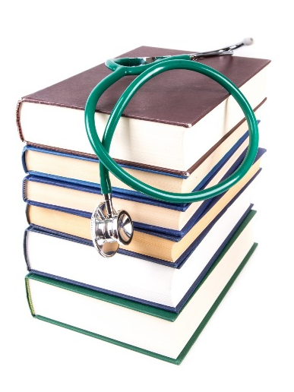
Our curriculum is designed to help faculty engage with stories and storytelling themes relevant to the daily lives of health care and science professionals. Experiential seminars offer instruction on writing theory and practice, contextual information about literary narratives, questions for discussion, and reflective writing prompts.

Writing workshops provide participants with a venue for peer coaching on pieces developed outside of sessions, with the goal of aiding participants in preparing at least one piece of writing to a form suitable for submission to a peer- reviewed journal by the end of the course.

We are currently piloting the NWP within DOM. Next year, we hope to offer the course to all BUSM faculty, including clinicians, educators, and researchers. Please email Christy Di Frances, PhD, MA, for more information (christyd@bu.edu).

Narrative Medicine Resources

The resources on this page are a starting point for healthcare professionals looking to explore NM.

Some Places to Read & Publish Narrative Writing
- ‘A Piece of My Mind’ and ‘Poetry and Medicine’ in JAMA
- ‘Ad Libitum’ and ‘On Being a Doctor’ in Annals of Internal Medicine
- Ars medica
- Bellevue Literary Review from NYU Langone Medical Center
- Examined Life Journal from the University of Iowa Carver College of Medicine
- ‘Healing Arts: Materia Medica’ and ‘Healing Arts: Text and Context’ in JGIM
- Healing Muse: A Journal of Literary and Visual Arts from SUNY Upstate Medical University
- Hektoen International: A Journal of Medical Humanities from the Hektoen Institute of Medicine
- Hospital Drive from UVA School of Medicine
- Intima: a Journal of Narrative Medicine
- Journal of Medicine Humanities
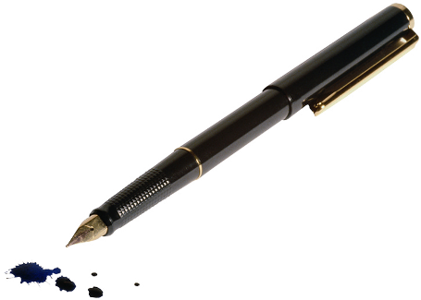
- Literature and Medicine from Johns Hopkins University Press
- Medical Humanities (BMJ)
- ‘Medicine and the Arts (MATA)’ and ‘Perspectives’ in Academic Medicine
- ‘Narrative Essays’ in Family Medicine
- ‘Personal Views’ in BMJ
- ‘Perspective’ and ‘Medicine in Society’ in NEJM
- Research and Humanities in Medical Education (RHiME)

Some Texts by Physicians & Scientists
- A Country Doctor’s Notebook by Mikhail Bulgakov, trans. Michael Glenny
- A Life in Medicine: A Literary Anthology, ed. Robert Coles
- Being Mortal & Complications by Atul Gawande
- Black Man in a White Coat by Damon Tweedy
- Chekhov’s Doctors: A Collection of Chekhov’s Medical Tales by Anton Chekhov, ed. Jack Coulehan
- Life of Sir William Osler by Harvey Cushing
- My Own Country by Abraham Verghese
- Narrative Medicine: Honoring the Stories of Illness by Rita Charon
- Poetry by John Keats
- Poetry in Medicine: An Anthology of Poems About Doctors, Patients, Illness and Healing, ed. Michael Salcman
- Penseés by Blaise Pascal
- Sherlock Holmes stories by Sir Arthur Conan Doyle
- Silent Spring by Rachel Carson
- The Doctor Stories by William Carlos Williams, ed. Robert Coles
- The Kite Runner & A Thousand Splendid Suns by Khaled Hosseini
- The Moviegoer by Walker Percy
- Various writings by Friedrich von Schiller
- What Doctors Feel by Danielle Ofri
- When Breath Becomes Air by Paul Kalanithi

